International conference on engineering and product design education
4 & 5 September 2014, University of twente, the netherlands

UNDERSTANDING THROUGH MAKING ANDING THROUGH MAKING
Julian Lindley¹, Richard Adams¹, John Beaufoy¹ and Stephen McGonigal¹
¹University of Hertfordshire, United Kingdom
abstract
This paper’s core theme is incorporating an empirical approach in the understanding of physical value(s) within Product Design (PD). It is a reaction too, and an acknowledgement of the changing nature of both the students previous experiences and the value of design to the modern world. With the former, some applicants lack the breadth of basic skills in drawing, making and experimentation. Indeed many lack a curiosity which is natural to design. This is in part due to the diminishing number of applicants from Foundation Courses in Art and Design (United Kingdom). These pre-degree courses encourage experimentation and play in understanding materials and structures. Another observation is that design has progressed beyond the production of artefacts to a process of problem identification and solving [1]. In this context Sustainability, Brand and Human Centred Design are all common themes within design curricula. However focusing on these in an already congested curriculum has left some of the basic skills and investigations lacking in students vocabulary and skills within design. This paper outlines a way in which an understanding of structures and objects can be achieved. Two projects are cited, firstly a project which gets students to think with their hands and make quickly. The second project builds on this experience with a mechanical design challenge, that of an Automata. The combination of these projects equips students with a preliminary understanding of construction, mechanics, materials and aesthetics. This is a starting point for understanding the physicality of artefacts underpinning PD Education.
Keywords: Making, Playing, Mechanics, Re-use, Structure

1 Introduction
It can no longer be assumed that students entering Design Education have an experience of experimentation with materials and structures that is, making. In the UK this can be attributed to two causes (amongst others). Firstly more applicants come directly from School. This is in contrast to previous years when students spent a year on Foundation Courses learning to have an inquisitive mind and play with materials. Research by Wilgeroth and Stockton [2] supports this view with decisions on why students study PD at degree level being arbitrary rather than a knowledge of and application of the subject. Although in schools students are taught design methods this is an academic approach and many only experience real objects when making their final pieces. Secondly we live in a throw-away culture. If a product breaks or fails it is easier to purchase a new one rather than service or repair. This has removed the inherent ability to tell if something is structurally ‘right’ and basic understanding of construction.
The authors have taken steps to address this shortfall by introducing a broader approach to 3D in the early stages of the Degree Programmes (BA Product Design & BSc Industrial Design). In the instance of this paper, two projects are cited which together introduce students to an empirical approach to materials, mechanisms and structures.
The first project is a quick construction project, getting students to design by making. In essence the project is about the deconstruction and re-constructing of chairs. Based on the work of Martino Gamper [3], students are challenged to make new chairs using discarded and broken chairs as source material. Within this construct issues of material and object value can be discussed as well as product lifetime, product evolution and second life.
The second project involves simple mechanisms. With this project students start investigating on paper but quickly need to develop with simple mechanical mock ups both in 2D and 3D.

2 PROJECT 1: dE-CONSTRUCTED CHAIRS

2.1 Martino Gamper
The inspiration for the project was the work of Martino Gamper who challenged himself to make 100 chairs in 100 days [3]. The final output of 100 chairs (Figure 1) created a challenging visual feast. Each ‘new’ chair’s visual language played on the echo of past chairs as much as the new forms created. Viewers perceptions are based as much on their own memory as the work in front of them. Some contained visual puns while others challenge our notions of what a chair actually is.

It is possible on first glance to see the chairs as assemblies of diverse elements, yet on the second to perceive them as singular pieces. To report on only one of these aspects is not enough [4].

However the questioning nature of the project is what makes it valuable, Gamper himself states:

The motivation was the methodology: the process of making, of producing and absolutely not striving for the perfect one. [5].

The starting point for the students was intended to be very different in methodology from the processes that they had been taught in school.
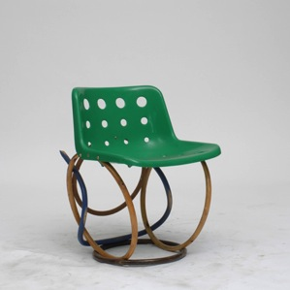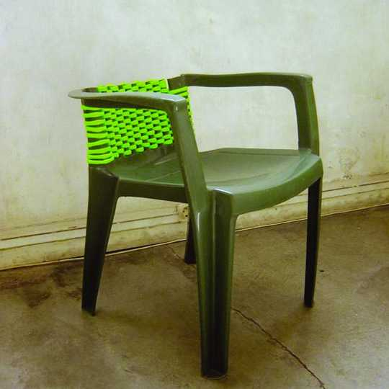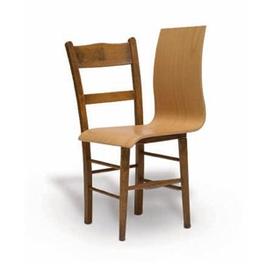
Figure 1. Work by Martino Gamper

2.2 De-construct, Re-construct Challenge
The project brief was quite straightforward, groups of students (2 – 3 per group) were given discarded chairs and told to use these as source material to make ‘new’ chairs. The time allocated was three days.
By referencing Gamper’s work in the project introduction allowed the staff to explore the notions of heritage, structure and visual language prior to the commencement of the project. Students were not trying to design chairs but create them. That is the final objects evolved from playing with existing materials each containing their own notions of form and language. Students were also constrained by the source material, no other materials could be incorporated, the only additions were fixings. This was emphasised by the short timeframe and the immediacy of physically taking chairs apart and reconstructing them. Essentially the students were taken on a journey of discovery through deconstruction and reconstruction with their own intuitive design sensitivities guiding the design decisions. This approach echo’s that of Sjøvoll and Gulden [6]. This is an empirical approach and the sketchbook was not used to design but occasionally to note the ideas found through making or resolve a construction detail.
Students assumed that the conclusion of the project was the delivery of a chair or chairs. However as
the project generated a large amount of ‘waste or scrap’ material they were further challenged to, in three hours, use this to make more chairs. This additional challenge forced the students to work even quicker, making decisions with their hands. Interestingly some of the results (Figure 4) were as successful as those which evolved over three days (Figure 3). This also made the students aware of what they had learnt over three days could now be applied almost subconsciously in this new challenge.

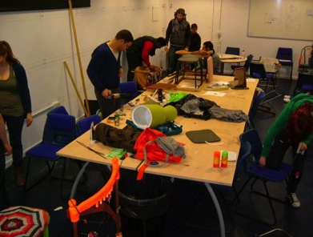
Figure 2. Experimentation in the studio

With a large number of chair constructions to reference and analyse, the de-briefing session unpicked the value of the project and introduce concepts from heritage and sustainability. This ‘Crit’ session was an important teaching aspect of the project. These themes included:
- Construction.
- Balance and harmony in 3D structures.
- Material usage and quality.
- Heritage.
- Visual Languages.
- Speed of decision making.
- Design process and the value of making as part of this rather than the result of it.
- Need/Purpose.
- Re-use and sustainability.
- Thinking with your hands.
- Chairs.

The project has now been run over four years, with old constructions used as source materials for the next project.
The resulting objects were used in a group discussion starting with recycling, re-use and product lifespans leading into a broader debate on what was meant by Sustainable Design [7] [8].
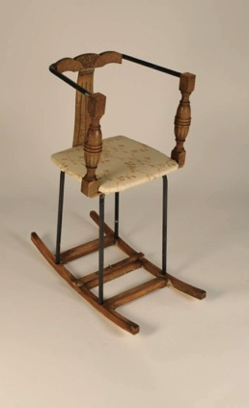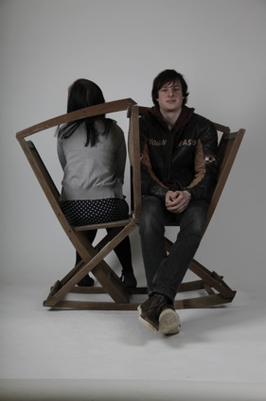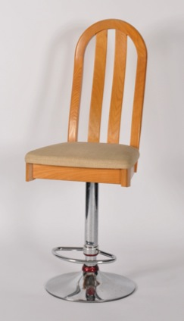
Figure 3. Final Chairs, 3 Days construction

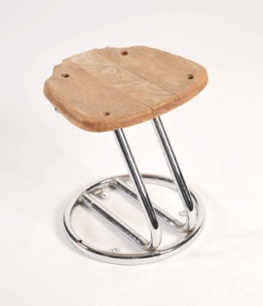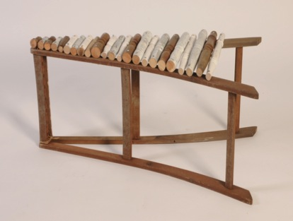
Figure 4. Final Chairs, 3 hours construction

3 Project 2: automatA

3.1 Purpose
The second project, ‘Design and Make an Automata’, demanded a deeper level of considered intellectual engagement with the challenge. This project with two specific stages, Stage 1 ‘Research and Design’ (six weeks duration part-time), Stage 2 (six weeks duration part-time) ‘Build your Automata’. There was a design review after the completion of Stage 1. The project references the work of Cabaret Mechanical World [9] and Lawrence and Alexander [10]. These advocate the playful nature of Automata where the excitement is gained from the simplicity of mechanism and humour in the moving stories.
Stage 1 needed to be a concept generation phase followed by simple lash ups to explore mechanisms. This involved a reflective loop where ideas which theoretically worked in sketch sheets needed modification after the first iteration in 3D materials. This design phase is important as Rodgers and Milton observe:

Product design is a three dimensional discipline, and while the immediacy of marker renderings and the visual gloss and ease of CAD offer huge possibilities, it is essential that designers model their concepts physically and test them in the real world. [11].

The connection between the sketchbook and workshop became strong. The success of the mechanism depended more on the ability to adapt through making than an initial understanding of mechanics. Overcoming mechanical difficulties, lack of accuracy in the workshop, reflection and adaption were all part of the learning curve indeed it teaches students to develop strategies to cope with failure. One key value of the project was in teaching students the relationship between sketchbook and making while introducing a hands-on approach to the understanding of simple mechanisms. Students also gained an awareness that theoretical ideas do not always work in practice but need modification and evolution.
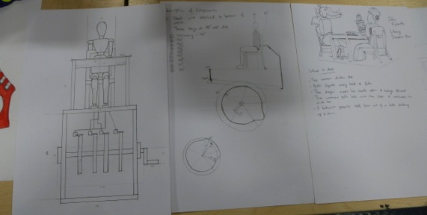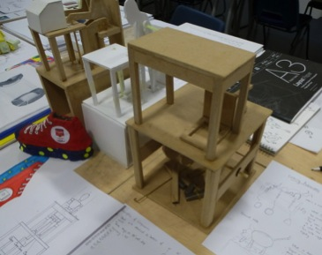
Figure 4: Automata, Sketches and Lash-ups
Stage 2 utilised the knowledge of what worked and what did not work in 3D to construct a finished piece. This again involved adaption, while an emphasis was placed on the visual appearance and craft of making.

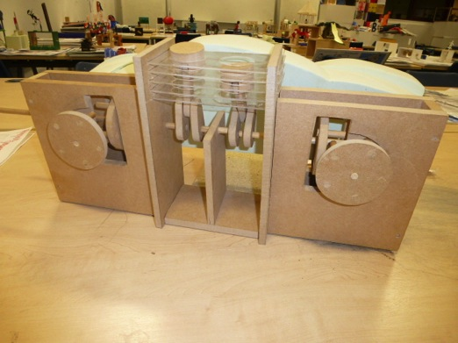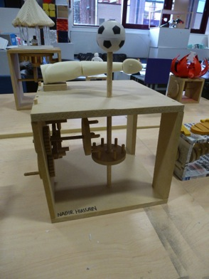
Figure 5: Automata, Final Models

4 how the projects link within the curriculum
Design Education is about equipping students with skills, contextual understanding and creative processes to address the challenges put to them in their professional lives. This need to work in and test within the physical environment is critical in both ID within industry and the training for it [12].

Whilst designing in the 3D digital environment allows for a faster and possibly more fluid process, we still have the need for the real object as seen in the ‘real’ world……..

………This ‘hand’s on’ approach can be used to finalise any design problems that may arrive during the digital environment, one such example is scale or fit. [12]

Both projects were set tasks to first year students of Product and Industrial Design as an introduction to 3D, the workshop and making as a valuable design method. Together they form a holistic approach to 3D from experimental to technical, with making and an ease of using a machine workshop part of the learning curve. The two projects explore different aspects of materials, structures, mechanics and making. The first, deconstructed/reconstructed chairs, forced students to experiment and work quickly learning by their mistakes. The second was more prolonged allowing students to generate ideas in 2D while putting these into practice in 3D. This became a circular process with students working between the two approaches. The work underpins the projects set throughout the three year degree programmes.

5 CONCLUSION AND REFLECTION
It is important to keep PD & ID Education rooted in the physical world as ultimately a large percentage of the work of designers is realising objects. As designers rather than engineers, the understanding must come from a ‘hands-on’ approach to learning through making rather than a quantitative delivery of the subject. Developing an intuitive understanding of materials and structure is paramount to success. This in itself becomes an important method within the design processes used by designers.
As these two projects are set early in the three year degree programme(s) it embeds the connection between creating and experimenting in 3D within the students design processes. This is evident in later projects where students use simple models to test ideas and evolve designs. This is different from using the workshop to produce final prototypes or presentation models. The fluidity between 2D and 3D work underpins our approach to product design.
Finally the paper has discussed how to introduce an understanding of making but not delved into why design. The value of making is best summed up by Daniel Charny in an introduction the ‘Power of Making’ exhibition at the Victoria & Albert Museum (2011, London):
It is one of the strongest of human impulses and one of the most significant means of human expression. To some, making is the fountain that releases creative ideas; to others, making is about participation in society as well as defining personal identity. To most of those who make, though, it is likely that they do not think of it as a creative activity. It is their way of making a living – an absolute necessity [13].

ACKNOWLEDGEMENTS
All product and industrial design students at the University of Hertfordshire. Also anyone and everyone who has donated chairs!

References
[1] Parker S, RSA Design & Society Social Animals: tomorrow’s designers in today’s world, 2009. p19
[2] Wilgeroth. P, Stockton. G. Who are the Future Designers? “The path leading to Undergraduate study of Product Design. In International Conference on Engineering and Product Design Education E&PDE09. Brighton, September 2009.
[3] Gamper M. 100 Chairs in 100 Days in 100 Ways, 2007 (Dent-De-Leone).
[4] Emily King. Cited in 100 Chairs in 100 Days in 100 Ways, 2007 (Dent-De-Leone). p7
[5] Gamper M. 100 Chairs in 100 Days in 100 Ways, 2007 (Dent-De-Leone). P73
[6] Sjøvoll V and Gulden T. The Making of a Journey – Identifying New Design Approaches in Contemporary Art. In International Conference on Engineering and Product Design Education E&PDE13. Dublin, September 2013.
[7] Thorpe A. Designer’s Atlas of Sustainability, 2007 (Island Press, Washington DC)
[8] van Hinte E. Eternally Yours Time in Design, 2004 (010, Rotterdam)
[9] Design Council. Available: http://www.cabaret.co.uk/ [Accessed on 2013, 5 September]
[10] Lawrence Onn A. and Alexander G. Cabaret Mechanical Movement. Understanding Movement and Making Automata by Aidan Lawrence Onn and Gary Alexander. 2006 (G&B Litho Limited, London)
[11] Rodgers P and Milton A. Product Design, 2011 ( Laurence King, London)
[12] The Quality Assurance Agency for Higher Education. Benchmark Statements. Available: QAAhttp://www.qaa.ac.uk/Publications/InformationAndGuidance/Documents/ADHA08.pdf
[13] Charny D. Power of Making, 2011 (V&A Publishing, London). P7

