Developing Metadata and Methodologies to Support Assessment of the Social Value of Buildings and Communities in Future Smart Cities

Andrew Williams

Submission made on the 25th July 2018.
Submitted to the University of Hertfordshire in partial fulfilment of the requirements for a Professional Doctorate in Engineering.

Table of Contents

Abstract 2
Acknowledgements 3
Research context 4
Intellectual property 5
Table of figures 6
List of acronyms 8
Glossary 10
Thesis structure and work programme 16
Chapter 1. Introduction, research proposition and thesis structure 17
Chapter 2. Background and discussion 31
Chapter 3. Related work 45
Chapter 4. Language concept and indicative mesh network construction 53
Chapter 5. Product development 73
Chapter 6. Data structure, mesh network profiling and analysis 91
Chapter 7. Conclusion 142
Appendix 1. Form completed by staff at Lister Hospital 158
Appendix 2. Patent - Optimising the use of energy 162
Appendix 3. Background research for BRE Health and profiling the mesh 175
References 185
Bibliography 196

Abstract

The cost of delivering social programmes (health, education, national security etc.) in all OECD countries is rising to an unsustainable level. The Internet of Things and increased connectivity are increasingly being seen by public and private sector organisations as a way of reducing costs and improving service provision.
As ICT progresses from existing in standalone devices to all connected devices (IoT) it will provide new opportunities to improve and integrate service provision. However, increasingly the physical existence of humans and their physical environments will become a key part of smart systems and the services they provide. Before this can happen, there is first a need to better understand how physical things can be codified thereby allowing them to be included into a system. Secondly, there is a need to integrate and harmonise all things (appliances, devices, fixtures/fittings, building fabric/components, community services etc.). Thirdly, the social outcomes of that integration need to be understood, and this calls for a new nomenclature, a ‘social language’.
This research seeks to address these three challenges by discussing the prioritisation of the needs of an individual and characterising all things in terms of the service they provide. It then proposes how these things might be ‘connected’ to form a mesh network that encompasses both current physical, and future virtual, service-delivery mechanisms.
The findings indicate that there is potential to codify things by their services in a meaningful way. It is also clear that this approach would offer much greater analysis of service delivery and be able to optimise that delivery in a more integrated and connected world.
To develop the work further requires considerable programming capability and capacity. However, while this research has involved largely theoretical scenarios, it has also developed several online ‘tools’ driven by the need to provide proof-of-concept models to support research as well as potentially generate income.
The objective to develop a ‘social language’ was acknowledged from the start as being extremely complex, in essence, trying to codify and systemise individual and community needs—even culture itself. However, it is a starting point for others to fulfil its objective in a practical way. The prize is to truly understand the social value of buildings and things in a smarter future and thereby improve wellbeing and social equity for all.

Acknowledgements

I would like to acknowledge the very genuine and personal commitment of my initial supervisor, Johann Siau. His knowledge, openness and accessibility made every discussion stimulating and enjoyable.
I would like to thank those around me who, as scientists, engineers, architects and experts of all kind, provided untold support and insightful comment regarding my work. I would particularly like to thank Mindy Hadi (BRE), Kiruthiga Balson (BRE), Dr Pandelis Kourtessis (UoH), Dr Georgios Pissandidis (UoH), Emilio Mistretta (UoH PhD student), Al-Azhar Zaher Lalani (UoH PhD student), Katy Johnston (BRE). A thank-you must also go to Guy Hammersley (BRE) for creating the right corporate environment for innovation to take place and for this research to happen.
I would like to thank BRE Trust for providing initial funding and particularly Professor Rodney Day (UoH) and the Doctoral College for their support which has allowed the research to be completed. I would like to acknowledge the support of Professor Reza Sotudeh for his initial vision and immediate grasp of the research objectives. His cautionary words went hand-in-hand with my thinking surrounding the complexity and open-endedness of the research. His words have stayed with me throughout the period.
I would like to thank my wife, Helen, and two daughters, Rebecca and Louise. They, together with many friends, provided untold support and encouragement. The need to stay focused inevitably calls on others to be burdened.
Finally, a general thank-you must also go to all those I have spoken to who, while trying to grasp the gist of my research, have unwittingly stimulated a thought or omission.

‘No man is an island, entire of itself’
(John Donne, Meditation XVII, Devotions upon Emergent Occasions, 1624).

Research context

The background of the sponsoring organisation and author is considered useful to help contextualise the programme of work detailed in this thesis.

BRE
The sponsoring company, BRE, is a research-based consultancy in the built environment sector. It was founded almost one hundred years ago and up until 1997 was a Government agency. Much of its early work was associated with the harder sciences surrounding building performance, materials specification and fire performance that were required to underpin building regulations. Latterly the focus has been more towards sustainability, certification and education and training of personnel.

The author
The author is a mature student with over forty-five years in industry. He is a chartered electrical engineer and has been a chartered marketer. After eleven years in research the remaining thirty-four years was spent in technology-based US and UK organisations. After 20+ at BRE he retired as Director of Innovation in July 2016.
The research contained herein aims to fill a gap in understanding surrounding the social impact (value) of buildings. It represents the author’s own ‘slice’ through several very complex issues that touch on culture itself. The primary driver for the author is the belief that, while ICT is being used increasingly by construction professionals to improve processes, it has yet to grasp what ‘smartness’ means in terms of building and community performance in relation to people and social value.

Intellectual property

The research initially started as part of a programme of work to develop ideas which would offer future commercial exploitation within the author’s research/consultancy organisation. As a result, the Intellectual Property (IP) remained the property of the sponsoring commercial organisation. Towards the end of the research the author retired, and agreement was reached that the research could continue. This included agreement to use data and information related to BRE Health (an assessment tool developed for care homes) but not any proprietary information on data collected. BRE Health remains the property of BRE; however, all other material and ideas contained within this thesis are the property of the author.

‘It is not our intention to obstruct your ongoing Engineering Doctorate, so this letter is to confirm that BRE has no objections to you continuing with your EngD. studies on the research topic previously agreed between you, BRE and the University of Hertfordshire.
This is also to confirm that you have permission to continue to use data and information related to BRE Health and associated previous project work for the purposes of completing your EngD.’

While at the organisation the author held five patents (see Appendix 2), granted and pending, three of which have some bearing on the research detailed in this thesis. However, all have now lapsed due to commercial reasons. Three patents were in the area of smart electricity and one was particularly focused on the transfer function of devices (things) and systemising generally. Patent preparation and filing was undertaken in collaboration with patent agents, Dolleymores, based in Watford.

Table of figures

Figure 1. Thesis structure and overall work programme. 16
Figure 2. Growth in public spending to 2030. 34
Figure 3. Public social spending based on detailed data for 1960-2009. 35
Figure 4. Percentage of the population older than sixty-five as a share of population aged 15-64. 36
Figure 5. Projected age profile for UK domestic and non-domestic building stock. 41
Figure 6. Expected growth in data. 43
Figure 7. Achieving desired outcomes; left) current situation, right) future situation. 57
Figure 8. Data, information and knowledge. 58
Figure 9. A people-centric approach. 62
Figure 10. Service streams. 63
Figure 11. An indicative mesh (upper) and a customised mesh (lower). 67
Figure 12. A neural network – synapse. 68
Figure 13. Indicative mesh topologies. 70
Figure 14. BRE Health home page. 78
Figure 15. Initial survey of type of care home. 79
Figure 16. Facilities available. 80
Figure 17. Performance of ICT hardware and systems. 81
Figure 18. Local and national ICT services. 82
Figure 19. Location and local amenities. 83
Figure 20. Findings are categorised by type and impairment. 84
Figure 21. Things weighted according to impairment or, outside care-homes, occupant need. 85
Figure 22. Area types assessed to support national benchmarking. 86
Figure 23. Attribute modification. 93
Figure 24. Primary attributes of a table (attribute table on the left is indicative only). 93
Figure 25. Sub-attributes of a physical table. 94
Figure 26. Sub-attributes of a physical table. 95
Figure 27. Sub-attributes of a footstool. 95
Figure 28. Service attribute table. 96
Figure 29. Realising comfort. 97
Figure 30. A very basic block diagram of a fridge. 98
Figure 31. Attribute classes and how they apply to things (a fridge). 103
Figure 32. Alternative service providers. 105
Figure 33. A more detailed block diagram of a fridge. 107
Figure 34. A control diagram of a fridge. 108
Figure 35. Issues surrounding the transfer function of electricity. 111
Figure 36. Connecting nodes. 112
Figure 37. Changing service delivery models. 114
Figure 38. Transmitted and received process and the generation of knowledge through increased smartness. 115
Figure 39. The ‘transmitted’ process (indicating primary services, dependencies and conflicts). 117
Figure 40. An indicative Receiving Process (realising the benefit of services including hard and soft attributes). 120
Figure 41. Systemisation knowledge and ‘humanising’ things (on the right is Maslow’s hierarchy of needs). 121
Figure 42. An indicative contour map of physical and virtual profile. (axes to be decided). 123
Figure 43. Stages in life used to profile the mesh. 124
Figure 44. The seventeen areas of personal need/happiness. 126
Figure 45. Home page of the mesh (personal/community) profiling tool. (thanks to Lalani, Mistretta and Lee for programming support). 128
Figure 46. A simple method of profiling based on responses to the seventeen areas. 129
Figure 47. Hatfield safety and security services (town shown in white). 130
Figure 48. User preferences/need (blue) overlaid on town services. 130
Figure 49. Watford health services and user preferences. 131
Figure 50. Watford educational services and user preferences. 131
Figure 51. RSS information provided according to personal need. 132
Figure 52. Service entry page and route identified. 135
Figure 53. Health needs within chosen radius/route. 136
Figure 54. Feedback from meeting with midwives (complete table in Appendix 1). 138
Figure 55. An indicative measure of service stream strength (capabilities). 152
Figure 56. Progression from IoT to the internet of community (culture). 154

List of acronyms

BIOS Basic Input Output System.
EDR Elderly Dependency Ration.
EU European Union.
FFD Functionality-First Design.
GDP Gross Domestic Product.
GP General Practitioner.
NHS National Health Service.
ICT Information and Communication Technology.
IoT Internet of Things.
LCD Lowest Common Denominator.
MTB Mother-to-be.
OECD Organisation for Economic Co-operation and Development.
PFI Private Finance Initiative, Public Private Partnership.
ROI Return on Investment.
RSS Rich Site Summary.
SFL Social Functional Language.
SIC Standard Industrial Classification.
SIE Socially Integrated Environment.
SPMT Service Provided by Mobile Things.
SPPC Service Provided by the Physical Community (other buildings).
SPPE Service Provided by the Physical Environment 1) building, 2) community.
SPPM Service Provided by Personal Mobility.
SPPS Service Provided by the Physical Space.
SPPT Service Provided by Physical Things 1) building, 2) community.
SROI Social Return on Investment.
UK United Kingdom.
US United States of America.
WHO World Health Organisation.

Glossary

Best practice: best practice is a term that is self-explanatory but in the context of this research it is used to describe the movement of the bell curve (of people) to the right i.e. improve. The best ROI (for example, for Government programmes) is often gained by changing the behaviour of a large section of the population by only a small amount. People that are ‘good’ require no input and those that are ‘bad’ may never change.
Big Society: Big Society is a Government initiative which empowers individuals to take greater responsibility for themselves and their communities; it is a national culture change programme (The Conservative Party 2013). It has largely been discredited as a name, but the underlying principles are still in Government policy today.
Community mesh: an individual’s community mesh is the physical (via, for example, hospitals and schools) and virtual service streams that allow an individual to live in a community of integrated services.
Complex problems: complex problems refer to interventions where the causal pathway is adaptive or emergent and where it is not possible to set out in advance the details of what will be the outcome. The intervention may not have predefined outcomes, but rather a vague, goal-level description of the desired end result without a clear pathway of how to get there (it might also include investigation of recursive feedback loops and emergent outcomes (Rogers 2008)).
Complicated problems: complicated problems are ones where to achieve an output there are multiple components often with multi-step causal chains orientated in a mesh. These might include multiple causal chains occurring simultaneously, suggesting more than one overall theory of change (Rogers 2008).
Connection rules: these are the rules that define how things are connected to form a mesh. They consider service inputs and outputs of each thing and what is, and what is not, compatible.
Elderly Dependency Ration (EDR): the EDR is the ratio of the elderly to working age population (G8 Employment and Labour Ministers 2005; OECD Economic Policy Papers 2012).
Entity: the existence of something, considered apart from its properties.
Environment: environment (e.g. built, virtual) is used to describe all aspects of a particular sector or discipline. In reality, it is more focused than that as the research consciously sacrifices certain aspects of both the physical and virtual environments to achieve its goals.
Function (-ality) First Design (FFD): this is a new concept proposed in this research. The purpose of FFD is to start the design process in terms of the functional needs that must be met to deliver an individual’s SIE (Socially Integrated Environment – see later). This includes the physical and virtual environments. Conceptually it is almost the reverse of, and well beyond, current architectural practices of post-occupancy evaluation and design.
Gross Domestic Product (GDP): GDP is an aggregated measure of production equal to the sum of the gross values added of all resident institutional units engaged in production (OECD 2001).
Horizontal: ‘horizontal’ (e.g. services/outcomes), in terms of this report, refers to the consideration of how parts of various sub-systems (data, processes etc.) can be utilised to deliver an integrated solution, an outcome, which is customised in terms of individual need. This is often referred to in the literature as joining up the ‘verticals’.
House/building: much of the work outlined in this thesis is focused on producing the generic building blocks required to construct functional models of buildings and communities. Generally, the focus can be considered as relating to the domestic environment but actually, as the key focus is people, it is more centred around individual needs. For example, it might be more pressing, in terms of both the individual and broader market transformation, to apply it initially in critical areas such as care homes or assessment of domestic premises as part of a hospital-discharge assessment process. In these examples, the interaction between the environment (built, natural and virtual) and the individual is most critical due to the individual’s shortcomings and/or inability to adapt.
Impact: this is a new geo-social ICT-based user interface, developed in this research, that mines local and distant virtual streams in line with an individual’s personal profile. The sources of the local virtual streams, for example, less than thirty- or fifty-kilometres radius from an individual’s location, are then geo-positioned along with other community amenities such as parks, shops, bus routes, local support groups, clubs etc. By doing so, Impact provides better connectivity between an individual and their community in line with their profile. It is also able to assess what is lost when a service is delivered electronically and an individual ceases to engage with the local physical amenities. This allows Impact to measure the benefits of electronic delivery and any possible drawbacks associated with isolation and lack of physical immobility resulting from its use.
Information and Communications Technology (ICT): Information and Communication Technology is a broader term than IT (Information Technology) and applies to a more integrated network of communications including computers, telecommunications and associated software (Davies 2010(a)).
Input, output: ‘input’ and ‘output’ are used as general terms meaning how a device (thing) ‘connects’ with other things in a mesh. In reality, things can be bi-directional, meaning that for certain processes ‘input’ and ‘output’ are reversed.
Intervention: an intervention is a distinct action or response required of an individual or provided by the community or service provider. An intervention may consist/require a number of services and a number of interventions may be required to deliver a process and meet individual need.
Knowledge, data and information: knowledge is what we know, data is fact and information is captured data at one point in time (Infogineering 2013).
Language: a language is a phraseology and vocabulary of a particular profession, domain or group; a system of symbols and rules (Oxford Dictionaries 2013(b)).
Machine: in the context of this research ‘machine’ is used to describe a system of interrelated parts with separate functions that are ideally suited (optimised/adaptive) to the end purpose. The idea that life or even culture will be ‘systemised’ is very emotive. Emotive or not, systemisation is going to happen if for no reason other than commercial gain. The key to success is thought to be that it must be done with transparency and user control. Tools and methodologies to systemise life, while appearing ‘big brother’, may actually provide positive benefits of transparency and audit in a future society.
Mass customisation: mass customisation is a term that was used initially in the manufacture of automobiles. It relates to the apparent juxtapositions of having the benefits of economy of scale from mass production while also being able to customise each product in line with the customer’s requirement. The term now applies to marketing, call centres, etc. (The Economist 2001).
Node: a node is a ‘thing’ that provides a service: for example, a TV, a fridge or a table.
Outcome, output: outcomes are end results whereas outputs describe service specification, delivery mechanisms, etc. (C4EO 2013).
Path: a path is a service route through a mesh. Collectively paths form part of the transmission profile.
Physical: ‘physical’ relates to 1) a physical thing such as a building, 2) a service or benefit gained from a physical thing through either a face-to-face intervention (which might also be associated with physical movement/displacement) or a physical intervention (sensing and actuation) that results from a virtual delivery mechanism.
Primary service attribute: primary, secondary, tertiary etc. attributes of the ‘thing’ are the services provided by the ‘thing’. These are customised in accordance to the individual profile, but customisation often only applies to the lower order primary attributes.
Private Finance Initiative, Public Private Partnership (PFI/PPP): PFI is a financial mechanism for raising private sector money for PPP contracts. A PPP is normally a ‘Special Purpose Vehicle’ consisting of a consortium of private sector companies contracted to construct/manage public sector infrastructure projects or service provision (HM Government 2013).
Process: a process defines the intervention(s) necessary to meet an individual’s need.
Received Process: the received process contextualises the propagated transmitted process in terms of the individual. To realise a quasi-outcome there is a need to optimise (provide a best fit) between what is transmitted, how well it is propagated and how well the received process contextualises the interventions for the individual.
Service path: a service path is a path through which a service is provided, no matter whether it is physically delivered, virtually delivered or a mix of the two. It is essentially the path created by node interconnects and the internal node function itself.
Service stream: a service stream is the categorisation of the service paths.
Service value: service value is the measure of the value the node provides which gives rise to a service value hierarchy.
Service: service, within the context of this study, refers to what a thing does and not what it is. Cowell (Cowell 1991) states that ‘what is significant about services is the relative dominance of intangible attributes in the make-up of the ‘service product’. ‘Pure services do not result in ownership although they may be linked to a physical good’ (Jobber 1995). A service is intangible; its quality is often defined just as much by those wanting the service as those supplying it. Furthermore, many services are time-sensitive; i.e. they are there one moment and not the next. For example, a hairdresser must not only be competent but must also receive a clear brief from the client. Failure of either of these could result in a poor haircut. A theatre seat, for example, is only of value when the show is on. Before and after the event it provides no service value within the context of entertainment.
Simple problems: simple problems are ones where the final output is known and the path to achieving it is known, predictable and consistent (Rogers 2008).
Smart cities: enhanced connectivity, big data and machine-to-machine communications will mean that many functions and services relating to an individual and how they live within a community will be delivered electronically in the future.
Social: relating to human society and its organisation (Oxford Dictionaries 2013). Social (e.g. benefit, value) in the context of this study is used as a general term to describe interactions and outcomes in relation to people. It embraces every need and responsibility of an individual, or several individuals in a community, and their relationship with the State as part of a developed society. It is used to differentiate the focus of the study from buildings’ or communities’ physical performance and environmental performance, although these are sub-sets of the final social value. It has nothing to do with social media except that social media may provide a service to some people.
Social Adaptive Building (SAB): a socially adaptive building is one that adapts automatically to an individual’s SIE; i.e. it responds to individual preferences, time of day etc. Research was undertaken by another doctoral student, Emilio Mistretta, as part of a broader package of work identified by the author, to develop a tag-less system for identifying specific individuals within a building. If developed the system would be used to stimulate the SAB. Arising from this was the concept of an ‘instantaneous house’: things configuring themselves instantaneously in recognition of a specific human presence.
Social equity (as a result of public expenditure on social programmes): The National Academy of Public Administration defines the term as ‘The fair, just and equitable management of all institutions serving the public directly or by contract; the fair, just and equitable distribution of public services and implementation of public policy; and the commitment to promote fairness, justice, and equity in the formation of public policy’ (The National Academy of Public Administration 1967).
Socially Integrated Environment (SIE): this is the systemised social environment specific to an individual and, perhaps stretching the analogy too far, could be likened to the BIOS of a computer. It essentially configures the mesh network in line with things in an individual’s physical and virtual world and customises the services according to user requirements and preferences. It is a new concept proposed in this study where user-demand services are integrated across various delivery mechanisms and across the community. It can be viewed as the ‘socio-human’ equivalent of Virtual Delivery Models used in the IT sector (Hubpages 1998). However, the SIE will not just consider user demand for services but in the future, it could well also define the user’s ‘responsibility’ to the community and State. Interestingly, ‘Sie’ in German translates to you, me.
Social programmes: social programmes, in terms of this research, are those programmes provided by public bodies for social purposes and include health care, education, national security etc. They can also include non-public body spending on social purposes.
Social Return on Investment (SROI): SROI goes beyond normal financial measures and assesses value in terms of social, environmental and economic costs and benefits. It particularly focuses on wellbeing and social equity within the Third Sector (The Cabinet Office, Office of the Third Sector 2009; Goodspeed, Lawlor, Neitzert and Nicholls 2009).
Sub-attributes: sub-attributes are sub-characteristics of the primary attributes and describe the attribute in more detail.
System thinking: system thinking is used in engineering and management consultancy. Much of its foundation is based on Deming et al and it was first applied in the manufacturing sector. This has now been extended to service-based systems, for example, in the health care sector (The Systems Thinking Review 2012).
Thing: an entity, an idea, or a quality perceived, known, or thought to have its own existence. Equipment, utensils, or other objects used for a particular purpose. (Oxford Dictionaries 2013(a)). See Chapter 6 for further explanation in terms of this research.
Transfer function: a transfer function is a mathematical equation used in control theory that describes the relationship between the input and output of a device. It is usually used in linear time-invariant systems and can often be used as an approximation for non-linear systems over a small range. The use of ‘transfer function’ in this research is primarily based on the descriptive nature of the words and not strictly the control definition. Other terminology has been considered, such as ‘the DNA of a device’, but again this is incorrect. The transfer function of a thing is distinct from the connection rules that define how things are connected to form a mesh.
Transmission profile: the term ‘transmission profile’ applies to a mesh and how it propagates services. It is distinct from the transfer function and the connection rules as it considers the overall propagation characteristics.
Transmitted process: the transmitted process consists of one or more interventions. Its objective is to achieve a quasi-outcome (the term ‘quasi-outcome’ has been used as, throughout this research, feedback has not been considered). The transmitted process will, when fully developed, include all that is required in terms of the supply-side (considering a unidirectional top-down process). The successful propagation of any process is dependent on an individual’s mesh transmission profile and, if it is capable, the response of the demand-side which is the received process.
Triple bottom line: this is a term used in the financial sector as a measure of the total cost (financial, social and environmental) and benefit of an activity, measured in monetary units (The Economist 2013(b)).
True sustainability: in the context of this work, ‘true’ sustainability includes people (the social agenda) and goes beyond just measuring how much environmental ‘damage’ the world can take.
Tunnelling: tunnelling is a term coined by Amory Lovins of the Rocky Mountain Institute in the US. It refers to a non-linear process where, for example, a building is fitted with well beyond the suggested levels of thermal insulation but the additional costs of doing so are more than offset by reduced heating plant costs (this applies to initial capital costs as well as running costs). In the context of this report, tunnelling refers to new business models and ways of working that are not realised by incremental improvements in existing systems or processes (Lovins, Lovins and Hawken 1999).
Vertical: ‘vertical’ (e.g. disciplines/services) are those that are confined to a particular sub-system.
Virtual (and virtual mechanisms): this relates to the delivery of a service via an ICT environment, including the infrastructure and any data conveyed. It may range from something as simple as data transfer or it may be a complicated physical intervention made possible by sensing, actuation and monitoring. Primarily, it relates to a spatial disconnection between the supplier of the service and the demand for the service.

Thesis structure and work programme

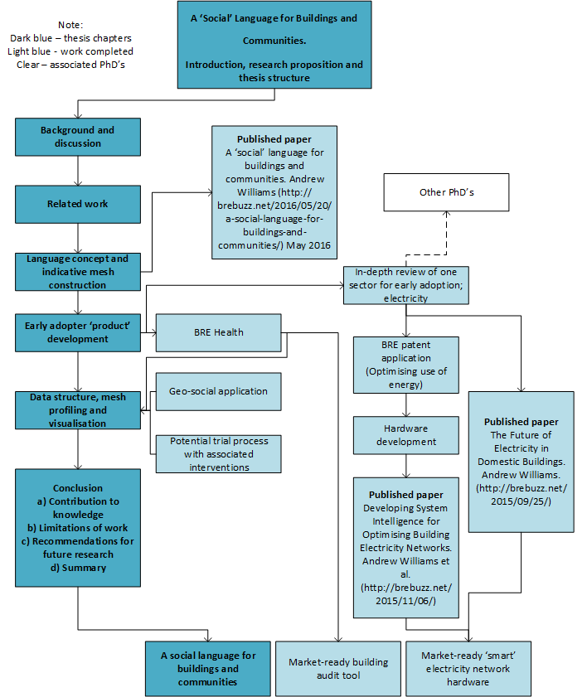

Figure 1. Thesis structure and overall work programme.

Chapter 1. Introduction, research proposition and thesis structure

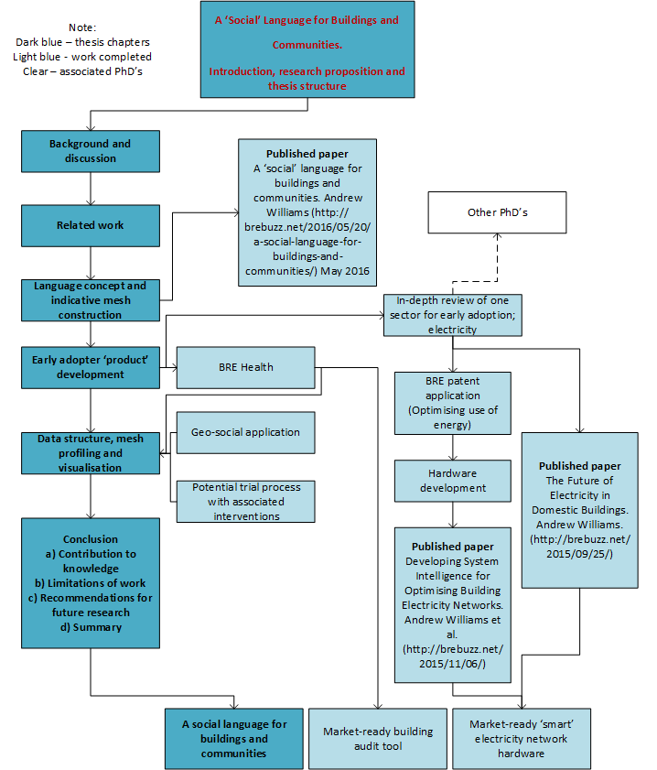
Developing Metadata and Methodologies to Support Assessment of the Social Value of Buildings and Communities in Future Smart Cities

Introduction, research proposition and thesis structure

  - 1.0 Introduction and research proposition
This thesis details a programme of research for an award of Engineering Doctorate. The research is surrounding smart-city systems and particularly focuses on how the built environment, and physical things generally, can be systemised as ICT capabilities grow and become increasingly embedded in things, buildings and the community. The focus of the research is, however, not on buildings, infrastructure or technology per se but an exploration of how they might be codified in terms of social outcomes, thereby improving the social benefit and equity arising from the use of smart technologies.

The research is in response to three main issues:
- The increasing cost of delivering social programmes in the UK and other developed countries.
- The opportunity offered by ICT to systemise things and provide new services.
- The need for a renaissance in how technology is considered, particularly in the context of the social agenda, social equity and true sustainability.

The world and its people are standing at a technological watershed where, for the first time, technology will be able to integrate and automate the very fabric of physical communities, social interaction and resource consumption. However, the built environment, and society more generally, has yet to go through a ‘techno-social’ renaissance whereby communities, buildings, things and their services are measured in terms of their social value not only as discrete services but how they collectively, as a system, support daily life. Such a social renaissance is necessary if technology is to play its part in delivering true sustainability – economic, environmental and social sustainability. If smart buildings and smart cities are to fulfil their potential, silo thinking must be avoided, and new scenarios and analytical techniques must be developed to help understand the benefits and drawbacks of increasing automation and systemisation.
‘The measure of any technology is the degree to which we live better by it.’
(Nolte 2002).
In general terms a community of today can be considered as a number of intelligent agents (people) loosely connected by networks based on activity (work, hobbies) or social need, who realise benefit from vertical nodes of supply (schools, hospitals etc.) largely predicated on physical mobility. As a result, culture and lifestyles have been influenced strongly by physical places and spaces. While increased mobility and communication have modified this paradigm, making things faster and to some extent decoupling demand from supply, it is still largely true. However, the inevitable result of the growth of ICT, big data and the IoT is not just to do what has been done in the past faster, but to integrate vertical nodes of supply, social interaction etc. and systemise all services to provide, yet unforeseen benefits – a result greater than the sum of the parts.
In the future, ICT will ‘blur’ traditional vertical nodes of supply as well as physical boundaries such as buildings and location. People will access their needs horizontally, picking and integrating (successfully or not, depending on their knowledge) what they need from a myriad source and, compared to the past, ‘consuming’ them on the move or in poorly characterised and uncontrolled environments, many of which will be domestic dwellings (McKenna 2013; Foresight 2013; Harris 2013). Health and education, for example, will still be done in hospitals and schools respectively but the individual will have available many parallel service offerings from both public and private sector organisations. As individuals become better informed, they will increasingly question authority as decisions are made more by a collective process as opposed to a single expert.
The research detailed in this thesis sets out to test a proposition which, if validated, will provide a powerful methodology/tool for assessing the societal value of buildings, communities and ICT in future smart cities. At the core of the proposition is the assertion that there is a need to know a lot more about people’s needs, the functional performance of buildings and communities, and the impact of ICT if we are truly to understand the value of smart cities in the future.

The research proposition is:
A ‘social’ (functional) language and methodology can be developed that will allow the built and virtual environments to be harmonised and the resultant system assessed in terms of its ability (value) to support individual and community outcomes in a future smart city (community).

The proposition is founded on some simple high-level propositions:
- National and local fiscal restraints, and the increasing cost of social programmes, will call for new ways of delivery in the future.
- The growth of ICT will continue.
- ICT will progress from being largely stand-alone to becoming ubiquitous and embedded in (all) physical things.
- Greater smartness, and its integration in physical things, will call for new approaches and tools to help systemise the various components and maximise/optimise cost effectiveness.
- ICT and technology will play a greater role in providing the physical, social and emotional needs of people and, by implication, social programmes of the future.

The validity of each of these will be supported and discussed in the following chapters. In themselves, however, they capture the main problem and opportunity: increasing pressure on delivering economic growth and the ability of ICT systems to provide improved cost-effectiveness.
ICT systems, driven by the need for efficiency improvements and/or commercial advantage, will shape culture by needs or belief. However, the very mechanisms of ICT interaction will, in themselves, define certain values and preferences just as any corporate branding today seeks to segment the market for commercial gain; future culture will be influenced by both the message and the ICT ‘envelope’ it is delivered in.
The need to understand better the delivery of ICT services and their systemisation is clearly driven by normal market forces but is also necessary to underpin economic growth. Many future public and private services will benefit not just from increased ICT speed/power, as they have over the past six decades, but once-passive and unconnected things will become smart and connected. As things grow in terms of numbers, connectivity and functional performance, an opportunity arises for systemisation where open-ended services, once connected only by intelligent agents (people), can themselves become systemised, closed-loop and outcome-focused. As this happens the potential arises not just to further integrate ICT platforms and devices but to integrate service offerings and use buildings and things in whole new ways.
Already this can be seen in simple terms with the introduction of smart meters and Time-of-Use tariffs. Smart meters are far from smart but simply linking Time-of-Use with cost and consumption makes the consumer part of a control loop. Supply (both energy and carbon emission) and demand can be harmonised by using price as the ‘lever’ to bring about change in behaviour. Variable pricing will not only help balance new intermittent renewable generation with demand but will embrace the cost of carbon emissions, thereby allowing the Government to meet its target of an eighty per cent carbon reduction by 2050 over 1990 levels.
Domestic smart meters will not only change behaviour, but they will stimulate new responses and technologies. For example, demand-side management (demand response) of electricity is relatively common in industry but unheard of in the domestic sector. It is the ability of things to be controlled remotely at times of high demand or carbon emission to reduce their consumption. In the future, the domestic consumer will need to make choices about how much electricity they use and when and smart grids and smart devices, and the algorithms that manage them, will help them do that; price will be the lever. In terms of the technology and communication protocols this could be done today although market adoption will take a lot longer, partly based on market acceptance and product availability. However, along with mobile phone apps for controlling boilers remotely or using occupant location data to ensure the building is at the right temperature when the occupant walks in the door, it does indicate what might be done. It is only a small step from that to embedded sensors, circuits and controllers in fixtures and fittings. Maybe even structural components such as bricks, blocks and insulation will take on new roles to save energy, carry out structural monitoring or better support wireless communications.
Systemisation, if done correctly, can allow disparate, historically unconnected vertical silos of, for example, health and education, to be brought together in horizontally configured solutions focused on outcomes and not just outputs. If this can be achieved, teaching and healthcare, for example, can consider the whole person and embrace social background, financial status, family history etc. Today, these silos are loosely connected in terms of general awareness of each individual and the professional staff that treat/educate them but as more data is captured and the number of control variables (monitoring, control, actuation) increase the greater becomes the chance of delivering a step-change in social value and cost effectiveness.
Service aggregation in the future will be key. Many product and services suppliers will attempt to do this for their own offerings, but the research detailed in this thesis proposes a way of characterising all things, active or passive, physical or virtual, thereby providing a mechanism by which they can be combined on a common platform to facilitate systemisation and analysis. The thesis outlines a ‘language’, with associated guidelines, rules and practical tools for capturing data and analysis of an individual’s life in a physical and virtual community.
To achieve this, the research identifies the lowest common denominator that allows disparate things to be connected to form a system within a building and the broader community. It then develops a methodology that supports the integration of each functional element of a thing, a building or the community and codifies it in terms of its social value. When completed, the final system can be examined in terms of its response, whether that is from top-down stimuli from national or local institutions, for example, or from the bottom up in terms of individual requirements.
The research considers the appropriateness of the research proposition in terms of the future of society, fiscal drivers, Government policy, ICT and the built environment. It then seeks to confirm, or otherwise, its validity and in doing so produce methodologies and tools to satisfy the proposition while at the same time identifying any strengths and weaknesses.
From the outset it was understood that to research fully and prepare a thorough response to the research proposition would be to touch on individual freedoms and, indeed, culture itself. If this were not enough, in giving the research an even cursory consideration, the daunting prospect arises of providing systemised solutions for every unique need to every unique individual in a community. The scale of this questions whether the study is even sensible at the outset.
However, while accepting the need for rigour, for example in ICT, architecture, engineering, social science or planning (all subjects touched on by the research), the assertion is that there is an equal need for systems engineering in respect to the potential service aggregation offered by the Internet of Things. At a superficial level the IoT may be considered as just the ability to switch smart things on and off remotely but at a deeper level it’s the opportunity to integrate and systemise things to deliver new services and reduce costs in a way that has not been possible before. Systems engineering, outside the construction industry, is nothing new but, beyond architectural design, post-occupancy surveys and ergonomics, it has never been possible to consider a building as any kind of a system, or machine, due to its passive physical nature. The research outlined here aims to develop the necessary thinking and the appropriate tools for that in response to the opportunities made available by increasing smartness.
The research focuses on the functional performance of buildings, their components and the surrounding community and then inter-connects them to produce an individual’s mesh network embracing their physical and virtual environments. The mesh itself is governed by the language, which is a set of rules and guidelines that not only detail the ‘inputs’ and ‘outputs’ of each mesh node (thing) but also how the nodes might be connected to establish congruency.
Each process required to achieve an output for an individual, for example, a health or education benefit, is broken down into individual interventions, each with its own characteristics. An individual’s mesh is then exposed to interventions with these characteristics and, where the mesh has things (nodes) capable of dealing with interventions with these characteristics, the intervention is promulgated through the mesh to the individual. The types of things in an individual’s mesh, and how their characteristics are modified by an individual’s preferences, change how the mesh responds, whether in the existing physical community or the increasingly virtual one of the future.
The mesh brings transparency to the delivery of services to apparently disparate people with disparate needs by disparate interventions delivered by disparate mechanisms. The resulting mesh will be a mesh of integrated and connected service environments, a Socially Integrated Environment (SIE). It will allow community service-providers of social programmes to analyse an individual’s mesh to see how robust it is in relation to the level of service required. It will also allow the benefits and dis-benefits of ICT delivery mechanisms to be assessed over conventional physical community models of today.
The research is cross-disciplinary in nature and intentionally trades subject matter depth for cross-discipline integration. The research draws on building performance, architecture, social science, control theory, systems analysis and network theory to arrive at a methodology that provides a way of validating the research proposition.
At the very start of the research it was acknowledged that, to make any progress, there was a need to accept a certain level of ‘intellectual trading’ between in-depth knowledge of each professional discipline and inter-discipline system complexity. The trading of vertical rigour for horizontal system understanding is tentative and acknowledged as highly risky. However, the hope is that systemisation resulting in, for example, task-orientated solutions and outcomes (not outputs), even within a tightly defined and limited regime, may provide benefits well beyond the largely ‘open’ service environment in which people function today. This is especially as many services required by individuals and communities are common and ideally placed to be systemised. The alternative to trading vertical rigour for horizontal system understanding is the prospect of integrating and systemising all aspects of all individuals in a community. At present this is completely unrealistic but rather than walking away from the challenge, the ideas detailed in this research should be considered as a small first step in bringing transparency to these complex issues.
As a result, the research is undertaken in the full knowledge that it has limitations and shortcomings. However, if the proposition can be broadly satisfied at a superficial level initially, additional vertical rigour can be added to the methodology later, thereby growing knowledge and understanding.
Despite its limitations and shortcomings, the approach is thought to be fundamentally sound and worth further examination. The indications so far are that the approach provides powerful insights and solutions to the complex issue that is people’s lives and their interaction with buildings and their community.
The research has been undertaken in a commercial environment. At its core is the development of a language that will support the systemisation of things for social benefit; however, this is unlikely to have any commercial benefit without considerable further development over a long period of time. To help mitigate this commercial limitation, two areas have been explored in more detail. These could have earlier market potential in themselves as well as provide very valuable insights into how the language might finally work and what tools may be required to capture the necessary data. These are:

  - BRE Health
BRE Health is an online audit tool for capturing building (and things) information which can then be used to construct an individual’s community mesh. Augmenting BRE Health is a social profiling tool and a geo-social application which has been developed to assess the benefits and dis-benefits of delivering virtual services in a community.
  - Smart electricity
Electricity is one of the easiest things to measure and control and its development in terms of smart systems is driven by de-carbonisation of the grid. Smart, local hardware is required for optimising electricity consumption as part of a distributed energy (electricity) storage strategy in buildings, and prototype hardware was developed as part of this research.

  - 1.1 Outputs
A number of outputs have been produced by the research, these include:
Core language development
Publication outputs:
- The thesis.
- Paper – A ‘Social’ Language for Buildings and Communities.
Developing Metadata and Methodologies to Support Assessment of the Social Value of Buildings and Communities in Future Smart Cities. Paper 1: An Introduction. BRE Buzz 20 May 2016 (Williams 2016).
Alpha-stage web tools (‘products’):
- BRE Health.
- Social profiling application.
- Geosocial application.

Potential early uses of systemisation - electricity
Publication outputs:
- Paper – The Future of Electricity in Domestic Buildings. 28 Nov 2014. Designing Buildings Wiki (Williams 2014).
- Paper – Developing Systems Intelligence for Optimising Building Electricity Networks. BRE Buzz (Williams et al 2015).
- Hardware development (in partnership with Emilio Mistretta and Al-Azhar Lalani).
  - 1.2 The research and buildings
The research contributes to the understanding of how buildings and things may be considered as machines in a people-centric community system facilitated by ICT. It introduces service, what a thing does and not what it is, as the lowest common denominator that allows integration of passive and active things to produce an individual’s service mesh network; this has been termed their SIE. The network itself is governed by a social language that defines the rules of mesh construction and each node in the mesh (a thing) has its own input and output attributes that are connected by a transfer function. It introduces how the transfer function might be used to provide new opportunities in future control scenarios and how multi-service paths may provide new services though association.
The research proposes a methodology for capturing data on buildings and things and how the services they provide might be prioritised by individual or group need. It suggests how outcomes (quasi-outputs) might be dis-aggregated to a number of interventions and how these might be propagated across the mesh using the language. It considers the effectiveness of propagation in terms of physical and virtual service flow and hence opens the opportunity for analysing the progression from physical to virtual environments.
The research contributes to the understanding of community life by placing community services in the context of user preferences through the development of a geo-social application. The application not only shapes the delivery of community services in accordance with individual need, but also identifies what might be lost from life, as currently understood, as services are delivered electronically, i.e. the dis-benefits of ICT.
The research is resolutely people-centric in response to the author’s view that ICT systems and interfaces, at a user level, are not user-centric and are yet to develop solution-based offerings. The pseudo-logic introduced by most interfaces is, no doubt, based on the views of engineers and focus groups, but still forces the user to think in a special way which is often alien to those not conditioned to that way of thinking. ICT itself will shape culture. The author realises, with humility, this research is itself a view from an engineer. However, if the research has any merit it is a call for social scientists of all types to develop thinking in terms of systemisation and not leave it to engineers and ICT professionals.
The built environment influences people’s lives, and in the future buildings will inevitably become more active themselves and/or activities will be performed in them for which they were not designed. The application of ‘smart’ to buildings will improve and extend their performance in relation to individual needs and resource efficiency. Looking to the future, the potential to control a building in terms of electronic hardware and software is likely to develop much faster than the building itself or the knowledge of how to integrate it in a way that optimises building performance and occupant need. If a holistic approach is taken, the potential exists to ‘tunnel’ to new service and business models. The hope is that this research goes some way to helping.
Whether the horizons are twenty years, fifty years or even a hundred years down the line, smart cities and smart buildings will, at some level, become a reality. The question is, how building and community performance will be measured and assessed, in its entirety, when it is more akin to an electro-mechanical system rather than architecture or construction. And, given that at every incremental step in automation a plethora of new control scenarios become available, at what level does the building truly become a machine?

  - 1.3 Preamble and vision
Conceptually, perhaps, buildings can be compared to the Internal Combustion Engine (ICE) of forty or fifty years ago. In terms of the mechanical engineering aspects of an ICE, although they have improved immensely, Henry Ford would still recognise them today. They are still largely reciprocating machines with cranks, pistons and valves which are fuelled by petroleum spirit. The same cannot be said, however, of the electrical/electronic engineering and the control regime under which the mechanical engine performs and the benefits it delivers.
Within a slowly changing built environment sector the biggest changes in building performance and social improvement could come from the control environment under which the building, and the community in which it exists, operates as part of an integrated community supply-chain.
As the smart agenda grows, the control opportunities for buildings and their occupant need also grow. However, the level of ‘smartness’ and the benefits it can bring do not follow a linear relationship. Forty years ago, electronics provided a bigger spark to ignite the ICE’s fuel/air mixture, similar perhaps in terms of advancement to today where the electronic thermostat provides better control of temperature in a building. Up to a certain level of automation the benefits are largely vertically orientated and confined to that particular sub-system. Beyond a certain level of smartness, i.e. a system with sufficient monitoring and control variables across a number of sub-systems, there is a step change in the potential control scenarios and the resultant benefits become more horizontal in nature. Of course, some may see this as a bad thing but, like it or not, it is happening to communications, business practices, entertainment, transport, utilities etc.
Buildings in the future will be subject to convergence just as will many other sectors, and the inevitable move to greater smartness is just part of the reassignment of human tasks to alternative agents which has been going on for thousands of years:

• Human muscle to animal muscle.
• Muscle tasks to machines.
• Mind tasks to calculation machines.
• And in the future, conscious tasks to mental machines.
(Nolte 2002).

Perhaps when considering buildings and their system performance there is even a need for a new term to describe the entire building. Horizontal convergence will mean that those issues traditionally ring-fenced in terms of technology, purpose or location will have their boundaries blurred as they function as part of a broader system. For example, room lighting levels and computer VDU brightness levels may well become interrelated. While a building’s physical presence will still be recognisable, and the physical form will still keep us warm and dry, in the future the tasks being undertaken in them and their response to occupant need, resources and waste will change dramatically.
However, the concept of systemising buildings, albeit partly in terms of their design and construction, is nothing new. Approximately one hundred years ago a vision of a house being a machine was proposed by the architect Le Corbusier. Already the notion was clear that architecture was about systemising building design and construction while at the same time recognising that the needs of people were (largely) common. While Le Corbusier’s modernism is in evidence today in terms of architectural design and construction, houses have never really become machines in terms of their functionalism. This was due in part to ‘systemisation’ and ‘machine’ both engendering a perceived conflict with individual identity and freedom in occupants and professionals alike. However, this is the result of immature thinking and poorly developed markets, as truly realising the full potential of smartness and systemisation does nothing to restrict freedom, but rather, opens a whole new series of opportunities for innovation and cost savings – perhaps as mass customisation did.
One quote resonates with the author’s views about the future of smart buildings and the inevitability of systemisation:

'The house is a machine for living in' was one of Le Corbusier's favourite slogans; it appears numerous times in his writings. The slogan itself already suggests that the house is not about living, it is already about something else. Pre-occupied with pure geometries and philosophies, modern architecture did not really provide the house which is a machine to live in. This to my mind is not really surprising or tragic.
What I find very surprising and indeed tragic is that we are yet to see the house which is ‘a thing for living in’.
Free from all needs to symbolize, satisfy irrelevant styles, and convey imaginary associations.
Free from all superimposed and irrelevant metaphors…
Can a house be at last about living? With all the complexities and specificities it demands, at a specific place, for specific users, with specific needs and wants? Free from all superimposed and irrelevant geometries…
Can the specific conditions, internal and external forces, needs and wants, generate the geometry they really call for?
Free from pseudo-scientific "precise" analysis, used in the end graphically, in a way which renders its "precision" meaningless.
How about precisely comfortable, or precisely performing. Can it be just more or less, fantastic? Can it be roughly great?
If it can, and I believe it can and eventually will, it is not simple and will take time.
As in order to respond to life as it is, and not as we imagine it to be, we have to develop specific tools that will help us to better understand what "it" is.’
(Scenario Architecture date unknown). Note: for general information about Le Corbusier see (Gallagher 2001).

While inevitably the challenge of defining what ‘it’ is for any individual, or a number of individuals in a building, is beset with many problems, can a house finally be ‘about living’ free from all ‘superimposed irrelevant geometries’? One that meets ‘all the complexities and specificities’ of living at ‘a specific place, for specific users, with specific needs and wants’?
As physical human beings we require physical geometries by way of boxes to protect us from Mother Nature. However, much of what the smart agenda offers is not related to physical geometries and it can deal with complexity while at the same time being specific in terms of place and user. If anything has been learnt since the development of the transistor by Shockley, Bardeen and Brattain (Emmerson 2003) back in the 1950’s it is that ICT, the ubiquitous microchip and the growth in data, big data, is ideally placed to deal with complexity and specificity at the same time. In theory at least, mining specificity from complexity for each individual and building using ICT and big data should help deliver what ‘it’, a person’s life, is.
Albeit in a different context, Le Corbusier’s statement of ‘the house is a machine for living in’ may finally come true through the smart agenda. However, for the house to be considered as a machine, more needs to be known about its function and of the needs of those who occupy it.
Without this, we are just building spaces in the hope that they will be more or less adapted to meet requirements or, which is more likely, the space will adapt the occupant, continuously forcing the occupant to accommodate its short-comings: short-comings which have in the past been orientated towards the basic physical needs of safety, security and comfort. However, in the future these short-comings could become even more pronounced as basic physical needs are augmented by new demands of health and care provision, education, governance and social equality.
Building design, a structure of spaces interconnected by access passages that have been founded in the past on, to some extent, human scale and access, must change. For to truly realise the benefits of smartness and systemisation, and avoid market reticence, requires new understanding and a much more holistic and integrated approach to the changing capabilities of technology and the needs of occupants as their relationship with communities and services, both physical and virtual, changes.
It raises the question of all buildings, not in terms of their aesthetics or monetary value, but the functions they perform and the value they bring to an increasingly connected society where traditional, vertically orientated centres of national and local civic governance and amenity will soon be delivered via distributed ICT processes, promulgated on non-specific platforms and ‘consumed’ in innumerable physical locations.
To truly understand the value of buildings in a future society, it must be realised that the building must not be just a structure for supporting cables and enclosing devices but must be part of the overall service provision itself. That service is defined not by the engineering and sustainability challenges to keep buildings standing, but by the social benefits those buildings provide their occupants in a more connected, closed-loop and data-rich society. This service provision is demanded of buildings by a changing society disrupted, and yet offered so many opportunities by the digital revolution.
Finally, maybe, the smart agenda will go some way to making the house (building) a machine for living in. A machine not to constrain people or communities and fire fierce debate surrounding classical and modern architecture, as did Le Corbusier, but one as a system of interrelated parts that are ideally suited, optimised and adapted to the end purpose: a machine seen not only as a physical envelope with a visual aesthetic but one where its functional performance and value is anything but rooted in its simple, physical past.
Today, a century on from Le Corbusier’s statement the opportunity to consider a building as a machine may finally be realisable. Not as Le Corbusier considered it as an industrial suppression of human culture and urbanism giving rise to the modernist movement that largely still survives today but as control scenarios that deliver social benefit within the visual richness and satisfaction that can be gained from seeing or being in a well-designed building of human scale and accessible to human sensibilities (Salingaros 2006; HRH The Prince of Wales 2009).
However, even today the mere mention of the word ‘system’ in association with buildings and communities raises strong and often polarised views. Architects view ‘system’ as in some way an industrialisation of their work constraining their design freedom either in terms of layout, components or construction method. The people that occupy the buildings and form the communities in which we all live are also rightly concerned about their lives being systemised, as it represents a threat to freedom and personal choice. The fact is, however, that culture is defined by routines and systems and while we all think we are different we regularly conform to our stereotype. Modern day consumerism also segments and systemises our interactions. The unstoppable growth in commercialism on the back of ICT, the Internet of Things (IoT) and big data will inevitably mean that individuals and the buildings they occupy will be subject to proprietary systemisation even if the architectural discipline that designed them was not.

As Christopher Alexander argues:
‘We must face squarely just what the task of city planning is; it is nothing less than the design of culture. A culture is a system of standard situations. Each of these situations specifies certain roles, certain allowed limits of behaviour for the persons in these roles, and the requisite spatial setting for this.’
(Alexander 2003).

In terms of the built environment, both architecture and planning shape and reflect culture and how people live their lives, and it would be foolhardy to comment on the vast body of existing work, (for example, Barton 2000; Barnett 2011; Carmona 2003; Cuthbert 2006; Carmona 2010). However, while people as physical entities living in a physical city will continue to be defined by roles, behaviour and spatial setting, in the future many of the traditional community service-delivery models and individual interactions will change. They could be largely independent of location (either building type and/or personal mobile services), may not be provided by specific centres of excellence (often associated with specific building types; for example, hospitals) and will not be predicated on physical mobility as they have been in the past.
Already modern-day culture is changing as a result of ubiquitous ICT and communications and, as things become increasingly smart and open to systemisation, future cultures will not just be defined by passive city things, structures and physical networks (transport) but by data, online social networks, software algorithms and proprietary ICT systems.
It’s now time to bring new analysis to how buildings function in just such a future: analysis that allows their physical presence and performance to be codified alongside that of future virtual environments; codified in terms of a more dynamic and responsive value to the individual; codified in terms of their social benefit and outcomes - the real value of buildings in the future.

Chapter 2. Background and discussion

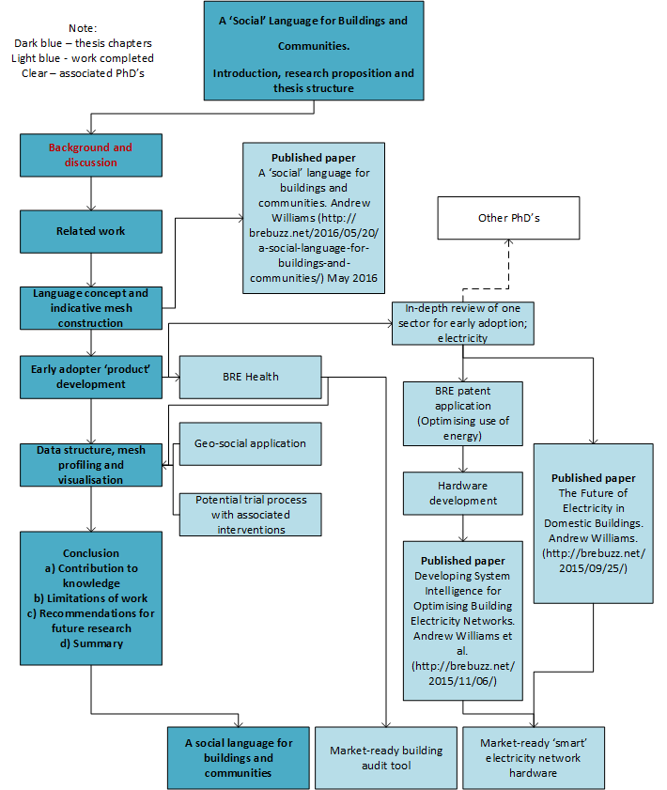

Background and discussion

  - 2.0 Introduction
This chapter provides a summary of the context in which the research was undertaken. The language and its development impinge on so many technical, social and cultural areas it makes a comprehensive bottom-up review unachievable. In response to this, and after relatively extensive reading, it was decided to identify whether -or -not it was broadly compatible with the strategic direction of Government, society, ICT and sustainability. If so, the language could be developed, while always questioning its validity and novelty. The tools (BRE Health etc.) and products developed, however, were more tangible and hence were able to be researched more specifically.
In terms of developing a social language, two key criteria needed to be met before the research could continue:
- The language had to be broadly compatible with Government policy (social agenda), sustainability and ICT direction and capabilities.
- The use of service as the lowest common denominator to combine all things to form a social system facilitated by ICT had to be valid and novel.
The breadth of the research and background dictated a methodology best described as ‘successive approximation’. A step was taken forward and its implications were explored. If successful, the learning was used to shape the next step. In more common parlance the research is founded on the need to validate a research proposition and hence is deductive in nature (Research Methodology 2018).
At any time in the research it was understood that it might falter given the magnitude of the task. The assertion, however, is that with suitable analysis of large, service-based data sets an approximation can be made to systemising all things, physical and virtual, in terms of a future socially orientated system. The assertion is still maintained by the author.
Given the assumption that a language could be produced it was decided to focus on the impact and interrelationships of the language rather than specificity of the data itself. However, where to start on something that touches life itself? Sustainability was chosen as, in its broadest context, it deals with human existence on planet Earth.
Ever since Rachel Carson wrote ‘Silent Spring’ in 1962, ‘environment’ has grown to become a household word (Atwood 2012). In developed countries, the focus on environmental sustainability over the past fifty years has been driven by a rapid growth in resource consumption although in current practice ‘sustainable development’ is paradoxically often referring to how much abuse nature can withstand, rather than to how much it should be respected (Hill 2011).
The resulting economic growth over that period has allowed environmental sustainability to flourish and even support competitive advantage as corporate organisations jockey for position within global markets (Hill 2011). In the future, however, there are two key questions facing civilisation:

- What number is too large for the world population?
- What is the time-horizon for sustainability?

The growth and acceptance of sustainability has largely been concerned with environmental sustainability and not true sustainability that embraces economic, environmental and social aspects. Economic growth is a complex issue but, in terms of environmental sustainability in developed countries, it has both driven the need for it and at the same time funded its growth. To deliver true sustainability, however, societal and social aspects must be part of the mix, however, this needs to be delivered in a worldwide model of market forces within a capitalist economy (Alexander 2003; Cuthbert 2006) with its associated resource/fiscal constraints.
Whilst not undermining the need for environmental sustainability, the question for most developed societies over the next fifty years is how to maintain economic growth at such a level as to offset the continuing rise in costs of delivering social programmes. If, in the longer term, the assumption is that societies need to be ‘truly’ sustainable, then how will the existing models of economic and environmental sustainability adapt to cope with the new demands placed on them by the social intruder? The assertion is that the next fifty years will be the turn of the social agenda, and new ‘social’ funding business models need to be developed and adopted.
By focusing on the social agenda, the research proposition raises a number of broad questions at an individual and societal level:
- People, the focal point of smart cities: how do we understand people’s needs better and deliver integrated physical and virtual services in the future?
- Fiscal and resource restraints: what are the macro drivers that will force a change in the way society progresses and how will integrated and devolved services provide greater and more cost-effective social development and equity?
- Communities: what is a community of the future and how will physical communities of the past be augmented and harmonised by virtual communities of the future (here ‘community’ does not refer to social media)?
- The changing face of the built environment: how should buildings and infrastructure be considered differently in the future and what role do they play in providing social benefit?
- ICT: the delivery of better and more cost-effective Government (social) services is predicated on digital platforms. How will the benefits of ICT be measured in relation to existing delivery mechanisms; how will ICT mature from a largely vertical technical discipline to a ubiquitous, non-proprietary platform for social progress?

To help contextualise the work in relation to the questions above, three key sectors are considered:
- The National Agenda – Social and Fiscal drivers.
- Cities and buildings.
- ICT and big data growth.
Coupled with this is the background research related to the two product development areas:
- BRE Health.
- Electricity in Domestic Buildings.
These are considered in Chapter 5, Product development. As the name suggests, they have been chosen as potential areas for commercial exploitation and as a result have been dealt with separately from the general background and discussion relating to the language here.

  - 2.1 The national agenda: fiscal drivers
In the UK, despite a relatively buoyant GDP (CBI 2011; The Guardian 2009) over the past twenty years, the 2020 Public Service Trust (2020 Public Services Trust (a) 2010) has projected that, if left unchecked, the cost of total public expenditure in the UK could reach fifty-two per cent of GDP by 2030: an unsustainable situation according to economists.
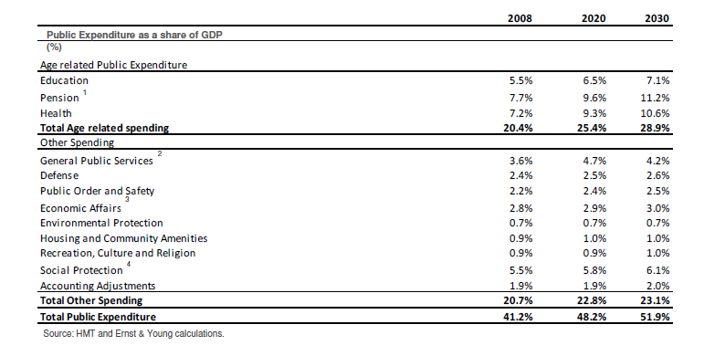
Figure 2. Growth in public spending to 2030.
(2020 Public Services Trust 2010). Assumptions: 1) GDP real long-term growth, IFS 2010 lower bound assumptions at 1.75%. 2) Age related spending, ONS projections. 3) Other spending growth at HMT 2008 assumptions. 4) Debt service growing at 9.4% in real terms on average over the period from 2010/11 to 2014/15 (based on IFS projections) and then at historical trend.

Currently for OECD countries it accounts for twenty-one per cent of GDP but this figure is much higher when spending by non-public bodies is included. While the UK is not alone in experiencing the rising costs of public social spending, as many OECD countries are in a similar position, the hope is that digital delivery of public services (and greater involvement of the private sector) will save billions of pounds a year while at the same time improving services and social equity.

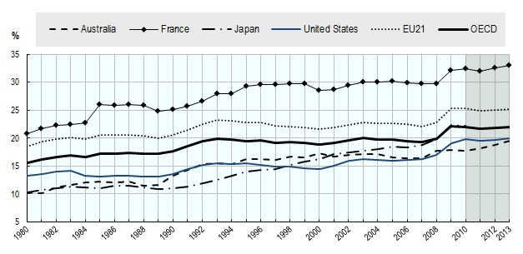
Figure 3. Public social spending based on detailed data for 1960-2009.
National aggregates for 2010-2012 and estimates for 2013, in percentage of GDP (OECD 2013; OECD 2011-2012).

The UK population is ageing (Age UK 2013) and the prediction is that over the next forty years the ratio of the population older than sixty-five to that of the population aged 15-64 will fall from approximately 1:4 to approximately 1:2 (Silcock 2012). The situation is not unique to the UK and applies to all OECD countries to a greater or lesser extent.
Figure 4. Percentage of the population older than sixty-five as a share of population aged 15-64.
(OECD 2012).

While people living longer is something to celebrate, the resulting healthcare needs combined with a lower birth-rate (Jeavans 2004) and a general escalation in the costs of other non-care related programmes means that the cost of delivering social programmes is reaching an unsustainable level (UK Spending 2014). The UK, like many other developed countries, needs to develop new delivery models for private, public and third sector services if future societies are to benefit from what is taken for granted today.

  - 2.2 The national agenda: social/cultural drivers.
  - 2.2.1 Culture change
In terms of functioning within a capitalist free-market economy, a more ‘hands-off’ approach is also in keeping with Government philosophy. As the role of Central Government changes from that of a central provider to one of standard-setting and performance-monitoring, services will be increasingly delivered by private and third sector organisations as a way of reducing public sector spending on social, and other, programmes. New models (2020 Public Services Trust 2010(b)) will be developed for empowering local communities to make their own decisions, specific to their local needs. More freedom will be given to local charities and the third sector to develop new funding models and the necessary social contracts with the community groups or individuals who will act on these decisions. This will result in local communities and individuals progressing from passive consumers to informed participants (Howes 2012; Cowper, no date).
How this devolvement of power and services impacts a more integrated and structured service delivery model, if it arises, is a major question.

  - 2.2.2 Big Society
The thinking behind ‘Big Society’ was first detailed by Tony Blair’s ‘Third Way’ and it was David Cameron who gave it the title of Big Society (The Cabinet Office 2010). While perhaps these words have been tainted as a defined Government initiative, the underpinning philosophy is still valid. Big Society is essentially the Government devolving some of its powers for non-critical social care to the local community. Its objectives include:
1. Giving communities more powers.
2. Encouraging people to take an active role in their communities.
3. Transferring power from Central to Local Government.
4. Supporting co-ops, mutual, charities and social enterprises.
5. Publishing Government data.
People expect more control of their own lives and their communities while at the same time Government, with its increasing fiscal restraints, can only do more with the help of charities and the nation’s people. The approach is also thought of as a possible way of reviving people’s belief in democracy and the political system by making it more personal and specific to local areas and communities (HM Government, date ongoing). The underlying principles are still very clear in Labour Party policies and it has been branded the ‘One Nation Project’ and ‘People Powered Services’.

  - 2.2.3 Social Return on Investment
Social Return on Investment has evolved from social accounting and cost benefit analysis. It is similar to the ‘triple bottom line’ in accounting but it places a monetary value on outcomes and thereby allows comparison of the social performance of different initiatives. It is often used by charities and the third sector and it can be used for assessing outcomes that have already taken place or how an initiative might meet a predicted outcome.
As Government policies take effect it is interesting to consider how the research proposition and subsequent language may be able to support, or be in keeping with, the apparent direction set by Government.

  - 2.2.4 Digital Britain
The UK is one of the most developed digital economies in the world and the Government’s original Digital Strategy back in 2010 (The Cabinet Office (a)(b) 2013; Rumens 2016) has sixteen actions. These can be summarised as:
- To create digital services so good that people will choose to use them.
- To support those who aren’t online.
- To build digital capability.
- To use digital to improve policy making.
While business and commerce have embraced the digital revolution to stay competitive, the Government’s Digital Britain initiative is targeted towards the general public. Without the population being able and willing to use ICT the Government will not be able to meet its objective of:

‘Putting users at the heart of Government’s digital services.’
(The Cabinet Office 2013(a)).

The strategy was updated in 2015 (Digital Britain 2); the original objectives were developed and moved closer to market. The aims are:
- Unlocking digital growth.
- Transforming Government.
- Transforming day-to-day life.
- Building the foundations.
(The Department for Digital, Culture, Media and Sport 2015).

In addition, the recent Digital Economy Act (2017) (HM Government Legislation 2017) addresses many of the practical issues surrounding a future digital world including digital infrastructure, intellectual property, public service delivery and civil registration.
The breadth and depth of the digital revolution is all-embracing, and a digital economy is central to the UK’s planned growth and international competitiveness. The Government’s drive to ‘digitise’ Britain will, it’s hoped, receive the support of the hearts and minds of individuals, as well as their data, as they move to a smarter future (The Cabinet Office 2013; Helsper 2015).
Without trying to second-guess Government policy people and communities of the future will take a greater role in defining their needs from within an open framework of Government digital services. The research proposition and language are fully aligned with this. However, there is a cautionary note surrounding control, or the more acceptable term of ‘defining need’. It will be interesting to see how society views the ‘brand’ of Government verses the ‘brand’ of large commercial organisations (charities or otherwise) vying for customers and their data in the future. The latter may, in time, have just the same connotations, good and bad, as Government has today. Control itself will become proprietary.

  - 2.3 Smart cities, buildings and ICT
The very scale of issues embraced by the term ‘smart city’ is daunting and often viewed as very distant and irrelevant to today’s world despite a rapid increase in technology and the clear fiscal drivers. However, already many city councils, utilities, ICT and infrastructure companies are considering smart technologies to improve performance or better manage the capital asset (TSB 2013; Buscher 2013; The Department of Business Innovation and Skills 2013; Centre for Cities 2014; Deloitte 2015; Huawei 2017; Mott MacDonald 2016). An everyday example of what is to come; smart motorway signs are now becoming a common sight.
The world’s population is expected to be over nine billion by the year 2050 (United Nations 2013) up from that of seven billion today of which a predicted seventy per cent (World Health Organisation 2010) will be living in cities. Cities are the manifestation of the economic value of labour (Cuthbert 2006) and they provide a living standard for the urban population which has historically been underpinned by physical location and physical mobility.
Conversely, while ‘smart’ services imply more efficient and cost-effective delivery they also have the potential to spatially decouple the supply from the demand for certain activities. It is interesting to consider whether ICT will decouple certain business models and economic growth from the physical location (cities) or whether physical location and face-to-face social interaction will dominate and keep people together.
A good community or ‘place’ is governed by many physical, social and cultural aspects but in the future ICT will also provide a new ‘glue’ that will bring people together based on their needs or interests (Amin 2002). This ‘glue’ will question how conventional communities should respond and what a community of the future will look like when it’s no longer just a community of place, driven by economic necessity, but a community of preference and culture (Donaker 2017).
Winston Churchill once stated:
‘We shape our buildings and afterwards our buildings shape us.’
(The Winston Churchill Centre and Museum 1943).

The judgement of what is a good building or community is often highly subjective (Jacobs 1961) and is normally closely associated with the views of the assessor. While an architect would hopefully not design a building that fails to protect the occupants from the natural elements, amongst his or her peers a good building is likely to be based more on aesthetics, novelty and perhaps the use of leading-edge materials and technology. Similarly, a client/investor is likely to make a judgement on Return on Investment or perhaps a corporate statement; a planner, on urban aesthetics, street-scape and communities; a transport advisor, on traffic flows and urban transit.
However, in a future society a building and its spatial setting in a physical community or city will be overlaid with the new service-delivery models of a smart agenda, fixed and mobile, thereby changing the culture of communities. A building with its largely physical and heavy construction, which is only connected to basic utilities and relies on intelligent users and transport to deliver ‘life’, is no longer the whole story. Perhaps ‘building’ is no longer a good descriptor, certainly in terms of a smart building’s performance, which in the future will be a smart personal environment operating in a smart building as part of a smart community system. What is needed is new understanding and a new inclusive nomenclature.
It is not unrealistic to think that, in the future, an individual could be content to live in a physical building or a community which is, in current terms, less than ideal, if its deficiencies can be addressed by virtual means. For example, physically an individual could be living in Leeds whereas many of their services could be provided by London-based organisations with their associated visual, social and cultural influences.
As an aside, the impact of these virtual cultures on lifestyle choices, happiness and overall culture could be explored in more depth by developing, for example, Maslow’s Hierarchy of Needs to embrace the thinking in this research. This is discussed more in Chapter 7, Future research.
While an in-depth discussion surrounding all facets of architecture is well beyond the scope of the study, despite planning charrettes and post-occupancy evaluations (see Chapter 3, Related work) good functional design is often swamped by architectural elitism (Salingaros 2003), market trends or poorly informed clients:

‘In fact, buildings designed according to irrelevant considerations have been programming our real lives from the day we were born. Designed, based on considerations which are far from being related to us, these buildings are programming almost every step we make.’
(Scenario Architecture no date).

Most of the UK’s future building stock already exists. Despite changes made by new-build and refurbishment programmes approximately eighty per cent of the domestic stock and seventy per cent of the non-domestic stock that will be standing in 2050 is already here today.

Figure 5. Projected age profile for UK domestic and non-domestic building stock.
(MacKenzie 2010).

This represents a significant challenge, both in terms of refurbishing the fabric to meet carbon reduction targets (Davies 2010(b)) and in improving the functional performance (Brand 1994) of the spaces in line with changing use and the new functionality provided by ICT.
The increased use of ICT will inevitably make a building more responsive in terms of, for example, its energy consumption. However, this is only part of the story. The real value of buildings in the future will be in terms of how they function, individually and collectively, to deliver social benefit as they become a link in a distributed supply-chain of service. When this happens, the social functional performance and flexibility of a building, and how it relates to occupant lifestyles, will dictate whether a building is good or not; existing space, what defines the space, what’s in the space and how the space functions will now be part of the service delivery mechanism.

‘The actor changes the state of the world.’
(Verstraete 2013).

This poses a fundamental question and potential opportunity. What is a ‘building’ in the context of an individual in the future and is there a need for a new term to do away with its heavy and passive connotations? And can the proposition help bring clarity to the value of the built environment and of its associated systems that are not limited by the normal linear sequence of events in building refurbishments (see Chapter 7, Future research)? Even the lower needs, for example, of Maslow’s Hierarchy of Needs could be influenced/improved by virtual services, let alone the higher needs. If it can do this, then the research proposition and its language will essentially decouple the slow-changing physical built environment from the much faster-changing service, provided by virtual means, and its collective value. This gives rise to the possibility that the concept of a SIE may help ‘tunnel’ to a new way of thinking about building functionality and its social value. It represents a bottom-up approach to design.
In terms of buildings, Alexander and his Pattern Language (Alexander 1977), Salingaros and his physical order (Salingaros 2005; Salingaros 2006) and HRH The Prince of Wales (HRH Prince of Wales 2009) consider that there is a natural scale and order that is in balance with (human) nature. Hi-tech and progressive buildings, and possibly all buildings in the future, may be smart but perhaps by being so they fail to satisfy a basic need for human scale and functionality (Drury 2008; HM Government 2015): something related to what ‘it’ (Scenario Architecture) is. Architecture, while using advanced ICT and modelling techniques, does so largely only to improve existing processes and not to explore new social and community models based on smartness and its impact on design. The proposal is that a concept of Functionality-First Design is developed (see Functionality-First Design in Chapter 7, Future research).
Interestingly, while buildings have a role to play in developed countries, it is not the same in developing countries. Many of the latter are geographically diverse, have limited physical infrastructure and poorly developed national institutions. Where this is the case, many aspects of their needs in terms of social programmes are provided by mobile technology and, as a result, their ability to provide a truly personal, location-independent service is often more advanced than in some developed countries (The University of Cambridge 2011).
ICT is now fundamental to many people’s lives but in the future, it will progress from existing in discrete, stand-alone devices, for example, a laptop computer, to being embedded into most things.

‘The further integration of IT in everything we do may result in the IT function to disappear, not because it is no longer needed, but because it is embedded in everything we do. We should be ready for such innovation.’
(Verstraete 2013).
While the IoT is often associated with products and devices, the building’s fabric, fixtures and fittings themselves are also likely to become host to smart sensors and devices, all of which will allow the building to become more dynamic and responsive to occupant need. Already many commercial organisations, including utility companies, retail and system integrators, are vying to become the preferred supplier of new, smart technology, for example, Panasonic (Panasonic 2014). However, a smart future will call for new understanding in interoperability not just between one vendor’s products and another’s but also between construction components, things and other service providers, and hopefully between platforms and vendors.
The Internet of Things, big data and cloud-based operations will provide enough computing power and data to enable complexity and specificity to be provided at the same time to everyone. As the sophistication of intelligent agents improves, specificity will be based on preferences arising from social media/interaction, entertainment, purchasing, social/economic background, energy/waste profiles and general daily activities.

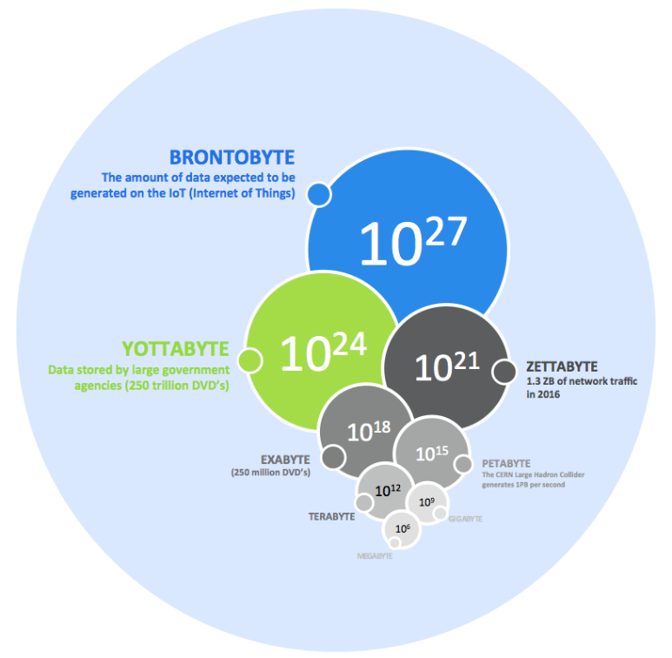
Figure 6. Expected growth in data.
(Morgan 2012).

A fine building can ‘lift the heart’ and the acquisition of a product in today’s consumer society produces its own sense of achievement and satisfaction. However, in terms of buildings and ICT and their impact on social sustainability, we are standing at a ‘watershed’ and it is now time to explore in greater depth their interaction with humans. This should be more natural and organic and based on daily need. It is not unrealistic to expect that the pace of change of ICT will be maintained and that those growing up with it today will be just as alienated when they get old, as the old are today. The problem is that today the aged and disadvantaged can survive without using ICT; however, future generations will not be able to.
The ICT sector functions within a highly competitive commercial and high-street market where functional performance (features and benefits) are used to gain or maintain competitive advantage. Functionality has always been the driver for ICT, as quoted by Steve Jobs later in the report. Physical design and style have only recently been added to the package. In the case of the built environment, however, it could be argued that it is almost the reverse. Size (number of rooms or floor area), facilities, location, cost, aesthetics and return on investment are probably the primary considerations for many domestic purchases. Recently, environmental performance of its structure, and the resources needed to service its spaces (Anderson 2006; European Commission 2013) and those who occupy them, has come to the fore but otherwise functionality takes second place. This might seem very harsh towards architecture, which is a very complex discipline and well-respected profession, but the functional performance of buildings has never truly been people-centric: something which will only get worse as ICT and interoperability bring a step change in options and control scenarios. See Functionality-First Design, Chapter 7, Future research.

Chapter 3. Related work

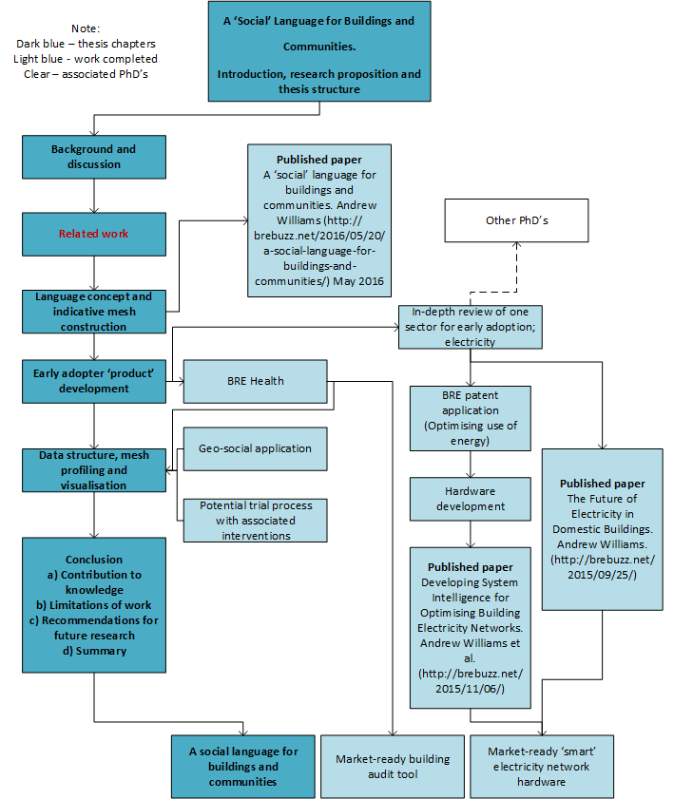

Related work

  - 3.0 Introduction
As might be expected the study impinges on many areas of work, either in terms of topic area, past initiatives or current/future working practices. Over the past 50 years there has not only been a move towards environmental sustainability, but individuals now have a voice. Many of the historic hierarchical government, workplace and social models are subject to direct and very public scrutiny (feedback) via social media and other ‘customer’ engagement initiatives. This trend towards greater people-centricity is common throughout the following work areas, to a greater or lesser extent, and is in response to greater opportunities (products, services, social status etc.) and freedom of choice in today’s world.

  - 3.1 Building Information Modelling
Any work to systemise buildings is inevitably intertwined with object modelling and, more recently, BIM (BRE 2016). Both of these are considered as new but in reality BIM as a concept has been around for thirty years or so (Quirk 2012) and can be traced back to GLIDE (Graphical Language for Interactive Design) (Eastman 1977) and even before that to the work of Douglas Engelbart (Engelbart 1962) in the early 1960’s. Object modelling, as a general term, has its roots in software development from the early 1960’s and later includes Constructive Solid Geometry, Boundary Representations, Computer Aided Design, Graphic Information Systems and many commercial design packages.
The concept of a building as a system can be traced back to the 1920’s not just in the architecture of Le Corbusier but also in the foundations of von Neumann’s mathematical theory of gaming and, later, Turing’s suggestion that virtual machines can emulate whatever virtual functions are required.
The digitisation of the construction sector is seen as key to achieving a step change in productivity and performance. Digital Built Britain (BIM Level 3) will not only deliver all the aspirations set out in the 2008 Bew-Richards Wedge but will go beyond the traditional built environment relationships to create a holistic and inclusive industry. The Government has committed to BIM Level 3:
‘The government will develop the next digital standard for the construction sector – Building Information Modelling 3 – to save owners of built assets billions of pounds a year in unnecessary costs and maintain the UK’s global leadership in digital construction.’
(Osborne 2016).

BIM uses object-orientated models, but its aim is to create virtual models that bring transparency to design, construction, in-use and deconstruction and it does this by linking a design model with a relational database. BIM is the process of creating graphical and non-graphical information in a Common Data Environment and represents the ability of the construction supply-chain to characterise its products and projects digitally.
Digitisation and, increasingly, Virtual Engineering have delivered a step change in productivity and performance across the manufacturing industry over the last two decades and the hope is that BIM will do the same for the construction industry. The construction process, like most manufacturing processes, is made up of many separate disciplines and specialities. However, in the case of construction, there is little consideration for up- and down-stream issues and this can lead to increased project costs, shortcomings in the final building and, all too commonly, litigation. Any restriction in design freedom is, as usual, viewed with suspicion and the author has first-hand knowledge of architects failing to embrace systemisation when he worked with the then Department for Education and Skills to produce a suite of publications: Standard Specifications, Layouts and Dimensions for Schools (Partnership for Schools, circa 2008).
The suspicion is perhaps justified, not just in terms of design freedom but status and reputation. Young architects leaving university, trained and fully conversant with BIM design software, may leap-frog a professional generation by compensating for their lack of experience through maximising the use of ICT design tools and the ‘intelligence’ they provide.
The progress of BIM itself is measured as a number of levels: 0 to 3. Level 0 describes projects where there is no collaboration and only 2D drafting being used. Level 3 is where there is full collaboration and a single shared project model is held on a central repository: similar to a document managements system. Level 3 is considered the ‘Holy Grail’ currently but it also raises issues of confidentiality, copyright and liability as a result of the shared process. This is important as the construction sector is particularly litigious.
BIM will go on to encompass BIM 4D, which will consider time, not in terms of building life but lead-times, timing of the construction process etc.; 5D which embraces capital cost management; and 6D which deals with facilities management and whole-life costing (McPartland 2017).
The Government committed to Level 2 for all publicly funded construction work by 2016 as a way of reducing construction waste by twenty per cent.
Having undertaken a review of material from policy makers and commercial organisations (HM Government (b) 2012; Nguyen 2016; Dowsett, date unknown; Autodesk, date unknown; NBS 2016; Designing Buildings Wiki 2018; Graphisoft, date unknown) it appears that BIM is primarily a construction initiative that, if fully adopted, will be an end-to-end initiative for supporting the construction process and the management of an asset over its lifetime in terms of its cost and life-cycle assessment. BIM is starting to use the word ‘social’ but it’s still within the context of established post-occupancy evaluation and other occupant assessment techniques. BIM does not deal with the services provided by building components or things and, as far as this research is concerned, falls short of what is required to truly systemise buildings in the context of people. Having said that, it is, of course, a great step forward and this research could be the next stage. This sounds like a bold statement, however, while at BRE the author made a presentation to, and had several one-to-one conversations with, the experts on BIM and they stated:

‘well beyond my thinking and miles away from current industry practice; even for the good ones.’
(Oakley 2016).

‘BIM could be part of this in the future.’
(Hammersley 2016).

BIM will inevitably interact more with the ‘softer’ issues related to building use as device and object data becomes richer in terms of functional performance. As it does so, occupant need will be classified into user types and hence modify the collective response of a building or area.

  - 3.2 Systemising buildings
It is not unrealistic to expect that others have tried to systemise buildings and during the research one particular example was identified that resonated in terms of vision and objectives. In the mid-1960’s, The Fun Palace project of Joan Littlewood and Cedric Price was a vision to bring engagement and participation to theatre. The Fun Palace was a theatrical project aimed at entertaining people as they gained more leisure time as a result of mechanisation after World War 2. The concept proposed by Littlewood was to design a theatre that provided a:

‘socially interactive machine, highly adaptable to the shifting cultural and social conditions of its time and place.’
(Mathews 2005).

The Fun Palace resonates with this research because the building did not follow the usual ‘static and solid’ building design process but considered its response to occupants in temporal terms, as dynamic ‘events in time’ rather than ‘objects in space’. It was a building of ‘indeterminacy’ which at its very heart was not made up of irrelevant styles and design cues but the needs and preferences of its occupants.
As an aside, prior to reading extracts about the Fun Palace, the author had proposed the concept of an ‘instantaneous house’ while at BRE in 2010. Latterly, while working on systemisation, the author secured funding for a doctoral study (see Chapter 5) to research the potential of producing a ‘tag-less’ locational system for locating specific people within a building. The research, if successful, will be a key part in configuring a building in accordance with an individual’s preferences as they walk from one room to another, thereby offering the possibility of an ‘instantaneous house’. This was initially conceived from the standpoint of energy efficiency but grew to include the ‘total experience’. Coincidentally, the Fun Palace also arrived at the ‘total experience’.
Littlewood and Price understood that cybernetics would be important and Gordan Pask, a cybernetic expert, joined the team. People using the facility would provide data on preference and interests and this would be used to modify the experience. The concept of ‘unmodified’ people, those entering the facility, and ‘modified’ people, those leaving the facility, was raised. At the time this was acceptable although today the thought of ‘modifying’ people seems much less so. Perhaps the use of the word ‘modified’ is too emotive in today’s environment; however, one way or another our experiences are being ‘customised’ today and will be a lot more in the future.

  - 3.3 Occupant need and behaviour
Three areas of work deal with occupant need and behaviour in the current design process and these are Design Charrettes, Post-Occupancy Evaluation (PoE) and Building Performance Evaluation (BPE) (Mallory-Hill 2012). All three techniques make a very valuable contribution to assessing the relationship between building design, the activities to be undertaken in the building and even the types of people in the building. However, none consider the building, thing or the community in terms of the services they provide and hence are unable to provide a framework for systemisation.

  - 3.3.1 Design Charrettes
Design Charrettes (BRE 2014) are undertaken before the design process and usually consist of facilitated workshops between design and construction professionals, building users and other stakeholders (for example, the local community).

  - 3.3.2 Post Occupancy Evaluation (POE)
The in-use performance of a building is often lower than the design performance and this is usually the result of building facilities not quite working as they should and/or the occupants not using the building in the way expected. POE is a way to help bring transparency to these issues and consists of a series of structured questions and interviews with stakeholders, usually undertaken several months after building occupation. It is essentially a way of gathering hard and soft data about how a building is performing in relation to the initial design brief and as a result helps architects gain experience of what works and what doesn’t for future reference. It focuses on key areas such as client satisfaction, environmental performance, social and economic benefit and even areas such as identity, atmosphere and belonging (RIBA 2016; RIBA 2017; CIBSE 1995). POE is largely related to commercial property and can link with operational and workflow processes. Many architectural practices don’t undertake POE but, if used correctly, it is a way of adding value in an increasingly commoditised design process, especially in the light of the growth of BIM.

  - 3.3.3 Building Performance Evaluation (BPE)
BPE is a broader-based evaluation process that includes POE but embraces other technical and building performance issues.

  - 3.4 Interaction design
As the name suggests, Interaction Design considers the interactions between user, the product and the services it provides. It was first applied to web interfaces and graphic design and strictly speaking it should only refer to the interaction between a user and a screen; however, the discipline has grown to include computers, mobile devices and much more. It has therefore been included in this chapter as, within some of the background research, services are mentioned. It also considers goal-driven design, usability and cognitive psychology; one of its aims is to use goal-driven design to satisfy specific needs and desires of the end user. It is closely linked with experience design and the more general user-design (Hassenzahl, date unknown; UX Booth 2015).

  - 3.5 Social network analysis, supply-chain logistics and pattern-of-life analysis
These are three well-developed areas of work that consider people, things and how they are connected. They can be considered as dealing with metadata as none deal with what is conveyed, more how and when it is conveyed. While supply-chain logistics initially only dealt with materials and products it now embraces services and it is supported by advanced software programmes driven by the need for just-in-time management and resource efficiency.

  - 3.6 Sustainability and quality standards
Since the late 1980’s BRE’s Environmental Assessment Method (BREEAM) has focused primarily on environmental sustainability but now BREEAM and other sustainability tools are increasingly considering the human aspects, as is research surrounding indoor comfort etc. BREEAM has in the past been an assessment process undertaken once the building has been completed but, as with in-use vs design performance, there has always been a performance gap between design and the final environmental performance of the building. To help reduce this, BREEAM is developing a pre-design assessment procedure to help reduce the risk of a poor post-construction assessment with its associated negative impact on building and client value. BREEAM is also trying to minimise the performance gap by BREEAM-in-Use (BiU). BiU looks at the whole-life performance of the building including operational costs, enhanced asset value and improved wellbeing and satisfaction.

  - 3.7 Home Quality Mark
BRE’s recently introduced Home Quality Mark focuses on assessing the home in terms of occupant benefits and includes not only running costs and environmental performance but also health and wellbeing (Home Quality Mark 2016).

  - 3.8 Virtual Engineering
Any attempt to establish a user-centric language for buildings also touches on Virtual Engineering (Cecil 2010). Virtual Engineering is a process used in, for example, the automotive sector, where an engineering project or system is produced in a virtual environment complete with its associated internal interactions and behaviour. While this is very difficult and time-consuming the benefits in terms of collaborative, multi-disciplinary product development, system optimisation, risk reduction and cost reduction are huge. One aspect of Virtual Engineering is that it gives users the ability to interact with the virtual system and hence improve the user experience and outcomes.

  - 3.9 Social, operational and knowledge management analysis
The research also encroaches on existing well-developed fields of social, operational and knowledge management analysis. Today much of this is driven by human, ecological, social and systems analysis ranging from election campaigns to military and logistic planning. For example, the Cynefin Framework developed by Dan Snowden (Kurtz 2003) and further developed by IBM, is used to support complex adaptive systems theory.

  - 3.10 General
The research proposition and subsequent research touches on many professional disciplines and topic areas and the thought of systemising social interaction is not new. Today much of this is associated with smart systems, which by extension implies some sort of systemisation, and that agenda is being driven by ICT and other corporate organisations (May 2017).
Much of the development appears to be associated with hardware and devices but it is in the contacts and personal data where the true value lies.
A modified version of the 1960’s Fun Palace’s vision seems to capture most closely the work in this thesis where the individual experience is an event in time and not an object of place. Unlike the 1960’s, however, our modern times do not always see science and engineering as our saviour and the issues surrounding ‘Big Brother’ are very real. Already, consumer voice-activated devices are advertised with the strapline ‘the Google way’.
The future is difficult to predict but winning over the hearts and minds of people on the journey to smartness is the Achilles’ heel, not the technology itself. Also, one size will not fit all as different cultures and age groups will respond differently to the impacts on privacy resulting from the drive to achieve it.

Chapter 4. Language concept and indicative mesh network construction

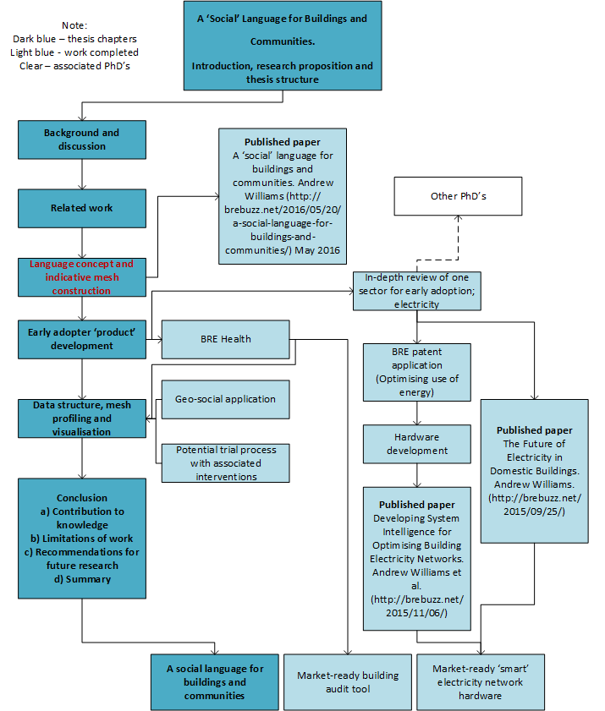
Language concept and indicative mesh network construction

  - 4.0 Initial considerations
In this chapter the foundation of the language is considered. The starting position is an individual surrounded by, and interacting with, their local environment. This environment is, if indoors, within a room and the room is within a building. The building is within a (local) physical community. As the individual goes about their daily life, they demand things of their environment, building and community. In doing so, they are called upon to act and, directly or indirectly, they produce ‘waste’ as a result.
By considering an individual in a community in this way, the study is not only truly people- centric but ‘streams’ of service with common characteristics can be identified, thereby providing the first steps towards a new language.

The research proposition (a reminder):
A ‘social’ (functional) language and methodology can be developed that will allow the built and virtual environments to be harmonised and the resultant system assessed in terms of its ability (value) to support individual and community outcomes in a future smart city (community).

The use of the word ‘social’ places the focus of this research on benefits to individuals and society and not on the physical performance of things or their environmental impact, although these are sub-sets that will be dealt with later. As a result, the first step is to place people at the centre of the analysis.
‘Smart cities’ originally applied to the greater use of ICT in city infrastructure systems such as electricity, water, transport, waste etc.; in districts or councils where there are specific problems well-developed smart systems can usually be found. ‘Smart cities’ today, however, has become a catch-all term that applies to most things concerned with increasing population growth, urbanisation, cost reduction and improved services through the use of ICT, smart systems and the Internet of Things. In terms of this research, however, it is the opportunity to replace silo-based vertically orientated services with horizontal, process/outcome-orientated, user-defined services by way of a social language of systemisation.
The use of the words ‘social’ and ‘language’ in this research has already been explained and as long ago as 1977 Christopher Alexander et al (Alexander 1977) applied the term ‘language’ in their book entitled ‘A Pattern Language’ which detailed the design of several hundred building elements based on producing buildings with ‘human scale’. More recently Salingaros (Salingaros 2005) in his book ‘Principles of Urban Structure’ has considered urban form and structure in the hope it will lead to ‘urban science’: the application of physics and fractals to ‘urban coherence’ provided by the ‘correct combination of geometry and connection’. Both deal with how people engage with buildings and communities and do so in a very thorough and thought-provoking way. However, perhaps design itself needs to be contextualised in a truly people-centric way as part of a truly connected system of the future (see Chapter 7, Future research).

‘Design is a funny word. Some people think design means how it looks. But of course, if you dig deeper, it’s really how it works.’
(Wolf. Interview with Steve Jobs. 1996).

This is not to diminish in any way the importance of how a design looks. Indeed, for many people, perhaps one of Apple’s significant contributions to ICT is their contribution to the visual design and move away from grey boxes. Similarly, a well-designed building can lift the heart with its appearance while at the same time provide comfortable and agreeable internal spaces capable of supporting daily life in an environmentally friendly way. The question is, how well is ‘how a design works’ understood for buildings, particularly in the context of the smart agenda and new community models? Design Charrettes and Post-Occupancy Evaluation have already been discussed (Chapter 3, Related work) but these assessments are largely subjective and require interpretation in the architectural design process: a process that can be often more related to how it looks than how it works (Mehaffy 2002), especially in the context of this research. The research detailed in this thesis is more decoupled from the built environment form and its spatial setting which, while important, is an attribute scaled by individual choice and contextualised in terms of outcomes required. This does not imply design anarchy as the visual aesthetic of a street-scape is fundamental to its overall impression and provides a sense of identity for those living there.
The fact that more automation and control will enter the built environment and community living is hopefully not open to question, but what does this mean? Is a building, as we currently understand it, going to stay largely unchanged as a physical box and smartness remain the preserve of internal products and devices or is smartness going to become embedded in the fabric, and to what degree will this happen? As discussed already, there is often a very close relationship between the mechanical performance envelope and the electrical/electronic control environment under which a thing operates; but what does this mean for buildings? Before even answering this question, there is first a need to consider the attributes of the ICT sector, what it produces and the smart agenda.
The smart agenda:
• Is at some level applicable to all new and existing buildings.
• Produces products (including software and data) that has short life cycles (compared with buildings) paving the way for rapid change.
• Has the necessary scale (capabilities, investment etc.) to bring about change.
• Can cope with complexity and specificity at the same time.
• Is familiar to most individuals.

In many ways, how an individual uses a building or engages with the surrounding community can be viewed as largely an asynchronous heterogeneous system. Within a framework of typically vertically orientated community-service providers ranging from hospitals to the local corner shop, individuals interact as required, based on their needs and wants. Their information input is subject to multiple disconnected paths and their response is based on personal values, socio-economic background and peer influence. Access to services is often predicated on physical mobility within either the building or the community.
Depending on the quality and appropriateness of the information input, and the decisions made by the individual, this may or may not result in a satisfactory outcome. Even within a relatively well-defined process, perhaps a local civic amenity/service, there are discrepancies in the advice or service provided that often require interpretation by the, possibly ill-informed, individual.
For example, to achieve the best outcome in education requires much more to be considered than just the ability to teach the subject matter. The teacher can only be truly successful when subject matter is contextualised in terms of the student’s current understanding and situation. Whether this is achieved or not for an individual often depends on the teacher’s knowing the student as much as the subject matter.
‘People-centric services’ is not a new concept either in terms of business practices or smart city systems (for example, Manchester City Council (Manchester Digital Development Agency)). In the former that are usually applied to customer support initiatives and even in the smart city context, the latter, they are normally applied to connected things and information services, for example bus arrival times etc. The objective of this research, however, is to assign service attributes to things themselves and particularly passive unconnected things; the building and its fixtures and fittings.
So how can a complete, people-centric system be developed? At the most basic level, all individuals are subject to interventions and interactions, inputs and outputs, if you will. These include information exchange, building spatial reference/utility, internal environment, device/appliance benefits, consumption, community benefits etc. These interventions are associated with the basic need to metabolise oxygen, comfort, safety etc. but are also related to higher human need as mobile and social animals capable of processing information, taking actions and acquiring knowledge.
Currently much of an individual’s existence, and hence use of services, is based in the physical world with only relatively minor incursions of ICT which are mainly confined to information exchange via visual display units of various kinds and keyboard data entry hardware (excluding commercial/industrial applications etc.). Figure 7 (left) is a pictorial representation of the current situation. The three circles are connected to an extent that is specific to each individual. A business person travelling for their work might have very little interaction with their home or their community, whereas a homemaker may have significant interaction with both, as might a retired person. The scale and quality of the interactions themselves are the responsibility of the individual, the demand side, as is their interpretation of the interactions to achieve the required outcome. Success is partly dependent on the community in which an individual lives and the service it provides, but also on the individual’s knowledge, culture, class and personal initiative to harmonise the interrelationships.

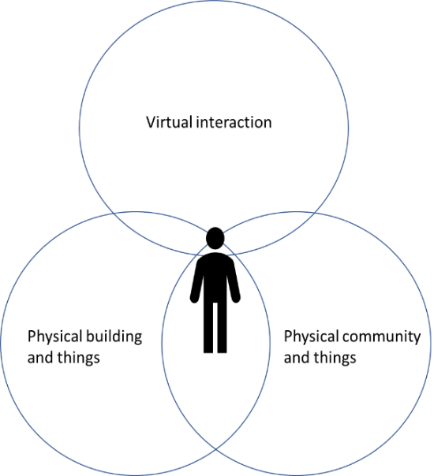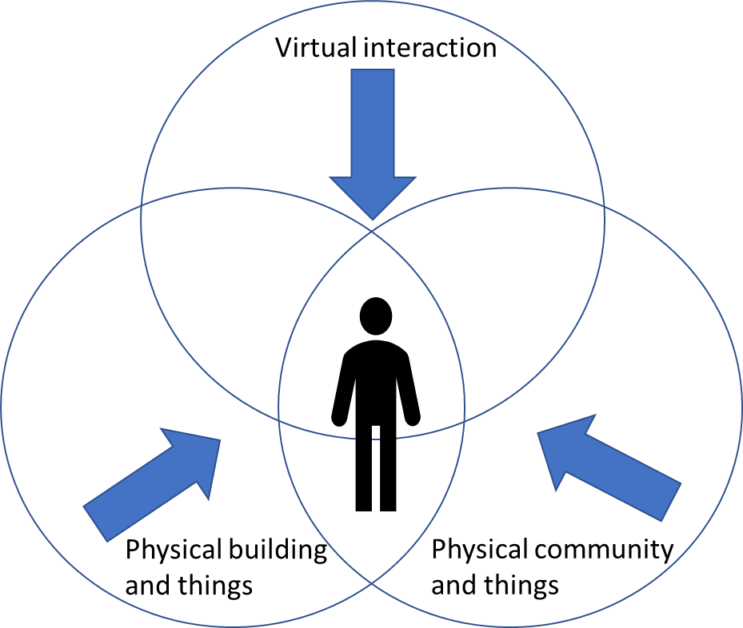

Figure 7. Achieving desired outcomes; left) current situation, right) future situation.

In the future, however, an individual, either through choice or analysis of interaction data, will take a greater role in defining their needs from a more integrated and connected suite of services from across the physical and virtual environments (Figure 7 (right)) (Borrell-Carrio 2004). The physical and virtual worlds will interact without user input as they collectively respond to the profile of an individual, and several individuals, in a community. As sensing, actuation and monitoring capabilities develop, the impacts of any intervention will become clearer, as will any secondary or tertiary implications; the system will become integrated and, if responses are fed back, it will become ‘closed loop’ and result in outcomes not outputs.
Many interventions are associated with physical things; for example, people with home entertainment. Home entertainment has historically been characterised by TV programmes delivered remotely (by electronic means based on radio communication) to the physical electronic device, the TV. Today, though, the direct association between a physical TV and TV programmes has been broken as TV programmes can now be streamed to a tablet or other connected device as convergence takes place. Going one step further, it can be argued that satisfying the full entertainment need of an individual may also call for physical comfort by way of a chair, environmental comfort by way of adequate room temperature, and even some food or drink.
This gives rise to the thought that the value of TV entertainment would be enhanced by the presence of a fridge and its ability to provide cold food or drink, or then maybe other things might be included in the ultimate entertainment experience, including the entertainment room’s physical or decorative condition - perhaps something as mundane as a skirting board. These ‘things’ appear to have little in common; some are active, i.e. they are ‘machines’ of some kind, while others are passive and largely decorative in nature; but the implications for the ‘association’ or ‘horizontal connectivity’ of what things do is very significant. When allied to knowledge of individual preferences they elevate the value of any offering to its highest state of contextualised services.
Successful horizontal systemisation can be considered as contextualising every intervention (action or need).

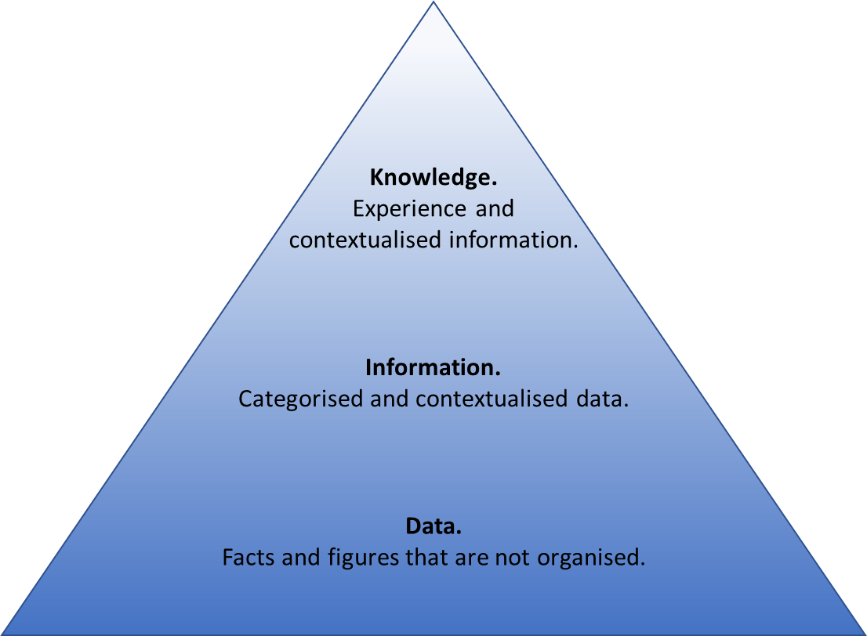
Figure 8. Data, information and knowledge.
(Frost 2010).
The performance of some aspects of a building may be very difficult to imagine as part of a smart system: for example, a brick/block wall. It is easy to see this as simply providing form, safety and environmental protection. Of course, walls also provide a visual aesthetic, thermal insulation, internal/external structural fixing, moisture transmission and acoustic insulation, to name but a few of their benefits. In the future they may also be, for example, an active component in thermal storage, a getter for indoor air pollutants, a radio frequency screen or wave guide. This is all before they get really smart in terms of materials, imbedded electronics, sensors, lighting and much more. While some of this might seem a long way off, much of it is being talked about now and it is only legacy issues in terms of existing buildings and time required for market transformation that stops this from happening today. Although, these are very big issues!
Normally the use of the word ‘thing’ in the context of smart buildings and cities is associated with the Internet of Things and, perhaps by implication, things that are active and, in some way, can be interfaced with ICT networks. In the context of this research a ‘thing’ is any part of a building or its contents, no matter whether it is active or passive, part of the building fabric, fixtures and fittings or its facilities. An analogy might be that of a molecule in chemistry. While making analogies is fraught with danger, a molecule is the smallest particle that retains the physical and chemical properties of the substance. In this research, a wall is considered as the ‘smallest particle’ but as thinking develops the wall itself can be further subdivided into blocks, mortar, render, plaster etc. (if considering existing materials and construction processes) as can the molecule into a nucleus, electrons etc.

If the functional performance of a wall is made up of several benefits as the molecule is made up from several atoms, then to systemise things there is a need for the following:

- A Lowest Common Denominator (LCD) that will allow all parts of a building, things and the community in which they exist to be brought together on a common platform.
- The LCD to relate to ICT delivery mechanisms.
- For all things to be capable of being interconnected to form a social system (a mesh).
- The system to be customisable in terms of a user’s physical and virtual environment, and preferences/impairments.
- The capability to analyse the system in terms of its suitability to deliver top-down processes and/or bottom-up user requirements.

Fulfilling these requirements can be considered as a ‘language’, a language of systemised social value; hence, a social language.

Language: a language is a phraseology and vocabulary of a profession, domain or group; a system of symbols and rules

(Oxford Dictionaries 2013(b)).

Like all languages, the social language requires its own rules and symbols to provide the basis of a consistent, congruent and meaningful approach.

  - 4.1 The Lowest Common Denominator, service
The need to establish a common denominator that might bring passive and active, as well as physical and virtual, things together is a critical first step in systemisation. However, how can the value of a table be compared to that of a wall, or a computer, and then be contextualised in terms of user need or preferences? After much thought the only way identified was to value things by what they do: i.e. a service-based model. At one level a service-based model does not sound very new or innovative as many organisations and things provide services, but the objective of this research is to assign services to all passive things (structure, fixtures, fittings etc.) thereby paving the way for them to be part of a smart city system.
While the use of a service-based model does have some limitations, which will be considered in Chapter 7, Limitations of work, it has several key advantages. Firstly, it creates the most closely related match to the needs of an individual and indeed services demand user-engagement to optimise their value, which is a key objective of the research. Secondly, by focusing on service, the model relates very closely to future market trends where convergence is driving new integrated and/or multipath service offerings. Also, the cost of hardware has been commoditised to such an extent that most organisations are striving to develop relationships as a way of increasing value and growing consumer experience. For example, in the commercial aviation sector, modern procurement practice is to purchase just the service of ‘thrust’ and ‘time’ and not be bothered with raising capital, depreciation, service life, maintenance staff, parts etc. for a jet engine. Hospitals are considering just procuring operating theatre time as an extension of PPP (Public Private Partnerships).
In marketing parlance, a service-based model deals with the benefits and not features of the product. A feature, for example, is the volume control on a TV whereas its benefit is the ability to control the audio level as required. While owning capital assets brings its own pleasures as a manifestation of personal achievement and outward expression of prosperity, in general market terms, younger people of today are more interested in experiences and not ownership unlike generations in the past. Perhaps, again, a service-based model is well adapted to the future.
If the LCD is to be service, then a language must be constructed that firstly identifies a prioritised list of service attributes for each thing (physical or virtual, active or passive) and then the rules of how they can be connected to form an individual’s living environment: a mesh network. Each mesh will be specific to an individual as it is comprised of their building(s), things and the broader community benefits. Each thing will be quantified by its service attributes and these will be customised/prioritised in line with the preferences, lifestyle or stage in life of that individual.
Interventions required by the individual or mandated by the State act as stimuli to the mesh. The mesh’s ability to react to these interventions will be a measure of how well an individual’s SIE is able to support their lifestyle now and how it might be able to adapt to changing needs or service delivery mechanisms. This new language, together with the resulting mesh, creates the potential to bring transparency to the progression from the physical environment of today to the increasingly virtual environment of the future.
Interventions can be single or many, as required to achieve an output or, ideally, an outcome, and each thing in the mesh can be uni- or bi-directional. The attributes of things can be considered by class and stream associated with the type or category of thing. Things are connected to form an individual’s mesh in accordance with the ‘connection rules’.

  - 4.2 Service streams
As mentioned in the Introduction, the development of a language must be people-centric and to achieve this people must be placed at the centre of any thought process. The starting point of how to systemise things, and possibly life itself, is simple. Currently people live in physical buildings and communities and through interaction with their building and its local community (Gehl 1996) they live fulfilling lives. Historically the boundaries of this interaction may have been only several kilometres’ distance away and even today many community interactions and services are probably delivered within a fifty kilometres radius of an individual’s location (assuming the person has a car). In the past, any shortcomings in the building or local community to meet an individual’s need required them, if the shortcomings were sufficiently limiting, to relocate. Before this, however, considerable stress may have arisen as the individual strives to live with the shortcomings.

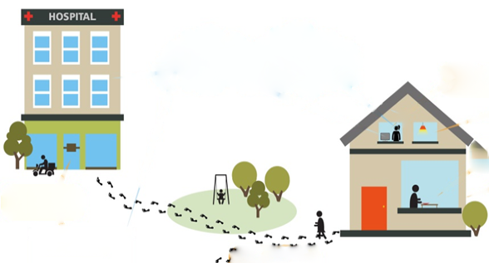
Figure 9. A people-centric approach.

Individuals interact with physical things provided by spaces and places but if this approach is developed a little further, the air we breathe and the daylight we see by is, in the context of a building, within a space we call a room. There will normally be several rooms in a building and the building will be located within a community. The number of rooms will be bounded by the size of the dwelling and services available will be defined by the size and capabilities of the community. All this defines a community and can be scaled accordingly.
However, as more needs are fulfilled remotely via virtual services there is the opportunity to ‘overlay’ a level of virtual information and functionality that could completely change how individuals benefit from, and contribute to, their building and their local physical community.
The services themselves can be categorised into Service Streams.

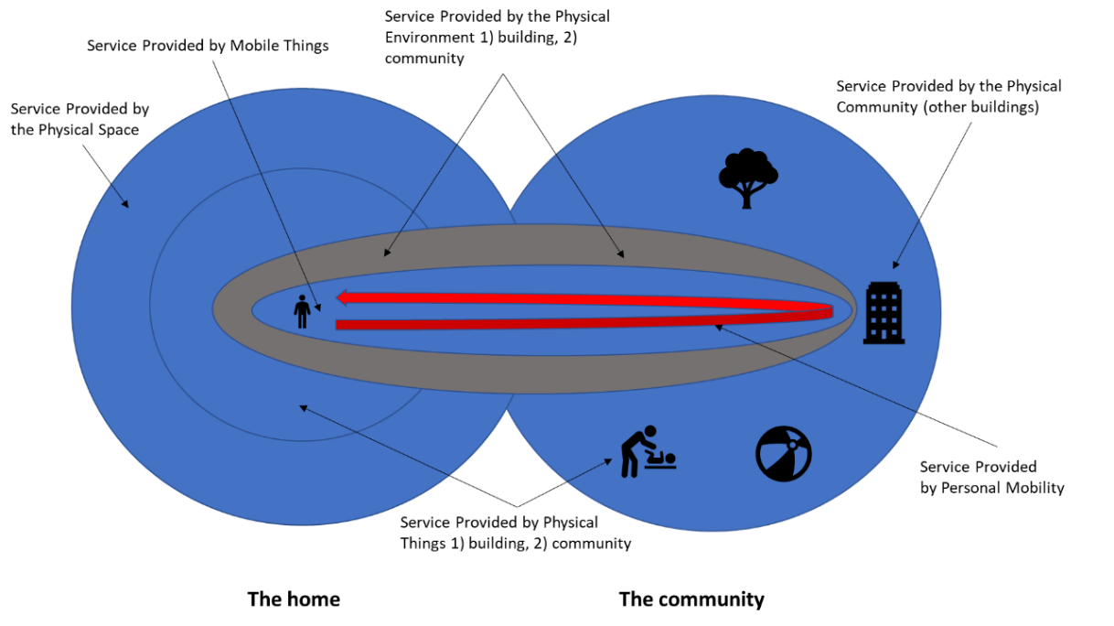
Figure 10. Service streams.

Service Provided by the Physical Space (SPPS)
This is the service provided by the physical space of a building. Defining the physical space are walls, ceiling, floor etc. The services of physical space relate directly to an individual in a room but also have an impact on, for example, the indoor physical environment and mobility.
Service Provided by Mobile Things (SPMT)
This is the service provided by any mobile thing. This could be an electronic device, in which case the service is a virtual information exchange, or, with the help of actuators and sensing, a physical intervention. It could be, for example, a pencil. In this case the thing is still mobile and capable of a physical service but, unlike the phone, its primary attribute is not virtual.
Services provided by fixed ICT things are considered as other things and their services can be classed as providing virtual information (primarily by keyboard and visual display) and physical interventions (through actuators and sensors). As will be seen later, the streams can be sub-sets of each other, as virtual delivery mechanisms (desktop, laptop, mobile phone) can be fixed or mobile, with either allowing a service to be provided independently of location. This may mean that personal mobility is not required to access the service as it would be if a thing were fixed.
Service Provided by the Physical Environment (SPPE, 1) buildings, 2) community)
This is the service provided by the physical environment and includes air, light, warmth etc. It is sub-divided into two categories to delineate between buildings and ‘outside’.

Service Provided by the Physical Community (SPPC)
Other buildings in the community are just considered as ring-fenced service providers and are typically centres of excellence often associated with bespoke building types, for example, a hospital or school. In a mirror image, the community building would be seen as providing a service to the individual.
Services also exist between humans and therefore these interactions could be classed as just interactions between things, either in the home or community. Many of the human needs characterised later can only be met by other humans but inter-human services, while compatible with the general service-based model, have not been considered in this research.
Service Provided by Personal Mobility (SPPM)
Service of personal mobility considers both the physical benefit of exercise, and mobility as a precursor for accessing most other services within a building or the community space. In many ways the service provided by mobility seems the most incongruous of the streams. However, as physical entities living in physical communities, humans require mobility (and dexterity) not only to maintain their fitness and wellbeing but also to realise service value from physical things located throughout the building and community. Service of mobility is both of value itself and is a precursor to accessing other, non-adjacent services.
Service Provided by the Physical Thing (SPPT, 1) building, 2) community)
These are the services provided by things in the building and in the community not including those provided by the building itself. A physical thing can provide a physical service, an example would be a physical table, or it can provide a service of information depending on its primary attribute. The primary service attribute of, for example, a display board is to convey information. A computer largely does the same thing, but individuals can interact with it depending on their requirements. What allows this to happen are the input attributes being supplied with information from the chosen web pages – this will be considered later. Of course, computers can do this virtually and eventually they will be able to progress from just information exchanges to provide physical interventions by way of actuators and sensors.

  - 4.3 Service streams and outcomes
Many real-life interventions may require several services to be delivered simultaneously and, to optimise the social value of buildings and communities, before any systemisation can take place, those interventions must be better understood in the context of individual need. So too must the process steps necessary to achieve the outcomes, whether those are provided by the community and local institutions or demanded by the individual. Automation must relate to how individuals actually live their life, but this cannot be done without knowledge and tools to characterise the buildings, things and communities over which defined processes can be run to deliver the desired outcome. This is difficult enough for a simple service of, say, temperature, which is a sub-set of comfort. Having remote control of a thermostat could be very important for energy saving, and be part of an automated process, but if the lagging or ventilation in the building is not appropriate then there may be a risk of frozen pipes, mould growth and poor air quality. A saving of, for example, ten per cent on an energy bill may be quickly offset by the cost of a leaking pipe or poor health. This is not to say that a remote-controlled thermostat, or any other device, is ill-advised but that contextualising the service it offers in relation to things, processes and outcomes requires a better understanding of the things themselves and their interrelationships.
Things and buildings are systems in their own right and, certainly in the case of buildings, have been the focus of considerable research and analysis over many years. However, for example, in the case of good air quality, another variable in comfort, the interrelationship between room temperature, room humidity, mould growth/type, wall finish, wall structure, outside temperature/humidity, ventilation rate, occupancy level, lifestyle and personal sensitivity are all things that impact internal air quality and hence, at the highest level, comfort. In the case of the built environment, each of these is well understood but they have not been mapped to provide even a crude control diagram showing interdependencies and sensitivities. Any controlling strategy to optimise social value (in this case, comfort) must draw on well characterised building and thing performance and this is an area of future research (see Chapter 7).
By considering a service-based model and classifying an individual’s interactions with things by their stream type, the hope is that the first step has been taken in systemising buildings and communities. For the moment the streams are just considered in terms of what the building and community are providing an individual. However, the streams can be bi-directional depending on the thing, and the approach can even be used to map resources such as energy or food, allowing them to become part of the service network.

  - 4.4 Indicative mesh construction
When considering how to construct a community mesh, inspiration was gained for a famous quote:
‘A rose is a rose is a rose.’
(Stein 1913).
This can be interpreted to mean a semiotic (study of signs and sign-using behaviour) chain that translates:
- The surface structure; the physical rose itself
into
- A symbol of a rose; the imagery captured through vision
into
- The deep structure; the conceptual ‘meaning’ of a rose with memories and associations.
(Nolte 2002).

Using this analogy, a language can be constructed where the surface structure of a community/building can be connected to the deep structure of individual outcomes via a mesh network of service paths to which rules and performance metrics can be attached.
The deep structure embraces memories and associations, but these are already contextualised in the human mind whereas the production of contextualised services calls for their customisation not only in terms of individual need but also other services. This is an additional stage between the ‘imagery’ of a rose and the ‘meaning’.
For example, the physical rose is a thing but in terms of lessons for mesh construction it is considered by the service it provides. Simplistically a rose could be considered as providing an aesthetic value. While this might appear dismissive of one of nature’s beautiful flowers, a metric could be applied to this in relation to the preferences of the individual. The beauty of a rose, while undisputed, is, however, dependent on the context. On a wet and windy day, or when perhaps the observer is under pressure, its beauty is still there but its aesthetic value may be diminished. The hidden layer, the mesh, links the services required to provide the highest value for the primary attribute (see later) of the thing.
Perhaps another analogy is that of photography. A good photograph is not one that is an exact facsimile but one that recalls memories and emotions in the viewer’s mind, the value of which could be well beyond its composition or the photographic prowess of the photographer.

  - 4.4.1 Attributes and preferences
If this approach is now extended to represent the things in an individual’s life then the hidden layer must integrate direct and associated services while at the same time contextualising them in line with personal preferences, lifestyle etc. The ‘hidden’ layer may be far from hidden, as the individual clearly knows what things they have, but the route by which the service arrives and its interaction with other things and services en route may be completely unknown. The success by which the things and service paths are configured will define how effectively an individual’s needs are met and, therefore, that individual’s quality of life.
In the indicative mesh in Figure 11 below, the mesh is purely concerned with what things an individual has and their defining attributes – only primary, secondary and tertiary attributes are considered. In the customised mesh in Figure 11, the attributes have been prioritised in line with an individual’s preference. Considering the node at the top right of the customised mesh, its primary attribute is second in the individual’s preferences. Its secondary attribute is their third preference whereas its tertiary attribute is primary. If this were the case, then something (a service) that is very important to the individual is being provided by a thing where it only ranks third on its list of attributes – clearly not ideal.
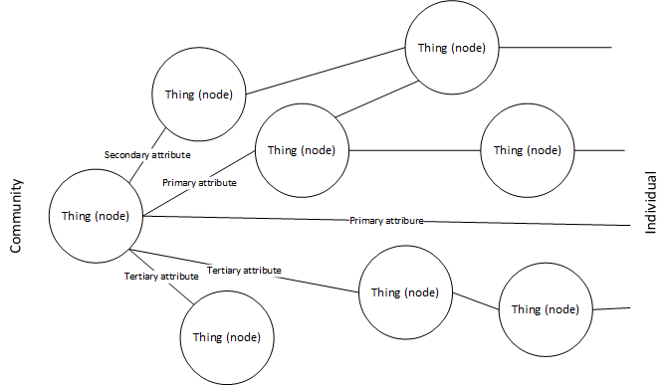
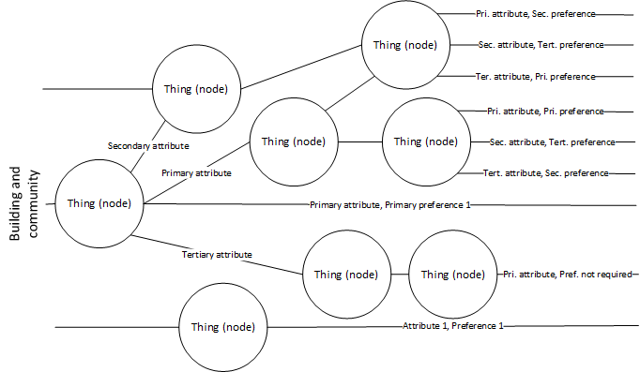
Figure 11. An indicative mesh (upper) and a customised mesh (lower).
While there is some convergence of services provided by things, for example ICT, the more specific the attribute need and/or the preference, or the combination of attributes/preferences to meet the required outcome, the more likely it is for the service to be provided by only one thing or one set of mesh circumstances. As the attributes drop to tertiary and below, and preferences become less exacting, there is greater potential for alternative things (paths) to be identified. However, the delivery of the service may become opaque, include more nodes, and become less well defined in terms of its propagation characteristics (see later).
Looking ahead to the development of the language, it is clear that a mesh-type structure with attributes and preferences can be used to represent things. However, before developing the language in more detail it is worth considering what tools and techniques are available for mesh visualisation and analysis. Also, as the mesh becomes more complicated it is likely to have a considerable number of redundant or essential (necessary for service delivery or unavoidable, perhaps due to location, impairment etc.) paths. These can either be removed if they are redundant or dominate service flow if they are essential. As a result, it is interesting to consider simplicity and complexity and how complex and complicated mesh structure might be dealt with.

  - 4.5 Neural networks
The construction of a mesh network is also very similar to a neural network, which can be considered as having a hidden layer and inputs and outputs (if considering a simple feed-forward network).
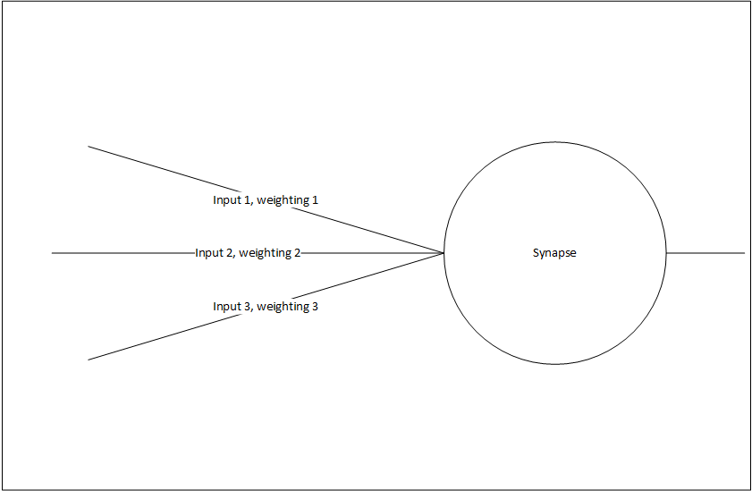
Figure 12. A neural network – synapse.

Nodes (neurons) in neural networks typically, however, have a binary output based on an activation threshold, with that threshold usually being the sum of the weighted inputs. In terms of the service mesh, each node has a number of input and output attributes. A node can have only outputs (in a feed-forward network), it can have inputs and outputs, and each node can be uni- or bi-directional. The inputs and outputs of a node can be connected directly or via a transfer function (linear or non-linear) of the thing. Nodes can then be connected in a meaningful way to produce the mesh.
In terms of the service mesh, as the physical delivery of services is gradually replaced by virtual ICT delivery mechanisms the virtual paths within the language will get stronger, essentially mimicking the synapses in the human brain that grow stronger as they are used more often. A completed mesh will also support analysis of alternative paths for delivery and help identify how service supply boundaries will blur in the future, moving on from, for example, physical centres of expertise such as a hospital to healthcare being delivered by various groups across the community, at different locations and via ICT systems. Perhaps a dynamic mesh network could help avoid ‘community dementia’ (i.e. improve its vitality) as gaining new experiences helps avoid human dementia?
To address one of the initial concerns raised in the Introduction, by contextualising the service attributes by not only how they relate to each other but also individual preferences, fully contextualised information is provided. The adaptation of the service provides a user-defined ‘pull’ mechanism and not an often ad-hoc commercially defined ‘push’ mechanism and, by doing so, removes much of the interpretation required by individuals in today’s vertically orientated service environment. It accentuates the potency and cross-connections in the mesh service paths where possible and ultimately opens the capability, if sensing and feedback are present, of delivering outcomes.

  - 4.6 Mesh types
There are several mesh analysis tools available on the open market, including iGraph, NodeXL, NetworkX and a beta-stage version currently being developed by Eric Berlow (Berlow 2016) in the USA. Other mesh analysis tools may also be used, including those for managing the supply-chain. In this case each node in the supply-chain software would be a thing and they would be connected in accordance with the language rules, this is discussed more in Chapter 7, Future research.

There are different types of topology:
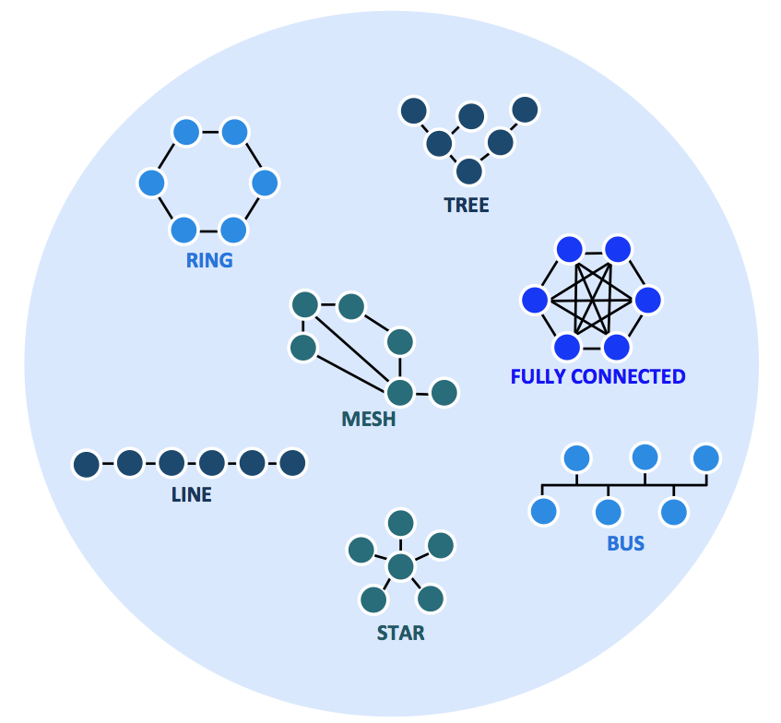

Figure 13. Indicative mesh topologies.

Given the number of things and their attributes, the mesh will become very complex very quickly, especially if nodes are fully connected and bi-directional. However, there will be a significant element of commonality and redundancy as many of the interventions, things and attributes will be essential for life and common to many individuals, beyond control physically, or mandated by Government or institutional service providers. This means that, while the initial mesh might be very complex, it will be possible to ignore or re-use parts from other meshes thereby simplifying mesh construction and analysis.

  - 4.7 Sensitivity
Despite the aforesaid commonality and redundancy, the mesh network will be very complex, so it is interesting to consider the limits of analysis and its reliance in practice:

‘the art of dealing with the complicated and complex real world lies in knowing when to simplify and when, and how, to complicate.’
(Rogers 2008).

However, to make the right decisions as where and when to be ‘simple’ or ‘complex’ the terms first need to be understood:

Simple problems: simple problems are ones where the final output is known and the path to achieving it is known, predictable and consistent.
Complicated problems: complicated problems are ones where to achieve an output there are multiple components, often with multi-step causal chains orientated in a mesh. These might include multiple causal chains occurring simultaneously suggesting more than one overall theory of change.
Complex problems: complex problems refer to interventions where the causal pathway is adaptive or emergent and where it is not possible to set out in advance the details of what will be the outcome. The intervention may not have pre-identified outcomes, but rather a vague, goal-level description of the desired end result without a clear pathway of how to get there (it might also include investigation of recursive feedback loops and emergent outcomes (DM&E, date unknown).

In general, problems are rarely one-dimensional; simple, complicated and complex systems frequently overlap. Initial mesh construction would be considered as ‘complicated’, but this would be expected to change, possibly to ‘complex’, as it develops.

  - 4.8 Summary
Having considered how a social language might be developed and the building blocks necessary for its construction, three key areas of further research are required:
Data acquisition:
- Identify the physical things in an individual’s building and community.
- Identify the service attributes of each thing.
- Identify personal preferences.
- Prioritise the service attributes for each individual and/or task.
Connecting these, the language, requires knowledge of:
- The transfer function of each thing.
- Node (mesh) connection rules.
- The interrelationship of services (duplication, dependencies, redundancy etc.).
Service propagation (top down) requires knowledge of:
- The process steps necessary to achieve outcomes.
- The things required for those process steps.
- Node/mesh propagation characteristics (resulting from attribute preferences).

These will now be considered in Chapter 5 and 6 following. However, the research has also been undertaken within a commercial environment and the opportunity was available to not only pursue the research objectives but also develop products for commercial exploitation. The first is BRE Health. This provides a framework for capturing data which can not only support research but also be used as a commercial audit tool. The second is smart electricity, its storage and smart control strategies. Both are driven by significant market forces. The first being the aging population and the increasing cost of healthcare and the second, energy security and the de-carbonisation of the grid.

Chapter 5. Product development

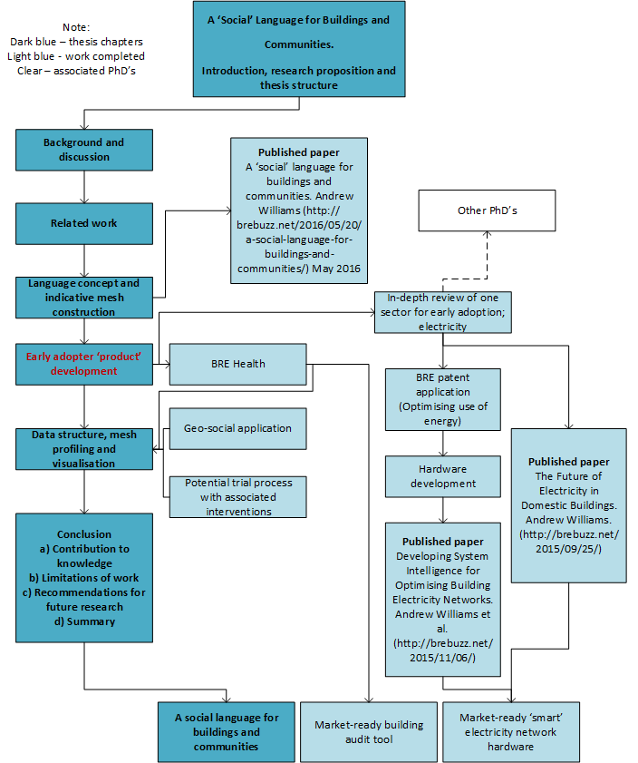

Product development

  - 5.1 BRE Health
Note: During the research period, BRE Health was developed to a beta-stage and trialled on one care home in Bournemouth – Draper Road. It has yet to be exploited and remains the intellectual property of BRE. The visuals provide an indication of its key components and their inclusion in this thesis has been agreed by BRE. Please see the summary of intellectual property issues at the start of this thesis.

  - 5.1.1 Background and discussion
As outlined in the previous chapter, one of the first requirements for constructing an individual’s social mesh is to identify what things they have in their building, the building itself and the local community. To do this, BRE Health was developed and it fulfilled two main objectives. Firstly, it was a practical tool that provided a route to capturing data on a building which subsequently could be used for social mesh construction, and secondly, it offered potential as a stand-alone commercial offering to generate consultancy income. The care home sector, due to the highly specific demands placed on buildings and communities by the elderly and impaired, is an ideal sector to test ideas surrounding the interaction between buildings and people.
Care homes are a very important part of the care network in the UK, and BRE Health effectively measures the value a building and its digital infrastructure brings to the existence and activities undertaken within the building (but not its environmental performance or the level or quality of care provided by care professionals). By doing this for all resident-facing aspects, both physical and digital, BRE Health brings clarity to how these aspects work in harmony to allow residents to live in comfort and with dignity today as well as how well the care home is equipped to deliver digital care in the future.
The OECD's Berglind Asgeirsdottir puts it (within the context of the burden of ageing population):

‘Speaking of the 'burden'... will only be valid if we fail to restructure society and its institutions to reflect these new realities.’
(Jeavans 2004).

In the past fifty years NHS spending on the public provision of health and social care in the UK has grown from 3.4 per cent to 8.2 per cent of GDP. If the next fifty years follow the same trajectory this could increase to approximately fifteen per cent of the UK’s entire GDP (Appleby 2013). During the same period, spending on long-term care could rise to as much as 2.5 per cent of GDP. At a national level, paying for this care will become increasingly difficult.

In 2010 there were over 18,000 care homes in England offering approximately 460,000 care home places (Care Quality Commission 2010). Between 2007 and 2032 the number of publicly funded older people in care homes in England will grow from approximately 230,000 to 380,000. Over the same period, those who are privately funded will grow from approximately 110,000 to 240,000 (King 2010). By 2041 the total number of care-home places may rise to over 800,000. While the increasing age of the population is something to celebrate it does place new demands on care homes, domestic dwellings and communities, which raises the question of how well they are equipped to respond.

  - 5.1.2 BRE Health product development
Clearly there are many tools and processes surrounding the assessment of buildings generally and hospital/care facilities specifically (see Appendix 3). BRE Health is different in that it not only deals with the normal things associated with building assessment (spaces and places), but it also deals with fixtures and fittings, devices and appliances, ICT networks, ICT services, the local community etc. and then considers them in terms of the service they provide to occupants. By weighting the resident-facing services by both personal choice and, for example, impairment, the performance of a building can be comprehensively assessed in terms of those living in the building, its physical location in a community and its virtual services. Taking this data and constructing a mesh network using the language allows living to be better understood now and in a smart future.
The approach and methodology can be extended to any building simply by refining the audit questions in line with the building type (although the existing questionnaire is so comprehensive this probably entails just removing redundant questions) and weighting the findings in accordance with individual need or preference. As a result, it could be applied to domestic dwellings generally or, for example, as part of a hospital discharge process for patients leaving hospital to convalesce at home. It can also be extended to commercial and business properties to improve staff satisfaction and even, potentially, productivity.

BRE Health, as a stand-alone tool, can:
- Provide guidance to prospective residents and their families as they select the most appropriate care home for their needs.
- Allow care-home owners and managers to rate their care homes in relation to national best practice.
- Assess a care home in relation to its performance for a specific impairment, for example, dementia.
- Help Local Authorities, care specifiers and hospital discharge teams select the right care home.
- Support nursing and medical care by bringing transparency to how the building and its digital systems and services can underpin current and future digital care.
- Provide a roadmap for refurbishing or upgrading care homes in relation to the built environment and its digital infrastructure and services.
- Provide a national rating scheme for care buildings (and their associated digital systems).
- Showcase good care homes and flag up those that could be improved.

When a care-home owner or manager decides to have their home assessed a trained surveyor visits the care home to undertake a thorough survey of the building, its IT infrastructure and, to a lesser extent, the local community. As all care homes are different the database that underpins BRE Health is first customised to suit the care home in question through an online questionnaire that is typically completed by the care home manager or owner prior to the surveyor visiting the home. Once this has been completed a registered surveyor visits the site and undertakes the survey which typically takes approximately half a day. The surveyor assesses areas such as:

- The physical building: location, access control, security and safety, movement, fixtures and fittings, décor, design and colour, lighting, flooring, heating, indoor space, outdoor space, staff/resident communication and empowerment, use of ‘memory boxes’, mobility scooter storage space etc.
- The ‘digital building’: broadband speed, security reliability and resilience, connection to external call centres/medical networks, digital connectivity across the building/rooms, smart devices for building/appliance control, co-located services at workstations etc.
- The physical community: organised events and outings, transport links, entertainment and shopping centres, local clubs and support networks etc.
- The virtual community: online community services, connection to family and friends, online purchasing, prescriptions, community groups, hobbies etc.

Once the physical and virtual environments have been surveyed, BRE Health allows the findings to be compared to national best practice and/or for them to be weighted in relation to the day-to-day activity or care need of the resident. BRE Health also provides an insight to nursing or care professionals as to how well the care home supports or hinders their daily work.
In terms of digital capabilities and performance, BRE Health assesses the end-to-end system not just in terms of the technology but what it can do for occupants and care providers. It assesses issues such the provision of audited offsite response centres, contended and uncontended connections to the building, system resilience and, finally, the cable connections or Wi-Fi coverage in each room. BRE Health also pays particular attention to the digital services provided across the network and the training provided to residents and medical/care professionals. By doing so BRE Health assesses the viability, or otherwise, of a care home to deliver digitally enabled care and social services, whether these are provided via professional medical/care staff or through family and friends. BRE Health can quantify what can and can’t be delivered beyond the ‘hospital wall’, thereby bringing clarity to care provision in the broader community. Much of the analysis could apply to a domestic dwelling or any other building.
BRE Health contains nearly eight hundred questions and many screen pages, a few of which are provided here for information.

Access is via a home page:

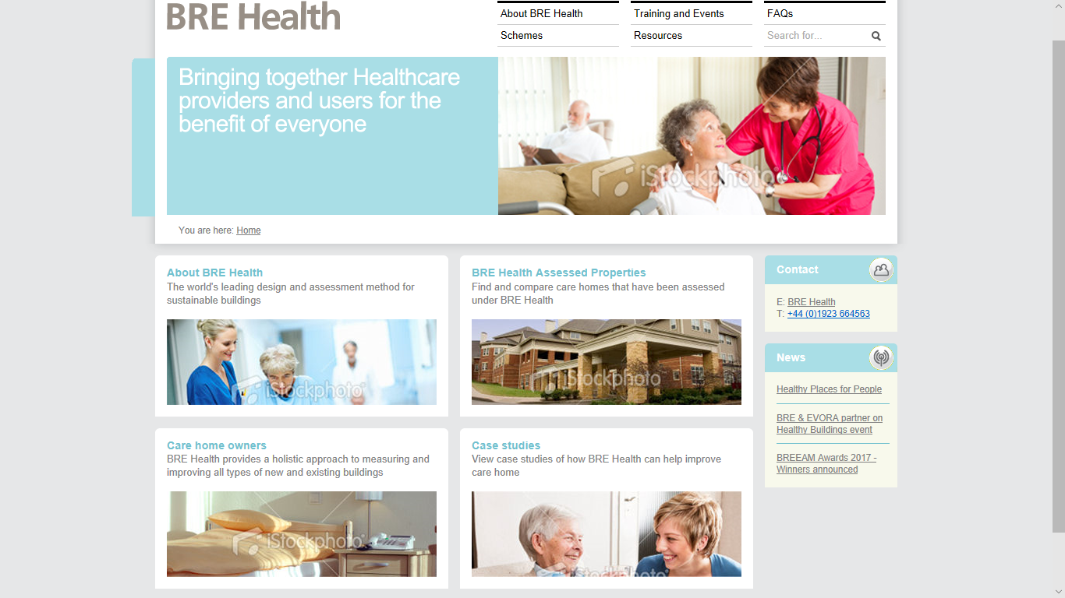
Figure 14. BRE Health home page.
Signing in as a building assessor allows access to questions categorised by type and/or logical surveying sequence:

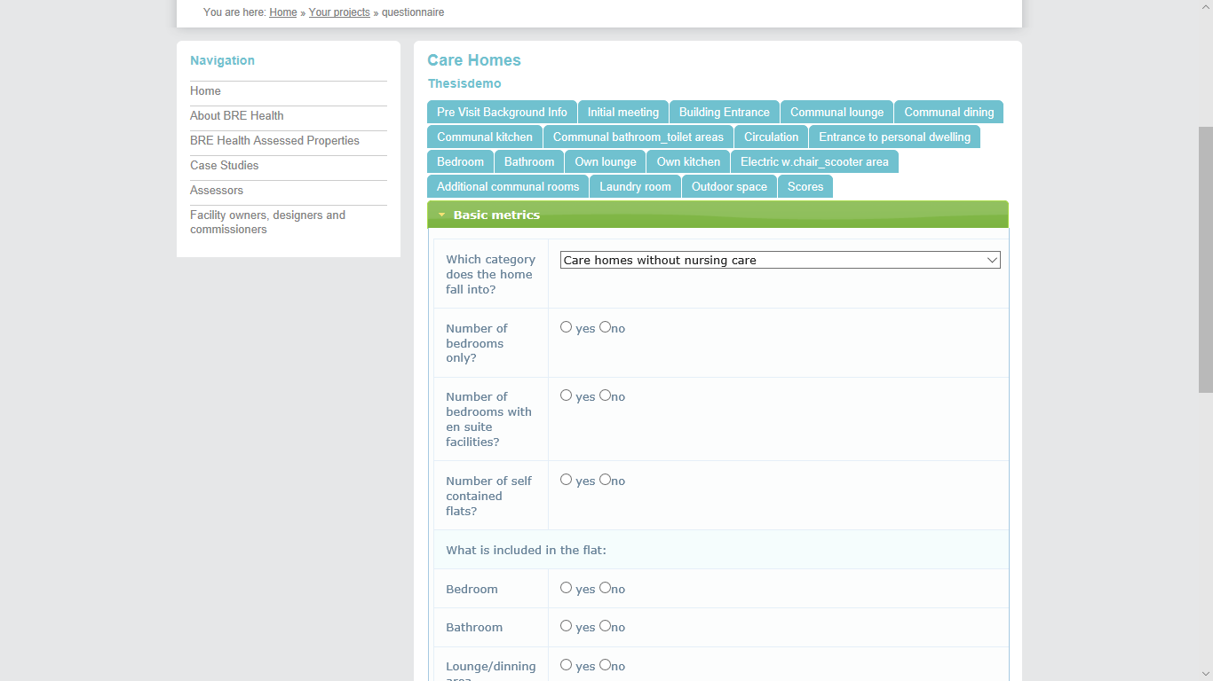
Figure 15. Initial survey of type of care home.
Each tab opens to show questions (configured partly by the process of the audit and by building area type):

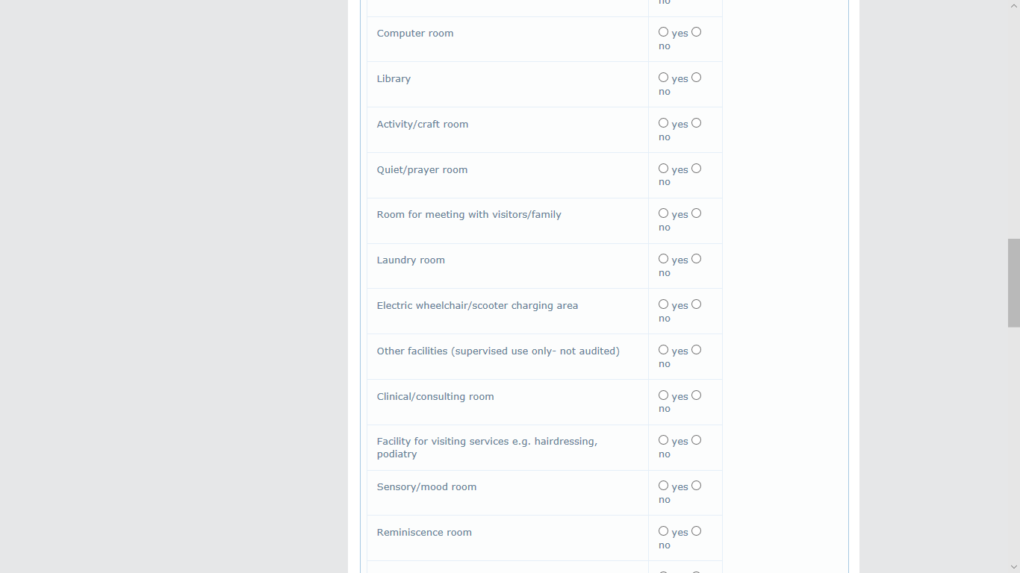
Figure 16. Facilities available.
ICT hardware is assessed:

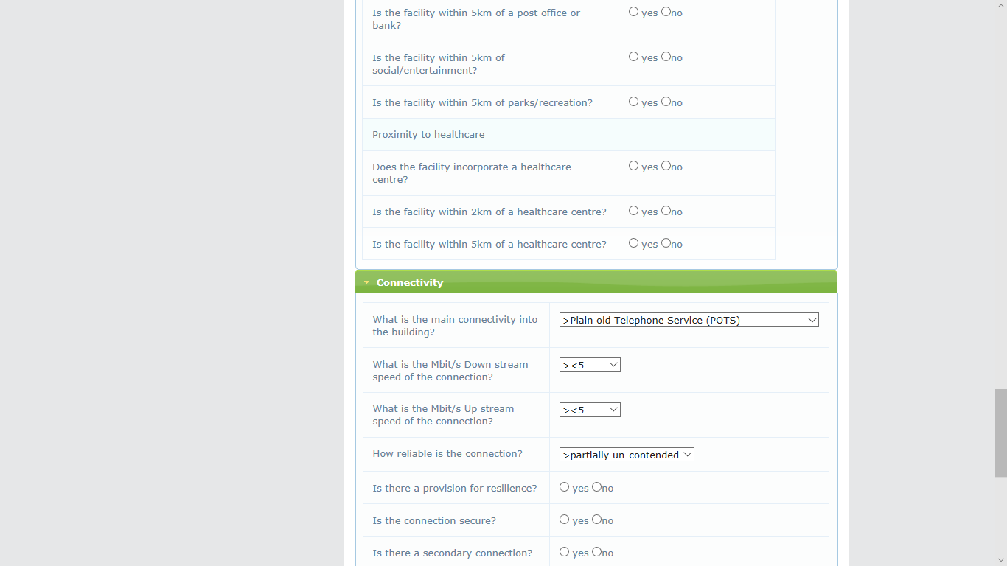
Figure 17. Performance of ICT hardware and systems.
ICT services, local and national, are assessed:

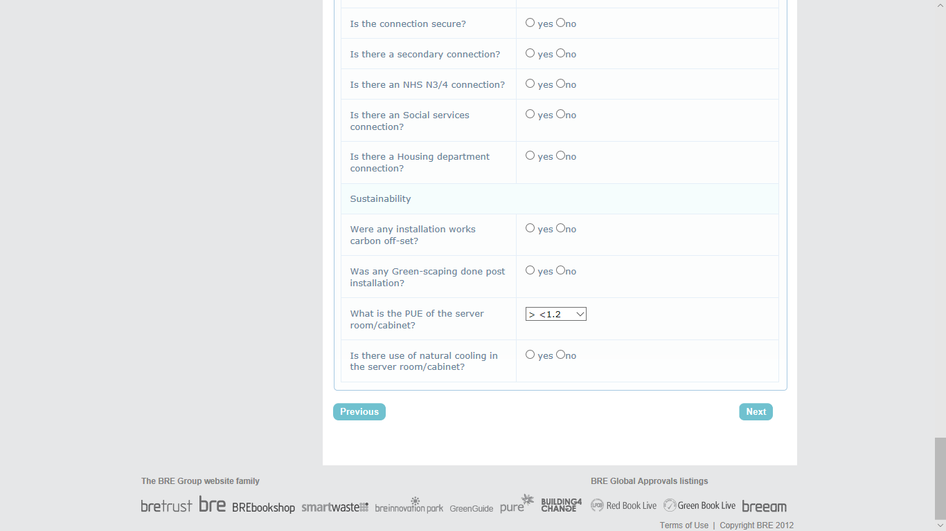
Figure 18. Local and national ICT services.

Local amenities are assessed:

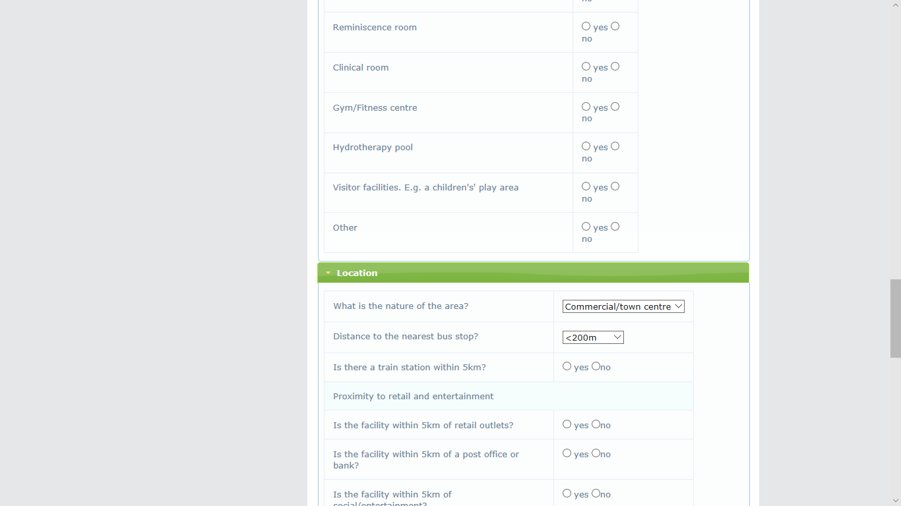
Figure 19. Location and local amenities.
Questions are categorised:

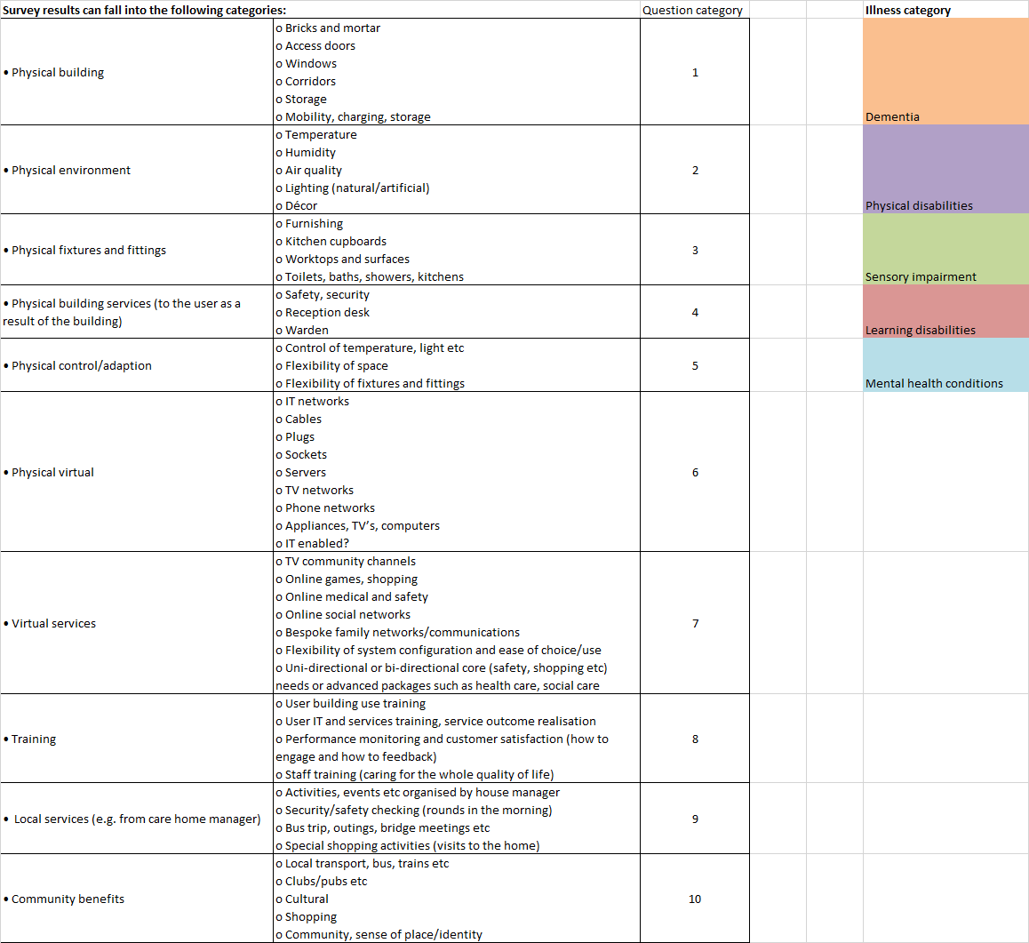
Figure 20. Findings are categorised by type and impairment.
The database behind BRE Health weights the scores according to impairment:

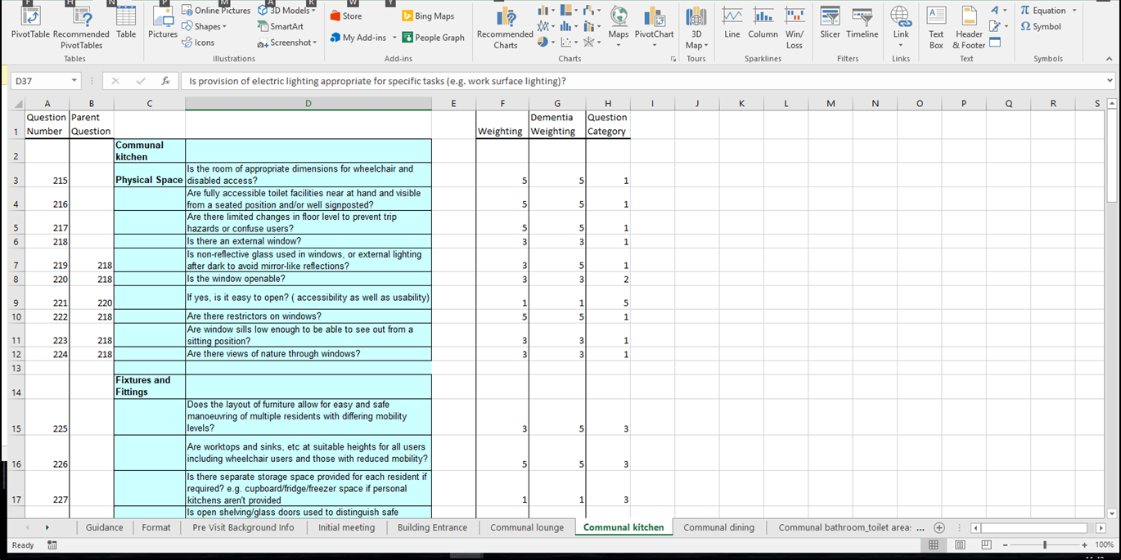
Figure 21. Things weighted according to impairment or, outside care-homes, occupant need.
The scores are then added up for each area (numbers are meaningless):

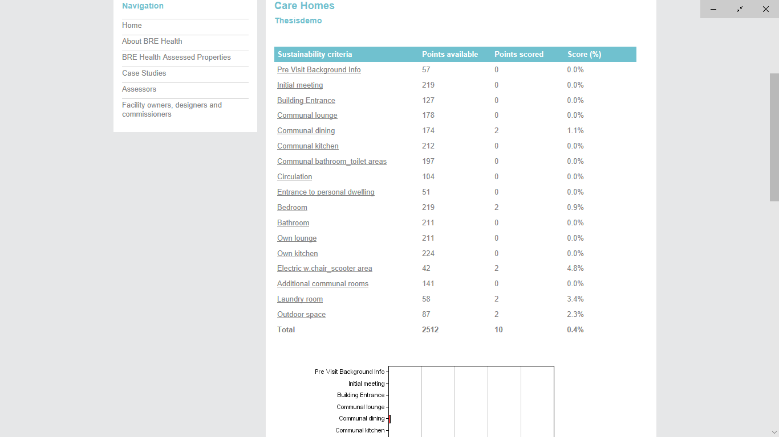
Figure 22. Area types assessed to support national benchmarking.
While, at a national level, delivering complex and complicated remote interventions may be some way off, simply enabling family or friends to monitor energy or water use to ensure daily life is going on as usual can be done today. BRE Health was trialled on a new care home in Bournemouth (Draper Road) and was deemed to be excellent in terms of its comprehensiveness, functionality and ability to be customised in line with occupant impairments.

‘BRE Health provides an extremely comprehensive assessment process for care homes and it is something desperately needed if we are to improve our care and move towards tele-care and tele-health. Its breadth and depth give a clear view of how building and community services can be better provided now and in the future.’
(Rosewell 2015)

Note: as might be expected, producing approximately eight hundred consistent and meaningful questions involves considerable effort and building/ICT knowledge and programming. If there is a need to explore the initial alpha-stage web tool in more detail the author will approach the owner, BRE, for permission.

  - 5.2 Smart electricity
  - 5.2.1 Background and discussion
Considerable focus has been applied to energy efficiency and the environmental performance of buildings over the last thirty to forty years and it could be argued that, while efforts must not be diminished in this area, in terms of market transformation the environmental performance of buildings is now embedded into the practices and procedures of the construction industry, as well as the national psyche. The next step is to assess buildings in terms of their social value, and one aspect that influences this is electricity.
Electricity is important nationally and for this research because:
- It has an impact on social issues such as fuel poverty and healthy indoor environments.
- It is the subject of a national campaign to reduce carbon emissions by de-carbonising the grid.
- It lends itself to control and automation and is ideally placed to explore product development ideas.
The electricity sector (devices, renewable energy and smart systems) was considered as a new area with potential commercial income and market research was undertaken and a review paper was written. The publication ‘The Future of Electricity in Domestic Buildings – A Review’ was written by the author and published in December 2014 (Williams 2014).
The review considers issues such as national drivers for change, electricity generation, storage, device consumption and networks and control scenarios. It also includes:
- How challenging carbon dioxide reduction targets might be met.
- Generation: the use of more intermittent renewable energy and inflexible nuclear generation.
- Smart meters and a potentially more dynamic electricity tariff structure.
- The growth in local generation through, for example, renewable energy installations.
- Electric vehicles and heat pumps.
- Changing appliance and device electricity-demand profiles.
- Smart devices (controllable and Internet (IP) addressable).
- Alternative domestic networks.
- Conversion efficiencies.
- Electricity storage.
- Novel control scenarios.

The UK Government has set stretching targets for carbon dioxide reduction and this, along with the EU’s Large Combustion Plant Directive (The Register 2012), is having a big impact on the UK’s electrical production capacity (National Grid 2011; Grid Watch 2013). As a result, approximately twenty per cent of the existing power plants are due to close in the next five to ten years (HM Government 2012(a)). This shortfall will call for over £110 billion of new investment in the next decade. However, to meet carbon dioxide targets, the new capacity will be more intermittent as a result of wind generation and less flexible as a result of nuclear generation.

To manage electricity more efficiently, the grid, and the user, will need to get smarter. In the next ten years domestic users, who represent one third of the total demand but two thirds of the volatility (Henry 2010) will progress from passive bill payers to highly informed energy consumers and producers. Energy use and cost will become transparent through the introduction of domestic smart meters and tariffs that vary depending on time of day. Machine-to-machine communications will enable things to match demand profiles against grid availability, and local generation and appliances will be remotely switched off at times of peak demand.

  - 5.2.2 Systemising energy
To explore how electricity might be part of a systemised social environment several projects, listed below, were initiated. The first is a commercial product-development initiative whereas the others are doctoral research programmes. The three doctoral studies are an integral part of the smart city research programme managed by the author, who raised the necessary funding and acted as an industrial supervisor. The projects would provide practical hardware to research and validate the proposition in terms of electricity.
The initiatives are briefly described here.
‘The Building 16 project’ (Williams et al 2015): this project investigated how distributed storage, particularly in mobile devices, could form part of a low-carbon strategy alongside local PV generation. Its aim was to externalise the storage and energy-demand functions of any device with storage thereby allowing their social performance/value to be optimised against energy consumption, cost or carbon emissions. A paper was written, entitled ‘Developing System Intelligence for Optimising Building Electricity Networks’ and published in November 2015.
Smart 240V Outlet Socket (Lalani ongoing): the aim of this doctoral study was to develop 240V mains outlet hardware and intelligence to identify loads by nature of their current draw over time. While in broad terms this has been done before, the uniqueness of the research was the techniques used to analyse the current waveform and deduce what were the appliance and devices responsible for its makeup. The outlet was to have an interface making it able to be read and controlled by a central command device and hence be part of the envisioned smart system.
A Building Positioning System (Mistretta ongoing): the second doctoral study was to undertake research into how a building positioning system could be produced that locates specific individuals in a building. This is necessary to produce an adaptable and agile system and ideally should be done without the need for individual tags or personal identification hardware.
As discussed earlier, extending beyond the concept of agile, adaptable and, hence, resilient electricity systems, the concept of an ‘Instantaneous House’ has been proposed. This concept addresses the possibility of making a building much more responsive as people move around the building, thereby reducing the time devices and appliances are on. If a building positioning system can be produced it will mean that, not only will the energy used by appliances and devices reduce as legislation drives energy efficiency improvements, but appliances and devices will turn on and configure themselves depending on who is in the room, thereby supporting service customisation.
Smart Meter Data Analysis (Ioannidis, ongoing): the final doctoral study considers how data from smart meters can be used to better understand a building’s electricity consumption or that of several buildings in a local community. As electricity is de-carbonised and transport and domestic heating is electrified, new demands will be placed on the local distribution network which are a weak point in the national supply network. The objective of the study is to identify network control dynamics that interact with appliances, devices and any available storage or generation to balance broader network capabilities with lifestyle and electricity demand. The study will interact with the other doctoral studies and with the B16 PoE project etc.

Prior to the work on electricity and smart-city systems the author was an industrial supervisor for a Power over Ethernet project at the University of Strathclyde. Several joint patents were obtained in the names of Councel, Williams and Stewart. The author lodged one (see Appendix 2) specifically relating to the transfer function of things/devices although, for commercial reasons this, and the other joint patents, have been allowed to lapse.

Chapter 6. Data structure, mesh network profiling and analysis

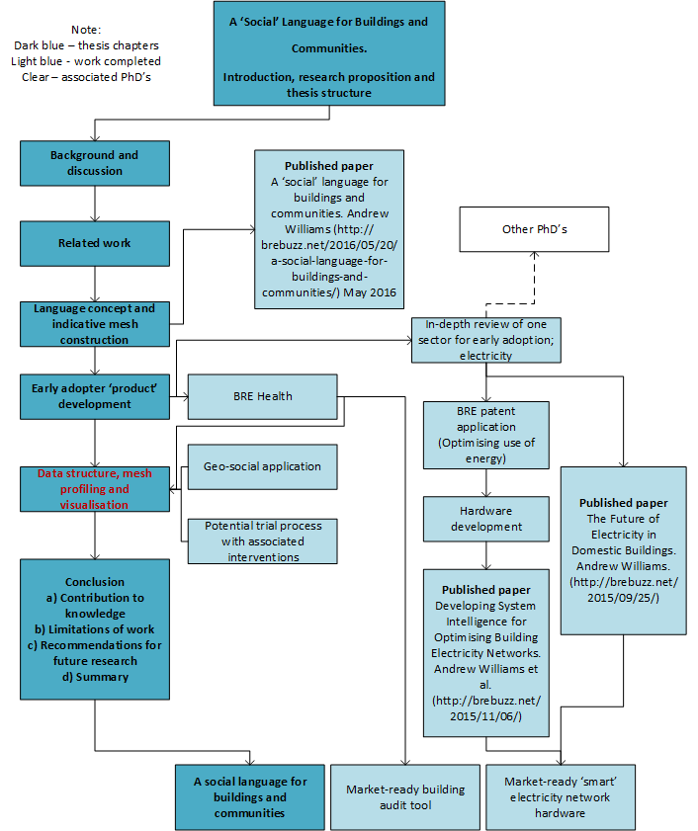

Data structure, mesh network profiling and analysis

  - 6.0 Introduction
In this chapter the key stages of developing a social mesh identified in Chapter 4, Language concept and indicative mesh network construction, are considered. Initial top-down thoughts about what might be needed to construct the mesh result in three key areas. The first is the need to identify what an individual has by way of things in their building and local community; this is met by a derivative of BRE Health. These things will then need to be characterised in terms of their service attributes in relation to individual preferences and intervention required. Finally, there is a need to identify the overall processes to be propagated across the mesh.

  - 6.1 The thing
In this research the physical or virtual ‘inputs’ and ‘outputs’ of the thing are considered only in terms of the service they provide, and they are written with inverted commas as they can be bi-directional. To return to the very simple example in Chapter 4 dealing with the control of the acoustic level of a TV, historically this would have been an electro/mechanical (rotary or linear) potentiometer mounted on the thing itself. It would require manual operation and the individual would need to be near the thing itself. Today, this is likely to be remotely operated and possibly via a graphic user interface. This has arisen firstly because the advancements in electronics and user interfaces have allowed it, and secondly because physical hardware, the potentiometer, can be costly relative to mass-produced electronics. The acoustic level can now be controlled from anywhere and potentially linked with other operational demands, such as a specific individual need resulting from a hearing impairment, the acoustic performance of the room, activities going on in the room, incoming phone calls requiring the TV to be muted etc. Decoupling the service from the physical hardware allows services to be events in time and not objects or activities in space.

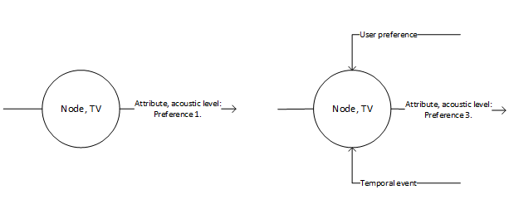
Figure 23. Attribute modification.

  - 6.2 Service attributes of things
As mentioned in the Introduction, the construction of a social language is based on common practices and procedures and not exceptions. As the language develops, and the databases become more comprehensive, its accuracy and scope will increase.

As a starting point a simple four-legged table will be considered. The primary service attribute provided by a physical table is as a work surface for undertaking tasks. An attribute table for a physical table may look like:

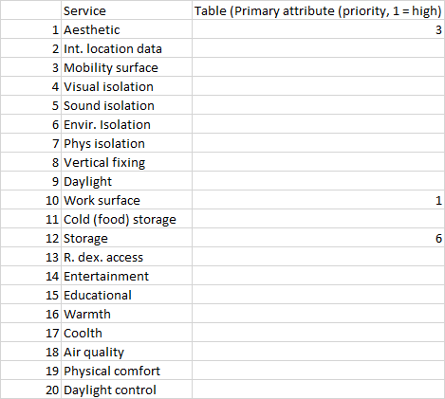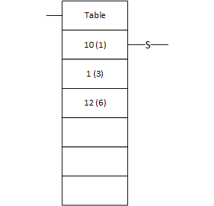
Figure 24. Primary attributes of a table (attribute table on the left is indicative only).

The table on the left in Figure 24 is a list of services provided by things. It can be populated simply by considering things in a rolling manner as they are identified in buildings or upfront before any buildings are surveyed. The key aspect of the services in the attribute table are that they must be able to distinguish, in this example, a table’s physical type. This is not in terms of style, colour, construction etc. but by the functional services it provides. In simple terms a physical table could be considered as providing the service of a work surface, and this might be considered its primary function. It is also likely to provide aesthetic value and, possibly, some storage value by way of drawers; these would be secondary and tertiary attributes respectively. Prioritising the service attributes distinguishes what the thing is and as the service descriptors become more comprehensive the table on the left in Figure 24 will be capable of delineating more things. Any ‘thing’ with the primary attribute (10) would have a strong correlation with the service need for a task surface. It would have a weaker association with the need for aesthetic value and poor association for that of storage.

However, considering a ‘work surface’ as the primary service of a physical table may appear incomplete both in terms of what a work surface is and the diversity of physical tables (and other things) providing the ‘work surface’. Further delineation can be obtained by separating the functional performance of different physical tables or they can be described by their physical characteristics of flat, at a working height, having a hard surface and clean. These could be classed as sub-attributes. Each primary and secondary attribute etc. could also have various sub-attributes although only the primary attribute is considered in this research.

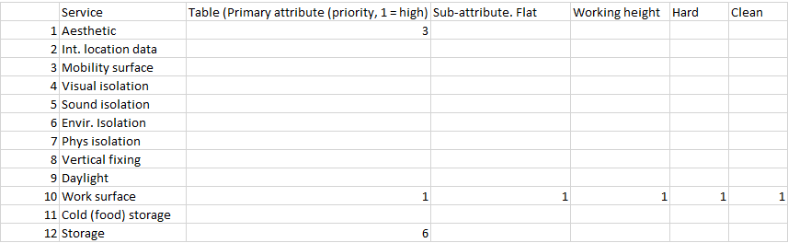

Figure 25. Sub-attributes of a physical table.

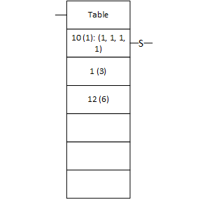

Figure 26. Sub-attributes of a physical table.

The same sub-attributes would apply to a kitchen worktop (physical location will be different) but not, for example, a footstool:

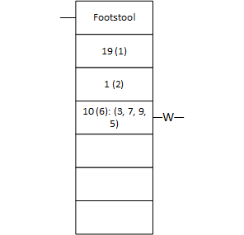

Figure 27. Sub-attributes of a footstool.

Here the correlation is weak. Its performance as a work surface has been taken as the average of its sub-attributes.

In this research, only primary, secondary and tertiary attributes will be considered. Attributes beyond tertiary and their sub-attributes add an additional layer of complexity not necessary for initial concept development but would increasingly delineate all number of things and hence all number of service choices.

Consideration also needs to be given to physical dependencies. A physical dependency is one where, for example, the service value of a table is only available if it has a floor to stand on. This could be included as the service value model is developed and by doing so a much more detailed vision will be gained of the physical environment and its interrelationships. This would also lead closer to BIM and object modelling generally although these approach from the standpoint of modelling for business and construction efficiency and not directly from the service value provided to individuals. It may also support better analysis as ‘normal’ physical dependencies are broken by new ways of delivering services, for example, a light switch without a wall. For this research a ‘normal’ building will be assumed, and obvious dependencies will be ignored.

A simple attribute table might look something like:

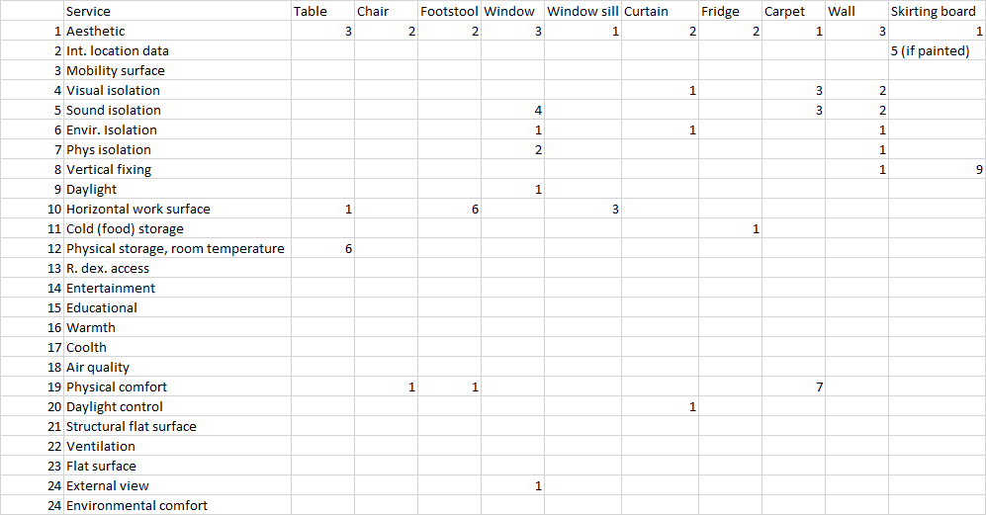
Figure 28. Service attribute table.

Down the left-hand side are the service attributes and each thing are rated by its primary, secondary, tertiary etc. service attribute. Terminology is key as some of the initial list of services are already a combination of various other services; for example, being comfortable in the home would call for internal environmental comfort, which requires warmth or coolness, good air quality, and physical comfort by way of a chair. It might also include seemingly disparate elements such as carpet and daylight (and its control). Warmth itself cannot be delivered without isolation from the outside and therefore walls, ceilings and floors are required.

As a result, the collective attributes from SPPS cascade through SPPE and SPPT to deliver comfort (Figure 29). Each attribute can be prioritised by an individual’s need which can also embrace the performance of the thing itself. For example, an individual might rate the service of ‘physical fixing’ highly as they have a need to fix a picture to the wall. However, an individual interested in sustainability may rate thermal performance higher and the sub-attribute to thermal performance could capture its thermal, acoustic etc. performance.

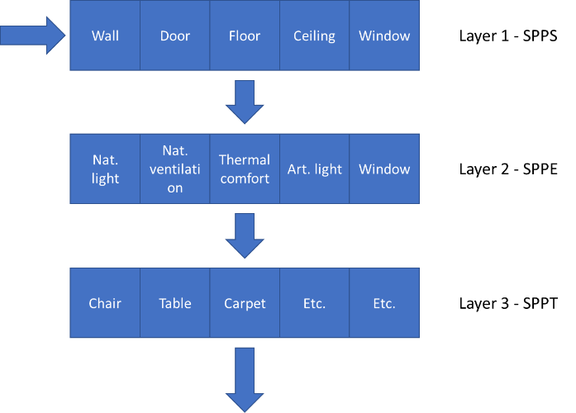
Figure 29. Realising comfort.

A deficiency (for example, the lack of a window) in the SPPS stream might remove the option for natural lighting (and possibly natural ventilation, depending on the window attributes). If the SPPE stream contains strong attributes of artificial lighting, then this could be an alternative but, for example, might not be an option if the individual has limited physical mobility or dexterity which would be embraced by the SPPM stream. Lack of mobility, for example, will also be impacted by the floor and this will be indicated by a poor ‘surface’ attribute; which might also include stairs. Any physical aid (SPPT) (for example, a wheelchair) will provide its own attributes which might mitigate any collective shortcomings in ‘building’ attributes.

  - 6.3 Service classes
Having considered the service attributes of simple passive things and how they are related there is now a need to extend the thinking to those things that are more complex, possibly active, and require services themselves to provide the final end-user service.
For clarity, up to now service streams/attributes have been identified that directly relate to the physical thing and what it is commonly understood to provide – the primary attributes. As already seen, primary attributes can be prioritised as primary, secondary, tertiary etc. For more complicated things that might have a complex transfer function connecting the input and output attributes, and possibly with a range of control variables, additional service ‘classes’ are required to describe the thing. To help understand the thought process two examples will be considered; a fridge (complex) and a skirting board (simple).

  - 6.3.1 Example 1: a fridge
In very simple terms a fridge can be considered as a box which is cold inside. By placing food in the fridge individuals have access to safe (cold) food. To realise this, the fridge needs electricity and the individual must place food in it for later use.

Figure 30. A very basic block diagram of a fridge.

However, a fridge is more complicated than that now and might be much more complicated in the future:
Thing: Fridge
Stream: Service Provided by the Physical Thing (SPPT, 1) building)
Primary Service Attribute Class:
- Coolth
- Food storage
- Aesthetic
- Etc.

Sub-attribute Class: not considered.
Associated Service Attribute Class: this class captures the services provided by the associations between other primary classes and will often represent the ‘horizontal’ integration of other classes in the future. For example, the association between the Primary Service Attributes of the fridge and the Supply Attributes (see below) could provide:
- Safe food to eat (enabled by electricity and dependent on Supply Attributes) and, in the future, possibly.
- Food ordering.
- Dietary advice.

Enabling Attribute Class: for example, electricity. Under this attribute class the ability of the thing to store energy and decouple the service from the enabling resource will be captured. In terms of the mesh this can be coupled with the upstream transfer function for electricity (see later).

Supply (or waste) Attribute Class: in this example, food. Included in this are not only the issues surrounding the supply of food, but the Associated Services provided by the primary fridge service (coolth). Like electricity, supply and waste attributes can have an upstream/downstream transfer function from the fridge.
Operational Attribute Class: the extent of control parameters (manual, manual/remote, virtual).
Reporting Attribute Class: the extent of sensing/reporting parameters (manual manual/remote, virtual).
Locational Attribute Class: fixed. This is a measure of whether the thing is fixed, portable or mobile. To realise some of the services there will be a need for personal mobility, sight and dexterity. These are not an attribute of the thing but an intermediate need to access services from fixed and portable things. They are the human gateways that allow interaction and will be discussed later.
Each of these will now be explained in a little more detail.

  - 6.3.1.1 Primary and Associated Service Attribute Class
This is a list of what might be understood as the main service benefits of having a fridge. Like many things, the fridge has a clear primary attribute and a number of other attributes. For example, in terms of an individual who places kitchen design as a high priority, the visual aesthetics of a fridge might be second in the Primary Service Attribute list. Many of today’s things could be argued as being still relatively simple in terms of their service value, and therefore there are only a small number of attributes in the Primary Class. This is likely to change rapidly when more ‘horizontal’ data becomes available and new service offerings result. These are captured in the Associated Service Class as they represent a service value but are only delivered via an association of the services provided by several inputs, outputs or things. Of course, the fridge might be considered as one of the more complicated things along with, perhaps, computers and TVs, but even passive things such as walls and windows could become active and much more complicated in the future (see Example 2: The Skirting Board later).

  - 6.3.1.2 Enabling Attribute Class
In the case of the fridge, electricity enables the delivery of the primary service of coolth and, hence, cold food. However, electricity itself can be considered as just units consumed and cost per unit or it can be considered in more detail both in terms of its:
- Internal conversion within the fridge and its controlling functions.
- Supply characteristics outside the fridge.
By understanding the relationship between electricity as an Enabling Attribute and the Primary Service Attributes (one or more of the service attributes in the class may be impacted by the enabling attributes or other classes) much greater flexibility can be gained over what the fridge does. This may be considered as being of little importance now but by 2020, or shortly after, smart meters will be introduced and, in addition to consumption and cost, time-of-use will become a critical factor in the supply/demand strategy of electricity. If a thing can store energy in some form (in the case of a fridge today it is its thermal (coolth) storage), this could be used to maintain the required service while at the same time not consuming electricity during peak times when the price is high.
Although electricity is a resource it is classified differently from the Supply Class, as electricity itself is not directly used/consumed by the individual; well, let’s hope not! What it does do is to provide a service such as coolth which in association with food provides safe food to eat. Electricity will, of course, also be an enabler of transport (mobility) in the future.

However, even this is not the full extent of what could be achieved. As the number of electricity generation sources increase, become more distributed throughout the electricity network (each with its own unique characteristics of cost, efficiency, carbon emissions and generation output, for example, renewable energy) then the supply itself can be considered in much more detail and have a transfer function itself. Here a prioritised service offering from the fridge and its connection by a transfer function to a resource, in this case electricity, with its own transfer function (see later) is a combination that could be classed as a truly transparent resource/service supply-chain.

  - 6.3.1.3 Supply Attribute Class
Individuals use ‘stuff’ and the Supply Attribute Class captures these attributes. The supply of goods and services is part of a supply-chain which is a well-developed discipline with advanced tools for its analysis and optimisation. However, the supply of food, for example, while a physical thing, is considered, in terms of this research, by way of its service value. While diet is much discussed today, by considering food by its nutritional service (and possibly even secondarily, preference) a clearer dietary make-up can be gained; nutritional labelling becomes part of the supply service. Trading between foods allows compromises to be made in nutritional value by disaggregating the value from the food (note, discussions were had at Sheffield University surrounding how existing supply-chain tools might be extended to include the service provided directly to individuals). The Supply Class also includes waste as a sub-set that has its own transfer function as it is reused, recycled or discarded.

  - 6.3.1.4 Control and Reporting Attribute Classes
Today a fridge has little in terms of control and reporting attributes but again this is likely to change dramatically in the future. While the workings of a fridge, even today, would allow for many usage options the only reporting service is normally a green light showing the fridge is on and, perhaps, a display providing an indication of the internal temperature. In terms of controlling the fridge the individual normally only has an influence over temperature within a set range, and this is often by a dial with an arbitrary scale from, for example, 1 to 5. Both the reporting and controlling functions are predicated on physical interventions and require a physical presence near the fridge together with physical dexterity to make the operations required.

The Controlling and Reporting Class can be prioritised and have two key areas:

- The control and reporting of the thing itself,
- The control and reporting of the thing’s other attribute classes (for example: the Supply Class, Associated Class and the Enabling Class).
As will be seen later, the potential to control and report the thing itself, based on the transfer function, could be very significant. However, the primary service is safe food, and this is a combination of the functional performance of the thing itself, its transfer function, and the supply and demand of food. For example, with sufficiently developed Controlling and Reporting Classes (which also impact the Enabling Class and others) the ability of bar-code reading may allow upstream communication that provides the service attributes of automatic food ordering or even dietary advice. Of course, the progression towards smartness creates the ability for this to be done and for the fridge to engage with the food supply-chain and any other virtual service offerings. However, the realisation of the primary service still requires physical mobility of the individual to place food into the fridge and remove it when required.

  - 6.3.1.5 Locational Class
Clearly the Service Attributes of a fridge cannot be realised if the individual is unable to reach the fridge due to an inability to access it, either through lack of personal mobility or a physical barrier of some kind. These issues are dealt with by personal preferences and defining the lack of suitable surface for walking on respectively. The fulfilment of nutritional needs would call upon these as part of the solution.
The Locational Class particularly applies to whether a thing is fixed, portable or mobile and thereby able to provide services without the need for personal mobility. Clearly a fridge provides safe (cold) food to eat that as a physical resource, requires mobility and proximity to realise the service of fulfilling nutritional needs. A fridge, however, has a Supply Attribute Class necessary to meet that need.
In this class, ‘mobile’ is related to information exchange and virtual physical interventions that are not subject to mobility. It is assumed that mobile services are near to the individual, and that the battery is charged!
There is also another dimension to location. It is difficult to see the future, but it may be fair to say that as services are delivered more electronically, people will become more sedentary and physically isolated. For many older people, while transport and mobility might be difficult, the necessity to engage with the physical community around them is often a welcome break from isolation or loneliness. To help understand the positive and negative impacts of physical/virtual delivery mechanisms a geo-social application, Impact (see later), has been developed. It brings clarity to how well a community can cater for an individual’s need, whether that person is with or without an impairment, and what the downsides are of virtual delivery mechanisms on, for example, health and wellbeing.

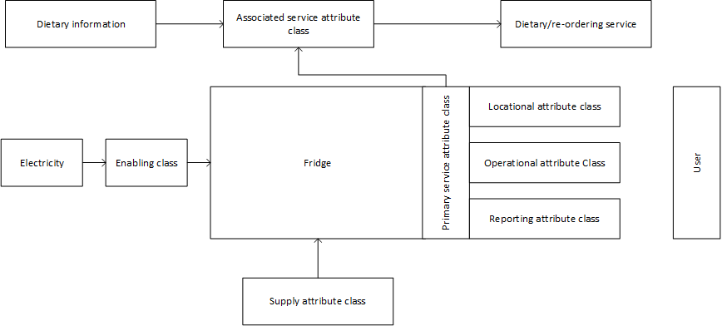
Figure 31. Attribute classes and how they apply to things (a fridge).

  - 6.3.2 Example 2: a skirting- board
Having considered a moderately complicated device, a fridge, that contains elements of storage, internal switching with hysteresis, variable losses etc, another much simpler thing will now be considered as an example, a skirting-board. Like the fridge the skirting-board is a local, physical thing from which service is derived. A skirting-board has been chosen as it is not obviously electronically compatible, is more associated with the physical structure of a building, is passive and requires no immediate enabling services. Completing the Attribute Class Table in a similar way to the fridge produces:
Thing: Skirting-board
Stream: Service Provided by the Physical Space (SPPS)
Primary Service Attribute Class (priority will change with individual need and/or things (mesh) environment):
1. Aesthetic (or locational information for an individual suffering from dementia)
2. Not applicable
3. Not applicable
Sub-attributes Class: not considered
Associated Service Attribute Class: none
Enabling Attribute Class: none
Supply (or waste) Attribute Class: none (within the context of delivering the Primary Attributes)
Operational Attribute Class: none
Reporting Attribute Class: none
Locational Class: fixed

The primary service of the skirting-board has been listed as ‘aesthetic’. The skirting-board is largely decorative and is used to cover where the wall and floor join. This can be unsightly depending on the wall and floor covering and often a gap can open depending on the floor type. These issues are largely related to the building’s physical structure and provide no service to the individual beyond their aesthetic value. Clearly the skirting-board may also provide draught exclusion and, if so, this would become another service, prioritised in line with individual need.
However, if the skirting-board is in a care home and painted different colours depending on where it is in the care home, then it provides another service: a locational service. Its value to individuals with an impairment is not just in terms of its aesthetic value but also in how it deals with their locational needs.
In a similar way, all parts of the building (walls, windows), things inside the building (tables, chairs, TVs, lights) and community services (education, health services) can be broken down and then prioritised in terms of user needs, preferences or lifestyle.

  - 6.4 Alternative things providing the same/similar services
Once the service attribute table has been constructed it is possible to detail what other things might provide the same services. For example, if an injection were required it would not be unreasonable to want a table and the services it provides: a horizontal surface for undertaking tasks. This can be provided by many things, but their attributes are different, thereby enabling choices to be made on the benefit of a perfect table vs the drawback of realising that perfect table. The situation may dictate that a ‘lesser table’ is, in fact, for that individual at that time, better.

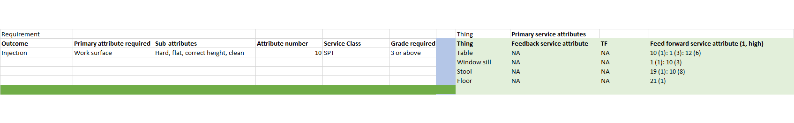
Figure 32. Alternative service providers.
A physical table could be further characterised as being hard, flat, correct height and clean: the sub-attributes. The attribute number from the attribute table earlier is 10 and it is a Service of a Physical Thing. If, for an injection, it has been deemed that a Grade 3 table or above is required, where 1 is a good match and 10 is a very poor match, a physical table with a ‘horizontal work surface’, Grade 1 assessment is ideally placed. Its other attributes are ‘visual aesthetic’ Grade 3 and ‘storage’, Grade 6 (if it has a drawer).
An alternative might be a windowsill. A windowsill is primarily assessed as providing an aesthetic value and it does this well, Grade 1; i.e. it is classified as 1(1). It does, however, provide a flat, hard surface that has been assessed as going part way to meeting the need for a physical table, hence 10(3). A similar approach can be taken for a footstool. Its primary attribute is comfort, 19(1), but it could act as a poor table, 10(8).

  - 6.5 Transfer function, things
What joins up the ‘inputs’ and the ‘outputs’ of a thing, a resource or ‘stuff’ is its transfer function: for example, the supply of coolth from electricity, the supply of electricity from fossil, nuclear or renewable energy or the supply of food from the ground (the function can be truncated depending on the required detail).
If the thing is passive and requires no inputs to provide its output service then not only are the service attributes simple but there might be no, or a very small, transfer function. If the device is smart and complicated with many functional variables that connect the input to the output, many of which can be specifically related to user needs and/or the physical or supply environment under which the thing exists, then it is complex.
To help understand a transfer function a fridge will once again be considered as an example, but this time it will be considered in terms of a process block diagram.

Figure 33. A more detailed block diagram of a fridge.

Immediately it can be seen that the connection between electricity and coolth is dependent on several internal and external (to the fridge) variables. The fridge also includes thermal (coolth) storage that may be used in a control scenario where the service (coolth) is still required but electricity is not available or needs to be scheduled, for example, at periods of peak demand. By knowing the fridge in more detail and how electricity is turned into the required service, it becomes possible to use the parameters of, for example:

- Efficiency (electricity to coolth conversion).
- Thermal storage (including the specific heat of the food contents at that time).
- Hysteresis.
- Surrounding temperature.
- Usage patterns (generally and in relation to time of day and electricity generation).
- Door opening periods.
- Door configuration.

All these can be used in a more advanced control scenario that decouples the direct, and rather limiting, relationship between electricity and coolth in a normal fridge (given the fridge does contain an internal thermostat). While some of these might seem a bit far-fetched, in terms of a control strategy they do provide a very fertile area for controlling the delivery of the service of coolth from a source, i.e. an Enabling Attribute, which in this case is electricity.

A control diagram of a fridge provides even more detail and reveals many opportunities for controlling and reporting the fridge’s functional performance.

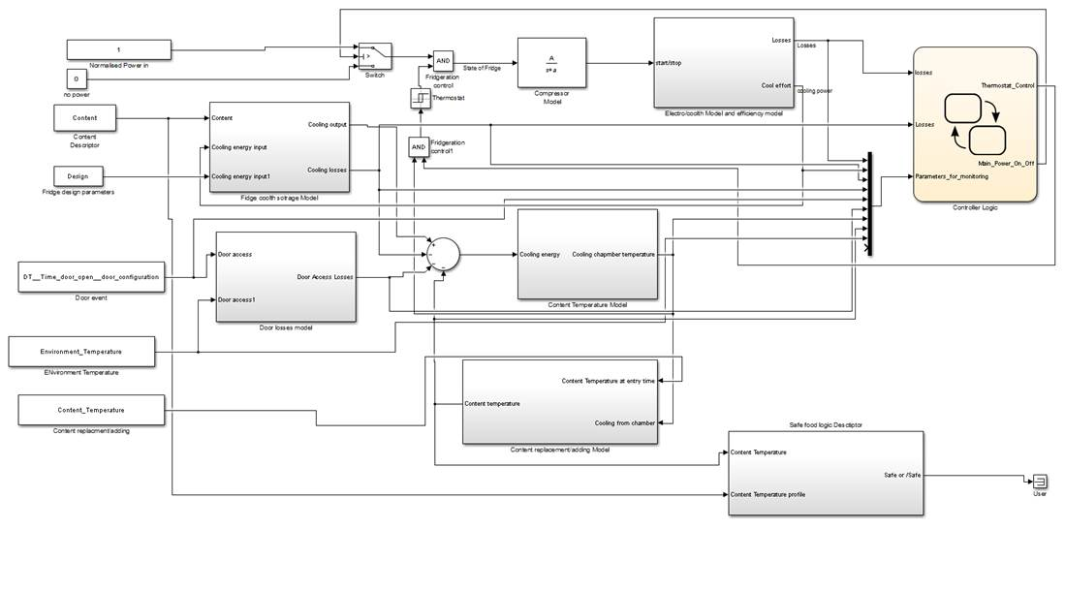
Figure 34. A control diagram of a fridge.
(with thanks to George Pissandidis, UoH).

In a similar way, other attributes (of things) also have their own transfer function. In terms of the fridge, the supply of safe (cold) food is predicated on suitable food being available for the consumer. Clearly the very well-developed discipline of supply-chain logistics could be distilled down to several consumer-applicable, and possibly just fridge-orientated in this example, issues that are key to providing the final service. The supply of food itself has many characteristics (for example, type, cost, quantity, expiry date, calorific value, nutritional value etc.) that could become part of the Service Attributes through association.
Other things such as a laptop computer or mobile device could also play an active part in any future control strategy. In terms of electricity, its operational consumption could be modified by altering the processor capabilities/function according to computing load, or its VDU intensity could change in line with room lighting levels. Both happen now but the former is governed by internal criteria and the latter is through a manual human operation. If both were externalised the computer might configure itself in a low-power mode when local generation or storage is low. It could also lower VDU intensity (consuming less energy) when the lighting conditions are good or make it higher if there is strong glare. The power-management strategy could also change depending upon which service attribute (primary, secondary etc.) is being delivered at the time. Its internal storage could be used as a buffer between electricity supply and service delivery and/or it could be part of a building-wide distributed storage capability. The storage capacity itself could be managed according to computer use and time of day or day of week or the weather forecast, to maximise local renewable energy use. While it is easy to think that these small-scale changes would make little difference, small power loads are proliferating nationally, and any savings will collectively have a very beneficial impact on the grid at periods of peak demand.
What this represents is, of course, an externalising of the control functions within the device or thing so that it can engage with a broader control strategy; the IoT will allow this to happen. This is part of the broader work programme managed by the author.

  - 6.6 Transfer function, resources and waste
In a similar way to giving a thing (device, appliance, building fabric etc.) a transfer function, i.e. how the ‘inputs’ are connected to the ‘outputs’, it is also possible to consider resources and waste disposal as having a transfer function similar to life cycle analysis for food etc.
Electricity, for example, is an Enabling Attribute for an electrical/electronic thing but electricity is not something that magically comes out of the wall outlet. Electricity itself has several issues surrounding its supply and, in relation to the thing, demand, and while these may have been simply cost and consumption for domestic users in the past, the future of electricity supply and demand is about to get much more complicated and connected.
For example, for years now many large commercial and industrial electricity users have had to consider time-of-use (half-hourly settlement period), power factor and availability. Many have also had to negotiate with their suppliers’ ‘demand reduction’ strategies to reduce consumption at times of peak demand. Together these measures represent the true cost of electricity supply which is something that domestic consumers have been oblivious to.
However, while all these issues are largely related to cost and consumption, those of carbon emissions and grid/local storage are now becoming part of the energy mix. Electricity generation and its resulting carbon emissions will no longer arise from one or two generation types but from a myriad different central and local sources, each with its own generation characteristics and local electrical and environmental issues. In the longer term the transfer function of electricity will interact with the transmission and distribution network and the thing itself to support a truly smart supply/demand electricity network.
The Mind Map below is not meant to be a definitive control sequence, which would be dependent on a required outcome, but it gives an idea of what might be some of the fundamental questions/ issues surrounding the electricity supply environment. With this data a whole range of control scenarios could be developed, such as lowest cost over time, lowest carbon emissions, guaranteed availability etc. Alternatively, the strategy at any one time might change depending on lifestyle need and/or priority of the thing consuming electricity.

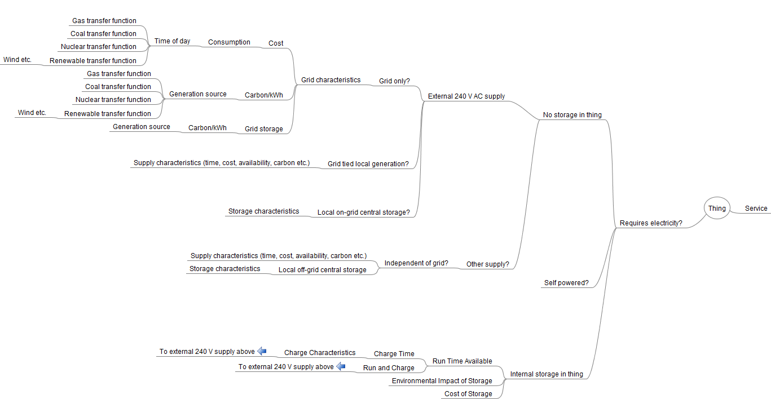
Figure 35. Issues surrounding the transfer function of electricity.
In a similar way the service of physical movement and dexterity can also be given a transfer function culminating in the human gateways of sight, touch, hearing etc. This is considered as part of the Receiving Process outlined later in the document.

  - 6.7 Connection rule (s)
In terms of delivering a final solution the network connection rules are also very important. The connection rules define what can and can’t be connected in terms of both consistency and congruency of the inputs and outputs between things. For clarity, the connection rules are related to the Service Attributes of a thing and are distinct from that of Dependencies and Enabling Attributes. Initially, the connection rules will be few and far between as many things (nodes) today and their attributes provide services directly to individuals – a mesh of today is many parallel channels with little depth. This reflects the statement earlier on in the thesis that it is human intelligence that ‘joins up the dots’.
Connection rules are a measure of the mesh depth; the greater the depth the more likely there are services provided to individuals, that themselves, require services. As the functionality and interface envelope of things increase, and they become more connected, targeted systemisation will ‘join up the dots’ and the connection rules will become more important. For example, the provision (of service) of virtual information does itself require information service sources.

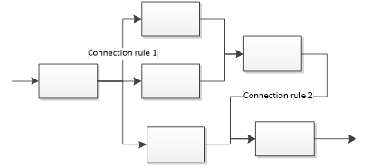
Figure 36. Connecting nodes.

Even today a simple series of physical and virtual outputs could be provided to an individual by one or more routes based on one thing or a group of things, depending on how those things were connected and an individual’s mesh capabilities. This is particularly the case for simple processes that are largely transferable between different things, such as information transfer.
Clearly each thing is categorised by its attributes, transfer function and connection rules but it is also categorised by whether it is physical or virtual and/or active or passive. In many ways these categories apply to a thing’s primary attributes, but it is important to describe a thing’s genre as it helps consider how physical mechanisms can be mapped to virtual mechanisms in the future. Today, for example, if an outcome for an individual requires an exchange of information (written or visual) this would be considered as largely routine using ICT technology. However, completing physical interventions remotely (by ICT) is only just evolving and is largely confined to simple commands associated with building plant and facilities. In the future, machine-to-machine operations will become common but remote interventions associated with human health and wellbeing will place whole new demands on the functional performance of virtual systems, data security and liability.

Once the mesh has been constructed there is a need to:

- Profile it.
- Define the process inputs necessary to achieve outcomes.

Once the mesh has been profiled the processes it’s going to ‘transmit’ need to be characterised. For example, from the point of view of delivering a top-down process, perhaps in response to a routine medical issue, this could consist of several interventions that might be capable of being delivered either physically or virtually and they may need services from the building or the community.

The processes and resultant interventions need to interact with the mesh things, for example, does a person have the thing required to deliver the intervention and the correct overall mesh profile to provide a reasonable alternative if the correct primary attribute is not available? Also, how does the individual interact with their mesh and in what ‘shape’ would they like its interventions? The combined answers to these questions set what the mesh can do and how it should do it. This is a mesh-wide issue whereas the connection rules relate more to the connection between things, although of course this impacts the final transmission profile of the mesh.

  - 6.8 The process to achieve outcomes
While the potential for physical things to be ‘customised’ to the individual or group need may seem very difficult the application of ICT to things, modern user interfaces and convergence across platforms allows the services from different things to be ‘presented’ in many ways.

Figure 37. Changing service delivery models.

Figure 37 shows in simple terms how service delivery will change in the future. The left-hand side (upper process flow) of the illustration represents today and the right-hand side (lower process flow) the future. On the left-hand side, an individual decides on the outcome required and then identifies what they think are the outputs necessary to achieve it. The chances of meeting the outcome are dependent firstly on the decision surrounding the outputs and then the ability to source them from the local community: hence the two question marks in the loop. A successful outcome is fraught with risk which is only minimised by knowledge and experience in dealing with questions such as:

- Is the initial process well understood?
- Is the outcome what is required; has it been interpreted correctly?
- Are the outputs available in the building/community?
- Do the outputs require customising or scaling?
- Will the sum of the outputs achieve the required outcome?
- Can the outputs be realised; for example, mobility/transport issues?
- Is the knowledge to use the outputs available; has the outcome been interpreted correctly?

On the right-hand side, outcomes will be contextualised in term of the individual by using their personal profile. Arising from that will be a process map that calls for a series of bespoke outputs. However, to fully satisfy the list there is a need for two process maps. The first is a ‘transmitted process’ which is the process to be transmitted across the mesh; for the moment this is considered as a top-down process, perhaps from the State. The second is a ‘received process’ which contextualises the services in terms of the individual. The receiving process has a mixture of ‘hard’ and ‘soft’ contexts. The hard ones are related to the things in an individual’s mesh (their home and community) that are modified by their physical preferences (mobility, dexterity, chosen location etc.) whereas the soft ones are related to an individual’s understanding and knowledge.

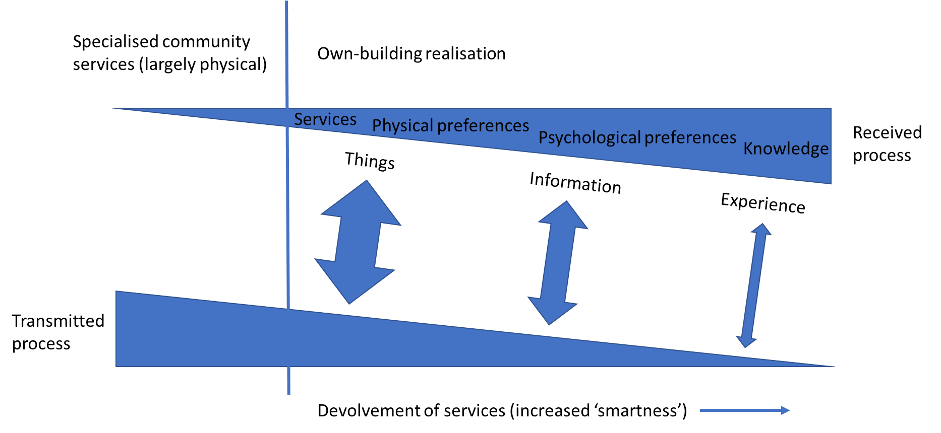
Figure 38. Transmitted and received process and the generation of knowledge through increased smartness.

To the left of the vertical blue line in Figure 38, services are provided by specialised buildings, things and people and it largely reflects today’s situation. The realisation of services is often predicated on physical mobility and personal interaction and the processes are well defined. However, once outside those specialised centres, despite much improved ‘customer/patient’ care procedures, for example, over the past several decades, there is limited interaction. This is not a problem as the processes are constructed to cope.

To the right of the line, as smartness increases, the functionality of things increases (as do the integrated benefits), and contextualised information leads to experience and knowledge. Assuming the service delivery paths are met (represented by the interconnecting arrows), the transmitted process declines as the individual acquires the desired experience and knowledge necessary to meet their needs (for any given process). The strength of the connecting arrows themselves (the paths in the mesh) is also defined by the fit (priorities) between the transmitting and receiving processes. In the final analysis, the interaction between the transmitted process and the receiving process is bi-directional and the processes themselves need to cater for arm’s-length delivery in newly defined (sometimes non-specific) situations.

  - 6.9 Dependency and substitution
The integration of services propagated across the mesh from a top-down process is valuable but can only progress to a quasi-outcome when they are contextualised in terms of an individual’s understanding and knowledge. If this is done, and there is feedback showing that the outcome is as planned, then an outcome is achieved; the hard and soft attributes have been contextualised correctly. The soft attributes link to the human gateways (sight, hearing) and personal knowledge.

By simply producing a process map for each of the stages necessary to fulfil the need for, for example, an injection, the key elements (derived from a building audit) for delivery can be identified. If an individual has the necessary things, without any conflicts, and the common dependencies can be met, then a quasi-outcome may be achievable.

It is very difficult to capture the interactions possible by way of a diagram so the simple one below will be used to highlight some issues.

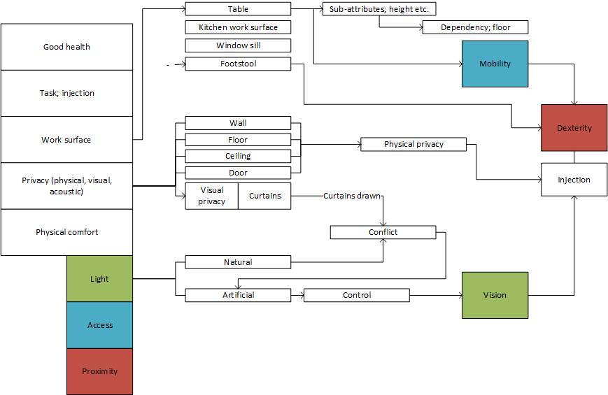
Figure 39. The ‘transmitted’ process (indicating primary services, dependencies and conflicts).

As an example, let’s consider the self-administering of a drug by injection (Figure 39). To do this there is a need for a work surface that is going to be satisfied by a table-like thing. The attributes, and probably sub-attributes in this case as the type of work surface is important in terms of its texture and cleanliness, can be defined by the transmitted process, perhaps in this case a medical practitioner. If the table-like thing is actually a table with a hard, clean surface this service need is met. If perhaps the table-like thing is a footstool then the service is, at first view, poorly met.
Within the ability to access the service of a table is the need for mobility. This is a function of both the individual’s mobility and, in this case, the service of a floor-like thing. Either poor mobility or poor floor-like service (or a combination of both) could limit access to the table-like service, particularly if the floor-like service includes attributes of stairs or, perhaps beyond the home, a hill to reach the pharmacist. In response to poor mobility the quality of the table-like service, and many other services, might be lowered to include other table-like things, for example, a footstool. While this has poor table-like attributes in the presence of a ‘proper’ table and an individual with ‘good’ mobility, its poor attributes are elevated beyond those of a ‘proper’ table in response to ‘poor’ mobility.
In the case for a need for privacy, for example, several services need to be provided. Physical privacy, which might also embrace physical security if the structure is of sufficient strength, needs the service of wall-, floor-, ceiling and door-like things. This also includes windows that have physical privacy and visual privacy attributes. In terms of the window, physical privacy can be provided but, without the use of blinds or curtains, visual privacy cannot unless the attributes of the window-glass changes to include switchable opaqueness, which is relatively likely. The attributes of ‘normal’ walls, floors, ceilings etc. provide both physical and visual privacy; however, with the increasing use of glass (and later smart materials etc.) in building facades the attributes are more akin to windows.
Obtaining visual privacy requires the service from a blind-like thing which may be an attribute of the window itself in the future or an additional thing. Again, to control this requires access which is predicated on individual mobility. Access, based on mobility, is used to describe the physical movement of an individual around a building or a community. Proximity is used to describe the physical locality of an individual to a thing and dexterity is the ability to interface (physically control) the thing. Human dexterity supports proximity/control attributes (SPPT stream; operating and reporting classes) and human mobility supports access attributes (SPPS stream; locational class) and human vision requires light attributes (SPPE stream). The stream SPPE is itself made up of several services provided by other streams; i.e. thermal comfort requires several environmental conditions to be met and many of these require things to deliver them. For example, while still maintaining the people-centric nature of the research, moving out from the person, one aspect of thermal comfort is having an adequate internal temperature and this service might be provided by a radiator. The radiator itself, if part of a normal gas-fired wet system, needs a boiler and this requires both electricity and gas to produce heat. The supply attribute for the radiator is a flow of hot water (it is passive and has no enabling attribute unless it is fan assisted) and the supply attribute for the boiler is gas with electricity as the enabling attribute.
In the future, of course, many of the historic associations between things and service attributes will be broken. For example, light switches could be operated acoustically, and any number of remote controls will, as they do today, decouple control from proximity. Even manual dexterity is no barrier to control, given modern interfaces and control scenarios.
The transmitted process in Figure 39 only includes services and simple conflicts and dependencies but, to move closer to achieving an outcome, there is a need to contextualise the transmitted process and the physical and virtual aspects of the mesh in harmony with user skills and knowledge.

  - 6.10 Outputs to outcomes and ‘systemisation’ knowledge
Up until now the research has considered the human interface with the mesh in a simple manner, with its interaction governed by basic issues such as mobility, dexterity and vision. However, the Receiving Process defines the interface between the physical individual and consciousness that includes experience, knowledge and the human gateways. It is what is required by the individual to realise service benefit.
Since Aristotle, it has been considered that there were five fundamental senses, but it is now argued that there are over twenty and possibly even over thirty (Durie 2005). While some of these might be a little obscure, and even debated, each represents a path to the brain and, as such, may potentially be used in the future as access paths to consciousness, the collective value of which may deliver self-actualisation (note: Maslow’s Hierarchy of Needs is used for simplicity; other approaches may be used as necessary).
Another way of visualising the service and its progression to an outcome is by using a Mind Map as in the case of electricity earlier. In terms of the Receiving Process, the lower arm of the Mind Map in Figure 40 deals with the thing; again, a table has been used as an example.
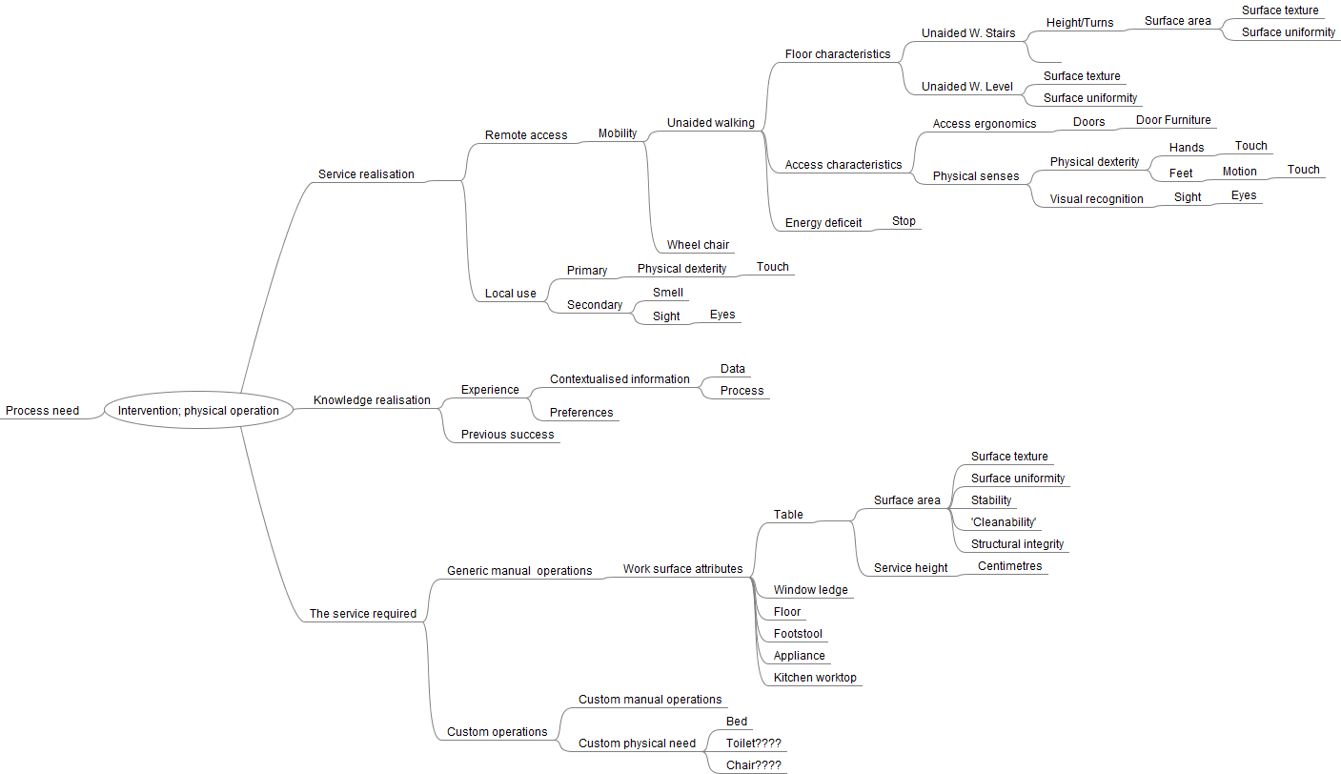
Figure 40. An indicative Receiving Process (realising the benefit of services including hard and soft attributes).
The upper arm starts by considering how the service will be realised, the location of the thing and, if it’s not local, how accessed will be realised (embracing the hard attributes). It then considers how an individual will realise the benefit of the service by the interface between the service and the human gateways, the path to consciousness. The middle arm considers how the knowledge to complete the intervention is gained and while this is truncated in the map it would continue to include alphanumeric interfaces (keyboards), VDU’s and the human gateways. The supply of data and its contextualisation could be similarly ‘unpacked’ and transparency in the data supply-chain would allow an individual to choose their sources and assign relative priorities. The realisation of all three arms (essentially an individual’s BIOS) will allow the intervention to take place in a satisfactory manner. However, if feedback is included then this can be verified and, if not, alterations can be made to the service stream, knowledge stream or realisation stream.
In general terms there is the potential to map each thing in an individual’s mesh, and their physical and virtual attributes (virtual attributes are currently mainly restricted to information exchanges), to the preferences and senses of an individual. The objective of this is not to consider new ways of engaging the senses as a way of improving communication paths, perhaps for someone with an impairment, but to consider how the systemisation of things, attributes and services collectively contribute to social value. A thing could be categorised not just by its service stream but also by its human need. A thing on its own (for example, a table) has physical attributes which satisfy a physical need that, in themselves, are useful. However, with the addition of other contextualised services (the Associated Service Attribute Class) and the required information to support understanding and rationalisation the very act of systemisation may lead to an increased sense of independence and achievement for the individual, moving them up Maslow’s hierarchy.

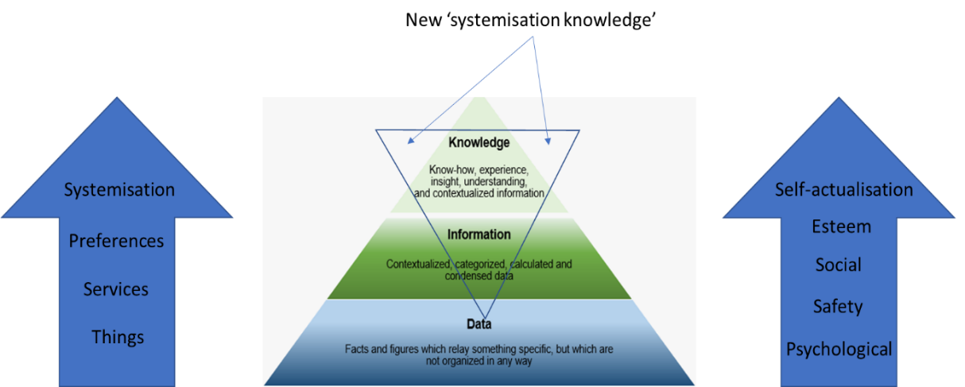

Figure 41. Systemisation knowledge and ‘humanising’ things (on the right is Maslow’s hierarchy of needs).
‘Systemisation knowledge’ is a combination of the ‘knowledge’ acquired from the horizontal integration of things, thereby elevating its value, and the inherent knowledge of the systemisation process itself. The inherent knowledge of systemisation is that imparted by those who design and configure the system (software, metrics etc.) itself. As mentioned earlier, this is already happening in professional circles where advanced building design tools (for example, Autodesk and BIM) are allowing newly graduated architectural students to leapfrog a generation in terms of their capabilities. In the fullness of time the individual assimilates the systemisation knowledge and gains ‘real’ knowledge. In terms of individuals it also reflects a changing society where individuals are expected to become more responsible for their actions and will be required to develop the necessary understanding and eventually, possibly, knowledge; for example, of energy consumption and generation.
In a similar way to services and energy, a product (thing) supply-chain can be constructed including labour, logistics and raw material consumption. This would link very well with supply-chain logistics and, if re-use, recycling and costs are considered, whole life costing. It could also link with modern methods of manufacturing, mass customisation, 3D printing etc. as manufacturing and supply-chains become more responsive and evolve to meet changing needs.
The mesh approach also allows alternative non-ideal solutions to be identified and therefore provide alternative value routes where the building, thing or community performance falls short of what is required for the delivery of a defined intervention and complete solution. As with many mesh network systems they are multi-input and multi-output but many of the intervening network paths are fixed, reducing the number (Berlow 2010).

‘there is no need to have infinite issues to end up with infinite design.’
(Salingaros 2005).

The mesh approach does not try to systemise people but brings clarity to the interactions and processes between them and the buildings and communities in which they live. It is perhaps akin to data traffic management/analysis (signals intelligence; pattern-of-life analysis) while not considering the message itself (Danezis, date unknown). Note: interestingly metadata is not considered data in UK, US and Australian law and as such is outside data privacy regulations.
Business models will also need to change not just to reflect a more dynamic market place but also how services from capital assets impact service revenue budgets. For example, the cost of installing a handrail in a care home may have a high capital cost but it could quickly pay for itself in terms of reducing the cost of accidents and patient hardship. These horizontal aspects are often not considered today; the only current driver for the installation of a handrail may be health and safety.
  - 6.11 Visual interface
To help visualise an individual’s mesh in relation to the physical past and virtual future a visual interface is suggested in Figure 42 (a way of visualising service stream compatibility is highlighted in Chapter 7, Future research). The visual interface helps capture mesh network performance and assess its effectiveness in delivering an individual’s SIE. The y axis could be scaled from services being delivered largely by physical means, as they are today, to increasingly virtual means, as they could be in the future. It will never be one or the other and, more importantly than that, each community will have its own profile depending on its service capability and its progress in rolling out virtual services. The x axis could be the seventeen service categories identified later and the z axis could be the personal profile of the individual.

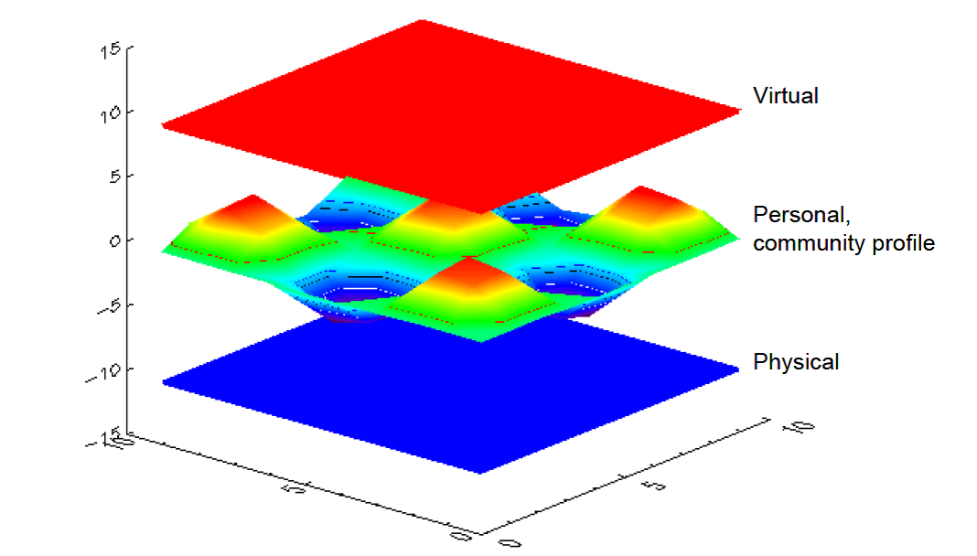
Figure 42. An indicative contour map of physical and virtual profile. (axes to be decided).

The personal profile plane (Figure 42) will be an individual’s SIE and at the same time represent a ‘slice’ through their interaction with their local community. In this case, for example, a red peak would be where there is a demand for a service that is able to be met by virtual means; the higher the peak the more it is satisfied by virtual means. Scaling this could be by a simple arithmetic sum of the number of virtual and physical nodes necessary to deliver the service. Several planes with a similar profile would represent a class or sector of the community. The overall contour profile of many people will represent the ‘culture’ of a community. When the plot is fully developed the ‘virtual’ and ‘physical’ planes will also be contoured, representing the community’s ability to deliver physical and virtual services as well as its progress towards virtual services.

  - 6.12 Profiling the mesh network
  - User profiling
As mentioned in the Introduction, throughout the research period there have been two areas of tension. The first is between the need for research and the need to develop products to generate income, and the second is between in-depth exploration of mesh construction and the necessity to demonstrate proof-of-concept horizontally. For this reason, considering the service mesh in more depth has been truncated in preference to developing usable tools to capture real-life data and support initial mesh development, if it is ever taken forward.
Recognising that the research proposition must be broadly satisfied, service is going to be considered by type and who/what normally provides it rather than service per se. For example, BRE Health selects a care home based on generic needs of an individual with a physical or mental impairment. A ‘memory box’, for example, adjacent to the front door of a care home flat provides the service of location and creates a sense of belonging. In the long term this service might be provided by many new things but, as a stepping-stone, the association between the physical thing and the service is accepted and used as an ‘intermediate’ profiling mechanism.
One such intermediate profiling mechanism is by individual type and/or stage in life:
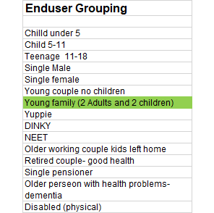
Figure 43. Stages in life used to profile the mesh.

As a simple example it would be realistic to think that a teenager would have different demands of their building, and possibly very different demands of their local physical community than would an old-age pensioner. The teenager may well have a requirement for a school, a youth club and a vibrant social circle, whereas a pensioner may be more interested in the location of hospitals and more sedate entertainment. A mother with a young family may be interested in a local medical centre, a childcare centre and other mothers to share her experiences. Other ways of categorising individuals could be used, such as psychometric analysis or simply how they respond to a questionnaire. In a similar way to individuals, both building and community services can be considered by type as an intermediate step.
While it is accepted that all old-age pensioners, for example, are not the same and do not require the same services from their building or community, the stereotype is often correct; the only requirement is to provide solutions to their needs with an appropriate level of certainty.
For individuals, seventeen areas associated with personal need/happiness have been identified from a literature review (assigned a specific appendix, Appendix 3) and consultation (Hadi, Balson 2014/5), ranging from education and health through to psychological and emotional wellbeing and recognition. These are listed horizontally in Figure 44 (page has been truncated) and include:
education, health, transport, safety & security (community), entertainment, consumption, disposal, environmental performance (community), local economy, biodiversity (connection with nature), communication and social connectivity, governance, wellbeing services, shelter (homes, public buildings), psychological wellbeing, emotional wellbeing, recognition.

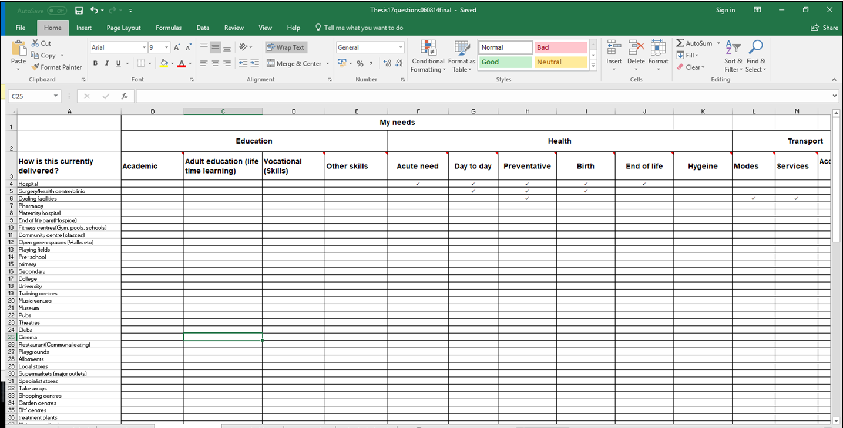
Figure 44. The seventeen areas of personal need/happiness.

Each of the seventeen areas can be sub-divided further to specific requirements or the institutions that would normally provide the services that underpin personal happiness. In no particular order these are:
hospital, surgery/health centre/clinic, cycling facilities, pharmacy, maternity hospital, end of life care(hospice), fitness centres (gym, pools, schools), community centre (classes), open green spaces (walks etc), playing fields, pre-school, primary, secondary, college, university, training centres, music venues, museum, pubs, theatres, clubs, cinema, restaurant (communal eating), playgrounds, allotments, local stores, supermarkets (major outlets), specialist stores, takeaways, shopping centres, garden centres, DIY centres, treatment plants, mains sewer/tank, black/green bins, central waste/recycling centres, collection, appropriate drainage, noise, air quality, street lighting, flood lighting, flood defence, roads, aesthetics (appeal), ambience, public art, clean streets, building maintenance, street maintenance (potholes etc.), public transport (bus, planes, trains), cars, taxis, car pools, cycling, walking, electric charging points, car parking, petrol, car maintenance, proper roads, permeability, safe streets (pedestrians & cars), CCTVs, street lighting, safe carparking and cycle stores, prisons, courts, police stations, crime prevention, graffiti removal, alleyways, cul-de-sacs, blind alleys, street. corners, being over-looked, employers, self-employed, job centres, meals on wheels, shopping delivery.

To support mesh construction, and produce a commercial product, a software tool was developed where each of the seventeen areas of personal need were assigned a visual graphic. On entering the page, the user is asked several questions to assess their needs in that area. These questions were not developed during the research but could be based on some of the well-established personal profiling methods or simply, as mentioned above, their responses to general questions relating to the seventeen areas (see Figure 46).
The seventeen areas are represented by a visual icon and ‘swiping’ across the page selects the next area.

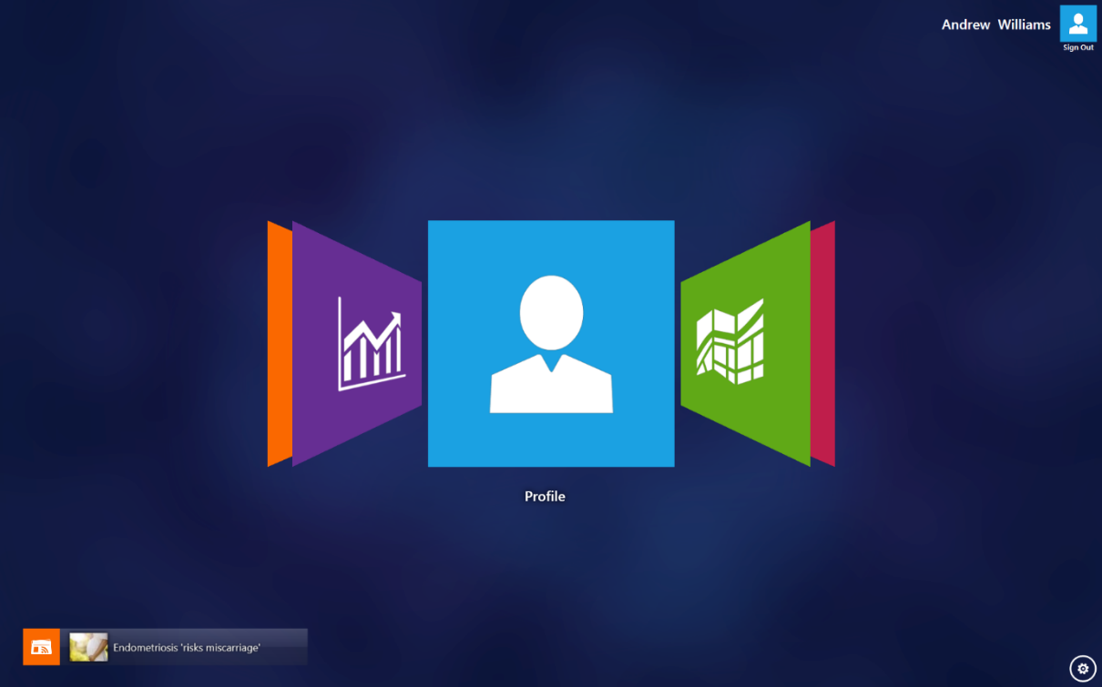
Figure 45. Home page of the mesh (personal/community) profiling tool. (thanks to Lalani, Mistretta and Lee for programming support).
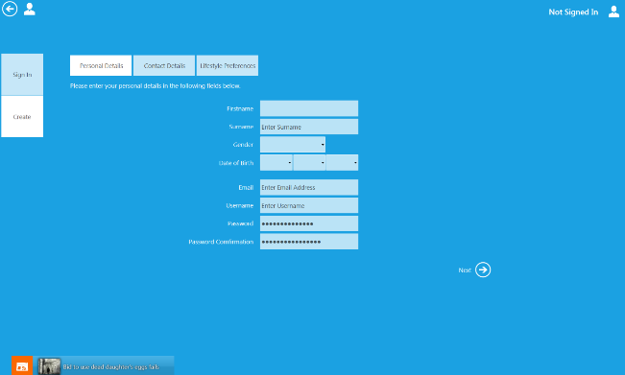

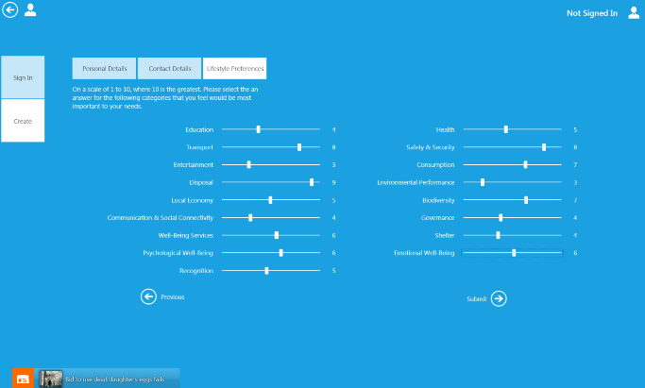
Figure 46. A simple method of profiling based on responses to the seventeen areas.
Behind the visual interface is a database of local amenities identified by an automatic online SIC code search and/or a manually entered, pre-defined database. To help visualise the findings a key is used as a metaphor where individual preference and community amenities (within a certain distance from the user) are scaled from the centre of the circular ‘lock/key’ graphic.

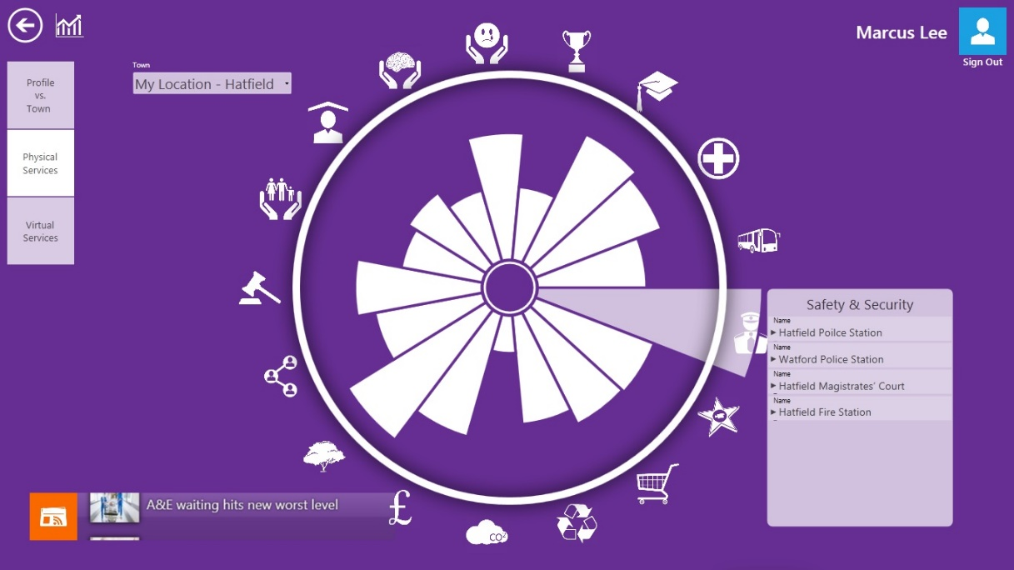
Figure 47. Hatfield safety and security services (town shown in white).

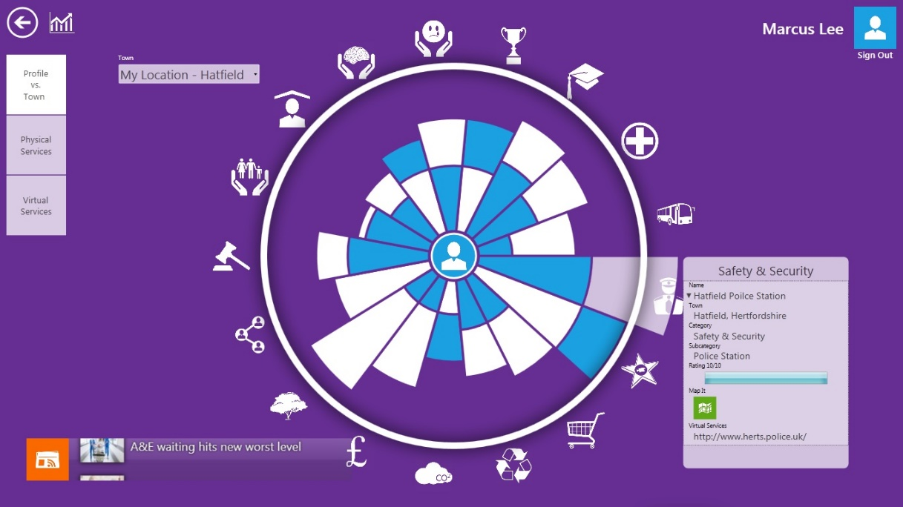
Figure 48. User preferences/need (blue) overlaid on town services.
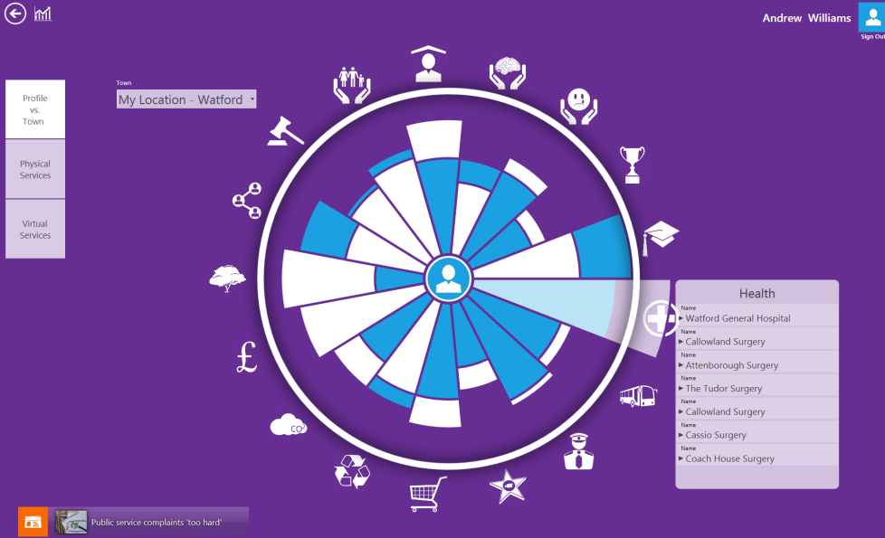
Figure 49. Watford health services and user preferences.

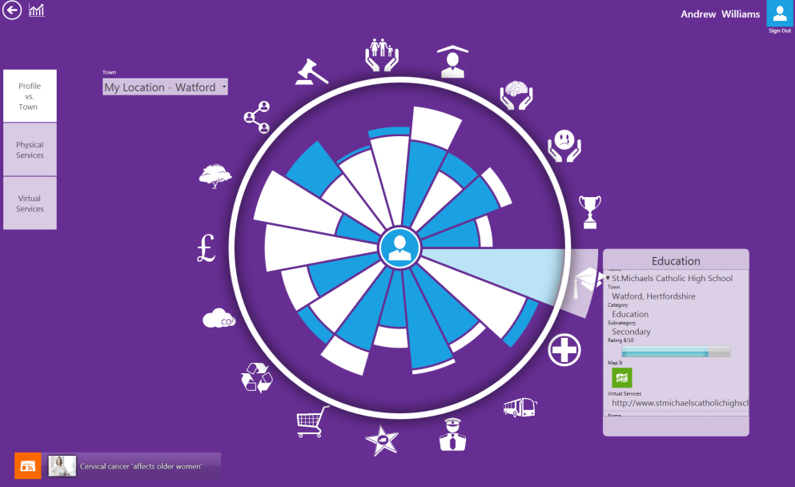
Figure 50. Watford educational services and user preferences.

By examining the results, a user can immediately get an idea of whether the local community can meet their need in the seventeen key areas and find the service provider’s name and contact details.
The software also searches RSS feeds and provides the user with local information that matches their profile as and when it becomes available (Figure 51).

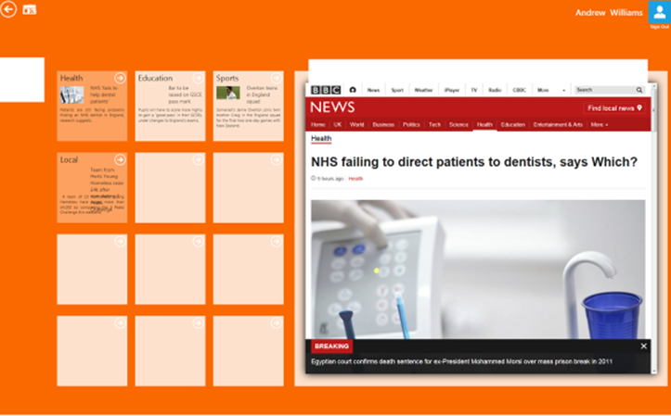
Figure 51. RSS information provided according to personal need.

To complete this table fully requires knowledge and understanding of the interventions necessary, whether a service is capable of being delivered virtually, and whether the individual has the things in their mesh to promulgate those interventions. With all these points addressed, any deficiencies in the physical community can then be augmented by virtual means. For a service provider, such analysis would allow them to produce a roadmap of how to develop virtual services in accordance with local physical amenities, an individual’s mesh and their preferences. The provider is likely to start by considering certain sectors of people or need and then grow their offering to wider applicability. While doing so, generic building blocks will be identified that will be common to most people and most needs, thereby making the introduction of new outcomes and associated interventions easier. However, the interaction with other outcomes and interventions will become more complicated as system complexity grows.

Having identified the personal profile of an individual and how well their local physical community meets their need, the impacts of remote delivery will be examined by way of a proof-of-concept software tool: a geo-social application.
Naturally, of course, a person’s happiness in a chosen physical community is dependent on many factors but communities and buildings force people to live in certain ways. If these are generally acceptable to an individual then that person may stay in a community but, if not, they are forced to live with its shortcomings, possibly causing them stress or anxiety. The alternative is to move to a community more suited to their needs. In the future, if these shortcomings can be remedied by virtual means, then the need to move might be removed.
The ability of a profiled mesh to bring transparency to these building and community shortcomings, and to offer a roadmap for the transition from physical to virtual services, is one of the key outcomes of the service-based mesh approach outlined in this research.
By shaping the virtual information feeds (websites, RSS feeds) to match a service user’s profile the application enhances community effectiveness though user-targeted information feeds. This is an important distinction from what’s available today on four accounts:
- The community information is ‘pulled’ in relation to the user profile and not, for example, ‘pushed’ by a news source.
- Information is provided/selected by geographical location and not just temporally as most information feeds are today.
- Information can be categorised into themes and solutions based on the user profile and available community services.
- The mesh can be profiled using more intelligent agents similar to those that are becoming more commonplace in retail marketing situations.

  - 6.13 A geo-social application: Impact
To this point the research has:
- Developed a tool for auditing buildings and supporting language construction (BRE Health).
- Identified an LCD that allows things to be systemised and explored how a mesh of things and their services might be constructed.
- Considered how services can be priorities in line with individual need and a transmitted and received process.
- Produced a tool for assessing, in a very visual manner, how well community services might suit an individual in seventeen key areas.
Access and mobility have been considered within the building but, as already mentioned, many services required by individuals today are predicated on mobility, increasingly by car. While some services will be ideally placed to evolve into virtual offerings, physical resources (food etc.) still require physical movement and actions. To scale these movements and actions a geo-social application has been developed. By mapping out a route from, for example, an individual’s home to the doctor’s surgery a list of community services is produced including those provided by shops, open spaces, transport hubs, community centres etc., i.e. a similar approach to how things were considered in a building. An open space, for example, can be similarly described by its service attributes as can a hospital or a school.
The geo-social application essentially provides an opportunity to link service attributes with community location and thereby assess how easily these can be accessed, just as in the home. It has been termed ‘geo-social’ as it links the geographical location of community services with the service preferences of the individual. ‘Impact’ is essentially mapping software that identifies services along a chosen route in line with the prioritised seventeen questions developed in the personal profiling tool. Once the start and finish destinations have been entered, a route is identified and all the community services and amenities along that route are identified. The information is mined from publicly available Google (SIC codes) and the services are rated by online customers. To enhance service provision, the personal preferences of those rating the services could be compared to that of the user, thereby providing an assessment of the service in the context of like-minded people.
In some ways Impact is similar to real-estate tools such as Zoopla etc. but Impact goes much further. While it might identify shops and parks it does so in the context of this research by way of their service attributes and in response to individual profiles. However, the geo-social application has other uses. While many of the outcomes of the ICT revolution will be positive the very nature of the differences embraced by new smart systems vs traditional systems will have an impact on people and future culture (Damant 2015). Within the context of this research, one key benefit of a virtual system is its ability to deliver services remotely and decouple service use from physical location. While this offers significant benefit in terms of time, efficiency and transport costs for the provider, it may also have some undesirable consequences; for example, reduce physical exercise and social interaction, both of which are very important for physical and emotional wellbeing.
For example, in the case of an elderly person, the geo-social application will highlight what is lost if a doctor’s consultation is delivered virtually and the need for physical activity and social interaction, while attending the physical surgery, is removed. A small financial saving or even slightly enhanced service provision using ICT will quickly be undermined if the individual suffers from social exclusion and diseases arising from their lack of physical exercise.
However, the above scenario is by no means the limit of the geo-social application. It could be used by individuals and Local Government to better understand local services, transport patterns and much more.

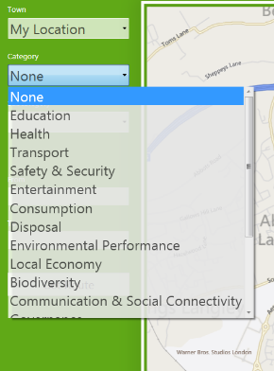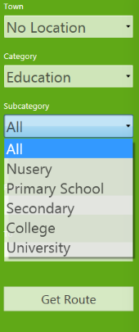
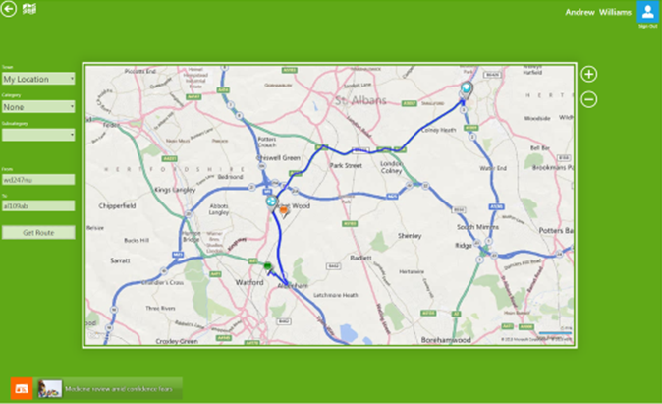
Figure 52. Service entry page and route identified.

Community services are then detailed.
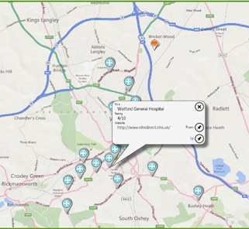
Figure 53. Health needs within chosen radius/route.

While the personal profiling tool and the geo-social application go some way to clarify the transition of services from physical to virtual there are many other issues, including traceability, audit, liability, cost/benefit and capital/revenue budgets that need to be addressed before processes can be systemised.
No matter what stage in life, or what the personality of individuals, the transition from local physical services that have stood the test of time, to virtual ones, will have an impact at a personal and community level, essentially changing the culture of future communities and society.

  - 6.14 A possible trial process with associated interventions
For the trial process to be useful it must be a real-life situation that has a diverse range of interventions that require delivering both physically and virtually. The outcome should also embrace formal requirements: for example, national guidelines, services from community institutions, charities and local support groups. It should also include, for example, mandatory issues, advisory issues, best practice and peer support.
After some consideration the requirements of a mother-to-be (MTB) from conception to childbirth were thought to have the necessary diversity for research purposes and yet be part of a common enough event to represent a test case and build confidence levels. To better understand these processes and their associated interventions, a workshop was run with a number of midwives and other associated staff and managers at the Obstetrics and Maternity Department of The Lister Hospital (Lister Hospital 2014/15).
Given the rather nebulous nature of the research it was decided that a semi-structured workshop would be best, lasting no more than two hours due to attendee work commitments. A semi-structured approach was adopted as the best option for data capture balancing freedom of ideas with consistent and structured answers. If the structure imposed any restriction on feedback, delegates were encouraged to share their views with the facilitator (AW) throughout the workshop and the feedback was summarised at the end to validate findings, stimulate other ideas and arrive at a consensus. The workshop programme was:
09:30 Welcome, introduction and workshop structure. (AW)
09:40 Smart cities – what does the future look like? (AW)
10:00 Why Maternity? (AW)
10:05 Group session (All) (coffee served at tables)
11:00 Feedback and discussion (All)
11:30 Summary and close (AW)
Eleven professionals attended the workshop and during the group sessions they were divided into three groups of three and one group on two. They were grouped to minimise influences on data arising from overly vocal individuals, managers imposing their views, errors between what should happen and what does happen etc.
After a formal PowerPoint presentation, each group was asked to fill in the form in Figure 54. The stages were entered on the left and details of the process were entered across the top. The questions associated with the process deal with who, what, why and when with freedom to comment at the end. Before commencing, the attendees were asked if they understood the objective and whether the form allowed them to express their views. After very lively debate the forms from each table were summarised during the Feedback and discussion session at the end.
Arising from these discussions, approximately sixteen relatively well-defined stages were identified for an MTB from pre-conception to childbirth and one page of comments follow by way of an example (see Appendix 1 for complete table).
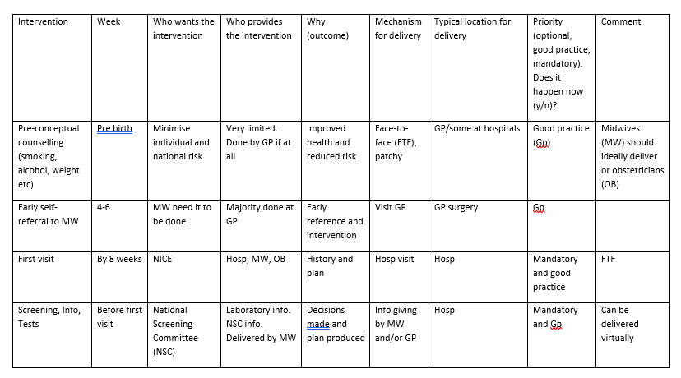
Figure 54. Feedback from meeting with midwives (complete table in Appendix 1).

As suspected, the interventions of an MTB are national, local, formal and informal and include:
- National and formal (legal) medical requirements dictated by NICE (National Institute of Clinical Excellence).
- Local midwifery and hospital practices.
- Local physical community support groups.
- Requirements for physical presence and testing.
- Significant opportunities for virtual delivery of material from both local and national best practices sources.
- Physically dispersed users (and providers) with potentially a broad social background.
- Duplication and, at the same time, lack of information.

Considering Figure 54 (and the complete sixteen stages in Appendix 1) reveals that, while some of the comments are slightly cryptic and need interpreting (it is a verbatim copy), it is clear that there are parts of the process of an MTB that need face-to-face contact with health professionals and other parts that could be delivered electronically, either knowledge-transfer initiatives or, perhaps in the future, a virtual physical intervention. Interestingly, the comments also include indications of shortcomings in the process that need to be improved. Some of these are clearly considered as being the responsibility of the medical profession, either to be delivered in a hospital or GP’s surgery, while others could be provided by charities, local support groups or friends and neighbours. Some of the what can be best described as ‘non-core’ interventions were thought to be very important in treating the ‘whole patient’ but it was acknowledged that they often fall through the cracks due to lack of time, poor communication between service providers (hospitals, GPs, community groups etc.) and/or a shortcoming in individual’s knowledge.
All but the simplest outcomes may require several interventions. If an intervention simply calls for an information exchange, and the individual has a mobile phone, the path is direct, requires only one node and the fact that they have read it is relatively easily audited. For example, line one in Figure 54 calls for counselling on the impact of smoking, alcohol and weight. The impact of this information will probably be higher if it comes via a face-to-face meeting with a health professional, and this could be one of the service paths, but outside of that, this type of communication is ideally placed to be provided by text messaging, email, papers, radio or TV campaign. It could also be provided by leaflets and/or included in promotional campaigns of charities, self-help groups and much more.
Countering this in the real world is that resources are limited and that this is unrealistic. The assertion is, however, that the cumulative impact of drip-feeding these types of message in a low-key manner can change attitudes. The cost to the NHS, and to the person, of smoking, alcohol and excess weight may easily offset the costs of mesh identification and the preparation of services necessary to do this. Indeed, a structured turnkey approach from, for example, the NHS dealing with these issues could engage with many ‘free’ and third sector communication paths providing an integrated and very powerful message communicating ‘best practice’ in these three issues. This approach would link well with the increasing responsibility of communities to deliver their own services in the future.
Conversely, some interventions will call for services that are propagated poorly or not at all. This could arise if the service needed is only propagated by nodes where it is a low-level attribute or where there are no nodes capable of propagation. The service may also be weakened to such an extent the service cannot be relied on to reach the individual, either through one or two nodes in the path with poor attributes (or poor connections) or many nodes in a path with good attributes (and good connections), each diminishing the service slightly. If alternative service paths cannot be identified the mesh must be strengthened or, for example, in the case of administering a drug, a physical visit by the district nurse or trip to the doctor’s surgery is required.
From unbundling this process a clear picture can be gained of what the characteristics of the necessary process and interventions are in relation to the propagation capabilities of a particular mesh network. Each intervention can then be further unbundled to the services required and these can then be assigned to the most appropriate service-delivery path.

  - 6.15 Proposed mesh analysis technique
In Chapter 4, consideration has been given to possible analysis techniques and tools that may help with resolving the mesh in terms of what it can and can’t do and where there are duplicative and redundant paths. Supply-chain logistics is one such technique and it has evolved considerably over the past thirty years to embrace services and many other aspects of supply-chain dynamics. To investigate this further, and how it might apply to the social language, a workshop was organised at Sheffield University Management School. Within the School is considerable expertise of supply-chain tools and techniques and their work specifically targets environmental performance and the softer aspects of product/service supply.
With the assistance of Professor Koh from the School a workshop was organised with eight post-doctoral and research staff. The workshop programme included:
- Welcome and introduction – Professor Koh
- The work of the School – Prof. Koh
- Systemising things, nodes and interconnects – A Williams
- Discussion – All
- Summary and close – Prof. Koh
The objective of the workshop was to test whether the concept of a social language (systemising things) could be justified within a group of academics and whether their experience of developing real-world supply-chain tools and understanding would support its use to solve mesh networks. Unlike the trial process workshop held with midwives, the very nature of the workshop and its attendees called for a more free-form and interactive workshop that lasted almost three hours.
The findings validated the language and it was clear that supply-chain techniques and tools could be a very powerful way to analyse networks. Unfortunately, the reporting of more detailed findings in this thesis is restricted, subject to a confidentiality agreement between BRE and Sheffield.
The author is indebted to staff from both Lister Hospital and Sheffield Management School for their willingness to help and openness to new ideas.

  - 6.16 Summary
This chapter ends the development of a social language for buildings and communities. Its objective has been to show how some of the key building blocks might be constructed and, to be true to its horizontal approach, it has explored concepts and proposed practical solutions ranging from data capture tools to trial, real-world processes. The hope is that, if the research has merit, others will develop the ideas further.

Chapter 7. Conclusion

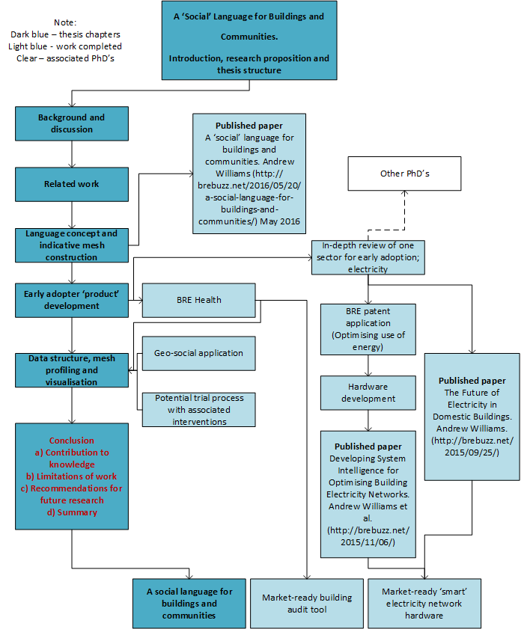

Conclusion

To conclude the research and provide a ‘springboard’ for further debate and development, this chapter has been divided into four sections; Contribution to knowledge, Limitations of work, Recommendations for future research and Summary.

  - 7.1 Contribution to knowledge
  - 7.1.1 Systemising passive things
Systemisation within the functionality of a product is well considered by product manufacturers but interoperability between products is less so (certainly between manufacturers) and systemisation of passive things, buildings and communities is unheard of. The ability to be able to now do this represents a significant contribution to knowledge and it opens the door to many new areas of research. Despite constantly questioning the validity of the research it appears that it can be very powerful in terms of producing and analysing systems orientated towards people and social outcomes. However, in doing so, the research can also make a significant contribution to many other areas including analysis of energy consumption, life cycle assessment, resource management, interoperability, building and community design, functionality of things, designing for impairments, social impact of ICT, and much more. The goal, if successful, is to identify and remove the conflicts and ambiguities that exist between people’s needs and the community, buildings and ICT things that deliver them. If this can be achieved, service provision and social equity will be improved and at the same time they will become more cost-effective.

  - 7.1.2 Service as a lowest common denominator
The use of service as a lowest common denominator is both simple yet powerful. Initially, it appears to have many weaknesses but as the research has developed it becomes clear that service is ideally placed to systemised passive things and is highly appropriate to future trends in government, business, personal responsibility, sustainability etc. The use of big data, smart algorithms and many data samples (everyday activities) allows for the service-based model to be optimised and outcomes to be achieved. The use of service as a lowest common denominator is a fundamental part of the contribution to knowledge arising from this research.

  - 7.1.3 A new nomenclature
A new language had been proposed that allows things to be considered as nodes with their own functionality (transfer function) within a mesh network. The language details how these might be connected to provide outcomes and services have been classified by streams and classes. The initial language, while not complete, provides a good foundation for others to develop it further. The language contributes to knowledge of how systemisation might be achieved which represents a whole new field of research.

  - 7.1.4 Practical tools
With a view to delivering understanding and a thesis that itself is horizontally complete, several tools and analysis techniques have been suggested. The concept of contour maps and service profiling by stream and class has been proposed which contributes to knowledge surrounding how service provision might be assessed and visualised.

  - 7.1.5 New ideas
In section 7.3, Recommendations for further research, many new ideas have been proposed that in themselves represent a contribution to knowledge. While these have not been developed in any detail they have evolved as -a -result of research into a social language and hence make a contribution to the overall thinking.

  - 7.2 Limitations of work
While the research proposition has been broadly satisfied, its scope, and many of the techniques necessary to fully satisfy it, fall outside the author’s knowledge and are beyond what can be learnt/implemented in the timeframe. This is an obvious consequence of the breadth of the research and manifests itself as a ‘tension’ within the research programme. From start to finish, beyond conceptualising the language, the biggest challenge was knowing when, and how, to ringfence the research.

  - 7.2.1 From a simple start
At first sight the research appears to be very simple and can be viewed as little more than an extension of simple marketing principles that have been in existence for fifty years. It fails to consider any discipline in any detail and, in terms of contribution, is largely theoretical and hence unproven in the real world. While all this is true, these shortcomings were acknowledged at the start and were felt necessary to free- up a route to explore systemisation of buildings and the built environment more generally. As the research has developed the initial shortcomings have been addressed.
  - 7.2.2 Service
The whole study has been predicated on service as a lowest common denominator. Without that there is no common thread that can be used to harmonise all things. As mentioned in the text, while it does adequately deal with offerings from things, buildings and communities, the use of service fails to embrace the pride and satisfaction of owning things, for example. The assertion is that a number of services can be added to form a proxy for, for example, enjoyment, entertainment and, perhaps, pride. This has not been done and moving into these areas is well beyond the author’s expertise. Confidence levels must be applied to all solutions provided by a mesh and statistical methods could be applied.

  - 7.2.3 Practical assessment/validation
In the initial project plan, there was provision for a community to be assessed, thereby providing real-world data on buildings, communities and people. This was to support language development and allow critique of its final application. BRE Health was used to capture data on one care home in Bournemouth but without adequately defining the language data structures and having the necessary software tools to analyse the data, any data captured and analysed would be subject to so many errors and interpretations any findings would be unreliable.

  - 7.2.4 Shortcomings in social science
To be true to the proposition and produce a truly people-centric approach requires a much better understanding of the social sciences than was brought to bear in the research. Despite many conversations with social scientists and architects (with a keen focus on occupant behaviour etc.) whole swathes of social science understanding must have been missed. Accepting this was difficult for the author, and it must undermine the research as, in truth, despite considerable reading summarised in Appendix 3, it’s another piece of work focused on people done by an engineer.

  - 7.2.5 Connection rule (s)
One specific area not dealt with in the study were the connection rules. These are essential to mesh construction and define what can and can’t be connected in terms of the inputs and outputs of the nodes. Initially, many mesh structures will be very wide but shallow. However, as interconnectivity gets stronger and service opportunity becomes more multi-path, the mesh will become narrower but deeper, calling for well-defined rules. An attempt could be made to develop the rules theoretically; however, it was felt best to use real-world data and processes making it easier and more relevant to establish what can and can’t be connected. Real-world data was not collected hence connection rules were not fully developed.

  - 7.2.6 Dealing with complexity
The research outlines a method by which the built environment and virtual environments can be harmonised and therefore satisfies the research proposition. However, throughout this thesis the word ‘systemisation’ has been used. Harmonisation implies things are not in conflict whereas systemisation implies a structured, more rigorous approach (working together or not, as the case might be). While to some extent these are complementary the key distinction is a matter of scale and time. Systemising all requirements for everybody is largely unthinkable today but harmonising simple well-defined processes, interventions and services with an individual’s mesh, modified by their preferences is, under the right terms, quite possible today. The distinction between the words, and its connotation for the user, will also change as the intelligent agents used to customise and marshal the services evolve to become more organic and biological in nature. The difficulty of systemising all service needs for all people was avoided in the research by the suggestion that duplicative and redundant (outside of control) propagation in a mesh is removed. The research was unable to fully investigate mesh analysis as the techniques are relatively niche, complicated and beyond the time frame available.
The beauty of the service-based approach is that it’s easy to postulate scenarios, as they are, mostly, commonplace for each individual. To do so for several scenarios and explore their interactions does, however, become very difficult very quickly. To develop the language further requires the programming of certain sub-routines and for these to support an iterative process of exploration and data structure development. Without this approach it’s just too difficult to ‘keep all the plates spinning’ mentally.

  - 7.2.7 Progression from material ownership to service use
For many individuals, services are associated with things, and ownership fulfils both a need for that service as well as an outward sign of success and prosperity. However, outsourcing, modern methods of procurement and even cloud-based ICT operations are all areas where the user benefits from the services without owning the asset and the expectation is that service-based offerings will grow rapidly in the future, thereby making this research more appropriate. To counter this is a concern, perhaps delineated by age, that by just purchasing the service, and not owning the thing that provides it, in some way control is lost. If the research is developed to a fully functional system, its value and acceptance by an individual will be based as much on the brand of the provider and the willingness of the individual to trust that provider, as it is on the use of service as an LCD.
  - 7.3 Recommendations for future research
The following provides a summary of where future research might be undertaken. The diversity of issues considered in response to the research proposition means there is a similarly broad range of areas that are either necessary to satisfy the language or completely new topics of research in themselves. The following is not an exhaustive list and the descriptions are, in themselves, very simple, but the hope is that after reading this thesis the direction and objectives of any further research is clear.

  - 7.3.1 Developing the service language
As already mentioned, it is very difficult to develop the language conceptually without using existing, or developing new, analysis techniques. These may include:
- Producing a range of software sub-routines representing things and their attributes and then connecting them in a trial mesh.
- Preparing mathematical representation of nodes.
- Using supply-chain analysis tools.
- Using mesh analysis tools.
The need to show how the pieces of the jigsaw might fit together horizontally, and thereby allow others to understand the language and develop it further, has unfortunately limited the time available to explore the following ideas in more detail.

  - 7.3.2 Functionality-First design
Design in the future must not just use ICT and data as a tool to support its long-established shortcomings but rather use their enhanced capabilities to develop a completely new people-centric perspective that guides design within the context of a connected, service-based, people-centric process.
The proposal is that a new concept of Functionality-First Design is established and that this is researched in detail. The objective would be to develop understanding of what ‘it’ is (Scenario Architecture, date unknown) and use that as the primary design driver as much as possible. Its strategy would be to start with human needs and processes and to map these through services, things, buildings, resources and communities. At some point these will overlap/interface with ‘conventional’ building/community design processes and become a continuum. Small evolutionary steps in building design and community services will not keep pace with the explosion of services and control options made available by increased connectivity, IoT and big data. Time and again this type of scenario i.e. the introduction of piecemeal technology in the built environment, has led to delayed market adoption of innovation as the market has recoiled in response to poor lateral thinking, technology failure and the negative press that arises.

  - 7.3.3 Adaptation of Maslow’s Hierarchy of Needs
Maslow’s Hierarchy of Needs is a theory in psychology that places the needs of individuals in five categories or stages, from physiological need to self-actualisation (later extended to include self-transcendence). The theory is that individuals need to satisfy the more basic requirements before they can achieve self-actualisation or self-transcendence. Much of his work was done in the 1940’s and 1950’s before computers as we know them.
The proposal is that research is undertaken to understand better the impact of virtual delivery mechanisms, and their interactions with current physical systems, on how an individual’s needs are met. This work needs to embrace how virtual systems modify each of Maslow’s five stages and the thinking behind moving from one stage to another in relation to building/community elements and the interoperability of building, device and community functionality.
The research may identify a physical and virtual hierarchy of needs that results from the psychological and cultural background of the individual.

  - 7.3.4 A building as a number of ‘shells’
Duffy (Carmona 2007) considered a building as a number of ‘shells’, from the long-lasting structure to the more rapidly changing internal fixtures and fittings. While the structural aspects of a building and the spaces it defines may not change for many decades, this is not so for things and consumables which could go through many product life-cycles in that time. The potential exists for the ‘shell’ approach to be extended well beyond the physical building and its services (building services) to embrace this research. The services required by the occupants and/or the processes to be undertaken within the building could define the attributes required and, therefore, the functional performance of the entire building. This way transparency will be brought to the process of ‘smart’ rollout and how to achieve outcomes efficiently. By doing so, a structured approach might be developed for upgrading (probably with the use of ICT) a building in terms of its service value to its occupants.

  - 7.3.5 Personal Service Level Agreements
Arising from the research detailed in this thesis is the thought that in the future there will be service-level agreements between an individual and the community/State. While this might be a difficult concept to embrace fully now, a truly sustainable future calls for much better transparency and accountability of each individual’s needs and actions whether in terms of their use of community/State services, their social contribution or resource consumption.
For several decades now, PFI and PPP have been used by Government to purchase the final service (for example, health care) without taking ownership of the fixed assets or variable costs necessary to deliver the service. At the heart of every PPP contract is a Service Level Agreement (SLA) that sets performance targets for each intervention or outcome. Once the SLA has been agreed by all parties it provides a framework against which performance and payments are made. Explicit mention of this has not yet been found in any Government policy documents but it is interesting to speculate how far SLAs might be developed. Will SLAs cascade down from public institutions to individuals? Will relatively soft ‘customer care’ and ‘patient charters’ firm up to be more comprehensive outcome-based SLA agreements that include what the individual must do? Could the SIE profile discussed in this document fit with Government policy of the future and represent the individual’s demand on, and responsibility to, the community/State? Could the SIE also capture/measure the SLA between an individual and the community, as suggested, for example, by ‘care credits’ (BBC News 2012; Greenfield 2018) whereby a person who cares for someone gains credits which they can then redeem when they need care themselves?
As services and resources become scarcer, and better targeted and controlled as part of an integrated system, individuals and their response will also need to be better controlled. For example, some drugs can be so well targeted that they are gender specific and are even produced in accordance with an individual’s DNA. As targeting improves, control and audit also need to improve, and this may be defined by an SLA. Ultimately, life-cycle analysis could identify an individual’s entire ‘life footprint’ based on their SIE.

  - 7.3.6 Transfer functions
The transfer function of each thing is the key to progressing from the surface structure to the deep structure. Further work is needed to develop this function for a range of things and to facilitate simulation it could be expressed as mathematical functions.

  - 7.3.7 Use supply-chain logistics to construct and analyse mesh network performance
Initial discussions were had with Professor Koh (Koh 2015) surrounding the concept of the service-based language applied to buildings and the possibility of using supply-chain logistics understanding and software tools to construct and analyse mesh network performance. A presentation was made by the author on the 19th June 2015 to the professor and approximately ten post-doctoral researchers at Sheffield University under a non-disclosure agreement between Sheffield and BRE.
At the meeting, and during subsequent discussion, it was clear the supply-chain techniques are ideally suited to network analysis and further work is required in this area.

  - 7.3.8 Smart electricity systems
Extending beyond the work of Mistretta, Lalani, Ioannidis and Williams and the work on agile, adaptable and resilient electricity systems, the concept of an ‘Instantaneous House’ should be researched. To reduce energy consumption there is a need to reduce not only what is being used by things but also the length of time they are used. This relates strongly to services in time and not objects in space. An ‘Instantaneous House’, and the services it provides, is physically unrealistic but exploring how it might be achieved, and its impact on services and occupants, could raise some interesting issues and spark future developments.

  - 7.3.9 Systemising building research - the interrelationships of buildings and things
There is a considerable body of work available on the performance of buildings, from geo-technical considerations to wind loading, life-cycle assessment and much more. Much of this body of research and analysis has been turned into building regulations and guidance for architects, building surveyors, facilities professionals etc. However, while the importance of, for example, good internal air quality is well understood, attaining it is a matter for building design or, if there is a problem, physical remediation or modifying occupant behaviour. To the best of the author’s knowledge, little has been done to quantify and systemise the interrelationships of the built environment and its associated sensitivity analysis and trade-offs. As identified in the text, indoor air quality is influenced by many things and these could be mapped to produce a control diagram with various input criteria, set points and sensitivities. By doing so, the service of indoor air is contextualised within the ‘indoor air system’, the building and the outside environment.
This approach could be applied to all other building parts and their interrelationships. If well developed, it would provide a very powerful tool for systemising buildings and go a long way to making the house ‘a machine for living in’. We need ‘horizontal’ building research.

  - 7.3.10 Socially Integrated Environment (SIE)
In the text the concept of a SIE was suggested. This is the mirror of systemising building research. It is the start of systemising social situations. Initially the systemisation could be very simple and probably linked to well-defined and closely supervised situations, perhaps routine, low-risk medical situations. The SIE could also support better building automation for energy, water etc. and possibly even make the building ‘socially’ dynamic rather than just physically and resource dynamic, something it must achieve eventually. This gives rise to the possibility that the SIE may help ‘tunnel’ to a new way of thinking about building functionality and its social value.

  - 7.3.11 Social profiling and the geo-social application – a real community ‘home page’
The profiling tool and the geo-social application should be developed to identify activities and information going on in the local community appropriate to an individual’s profile/lifestyle on a daily basis. It would be a true ‘home’ page but not in the normal ICT meaning. It would be a route for community information dissemination. Considerable thought has been put into this, even as far as using the tool to do something similar to a mass/energy balance (equivalence) for a community including energy, displacement, economic activity and social value – physics meets engineering meets social.

  - 7.3.12 Service of money
The use of service and things with transfer functions can be extended to areas where the service is not attached to a thing at all. Resources and even money (Bitcoin) can be treated as a service, allowing cost and benefit to be embraced within the mesh concept.

  - 7.3.13 Mesh testing
The nine-month period of a mother-to-be would be a very interesting situation to explore in more detail; however, sadly it is beyond the scope of this research. The opportunity to support mothers-to-be is seen as very valuable and there are obvious shortcomings and inconsistencies in the current system that could be redressed today. The MTB process also has the necessary diversity of interventions required to test the language and mesh performance fully. However, to do so would be to simulate real-world situations and to do this meaningfully would demand not only the construction of many databases but significant programming capacity to interpret them.

  - 7.3.14 Contour map
An indicative contour map was proposed but this would benefit from further development. If the axes could be made meaningful and consistent it would provide a very clear visual indication of how a community matches the needs of individuals and of the progression to virtual services.

  - 7.3.15 Contouring service streams
In general terms the performance of an individual’s mesh is indicated by the number and comprehensiveness (‘diversity’ and ‘strength’ of attributes) of the nodes in their mesh. An individual living in a building with good access, a well-managed internal environment, appropriate fixtures and fittings, full ICT capabilities and literacy and located in a thriving and diverse community with good transport links etc. is more likely to have a mesh capable of meeting their needs.
By using the service streams identified in Chapter 4 an initial assessment can quickly be gained as to the capability of an individual’s mesh. Figure 55 can be considered in two ways. Firstly, in terms of the type and scale of interventions necessary to achieve an outcome, and secondly, through the propagation performance of an individual’s profiled mesh. Outcome 1 (or mesh propagation performance 1) in Figure 55 may describe the mesh of an elderly person who is not ICT literate, does not have a smart phone and has limited physical mobility, making it difficult to access the physical community around them. Outcome 2 may describe someone with mobility and a smart phone but who gets limited services from the community/built environment. This latter type of profile, while being unfamiliar to most developed countries, could closely relate to Third World societies where mobile phones are used to deliver services but there is little in the way of physical infrastructure or community institutions.
By considering the order in which the service streams (SPPS etc.) in Chapter 4 are placed on a bar chart it would be possible to make general assumptions about the propagation characteristics of a mesh.

Figure 55. An indicative measure of service stream strength (capabilities).

A ‘U’ shape (as in Outcome 1) would indicate an old person, whereas an inverted ‘U’ shape would indicate a younger person or one living in a more remote environment (as in Outcome 2). Outcome 3 and 4 show good and poorly performing meshes respectively. Other profiles might include straight line (flat, incline, decline) or zigzag. Each of these will give a quick indication of the person’s mesh and/or how it has been profiled by their needs or impairment. By comparing (overlaying) the intervention requirements on the profiled mesh-capabilities by service stream, a quick assessment can be gained as to whether the outcome is likely to be achievable. Characterising the service-stream graph profiles by shape would become more reliable as more situations were analysed.
The ability of the individual to interact with the nodes, and the mesh more generally, is defined by their physical capabilities and personal preferences. Any characteristic of the individual (for example, lack of mobility, dexterity or vision etc.) or knowledge of their background (education, knowledge, experience etc.) would immediately impact nodes and the overall mesh performance. Even some simple knowledge of an individual’s mesh and their personal circumstances and preferences would allow services to not only be contextualised but for them to be delivered in a more integrated and empathetic manner. Doing this alone may provide significantly improved services in terms of the individual.

  - 7.3.16 Smart communities – the culture of smartness
In terms of internet development, Verstraete (Verstraete 2013) envisioned that it will progress from connectivity, to information and e-commerce, and then service provision (Figure 56). The graphic has been modified by the author and service provision has been relabelled ICT services. This is to distinguish between what service it provides and what, in the future, it will enable. The graphic has also been extended beyond systemising of active things (IoT) to include the systemisation of physical things. Eventually the physical existence of humans will become an integral part of the total service provision and physical buildings and communities, and their services (within the context of this research), will become part of the equation. Once this happens, there will be a culture of smartness as the internet is subsumed within a new community model.
Further thought should be undertaken surrounding the evolution of systemisation and a roadmap should be produced defining the characteristics of each phase as it progresses. The process of doing so will also bring to light new ideas and concepts.

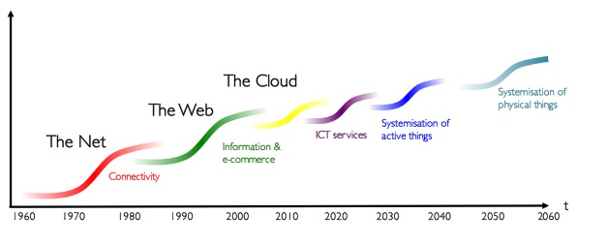
Figure 56. Progression from IoT to the internet of community (culture).

  - 7.4 Summary
This thesis introduces an approach that provides a new way of assessing buildings and communities in terms of their social value today and as part of the smart agenda in the future. The research is heuristic and not without its shortcomings but if these are treated in an appropriate manner the research is thought to have merit. While the starting position may seem very simple, and even naïve, the network solutions and implications surrounding buildings and their impact on individuals are every bit as complex as any other engineering, scientific or design discipline.
As an analogy, the research can be likened to throwing a stone into an irregular-shaped pond. The proposition is the stone, and what radiates from the stone as it hits the water are ripples. These are regular and relatively easy to understand but the reflections from the irregular-shaped bank and their interactions across the pond are complex and many. Some of these interactions have been outlined in this thesis but they are only a drop in the ocean compared to what can be realised by a fully developed service-based mesh. Unfortunately, the thesis has some repetition; however, just as the ripples in the pond interact with each other as they return to the centre, so must the research explore new interactions while continually returning to people.
The smart agenda potentially offers so much but just focusing on new technology or advancing a professional discipline is only part of it. Sure (in the vernacular), as the famous quote goes, ‘we don’t know what we don’t know’ (Donald Rumsfeld), and technology must drive forward as society develops, but even today there is enough technology to support a simple social language. Moving forward is good but so is looking left and right to break down silo thinking for greater individual and collective benefit. Specialism (commercialism) is, perhaps, similar to ignorance, arguably the enemy of broader understanding.
The service-based model does not concern itself with changes in things as long the service need required by the individual is met. By not doing so it is better adapted to the future and supports analysis of interoperability, not in terms of data bus connections and ICT protocols, but in terms of how the outputs of things, either within or between proprietary systems, can be brought together to deliver outcomes. However, as delivery models become increasingly arm’s-length and the processes run over the ICT network become more complicated, appropriate checks and balances to satisfy, for example, duty-of-care and legal requirements will be required.
It is easy to think that even trying to systemise things, buildings and communities is foolhardy and a waste of time or that the research outlined in this thesis is a panacea for all things related to people, buildings and communities and, perhaps, even culture. The fact is that the growth in technology and its application together with the IoT will provide the opportunity and the business models for many retailers, system integrators, energy companies, product manufacturers etc. to develop new business streams centred around customer data, relationship management and the ‘whole customer experience’. In the fullness of time the business drivers will cascade to many walks of life and the interrelationships between buildings, things, processes, resources (waste) and outcomes will become increasingly integrated and more tightly managed. Resources, whether we are talking about their consumption, re-use or recycling, will become more integrated with the things that produce/use them and the benefits they provide to the individual. Money itself is ideally placed to become just another (personal) resource. Only time will tell how the integration and targeting of services is perceived by the individual, where the value is created, and who owns and controls the data that creates it.
In terms of the built environment itself, buildings have never been seen as ‘products’ and as such have never been fully exposed to user/system optimisation as many other manufacturing sectors. Because they’re not machines, perhaps understanding their relationships with people has always been closer to art than science: a ‘soft’ interpretation of user needs integrated, well or poorly, into the design process. After that, it is the people that must adapt. In the future, as materials change and technology and ICT devices advance, the built environment and its relationship with people will change. However, this will be largely driven by organisations external to the built environment sector. The question is, is the built environment sector ready for buildings to be machines? Does it have the necessary understanding of systemised building performance and its social impact, or is the real value in the hands of those that provide the smart boxes, control functions and user interfaces?
Legacy issues mean that the biggest changes will initially come from the control environment under which existing buildings operate. While the physical ‘machine’ must be improved, every small incremental step in its performance, control or reporting will provide a plethora of new control scenarios and business propositions. The true impact of these issues on the built environment and those living in it are yet to be quantified. However, to move forward, traditional demarcations must be removed. The construction industry itself, however, has many barriers within its own design and construction process and is one of the most litigious. If it is to truly embrace smartness, social scientists, architects, engineers, town planners and ICT professionals must sit down and consider the social consequences of a smart community. The future will no longer be an incremental step in the process of moving pieces around the ‘physical community’ chess board and relying on intelligent agents, people, to sort it out. What makes a vibrant community in the future will be a new blend of the physical past and new virtual service value ‘without walls’. Now is the time for ‘horizontal’ building research.
By shaping data correctly and applying appropriate confidence factors the research provides a satisfactory response to the research proposition. A proposition that focuses on what buildings can do for people beyond just keeping them warm and safe. A proposition that forces exploration of how people and communities of the future can be better understood when life is no longer defined by just the physical world. One where passive things become active and every ‘machine’, both physical and virtual, from the smallest device to the largest community, interacts horizontally and produces a step change in complexity and opportunities. A proposition that may even support analysis of new service-delivery models in buildings and communities, no matter whether they are near or far, physical or virtual, and by doing so, possibly shed some light on how life and even culture might pan out as it morphs from one of physical place to one of personal environments and collective choice.
There is, of course, an elephant in the room. Unlike in the mid/late twentieth century, technology is now viewed with some suspicion and personal data (currently less specific than past ‘institutional’ data, but still very powerful) has devolved from being in the possession of a few, largely trusted institutions (for example, Government agencies, health establishments etc.) to private sector organisations. This is not to say that the Government is without its problems, but it is a democratically appointed body to represent the people and has evolved with the appropriate checks and balances. Data held by private sector organisations, however, is used for competitive advantage and ultimately for the benefit of shareholders. For the house to be a ‘machine’, those implementing it must demonstrate the right balance of competitiveness and trustworthiness. However, this might not be easy. Even ‘trusted’ institutions such as banks have largely failed to do this recently and the safe-keeping and use of data may call for an intermediary to broker its access and use, i.e. a Paypal-type organisation for data. Satisfying the proposition could provide very powerful solutions to improve social wellbeing or it could be very de-humanising depending on the context and how it is implemented.
The approach outlined in this thesis inevitably touches on many well established academic and professional disciplines and the potential interactions and overlaps are many, as are the conflicts, assumptions and questions. Systemisation and automation are part and parcel of the ICT sector; however, the key contribution of this research is that there is now a way of codifying everyday things, and the building itself, thereby paving the way for them to be considered as part of a machine – something that, to the author’s knowledge, has not been possible before.
In terms of a thorough research programme, the work is incomplete in all aspects, but that was always going to be the case. Its objective was to show how a horizontal language might be constructed and tested, and failure to address horizontality in the research, by showing either what tools might be required nor indicative user interfaces, would strike at the core of what the author was trying to do. To those with a vision, the research should provide almost limitless opportunities for further research. However, even with the rapid progress of ICT, it is difficult to see how income streams might be realised in the short-term.
The research has been undertaken with humility and deep respect for each profession and topic area mentioned. It is, frankly, a moderately well informed ‘stab in the dark’ based on forty-five years in industry. Having said that, research into prior art indicates that it is novel, and, by implication, it is difficult to believe that the research outlined in this thesis doesn’t advance professional practice in some manner. If it does that in some small way, it has fulfilled its purpose.
‘True’ sustainability was chosen as a starting point for this thesis which, in the final analysis, considers how humanity lives on and with the planet. While many arguments for and against sustainability are driven by short-termism, in the longer term, issues such as population growth, an ageing population, resource depletion, economic viability etc. will drive future society. Sustainability, and its relationship/impact on people, is just dependent on the chosen time-frame: fifty years, one hundred years or five hundred years. Any opportunity to become more efficient and cut short the profligate way humanity is living on the planet must be a good thing. Perhaps smart environments (possibly cities) offer a way of doing more with less; and maybe, just maybe, this research will help gain a better understanding of them in terms of people and the social benefit.

‘The measure of any technology is the degree to which we live better by it.’
(Nolte 2002).

End.

Appendix 1. Form completed by staff at Lister Hospital
Intervention | Week | Who wants the intervention | Who provides the intervention | Why (outcome) | Mechanism for delivery | Typical location for delivery | Priority (optional, good practice, mandatory). Does it happen now (y/n)? | Comment
Pre-conceptual counselling (smoking, alcohol, weight etc) | Pre birth | Minimise individual and national risk | Very limited. Done by GP if at all | Improved health and reduced risk | Face-to-face (FTF), patchy | GP/some at hospitals | Good practice (Gp) | Midwives (MW) should ideally deliver or obstetricians (OB)
Early self-referral to MW | 4-6 | MW need it to be done | Majority done at GP | Early reference and intervention | Visit GP | GP surgery | Gp
First visit | By 8 weeks | NICE | Hosp, MW, OB | History and plan | Hosp visit | Hosp | Mandatory and good practice | FTF
Screening, Info, Tests | Before first visit | National Screening Committee (NSC) | Laboratory info. NSC info. Delivered by MW | Decisions made and plan produced | Info giving by MW and/or GP | Hosp | Mandatory and Gp | Can be delivered virtually
Complex needs inc. TP, PU, MH, CP. Hard to reach | By 8 weeks | NICE, MW profession, best practice, OB | Specialist MW and MW | Improved care and safeguarding | Fragmented to non-existent | GP/Hosp but other agencies need to be involved | Mandatory and Gp | Need more sharing information and need specialist engagement
Screening – nuchal/dating | 11-13 | NSC, NICE | Hosp. staff | Identification of risk, plan and intervention | Hosp. | Hosp. | Gp.
AN appointment | 16 | NICE | MW, OB, GP rarely | Health promotion, monitoring | MW, OB | GP, Hosp. | Gp. | More at home and FTF time. Could be delivered virtually
Anomaly scan | 20+ | NICE, NSC | Hospital staff | Identification of a problem | Hosp. | Hosp. | Gp | Central local point. Feed in centrally
Antenatal education | 20+ | For all parents and families | Hosp. Limited private | Realistic expectations. Preparation | MW large groups. Private small groups | Community clinics. Hosp. | Should be Gp. Optional. Patchy | Increase sessions run by charities. Increase virtual education
Pre-pregnancy planning and education | Pre aged 11+ | Government | Teachers | Reduce teen pregnancy | Sessions PSHE | Schools and parents | Gp. Could be done virtually | One person feeding in to clinic. Charities
AN appointment | 24 to 41 | NICE | MW/OB | Monitoring | GP/MW/OB | GP/Community/Hosp. | Gp, mandatory | I Phone. F (fetal?) heart
Rh negative women | 28 | NICE | Laboratory, MW, hospital staff | Prevention of Rh disease | Hospital visit x 2 | Community/Hosp. | Mandatory | Drop-in centre. Local services
Immunisation Flu, Whooping cough ++ | Flu – only time wc 28 to 32 | WHO | GP, MW | Prevention | Visit | GP, Hosp. | Gp | Delivered where women are
Sweeps | T+7 if not in labour | NICE | MW | Reduces risk of complex intervention | Hosp. visit. Some community | Hosp, community | Gp | Needs to be offered to all women
Promotion of normality | During pregnancy | Profession | MW | Reduced interventions, surgery, long term complications. Promote self- belief | Patchy. MW, CMW | Hosp. | Gp. Needs to increase and be offered to all women | Active birth. Hypnobirthing, Water birth etc.
Promotion of breast feeding | Schools, advertising media, all professions | MW | MW | Promotion of health. Reduce ill health and obesity | MW | Antenatal visits. Patchy | Gp | Involving all family. Peer support. Media, government, employers, TU

Appendix 2. Patent - Optimising the use of energy
Other patents once held or pending by author: WO 2011/101687 A2: WO 2012/156712 A2: GB 2490736: GB 2493262: GB 2479758.
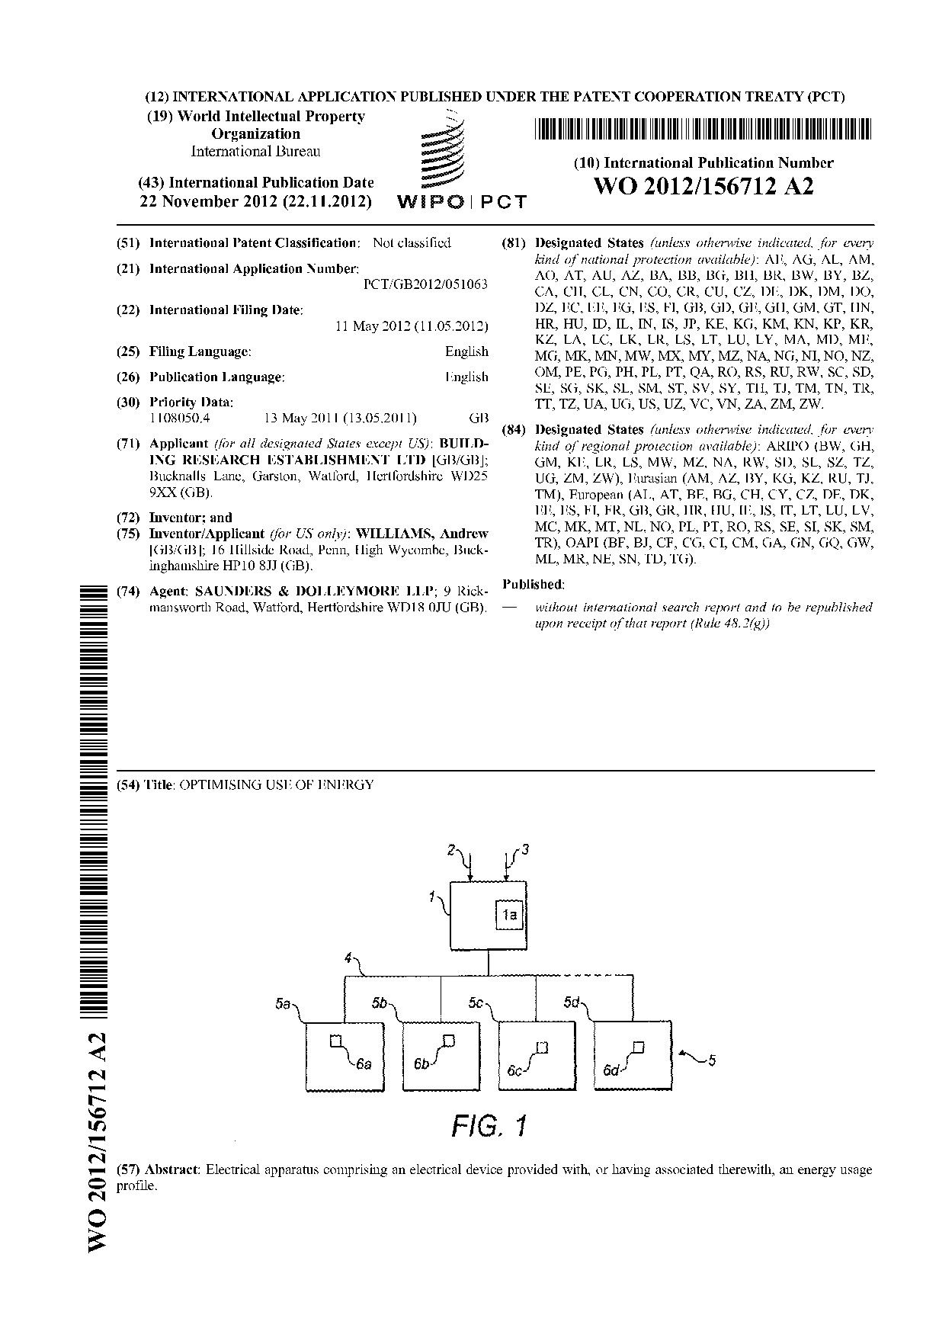

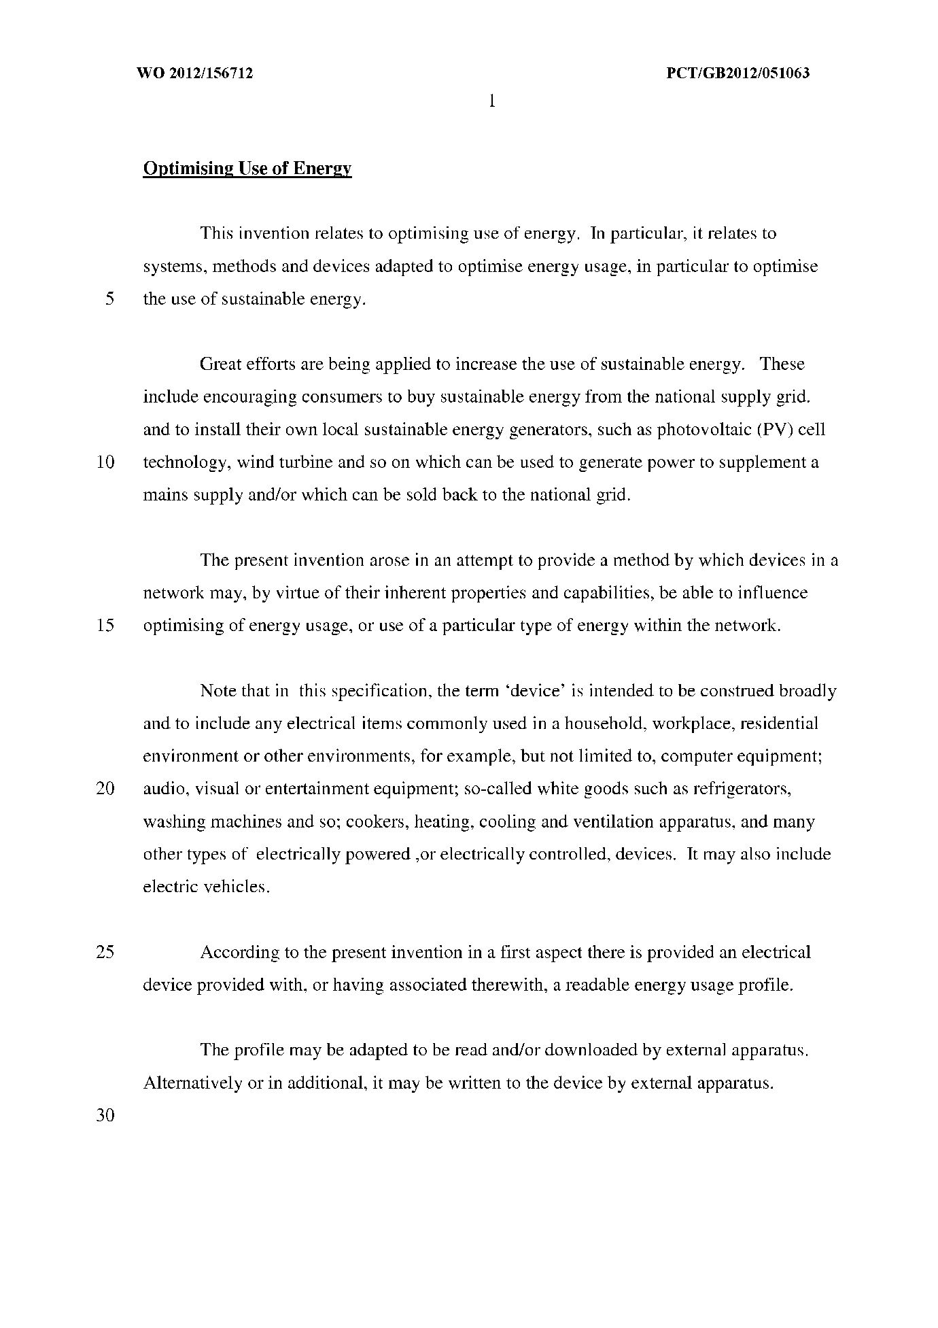

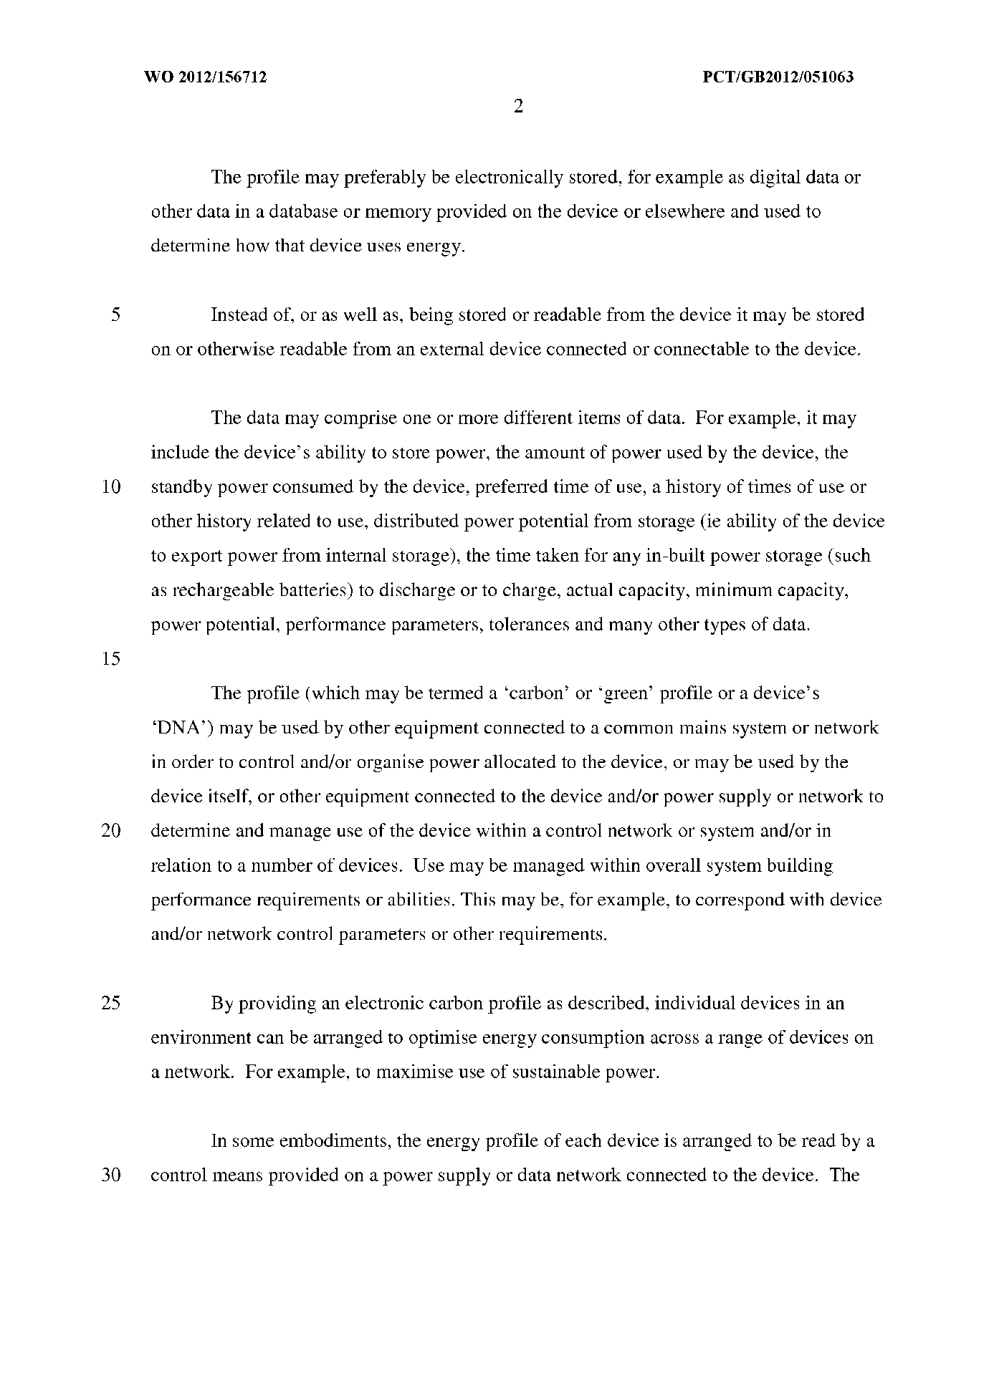

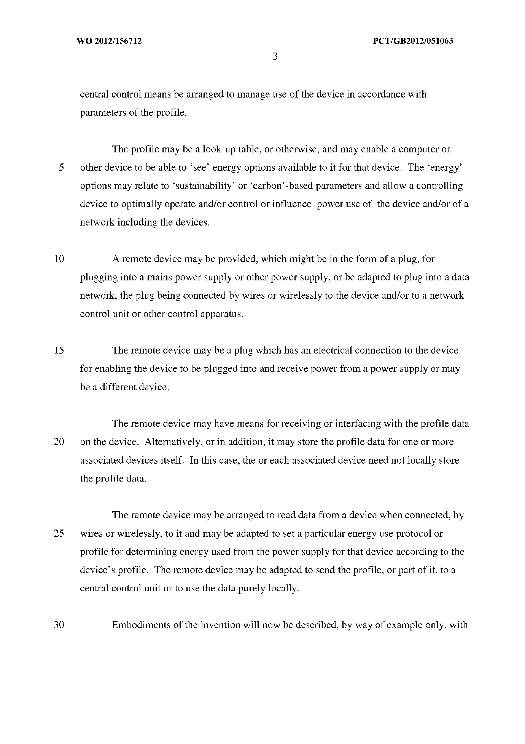

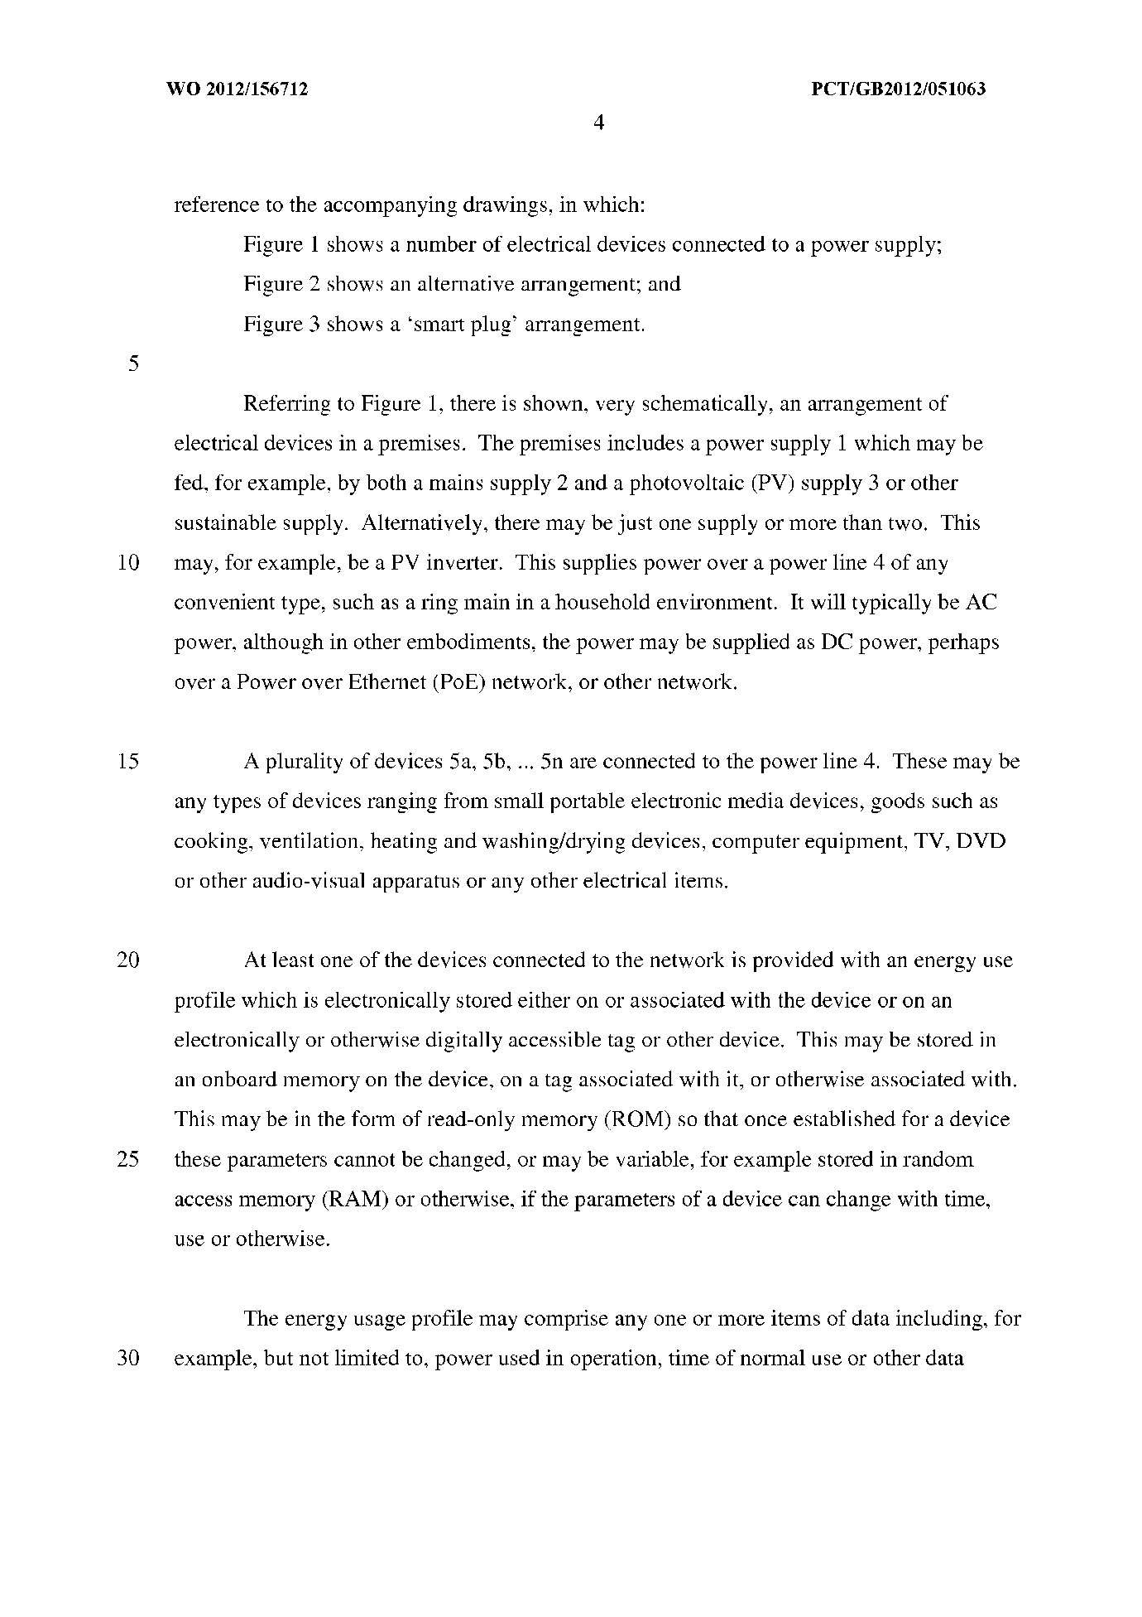

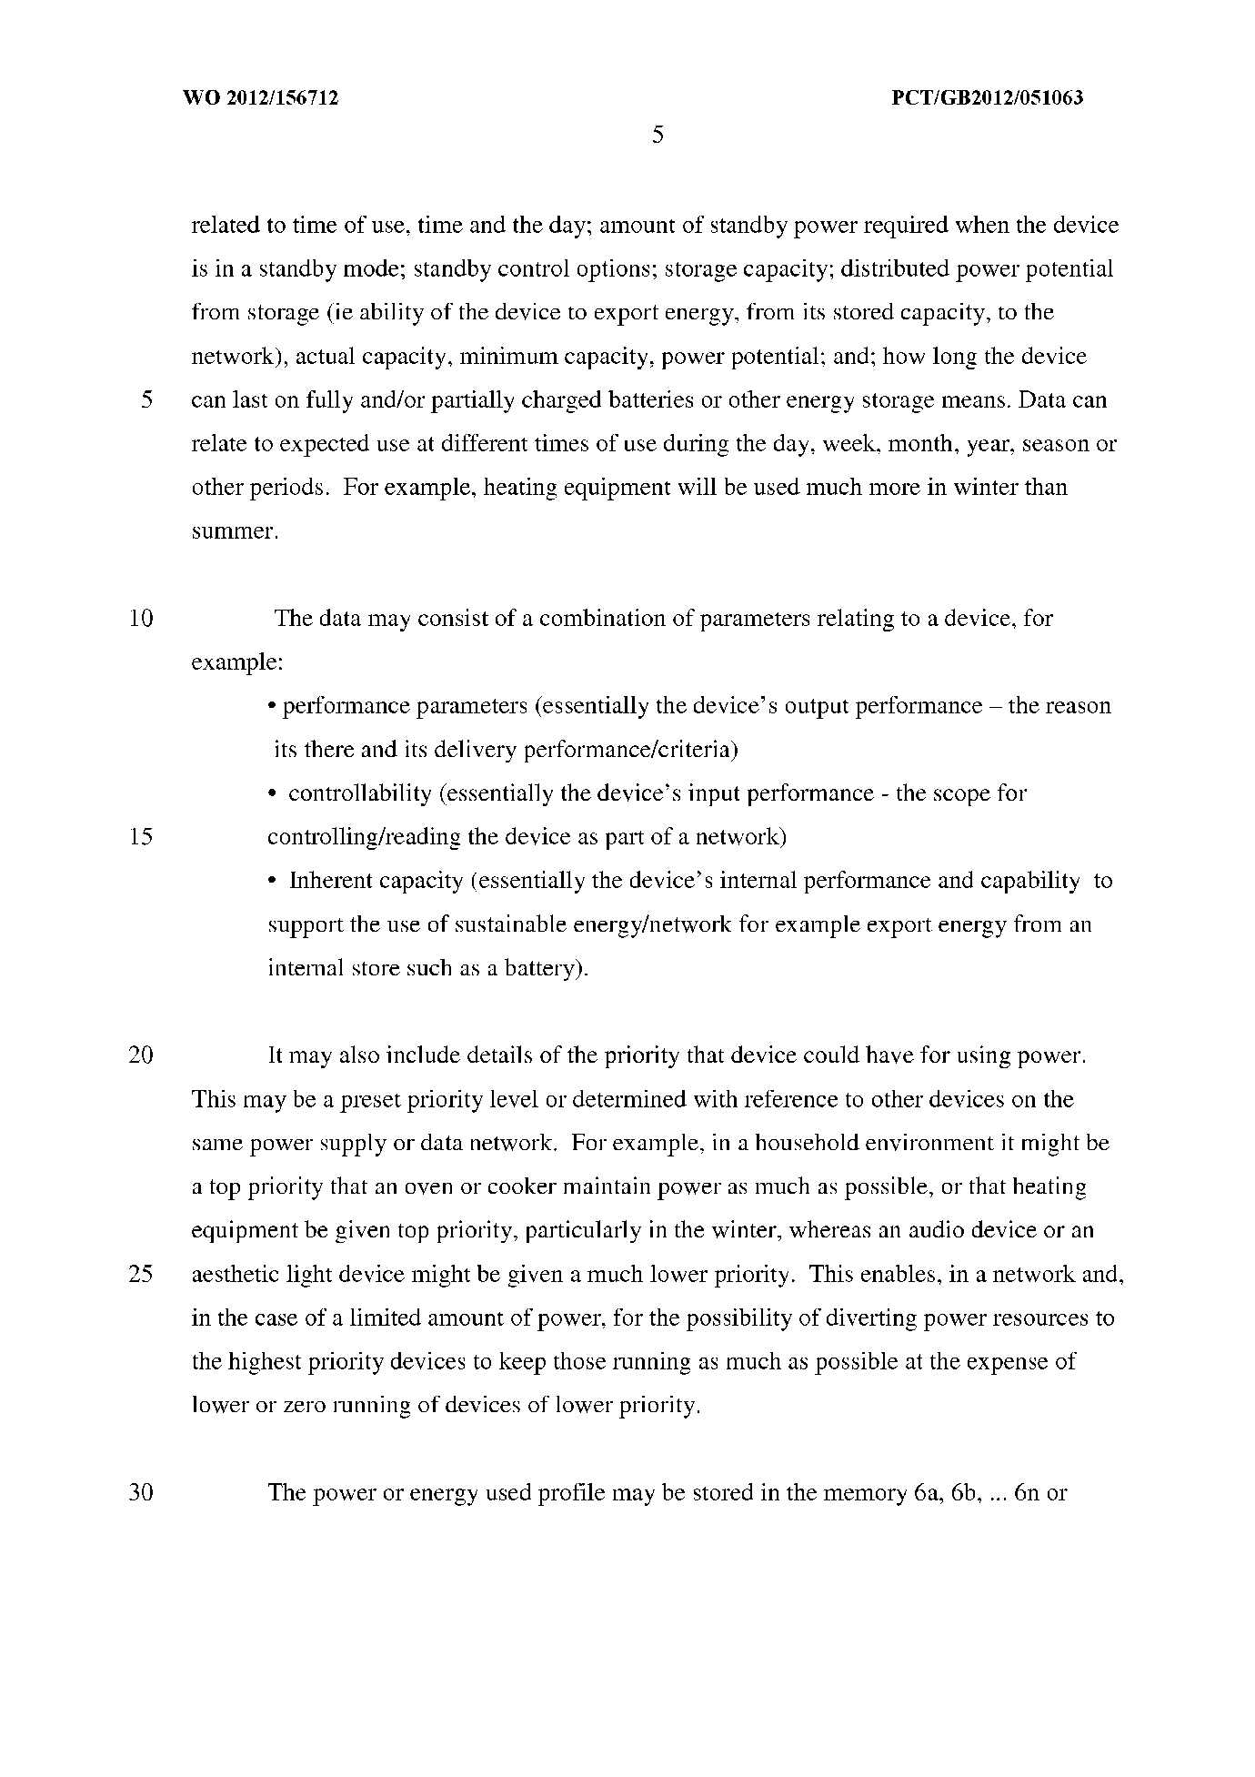

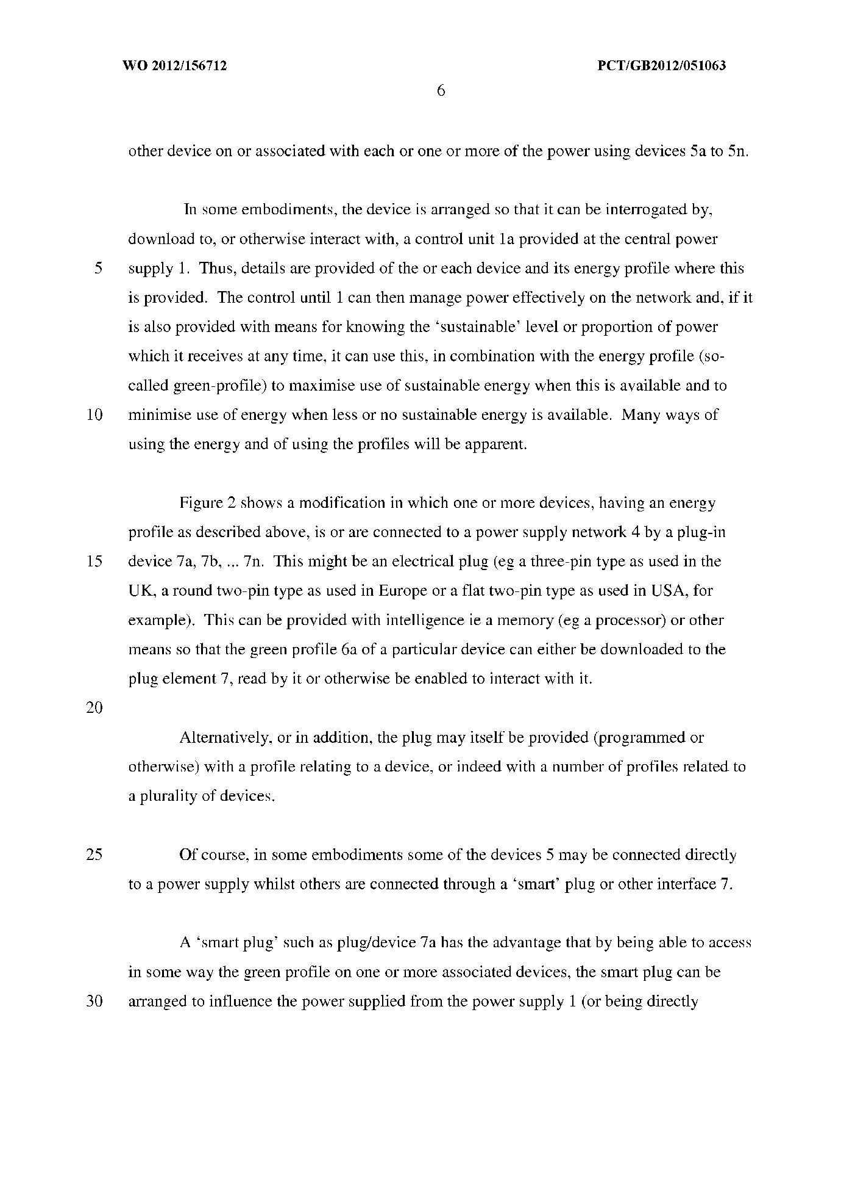

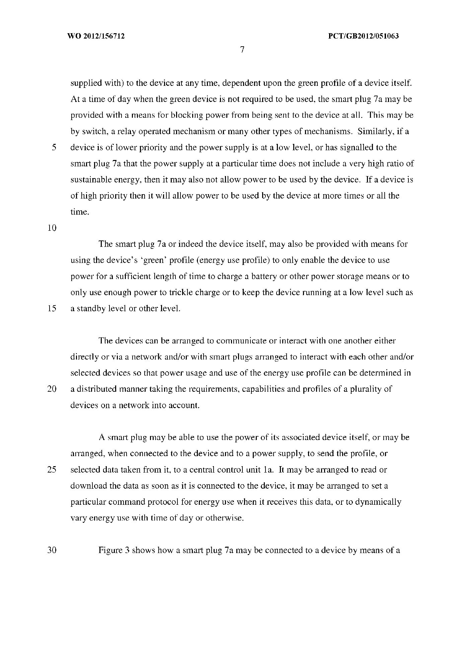

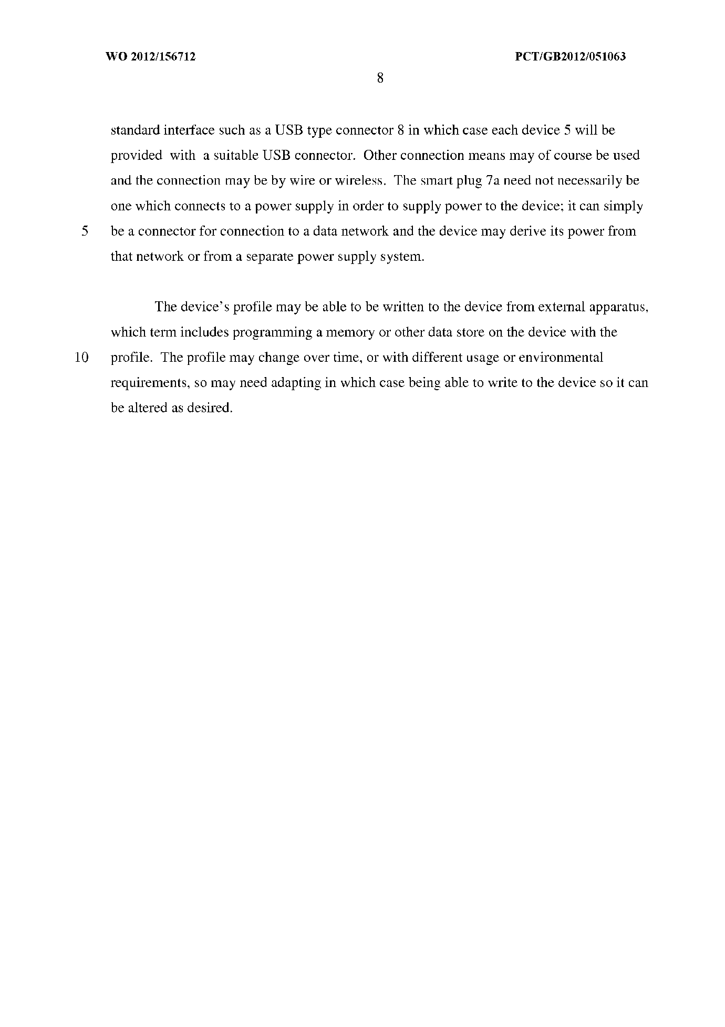

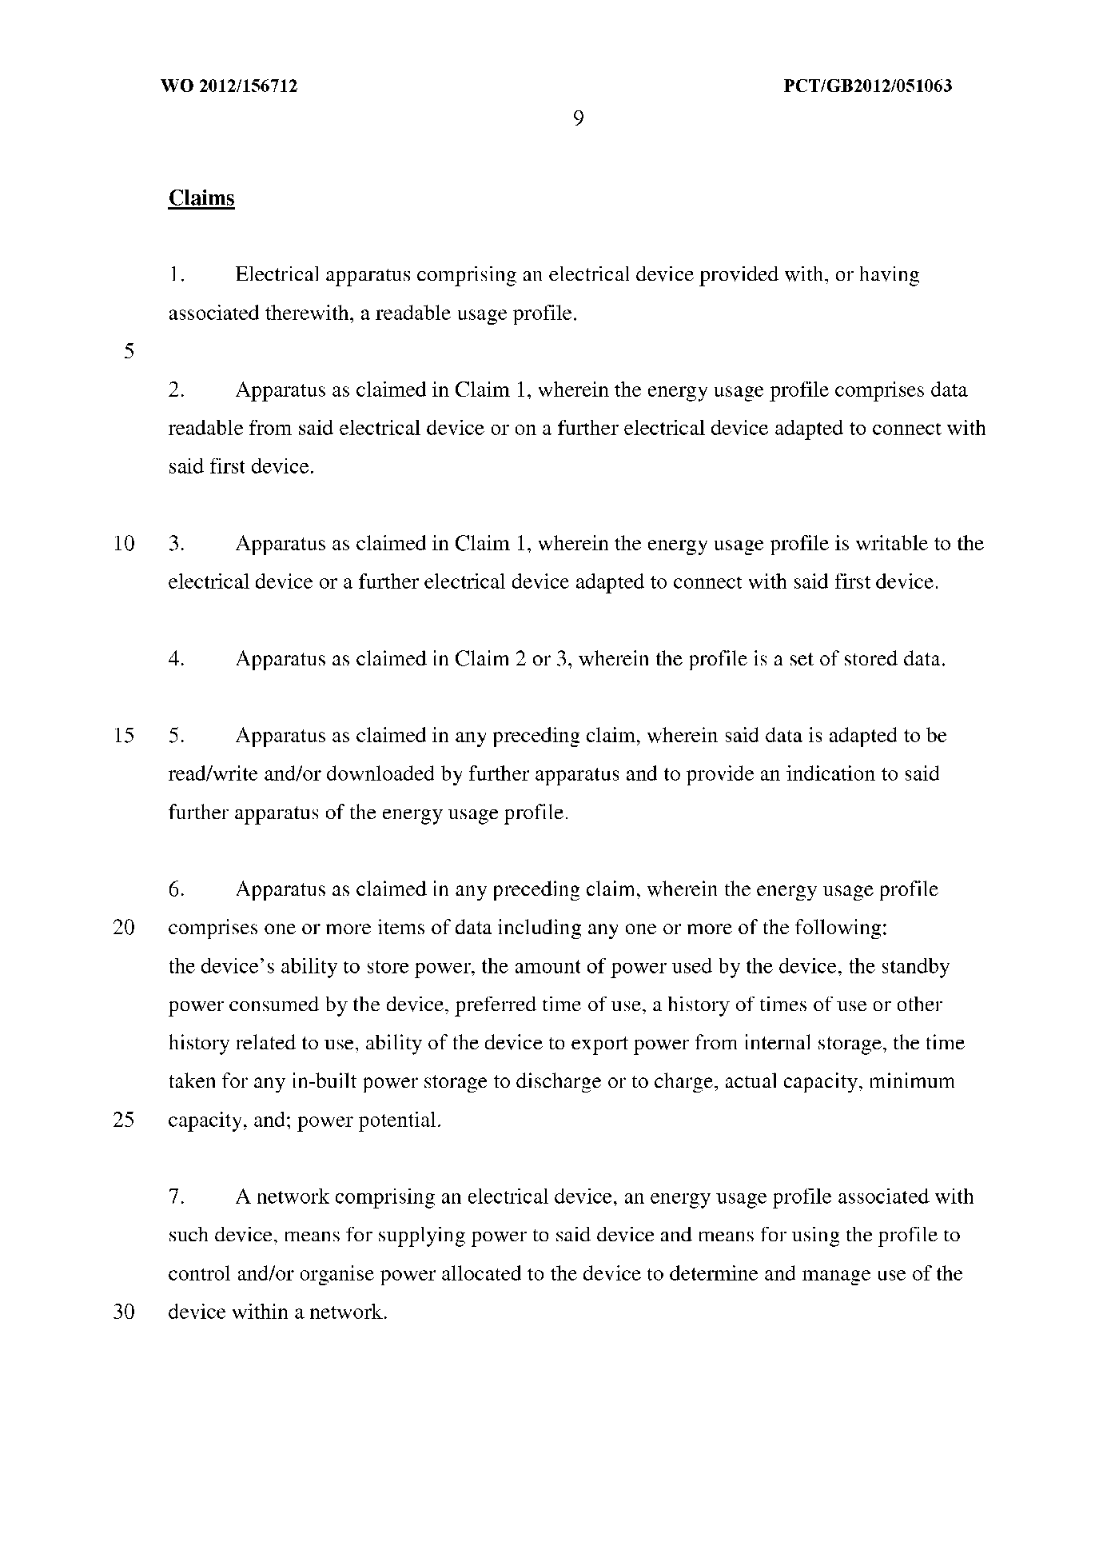

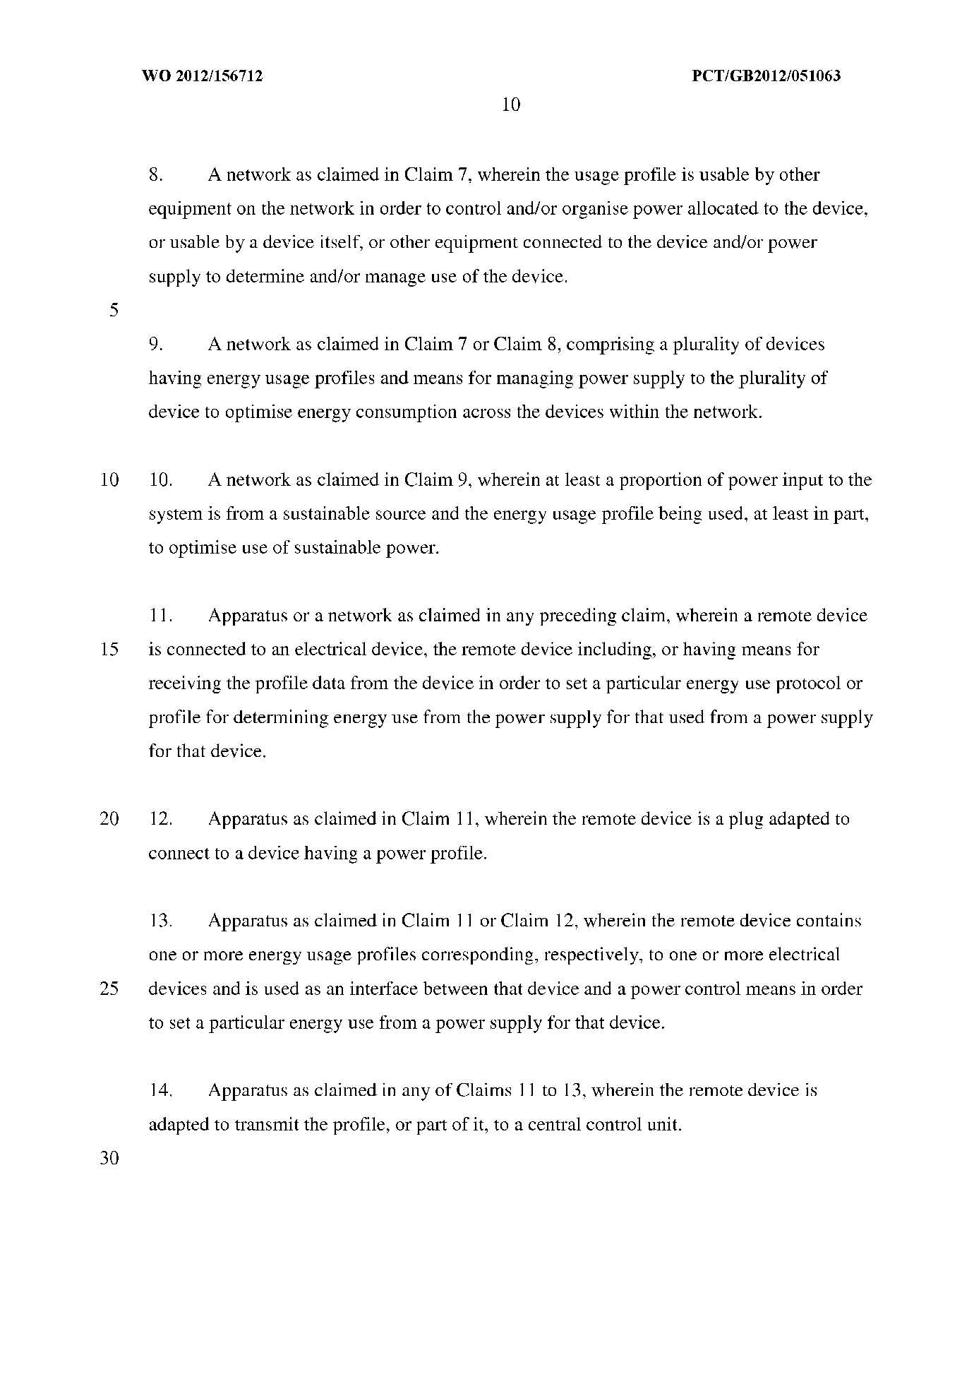

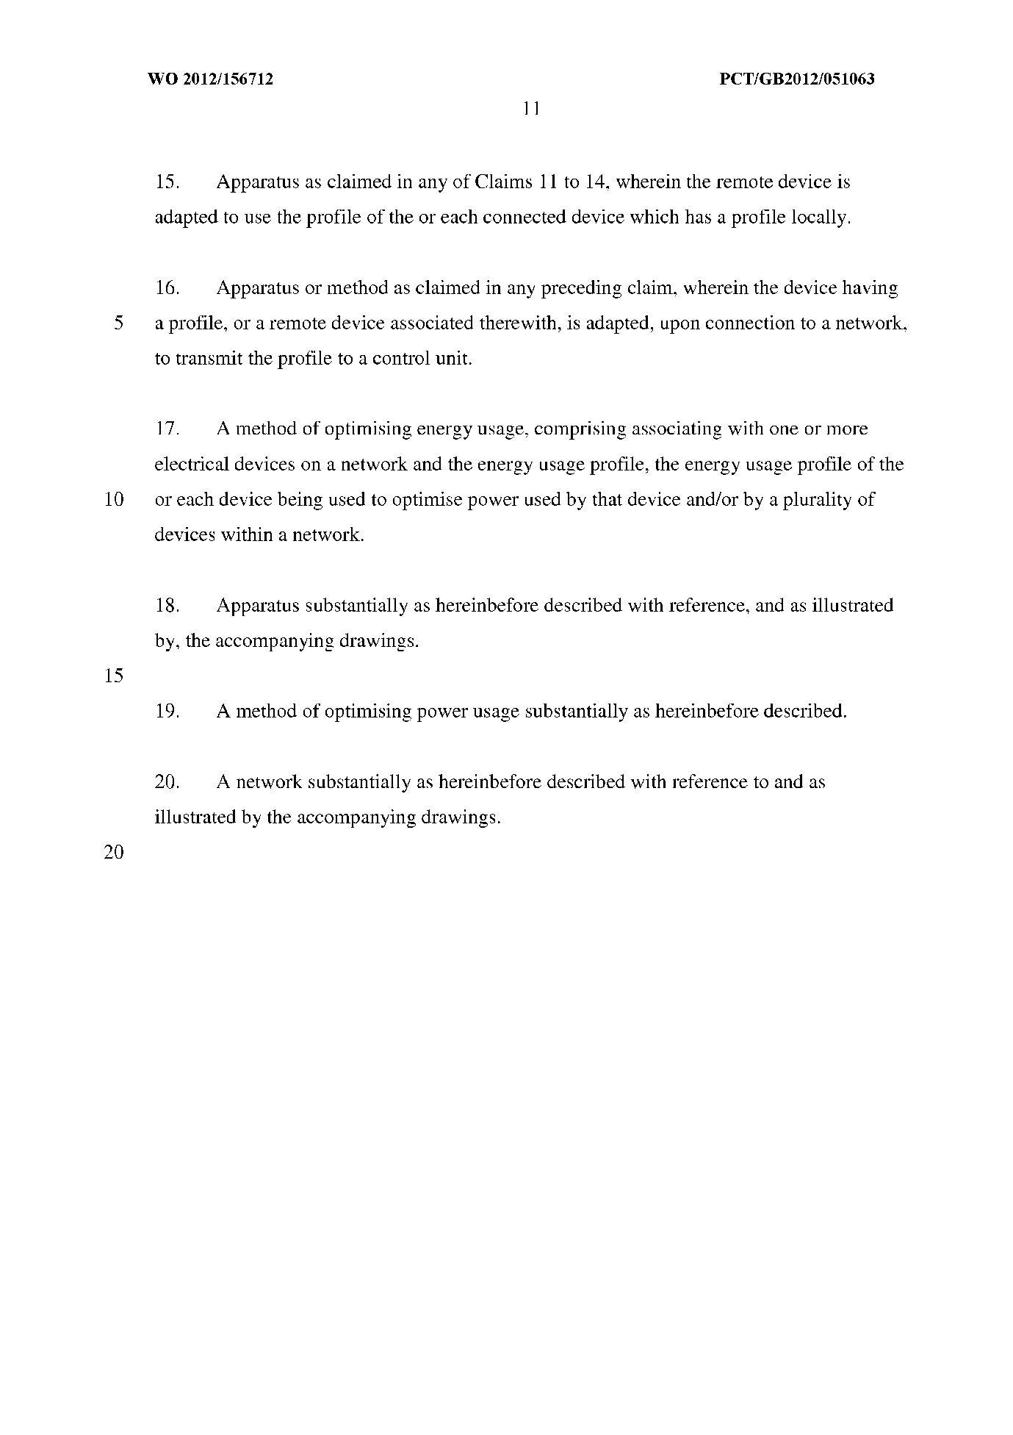

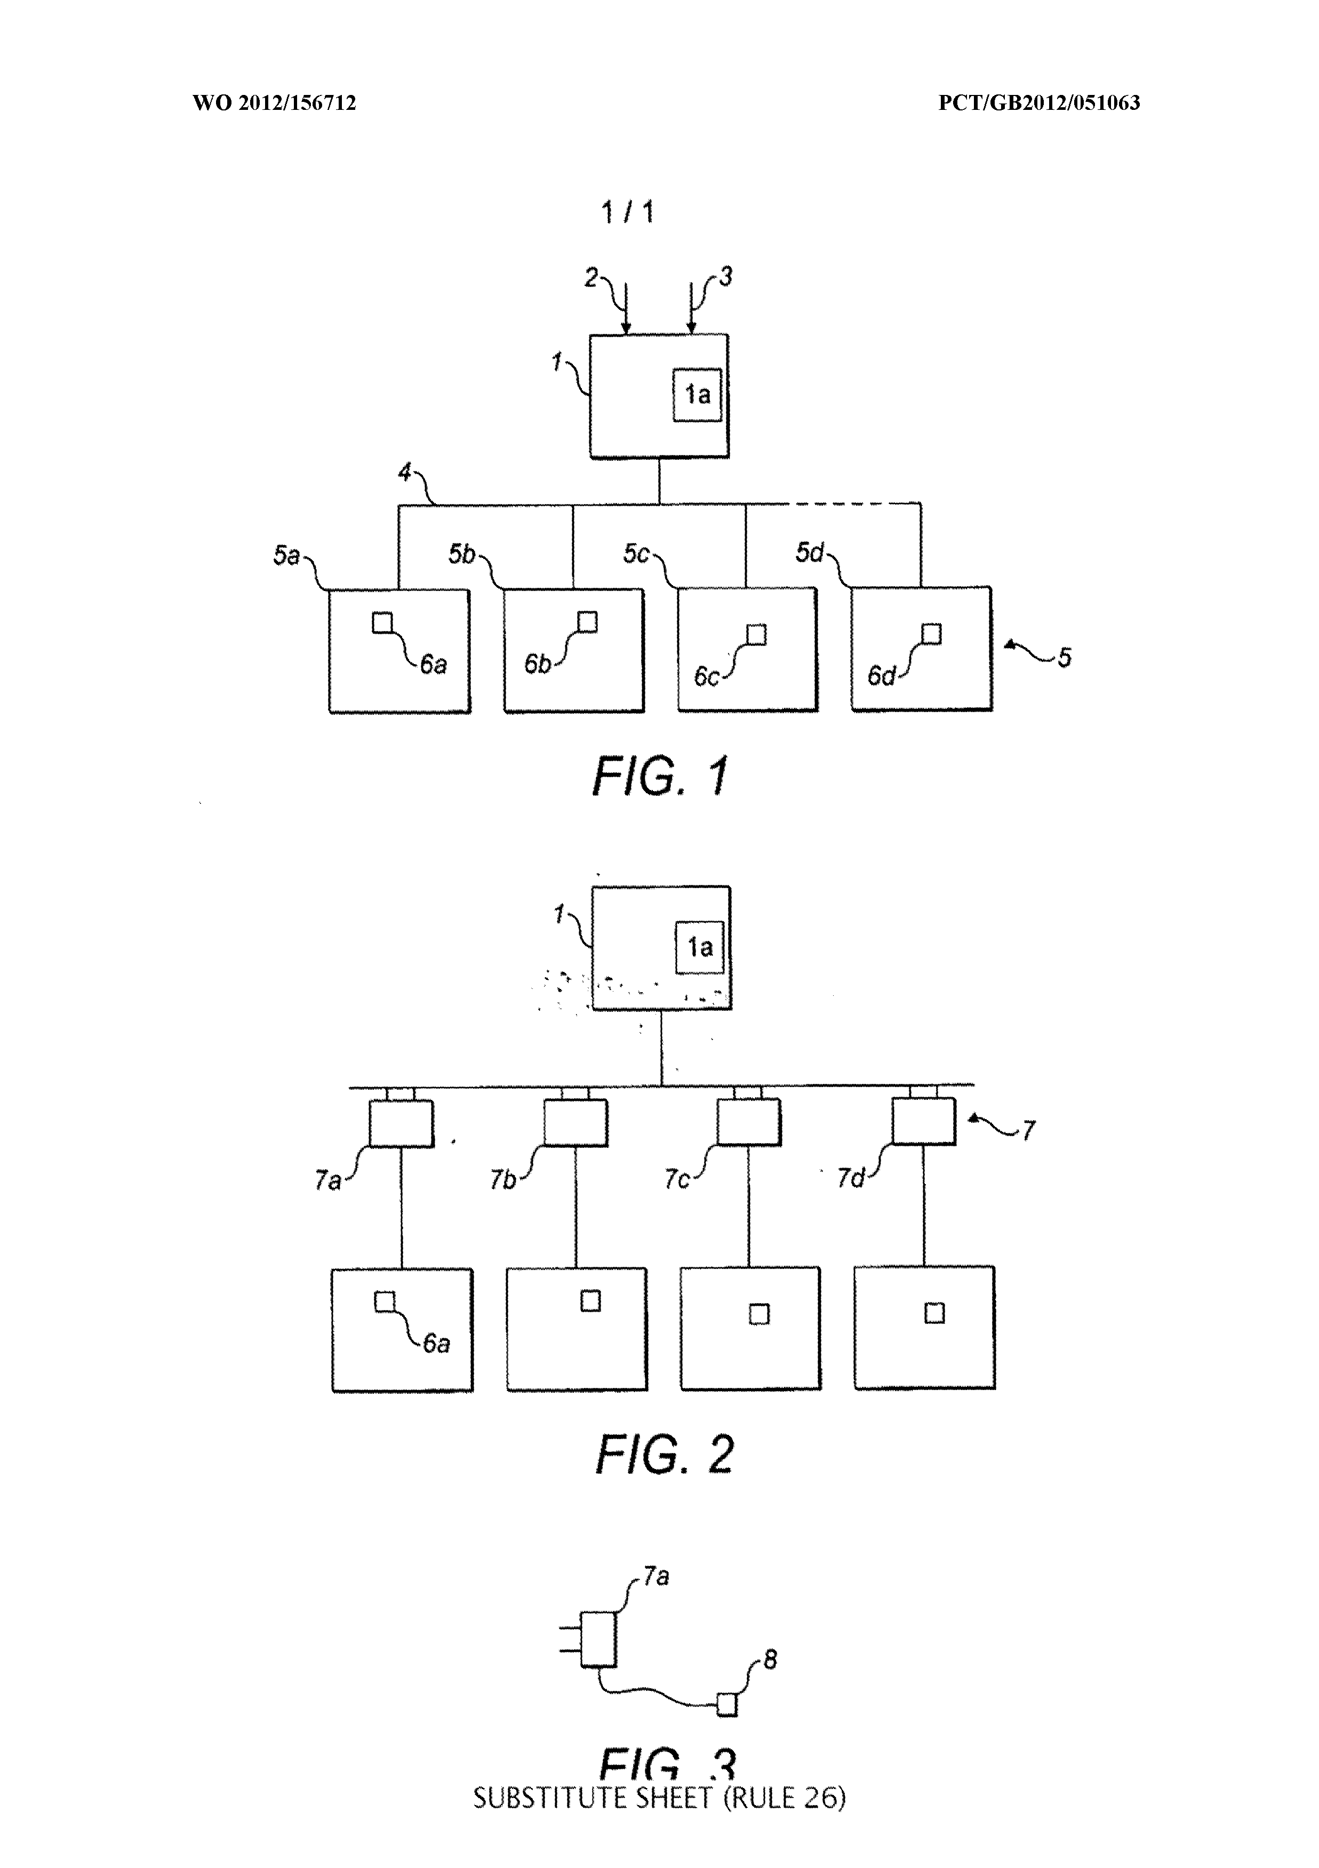

Appendix 3. Background research for BRE Health and profiling the mesh

There are many initiatives concerned with wellbeing, quality of life and the built environment and these are briefly reviewed (Williams, Hadi 2014/5). They are mainly UK initiatives, but some have broader scope e.g. WHO. The research into these references was primarily driven by the need to undertake market research for BRE Health but it also served as confirmation that a social language had not been developed.

General Wellbeing
Mindtools (https://www.mindtools.com/). This work focuses on how individuals can change their physical work environment in order to manage stress, covering:
- Furniture & Ergonomics
- Stress from Poor Lighting
- Combating Noise Stress
- Stress from Poor Air Quality & Pollution
- Maintenance & Tidiness.

Mind, five ways to well-being (https://mind.org.uk/workplace/mental-health-at-work/taking-care-of-yourself/five-ways-to-wellbeing/). This has tips for better mental health at work, based on NEF research. It identifies five ways to wellbeing (action themes): Connect, Be active, Keep learning, Take notice, Give.

Flanagan’s Quality of Life scale (https://www.researchgate.net/publication/9011706_The_Flanagan_Quality_of_Life_Scale_Evidence_of_Construct_Validity). This is a sixteen item self-report questionnaire rating satisfaction on a seven point scale (Flanagan JC 1982. Measurement of quality of life. Current state of the art. Archives of Physical Medicine and rehabilitation). Factors include physical fitness, socialising, learning, understanding yourself.

Stress assessments e.g. OSI (http://www.sigmaassessmentsystems.com/assessments/occupational-stress-inventory-revised/). This provides various theoretical models and measures of stress, anxiety, depression and mental health, e.g. Karasek showed that control (decision latitude) and work load are key factors and that stress is moderated through social support.

ONS - measuring national wellbeing (https://www.ons.gov.uk/peoplepopulationandcommunity/wellbeing/bulletins/measuringnationalwellbeing/2015-09-23). This work lists factors that should be covered in a measure of national wellbeing (links with the seventeen questions used to identify preferences):
- Income and wealth
- Job satisfaction
- Economic security
- Ability to have a say on local and national issues
- Having good connections with friends and relatives
- Having a good relationship with a spouse or partner
- Present and future conditions of the environment
- Crime
- Health
- Education and training
- Personal activities, including volunteering
- Cultural activities
- Unpaid caring, such as for children or other family members
- Spirituality or religion.

NEF Happy Planet Index (https://happyplanetindex.org/). This combines environmental impact with wellbeing to measure the environmental efficiency with which, country by country, people live long and happy lives.

Community wide scale
Many of these projects and initiatives focus on wellbeing at the larger community or city-wide scale e.g. WHO age-friendly cities, NEF programmes.

WHO, Age Friendly Environments Programme (http://www.who.int/ageing/projects/age-friendly-environments/en/). The WHO Global Age friendly cities - a guide. An international effort to address the environmental and social factors that contribute to active and healthy ageing. They propose six determinants of active aging:
- Economic
- Health and social services
- Behavioural
- Personal
- Physical
- Social.
The programme helps cities and communities become more supportive of older people by addressing these needs across eight age-friendly city topic areas – aspects of city life that overlap and interact:
- The built environment
- Transport
- Housing
- Social participation
- Respect and social inclusion
- Civic participation and employment
- Communication
- Community support and health services
The document includes an ‘age-friendly checklist’ for each section.

The Young Foundation. Local wellbeing – can we measure it. National and local wellbeing indicators (https://youngfoundation.org/publications/local-wellbeing-can-we-measure-it/). This is a three-year initiative to explore how Local Government can improve happiness and wellbeing of their citizens. Scales tend to focus more on people’s subjective satisfaction with different areas of their life:
- Social – family/relationships/sense of belonging/community cohesion/social support
- Personal – achievements/engaging activities/health and mental well being/material and financial well being
- Place – access and opportunities/safety and security/environment/quality of local area
- Indicators include: number of GCSE’s obtained, air quality, self-reported overall health and wellbeing, fear of crime, perceptions of antisocial behaviour, etc

NEF Good Foundations: Towards a low carbon, high well being built environment (http://neweconomics.org/2012/02/good-foundations/). This investigates what really matters for ‘people and place’ - neighbourhoods that support a good life for inhabitants and respect for environmental resource limits. Suggests that development projects should be working to promote high wellbeing in the areas of:
- Place happiness (PH)
  - Personal wellbeing – people’s experience of life in relation to their physical and psychological wellbeing
  - Social wellbeing – people’s experience of life in relation to those around them: their community
  - Economic and material wellbeing – people’s experience of life in relation to the conditions and circumstances of their lives, including their physical surroundings
- Place Sustainability (PS):
  - Resources used during construction or renovation.
  - Resources used across the lifetime of its use.
  - It is suggested to use a ‘design proof for sustainable wellbeing’ but do not detail which factors of the built environment may influence wellbeing.

Assessing healthcare facilities
There are several measures and indices developed to assess the quality of care and healthcare facilities. None seem to be very comprehensive, i.e. they focus either on the physical environment or on wellbeing rather than combining the two. The BMA report and MacMillan cover some of these issues.

The Care Quality Commission (https://www.cqc.org.uk/). Its role is to check whether hospitals, care homes and care services are meeting Government standards. It undertakes various surveys of patient satisfaction, but these tend to focus on the service provided (appointment time/ wait, explanation of side effects, etc.) rather than the physical environment: although cleanliness is one of the factors surveyed. Reports are published on inspections of care homes and how well they are meeting the Government standards that cover the following expectations:
- expect to be respected, involved and told what’s happening at every stage
- expect care, treatment and support that meets your needs
- expect to be safe
- expect to be cared for by staff with the right skills to do their jobs properly
- expect your care home to routinely check the quality of its services

Care Home environments and well-being (http://wrap.warwick.ac.uk/41585/). This identifies the design features that most affect older residents. Oxford Brookes and University of Warwick 2012. Research with care home residents to identify aspects of care-home design that have the greatest impact on the wellbeing of residents. Highlighted the importance of:
- Practicality (ease of access)
- Comfort (warmth)
- Brightness/lightness
- Openness (light, welcoming, visual transparency, space to manoeuvre)
- Views out to greenery
- Home-like design
- Attractiveness of building, furniture and decor
- Variety of spaces and rooms to provide for socialisation and privacy

Macmillan Quality Environment Mark (MQEM) (https://www.macmillan.org.uk/documents/aboutus/health_professionals/mqem/mqem-assessment-handbook-august2015.pdf). This uses an evidence-based tool that specifically assesses the physical environments in which treatment and support are provided to people affected by cancer. Assessment criteria include:
- Design and use of space: how clearly entrances are signposted, and whether the reception area is warm and welcoming. Privacy is an important aspect - do you have consultation rooms? Are screens available on request?
- Journey: Is your facility easily accessible to everyone in the local area? For instance, what is the cost and availability of car parking? How staff communicate with people about finding the facility - for example, do they send out public transport timetables or clear maps prior to appointments?
- Service experience: The quality of your service will be assessed. Points go to facilities which provide healthy meals, and where people can make their own hot and cold drinks. Assessors will look for high standards of cleanliness and tidiness throughout your facility, maintained through regular checks. Are patients able to control their personal environment? For instance, can you choose the lighting and temperature in a room? Natural light and gardens are also high priorities.
- User voice: However, outstanding a facility may appear, a big piece of the puzzle is missing if it doesn’t involve people with cancer in its ongoing development. For this reason, assessors will investigate the level of ‘user involvement’ your unit provides. And most importantly, they’ll look for evidence that these views are being taken seriously and turned into concrete change.

British Medical Association (https://www.ahsw.org.uk/userfiles/Other_Resources/Health__Social_Care_Wellbeing/psychologicalsocialneedsofpatients_tcm41-202964_copy.pdf). ‘The psychological and social needs of patients’ (2011). This discusses the social determinants of health and promotes the concept of patient-centred care, defined by The Institute of Medicine as ‘providing care that is respectful of and responsive to individual patient preferences, needs, and values and ensuring that patient values guide all clinical decisions’.
This definition lists six dimensions to patient-centred care:
- Compassion, empathy and responsiveness to needs, values and expressed preferences
- Coordination and integration
- Information, communication and education
- Physical comfort
- Emotional support, relieving fear and anxiety
- Involvement of family and friends
The report gives examples of activities that enhance mental wellbeing:
- Recreational activities (including board games, cards, bingo)
- Humour and health
- Creative writing, storytelling and poetry reading
- Music
- Visual art
- Theatre and drama
- Singing
It cites the Planetree model of patient-centred care that stipulates that healthcare environments should:
- welcome the patient’s family and friends
- value human beings over technology
- enable patients to fully participate as partners in their own care
- provide flexibility to personalise the care of each patient
- encourage caregivers to be responsive to patients
- foster a connection to nature and beauty
The report translates this into guidance for the physical environment and patient wellbeing.
- Layouts and way finding
  - ensure that patients are not overcrowded or over-concentrated
  - provide a variety of spaces such as a big day room
  - a dining room that is well lit and ventilated
  - a spacious lobby and corridors

- Comfort
  - give sufficient attention to natural and artificial lighting
  - Reduced noise
  - Views of Nature and access to gardens

- Social interaction
  - providing lounges, day rooms, and waiting rooms with comfortable movable furniture arranged in small flexible groupings. Studies in psychiatric wards and nursing homes have found that appropriate arrangement of movable seating in dining areas enhances social interaction
  - colour scheme, floor covering, curtains,

Various
Various health and environment UK rating schemes, benchmarking tools and design aids that cited in Appendix 1 of the BMA report that address how the physical characteristics of healthcare buildings/environments can aid the psychological wellbeing of patients.

Health Service Journal ‘Fit for Purpose’ campaign. Mental Health Trust performance ratings include ‘physical environment’ which looks at ‘environmental conditions, space relationships, service effectiveness, amenity, and location all of which impact on the successful delivery of client care’ and the rating categories range from ‘A’ (‘very satisfactory, no change needed’) to category ‘X’ (‘nothing but a total rebuild or relocation will suffice’)

Patient Action Teams (PAT). This is an annual assessment of inpatient healthcare sites in England that have more than ten beds. It is a benchmarking tool to ensure improvements are made in the non-clinical aspects of patient care, such as cleanliness, food and infection control.

The King’s Fund (https://www.kingsfund.org.uk/events/digital-health-and-care-congress-2016). ‘Enhancing the healing environment programme’. This encourages and enables nurse-led teams to work in partnership with patients to improve the environment in which they deliver care. The programme initially focused on improving acute hospital environments, before being extended to mental health and primary care settings.
NHS ‘Achieving Excellence Design Evaluation Toolkit (AEDET): assesses and evaluate new healthcare buildings. The toolkit consists of a ten-section questionnaire that looks at:
- functionality (use, access and space)
- impact (character, innovation, citizen satisfaction and internal, external and social environment)
- build standard (performance, engineering and construction)
NHS Estates review panel. This panel ensures that good design is embedded within the NHS hospital building programme by providing advice, guidance and support to the NHS in the form of a design review and subsequent report, highlighting comments and recommendations.

The Future Healthcare Network (FHN). This is an initiative that has been implemented to focus on planning, architecture, engineering, IT and the workforce in relation to the design of buildings for healthcare.

DH ‘Inspiring Design Excellence & Achievements’ (IDEAs): a design tool to aid Trusts, and their architects and design consultants, to develop their design ideas.

DH ‘A Staff and Patient Environment Calibration Tool’ (ASPECT). This evaluates the quality of design of staff and patient environments in healthcare buildings. It delivers a profile that indicates the strengths and weaknesses of a design or an existing building. The ASPECT toolkit addresses eight key headings (privacy, company and dignity, views, nature and outdoors, comfort and control, legibility of place, interior appearance, facilities and staff).

The Star Wards Initiative. This is a project which works with mental health trusts to enhance mental health inpatients’ daily experiences and treatment outcomes. Its aim is to inspire excellence in inpatient care. The handbook gives practical ideas for improving the daily experiences and treatment outcomes of acute mental health inpatients

The Nightingale Project. This project brightens up the environment in mental health services through art and music.

The Point of Care Programme. This involves two practical initiatives to ‘promote compassion in care and improve patients’ experience’. Experience Based Design and the US Schwartz Centre Rounds system.

NHS Estates Design Brief Working Group (DBWG) design briefing. This initiative is the subject of Appendix 2 in the BMA pdf document, which includes detailed sections on issues such as:
- Access
- Space
- Privacy, isolation and communality
- Character
- External environment
- Internal environment
- Urban and social integration
- Performance
- Engineering
- Construction

Wellbeing at the individual building scale.
Assessment schemes such as SKA, DQI and BREEAM mention wellbeing but focus on the features of the building rather than the person at the centre.

Wellbeing In Sustainable Environments (WISE). They carry out lots of research related to wellbeing and the built environment, particularly for older people. Recent NHS funded research on Designing to Optimise Mood in Care Homes for Older People.
The group has produced the ‘Measuring physical characteristics of housing: The Built Environment Site Survey Checklist (BESSC) (2005).

The RICS SKA (http://www.rics.org/uk/knowledge/ska-rating-/). This rating scheme has a wellbeing section, covering:
- Thermal comfort assessment
- Noise level standards
- Lighting design
- Daylight glare control
- Occupant HVAC control
- Ventilation rates
- Clean existing air supply ductwork
- Printer-copier equipment area ventilation
- Fine air filters
- DHW design
- Outside views
- CO₂ monitoring

BREEAM (http://www.breeam.com/). This has a health and wellbeing section, covering:
- Visual comfort:
- Indoor air quality
- Thermal comfort
- Water quality
- Acoustic performance
- Safety and security

Design Quality Indicator (DQI) (http://cic.org.uk/services/the-design-quality-indicator-dqi.php). This score designs and completed buildings for:

- Use
- Access
- Space
- Character & innovation
- Form and material
- Internal environment
- Urban and social integration
- Performance
- Engineering systems
- Construction

References

2020 Public Services Trust (a) (2010). The deficit; a longer-term view. Accessed 16th May 2011 from http://clients.squareeye.net/uploads/2020/documents/2020_deficit.pdf.
2020 Public Services Trust (b) (2010). 2020 Vision: A far-sighted approach to transforming public services. Accessed 30th August 2013 from http://www.2020publicservicestrust.org/publications/.
Age UK (2013). Later Life in the United Kingdom. Age UK. Accessed 15th August 2013 from http://www.ageuk.org.uk/Documents/EN-GB/Factsheets/Later_Life_UK_factsheet.pdf?dtrk=true.
Alexander, C.; Ishikawa, S. (1977). A pattern language. New York: Oxford University Press.
Alexander, J. (2003). The meanings of social life. Oxford: Oxford University Press.
Amin, A.; Thrift, N. (2002). Cities. Reimagining the Urban. Cambridge: Polity.
Anderson, B. (2006). Energy Performance of Buildings Directive. BRE. Accessed 15th June 2013 from http://www.bre.co.uk/filelibrary/Scotland/Energy_Performance_of_Buildings_Directive_%28EPBD%29.pdf.
Appleby, J. (2013). Spending on Health and Social Care Over the Next 50 Years – Why Think So Long?. The Kings Fund, February 2013.
Appleby, J. (2013). Spending on Health and Social Care Over the Next 50 Years – Why Think So Long? The Kings Fund.
Atwood, M. (2012). Margaret Atwood: Rachel Carson’s Silent Spring, 50 years on. The Guardian. Accessed 15th June 2013 from http://www.theguardian.com/books/2012/dec/07/why-rachel-carson-is-a-saint.
Autodesk, date unknown. BIM and the future of AEC. Accessed January 19th 2018 from https://www.autodesk.com/solutions/bim
Barnett, J. (2011). City Design. Modernist, Traditional, Green and Systems Perspectives. Oxon: Routledge.
Barton, H.; Tsourou, C. (2000). Health Urban Planning. London: Spon Press.
Batty, M. (2012). Urban Regeneration as Self-Organisation. USA: John Wiley & Sons.
BBC News (15 October 2012). New ways of caring for elderly people. Accessed 26th June 2013 from http://www.bbc.co.uk/news/uk-england-19930350.
Berlow, E. (2010) Simplifying complexity. TED. Accessed 14th December 2012 from http://www.ted.com/talks/eric_berlow_how_complexity_leads_to_simplicity.html.
Berlow, E. (2016). Private conversation between Berlow and Williams. (January 2016).
Borrell-Carrio, F.; Suchman, A.L.; Epstein, R.M. (2004). The Biopsychosocial Model 25 Years Later: Principles Practice and Scientific Inquiry. National Centre for Biotechnology Information. Accessed 18th February 2013 from http://www.ncbi.nlm.nih.gov/pmc/articles/PMC1466742/#!po=2.63158.
Brand, S. (1994). How Buildings Learn; What Happens After They’re Built. USA: Penguin Books USA Inc.
BRE (2014). Collaborative masterplanning with a charrette. Accessed 6th August 2013 from http://www.bre.co.uk/page.jsp?id=443.
BRE (2016). Are you ready for BIM. Accessed 3rd March 2016 from http://www.bre.co.uk/bim.
Buscher, V (2013). Private discussion with A Williams on smart cities and their future
C4EO. Outcomes not outputs. Accessed 30th August 2013 from http://www.c4eo.org.uk/themes/earlyyears/eresource/information-professionals/how-we-can-help/OBA-framework/outcomes-not-outputs/.
Care Quality Commission (2010). The Adult Social Care Market and the Quality of Care. Technical Report (2010).
Carmona, M. (2003). Public places, urban spaces. Oxford: Architectural Press.
Carmona, M.; Tiesdell, S. (2007). Urban design reader. Oxford: Architectural, p.303.
Carmona, M.; Tiesdell, S.; Heath, T.; Oc, T. (2010). Public Places Urban Spaces. The Dimensions of Urban Design. 2nd ed. New York: Oxon.
CBI (2011). A vision for rebalancing the economy; a new approach to growth. Accessed 14th July 2013 from http://www.cbi.org.uk/media/1231301/cbi_rebalancing_the_economy_report_301211.pdf.
Cecil, J. (2010). Virtual Engineering. Momentum Press. New York.
Centre for Cities (2014). Smart Cities. Accessed 9th September 2014 from http://www.centreforcities.org/wp-content/uploads/2014/08/14-05-29-Smart-Cities-briefing.pdf
CIBSE. Technical Resources. Post Occupancy Studies. Accessed 30th August 2013 from http://www.cibse.org/index.cfm?go=page.view&item=2481.
Cowell, D. (1991). The marketing of services. Oxford: Butterworth-Heinemann on behalf of the Chartered Institute of Marketing and the CAM Foundation, 1991. ISBN: 0750602090, 9780750602099
Cowper, J.; Samuels, M. (no date) Performance benchmarking in the public sector: The United Kingdom experience. OECD. Accessed 2nd August 2013 from http://www.oecd.org/unitedkingdom/1902895.pdf.
Cuthbert, A. R. (2006). The Form of Cities; Political Economy and Urban Design. Oxford: Blackwell Publishing Ltd.
Damant, J.; Knapp, M. (2015). What are the likely changes in society and technology which will impact upon the ability of older adults to maintain social (extra-familial) networks of support now, in 2025 and in 2040? Foresight 2015. Accessed February 4th 2017 from https://www.gov.uk/government/uploads/system/uploads/attachment_data/file/463263/gs-15-6-technology-and-support-networks.pdf.
Danezis, G (date unknown). Introduction to traffic analysis. Accessed 3 November 2017 from http://www0.cs.ucl.ac.uk/staff/G.Danezis/talks/TA-Amherst.pdf
Davies, G.; Riley, F. (a) (2010). Glossary of ICT Terminology. Ict4lt. Accessed 3rd August 2013 from www.ict4lt.org/en/en_glossary.htm.
Davies, H. (b) (2010) The challenge of refurbishing our existing building stock. CIBSE. Accessed 26th August 2013 from http://www.cibse.org/content/South_Wales/South%20Wales%20Nov%202010%20Seminar.pdf.
Deloitte (2015). Smart Cities; How rapid advances in technology are reshaping our economy and society. Accessed 3rd May 2016 from https://www2.deloitte.com/content/dam/Deloitte/tr/Documents/public-sector/deloitte-nl-ps-smart-cities-report.pdf
Designing Buildings Wiki (April 2018). Building Information Modelling. Accessed May 5th 2018 from https://www.designingbuildings.co.uk/wiki/Building_information_modelling_BIM
DM&E. Determining the Level of Complexity. Accessed 3 November 2014. Downloaded from http://dmeforpeace.org/discuss/determining-level-complexity-simple-complicated-complex.
Donaker, G. (2017). Why COOs Should Think Like Behavioral Economists. Harvard Business Review. Accessed January 15th 2018 from https://hbr.org/2017/10/why-coos-should-think-like-behavioral-economists.
Dowsett, R. (date unknown). Evaluating the benefits of BIM for sustainable design – a review. Accessed 24th January 2018 from https://www.reading.ac.uk/web/files/tsbe/Dowsett_TSBE_Conference_Paper_2013.pdf
Drury, A. (2008). Parker Morris- holy grail or wholly misguided? HATC Affordable Housing Consultants. Accessed 28th March 2013 from http://www.hatc.co.uk/blog/parker-morris-%E2%80%93-holy-grail-or-wholly-misguided.
Durie, B. (2005). Senses special: Doors of perception. New Scientist.
Eastman, C. (1977). A language for design information systems. Accessed 9th November 2015 from https://www.academia.edu/17473745/Glide_a_language_for_design_information_systems
Emmerson, A. (2003) Who really invented the Transistor? Bell Labs. Accessed 22nd August 2013 from www.beatriceco.com/bti/porticus/bell/belllabs_transistor1.html.
Engelbart, D. (1962). Augmenting Human Intellect: A Conceptual Framework. Accessed 14 December 2015 from http://www.dougengelbart.org/pubs/augment-3906.html.
Enzer, Mark. (2016/7). CTO for Mott MacDonald. Various discussions and presentations on smart infrastructure while helping launch a civil engineering course for the University of Hertfordshire.
European Commission. Energy Efficiency. Accessed 17th August 2013 from http://ec.europa.eu/energy/efficiency/buildings/buildings_en.htm.
Foresight, A. (2013). The thinking behind brainy buildings. NCE (New Civil Engineering), Issue 11.04.13 p. 8, 9.
Frost, A. (2010). Defining Knowledge, Information, Data (graphic redrawn). Accessed 12th March 2105 from http://www.knowledge-management-tools.net/knowledge-information-data.html
G8 Employment and Labour Ministers (2005). Aging Populations: High Time for Action. OECD. Accessed 26th June 2013 from www.oecd.org/els/emp/34600619.pdf.
Gallagher, D. (2001). Le Corbusier. Open Learn. Accessed 14th August 2013 from www.open.edu/openlearn/history-the-arts/history/heritage/le-corbusier.
Gehl, J. (1996). Life Between Buildings. Using Public Space. 3rd ed. Skive: Bogtrykkeriet.
Goodspeed, T.; Lawlor, E.; Neitzert, E.; Nicholls, J. (2009). A guide to Social Return on Investment. Cabinet Office. Office of the Third Sector. Accessed 8th August 2013 from http://dnwssx4l7gl7s.cloudfront.net/nefoundation/default/page/-/files/A_guide_to_Social_Return_on_Investment.pdf.
Graphisoft (date unknown). Open BIM. Accessed November 18th 2017 from http://www.graphisoft.com/archicad/open_bim/about_bim/
Greenfield, A. (2018). China's Dystopian Tech Could Be Contagious. The Atlantic. Accessed 13 April 2018 from https://www.theatlantic.com/technology/archive/2018/02/chinas-dangerous-dream-of-urban-control/553097/.
Grid Watch. UK National Grid Statistics. Accessed 22nd august 2013 from http://www.gridwatch.templar.co.uk/.
Hadi, Balson (2014/5). Private discussions within BRE.
Hammersley, G. (2016). Private conversation between Hammersley (BRE Group Director, BIM) and A. Williams. (May 2016).
Harris, A. (2013). Future Metropolis. E&T (The Institute of Engineering and Technology). Issue 8.2. Page 45 - 47.
Hassenzahl, M. (date unknown). The Encyclopedia of Human-Computer Interaction, 2nd Ed. Accessed January 21st 2018 from https://www.interaction-design.org/literature/book/the-encyclopedia-of-human-computer-interaction-2nd-ed/user-experience-and-experience-design
Helsper, E. (2015). Measuring Inequalities in a Digital Britain. Accessed 15th May 2016 from Measuring Inequalities in a Digital Britain | LSE Media Policy Project.
Henry, C.; Pollock, M.; Knight, M. (2010). Smart Grids. Siemens. Accessed 26th July 2013 from http://www.siemens.co.uk/events/pool/home/EFEF/smart-grids.pdf.
Hill, C. (2011). An Introduction to Sustainable Resource Use. London: Earthscan Ltd.
HM Government (2013). Code of conduct for operational PFI/PPP contracts. Accessed 3rd August 2013 from https://www.gov.uk/government/publications/code-of-conduct-for-operational-pfippp-contracts.
HM Government (a) (2012). Draft Energy Bill. Accessed 9th July 2013 from http://www.official-documents.gov.uk/document/cm83/8362/8362.pdf.
HM Government (b) (2012). Industrial strategy: government and industry in partnership. Accessed 27th March 2015 from https://www.gov.uk/government/uploads/system/uploads/attachment_data/file/34710/12-1327-building-information-modelling.pdf
HM Government (date ongoing). Community and society. Accessed 18th July 2013 from www.gov.uk/government/topics/community-and-society.
HM Government (Legislation) (2017). The digital economy Act. Accessed 2017 fromhttp://www.legislation.gov.uk/ukpga/2017/30/contents/enacted
HM Government 2015. Technical housing standards – nationally described space standard. Accessed 21 May 2016 from https://www.gov.uk/government/publications/technical-housing-standards-nationally-described-space-standard
Home Quality Mark (2016). HQM technical standard. Accessed December 16th 2017 from https://www.homequalitymark.com/standard
Howes, S. (2012). Government’s digital future & NAO’s changing approach. National Audit Office. Accessed 25th August 2013 from http://govdelivery.co.uk/pdfs/UK_2012_Sally_Howes.pdf.
HRH The Prince of Wales. (2009). A speech by HRH The Prince of Wales for the RIBA Trust Annual Lecture (London). RIBA. Accessed 30th August 2013 from http://www.architecture.com/TheRIBA/175thAnniversary/AnnualLecture/speech.aspx#.UiCiDqytwST.
Huawei (2017). UK Smart Cities Index. Accessed 19th March 2018 from http://e.huawei.com/uk/marketing-material/onLineView?MaterialID={A81CFA81-C7A8-4E8F-A088-963C7E73F3CC
HubPages. (1998). Virtual Delivery Model of IT Industry. Accessed 25th July 2013 from http://Anusheeltandon.hubpages.com/hub/Virtual-Delivery-Model-for-IT-Industry.
Infogineering. (2013). The Difference Between Data, Information and Knowledge. Accessed 3rd August 2013 from www.infogineering.net/data-information-knowledge.htm.
Ioannidis, A. (ongoing). Smart Meter Data Analytics for Energy Efficiency in Residential Buildings. PhD study at the University of Hertfordshire. Private conversation between Ioannidis and Williams.
Jacobs, J. (1961). The death and life of great American cities. United States: Random House Inc.
Jeavans, C. (2004). Welcome the ageing future. BBC News. Accessed 28th August 2013 from http://news.bbc.co.uk/1/hi/uk/4012797.stm.
Jobber, D. (1995). Principles and Practice of Marketing. Maidenhead: McGraw-Hill Book Company, Page 662.
King, D.; Malley, J.; Wittenberg, R.; Darton, R.; Comas-Herrera, A. (2010). Projections of Demand for Residential Care for Older People In England. PSSRU Discussion Paper 2624.
Koh, S. C. (2015) Presentation made to Professor S. C. (Lenny) Koh, BEng (Hons), PhD, FRSA of Sheffield Management School and approximately 10 post-doctoral researchers.
Kurtz, C.; Snowden, D. (2003). The new dynamics of strategy: Sense-making in a complex and complicated world. Accessed on 3rd November 2014 from http://alumni.media.mit.edu/~brooks/storybiz/kurtz.pdf
Lalani, A. (ongoing). Intelligent Signal Processing for the use in Device Identification using Smart Sockets. Doctoral student at the University of Hertfordshire.
Lister hospital (2014/5). Private discussions with several staff to identify current processes and interventions, where deficiencies arise, and how they might be redressed.
Lovins, A.; Lovins, H. L.; Hawken, P. (1999). Tunneling Through the Cost Barrier (original). Rocky Mountain Institute. Accessed 2nd August 2013 from http://www.rmi.org/Knowledge-Center/Library/NC99-06_TunnelingThroughCostBarrier.
MacKenzie, F.; Pout, C.; Shorrock, L.; Matthews, A.; Henderson, J. (2010). Energy efficiency in new and existing buildings. Comparative cost and CO2 savings. Watford: BRE Press.
Mallory-Hill, S.; Preiser, W.; Watson, C. (2012). Enhancing Building Performance. Wiley 2012.
Mathews, S. (2005). The Fun Palace: Cedric Price’s experiment in architecture and technology. Accessed January 12th 2017 from http://www.bcchang.com/transfer/articles/2/18346584.pdf
May, S (2017). Panasonic announces Tsunashima SST Japanese Smart City project. Accessed November 15th 2017 from http://www.insideci.co.uk/articles/panasonic-announces-tsunashima-smart-city.aspx
McKenna, P. (2013). The doctor is in your pocket. New Scientist, 4th May. Page 47-49.
McPartland, R. (2017). BIM dimensions - 3D, 4D, 5D, 6D BIM explained. Accessed 23rd September 2017 from https://www.thenbs.com/knowledge/bim-dimensions-3d-4d-5d-6d-bim-explained.
Mehaffy, M.; Salingaros, N. A. (2002). Architectural Myopia: Designing for Industry, Not People. Sharable: Cities. Accessed 14th February 2013 from http://www.shareable.net/blog/architectural-myopia-designing-for-industry-not-people.
Mistretta, E. (ongoing). Passive Indoor occupant localisation for smart buildings, utilizing wireless signal interference to enable buildings to intelligently adapt to their occupants. Doctoral student at the University of Hertfordshire.
Morgan, T. P. (2012). HP salivates over the future brontobyte digital universe. Peddling Vertica and Autonomy wares in the yottabyte era. The Register. Accessed 10th December 2012 from http://www.theregister.co.uk/2012/12/04/hp_discover_autonomy_vertica_big_data/.
National Academy of Public Administration. Standing Panel on Social Equity in Governance. Accessed 24th August 2013 from http://www.napawash.org/fellows/standing-panels/standing-panel-on-social-equity-in-governance/.
National Grid (2011). UK Future Energy Scenarios. National Grid. Accessed 14th May 2013 from http://www.nationalgrid.com/NR/rdonlyres/86C815F5-0EAD-46B5-A580-A0A516562B3E/50819/10312_1_NG_Futureenergyscenarios_WEB1.pdf .
NBS (2016). What is Building Information Modelling (BIM)?. Accessed February 3rd from https://www.thenbs.com/knowledge/what-is-building-information-modelling-bim
Nguyen, H (2016). Integration of BIM and IoT to improve the building performance for occupants’ perspective. Accessed 15 May 2015 from https://kth.diva-portal.org/smash/get/diva2:952126/FULLTEXT01.pdf
Nolte, D. (2002). Mind at Light Speed: A New Kind of Intelligence. Simon & Schuster International ISBN-10 0743205014.
Oakley, P. (2016). Private conversation between Oakley (BRE BIM Director) and A. Williams. (May 2016).
OECD (2013). Social Expenditure Database (SOCX). Accessed 18th July 2013 from http://www.oecd.org/els/soc/socialexpendituredatabasesocx.htm.
OECD Economic Policy Papers (2012). Looking to 2060: Long-term global growth prospects. Accessed 26th July 2013 from http://www.oecd.org/eco/outlook/2060%20policy%20paper%20FINAL.pdf.
OECD iLibrary. (2011-2012). OECD Factbook Economic, Environmental and Social Statistics. Accessed 27th June 2013 from http://www.oecd-ilibrary.org/sites/factbook-2011-en/02/01/04/index.html?contentType=&itemId=/content/chapter/factbook-2011-12-en&containerItemId=/content/serial/18147364&accessItemIds=&mimeType=text/h.
OECD. (2001). Glossary of Statistical Terms: Gross Domestic Product (GDP). Accessed 10th July 2013 from http://stats.oecd.org/glossary/detail.asp?ID=1163.
Osbourne, G. (2016). Chancellors Budget 2016. Bimstore.co.uk. Accessed from https://www.bimstore.co.uk/news/budget-2016-good-news-for-bim. Unconfirmed in Oral Statement to Parliament accessed from https://www.gov.uk/government/speeches/budget-2016-george-osbornes-speech
Oxford Dictionaries (a). Definition of a ‘thing’ in English. Accessed 29 July 2013 from https://en.oxforddictionaries.com/definition/thing
Oxford Dictionaries (b). Definition of language in English. Accessed 2nd July 2013 from www.oxforddictionaries.com/definition/English/language.
Panasonic (2014). Private discussions with smart city representatives in London held on 5th October 2014.
Partnership for Schools (circa 2008). Standard Specifications, Layouts and Dimensions. Accessed 15 May 2016 from http://www.partnershipsforschools.org.uk/library/BSF-archive/design-guidance/BSF-SSLD.html#
Quirk, V. (2012). A Brief History of BIM. Arch Daily. Accessed 3rd November 2015 from https://www.archdaily.com/302490/a-brief-history-of-bim
Research methodology (2018). Research approach. Accessed from https://research-methodology.net/research-methodology/research-approach/.
RIBA (2016). Post Occupancy Evaluation and Building Performance Evaluation Primer. Accessed November 27th 2017 from https://www.architecture.com/-/media/gathercontent/post-occupancy-evaluation/additional-documents/ribapoebpeprimerpdf.pdf
RIBA, The University of Reading, Arts and Humanities Research Council (2017). Building Knowledge: Pathways to Post Occupancy Evaluation. Accessed December 13th 2017 from https://www.architecture.com/-/media/gathercontent/post-occupancy-evaluation/additional-documents/buildingknowledgepathwaystopoepdf.pdf
Rogers, P. (2008). Using Programme Theory to Evaluate Complicated and Complex Aspects of Interventions. Accessed 9th September 2014 from http://journals.sagepub.com/doi/pdf/10.1177/1356389007084674
Rosewell, N (circa 2015). Private conversation between Rosewell (Strategic Sheltered and Extra Care Manager, Bournemouth Borough Council) and A. Williams.
Rumens, P. (2016). Building a digital standard for Government. Accessed 8th March 2016 from http://gds.blog.gov.uk/category/digital-strategy/.
Salingaros, N. A. (2003). Design methods, emergence and collective intelligence. Katarxis No.3. Accessed 14th February 2013 from http://www.katarxis3.com/Salingaros-Collective_Intelligence.htm.
Salingaros, N. A. (2005). Principles of Urban Structure. Amsterdam: Techne Press.
Salingaros, N. A. (2006). A Theory of Architecture. Germany: UMBAU-VERLAG.
Scenario Architecture (date unknown). A lost reality. Accessed 28th May 2013 from http://www.scenarioarchitecture.com/media/files/A_lost__reality.pdf.
Silcock, D.; Sinclair, D. (2012). The Cost of Our Aging Society. ILC. December 2012.
Stein, G. (1913). Sacred Emily. Accessed from https://www.writing.upenn.edu/library/Stein-Gertrude_Rose-is-a-rose.html
The Cabinet Office (2010). Building the Big Society. Accessed 15 October 2016 from https://www.gov.uk/government/publications/building-the-big-society
The Cabinet Office (a) (2013). Digital Britain 2: Putting users at the heart of government’s digital services. Accessed from 10123-001-Digital-Britain-2-Book.pdf
The Cabinet Office (b) (2013). Digital Britain 2: Putting users at the heart of government’s digital services. National Audit Office. Accessed 20th August 2013 from http://www.nao.org.uk/wp-content/uploads/2013/03/10123-001-Digital-Britain-2-Book-Exec-Summary.pdf.
The Cabinet Office; Office of the Third Sector (2009). Social return on investment - an introduction. Accessed 19th June 2013 from www.esd.org.uk/esdtoolkit/communities/DigitalInclusion/Guides/Social%20Return%20On%20Investment%20Guide.pdf.
The Conservative Party. Big Society. Accessed 14th August 2013 from http://m.conservatives.com/policy/where_we_stand/big_society.aspx.
The Department for Business, Innovation and Skills (2013). Smart city market: UK opportunities. Downloaded 23rd January 2014 from https://www.gov.uk/government/publications/smart-city-market-uk-opportunities
The Department for Digital, Culture, Media and Sport (2015). UK Digital Strategy - the next frontier in our digital revolution. Accessed 6th May 2016 from UK Digital Strategy - the next frontier in our digital revolution - GOV.UK.
The Economist (2001). Mass customization. A long march. Accessed 26th July 2013 from http://www.economist.com/node/691227.
The Economist (2009). Triple bottom line. Accessed 6th July 2013 from http://www.economist.com/node/14301663.
The Guardian (2009). UK GDP since 1955. Accessed 8th August 2013 from http://www.theguardian.com/news/datablog/2009/nov/25/gdp-uk-1948-growth-economy.
The Register (2012). Don’t panic, but UK faces blackouts by 2015. Accessed 11th July 2013 from http://www.theregister.co.uk/2012/10/08/energy_shortages/.
The Systems Thinking Review. (2012). About Systems Thinking. Accessed 13th June 2013 from www.thesystemsthinkingreview.co.uk/index.php?pg=3.
The University of Cambridge (2011). Mobile Communications for Medical Care. CASP. Accessed 23rd May 2013 from http://www.csap.cam.ac.uk/media/uploads/files/1/mobile-communications-for-medical-care.pdf.
The Winston Churchill Centre and Museum. Famous Quotations and Stories. Accessed 4th August 2013 from www.winstonchurchill.org/learn/speeches/quotations.
TSB (2013). A desk review of twenty-one submissions from city councils made to the TSB as part of their Smart City call in 2012/13.
UK Public Spending (2014). Public Spending Details for 2014. Accessed 10th August 2013 from http://www.ukpublicspending.co.uk/year_spending_2014UKbt_13bc1n_40#ukgs302.
United Nations (2013). World population projected to reach 9.6 billion by 2050 – UN report. Accessed 13th August 2013 from http://www.un.org/apps/news/story.asp?NewsID=45165#.UiHU-X-twSQ.
UX Booth, (2015). Complete Beginner’s Guide to Interaction Design. Accessed November 19th 2017 from http://www.uxbooth.com/articles/complete-beginners-guide-to-interaction-design/
Verstraete, C. (2013). The future of IT. 5 ways transforming our environment. HP Blogs. Accessed 6th August 2013 from http://h30507.www3.hp.com/t5/Cloud-Source-Blog/The-future-of-IT-5-waves-transforming-our-environment/ba-p/142579.
Williams, A. (2014). The Future of Electricity in Domestic Buildings – a review. BRE. Designing Buildings Wiki. Accessed from https://www.designingbuildings.co.uk/wiki/The_Future_of_Electricity_in_Domestic_Buildings.

Williams, A. (2016). A ‘Social’ Language for Buildings and Communities, Developing Metadata and Methodologies to Support Assessment of the Social Value of Buildings and Communities in Future Smart Cities, Paper 1: An Introduction. BRE. BRE Buzz. Accessed from http://brebuzz.net/2016/05/20/a-social-language-for-buildings-and-communities/

Williams, A.; Lalani, A.; Mistretta, E.; Siau, J. (2015). Developing system intelligence for optimising building electricity networks. BRE. BRE Buzz. Accessed from http://brebuzz.net/2016/05/20/a-social-language-for-buildings-and-communities/.
Wolf, G. (1996). Steve Jobs: The Next Insanely Great Thing. Wired, Iss. 4.02.
World Health Organization (2010). Global Health Observation (GHO). Urban population growth. Accessed 10th August 2013 from http://www.who.int/gho/urban_health/situation_trends/urban_population_growth_text/en/.

Bibliography

Alzheimer’s Australia (2004). Dementia Care and the Built Environment Position Paper 3 June 2004. Fight Dementia. Accessed 19th June 2013 from www.fightdementia.org.au/common/files/NAT/20040600_Nat_NP_3DemCareBuiltEnv.pdf.
Berlow, E. (date unknown). A Network Extension of Species Occupancy Models in a Patchy Environment Applied to the Yosemite Toad (Anaxyrus canorus). Accessed February 18th from http://www.ncbi.nlm.nih.gov/pmc/articles/PMC3741202/
Building Better Healthcare. Comment: The challenge facing the healthcare estate. Accessed 11th June 2013 from http://www.buildingbetterhealthcare.co.uk/technical/article_page/COMMENT_The_challenge_facing_the_healthcare_estate/88528.
Building Better Healthcare. EU-funded programme to develop first best practice guide for telehealth. Accessed 11th June 2013 from http://www.buildingbetterhealthcare.co.uk/news/article_page/EUfunded_programme_to_develop_first_best_practice_guide_for_telehealth/88026?dm_i=8EU,1GN9B,W27BY,4YS2V,1.
Building Better Healthcare. Major investment set to transform healthcare. Accessed 14th June 2013 from http://www.buildingbetterhealthcare.co.uk/news/article_page/Major_investment_set_to_transform_healthcare/88316/cn33937?dm_i=8EU,1HW8O,W27BY,537V9,1.
Building Better Healthcare. Special report: Telecare: A waste of time or the future of health and social care. Accessed 11th June 2013 from http://www.buildingbetterhealthcare.co.uk/news/article_page/Special_report_Telecare_A_waste_of_time_or_the_future_of_health_and_social_care/88767/cn36428.
Centre for Mathematical Sciences, University of Cambridge (2013). Smart Cities, Smart Energy. Annual Conference 2013. Cambridge University Energy Network. Accessed 18th June 2013 from http://www.cuen.org.uk/conference13.
Cohen, G. (2013). Promoting Sustainable Health Care. Healthier Hospitals Initiative. Accessed 11th June 2013 from http://healthierhospitals.org/media-center/spark-blog/promoting-sustainable-health-care.
Connected Liverpool - Building a Smarter City. Innovate Dementia Workshop. Accessed 27th October 2012 from http://www.connectedliverpool.co.uk/blog/innovate-dementia-workshop/.
Foremski, T. (2012). Should architects design buildings as if they were Web apps?. ZDNet. Accessed 12th February 2013 from http://www.zdnet.com/blog/foremski/should-architects-design-buildings-as-if-they-were-web-apps/2123.
Hards, S. (2013). Police use GPS trackers to find people with dementia (UK). Telehealth & Telecare. Accessed 11th June 2013 from http://telecareaware.com/police-use-gps-trackers-to-find-people-with-dementia-uk/.
Hards, S. (2013). Wales: Telehealth research participants sought. Telehealth & Telecare. Accessed 11th June 2013 from http://telecareaware.com/wales-telehealth-research-participants-sought/.
Hargrave, J. (2013). It’s Alive! Can you imagine the urban building of the future? London: Arup Foresight & Innovation.
Hasso Plattner Institut. GravitySpace. Accessed 11th June 2013 from http://www.hpi.uni-potsdam.de/baudisch/projects/gravityspace.html.
Hayashi, M. (2013). The lessons Japan has for the UK on Dementia. The Guardian. Accessed 16th June 2013 from http://www.theguardian.com/society/2013/jun/11/dementia-lessons-from-japan-hunt.
Health Facilities. VA learns hard lessons from hospital projects. Accessed 11th June 2013 from http://www.hfmmagazine.com/hfmmagazine/jsp/upfront.jsp.
Heath, A. (2013). Sustainable energy a necessity for basic healthcare in the developing world. The Ecologist. Accessed 13th June 2013 from http://www.theecologist.org/campaigning/1929108/sustainable_energy_a_necessity_for_basic_healthcare_in_the_developing_world.html.
Hilty, L. M.; Aebischer, B.; Andersson, G.; Lohmann, W. (2013). Proceedings of the First International Conference on Information and Communication Technologies for Sustainability. ICT for Sustainability. Accessed 2nd August 2013 from http://e-collection.library.ethz.ch/eserv/eth:6558/eth-6558-01.pdf#page=189.
HM Government (g) (Treasury) (2013). Spending Round 2013. GOV.UK. Accessed 28th August 2013 from https://www.gov.uk/government/uploads/system/uploads/attachment_data/file/209036/spending-round-2013-complete.pdf.
HM Government. Fourteen cities eligible to super-connected cities. Accessed 26th October 2012 from https://www.gov.uk/government/news/fourteen-cities-eligible-to-be-super-connected-cities.
Hollis, L. (2013). Are you alienated?. The Guardian, 20th April, p. 10.
Hough, M. (1984). City Form and Natural Process. Kent: Croom Helm Ltd.
Hunter, P. (2013). Journey to the centre of Big Data. E&T (The IET). Issue 8.3. Page 56 - 59.
IBM. Smart Energy. Accessed 17th June 2013 from http://www.ibm.com/smarterplanet/uk/en/smart_grid/ideas/.
Imperial College London. Digital City Exchange. Accessed 25th October 2012 from http://www3.imperial.ac.uk/digital-economy-lab/partnernetworks/dce/about_us.
Imperial College London. iCity: Building a Smarter London Breakfast Briefing. Accessed 25th October 2012 from http://wwwf.imperial.ac.uk/blog/digecon/.
Lea, R. (2013). Some see problems, others see solutions. The Times, 8th April, p. 45.
Lombardi, R. D.; Leach, J.; Rogers, C. (2012). Designing resilient cities. Bracknell: IHS BRE Press.
London Business School (2004). Measuring social impact: the foundation of social return on investment (SROI). New Economics. Accessed 24th June 2013 from http://sroi.london.edu/Measuring-Social-Impact.pdf.
Mitchell, D. (2012). Neil Smith obituary. The Guardian. Accessed 15th April 2013 from http://www.theguardian.com/environment/2012/oct/23/neil-smith.
NHS Sustainable Development Unit (2013). Sustainable development strategy for the health, health and social care system. Sustainable Development Unit. Accessed 24th May 2013 from http://www.sdu.nhs.uk/documents/resources/SDS_Final_Med_Res.pdf.
Putrich, G. S. (2013). Hospitals weigh safety, sustainability when reprocessing single-use devices. Plastics News. Accessed 12th June 2013 from http://www.plasticsnews.com/article/20130531/NEWS/130539973/hospitals-weigh-safety-sustainability-when-reprocessing-single-use-devices#.
Pym, H; Evens, A. (2010). What might the UK economy be like in the future. BBC Business News. Accessed 6th August 2013 from www.bbc.co.uk/news/10557724.
RIBA (2011). A Guide to Assisted Living, Towards LifeHome 21. Accessed 17 May 2014 from www.architecture.com/RIBAProfessionalServices/AGuideforAssistedLivingTowards LifeHome21.
Sweeney, C. (2013). Moving towards a paperless NHS: King’s College hospital. The Guardian. Accessed 14th June 2013 from http://www.theguardian.com/healthcare-network/2013/jun/07/paperless-kings-college-hospital.
Technology Strategy Board (Unpublished) Detailed analysis of the Future Cities Demonstrator Feasibility Studies. Arup (13th June 2013). Availability unknown.
Technology Strategy Board (Unpublished). City submissions for smart city demonstrator feasibility studies (1 to 30). Accessed 15th April 2013. Availability unknown.
Tetley, P. (2013). Cleaning the air. How exhaust system technology helps facilities improve environment of care. Health Facilities. Accessed 13th June 2013 from http://www.hfmmagazine.com/hfmmagazine/html/WebExclusives/WebExclusives_0513Infrastructure.html.
The Kings Fund (2013). Is your care home Dementia friendly. EHE Environmental Assessment Tool. The Kings Fund. Accessed 15th May 2013 from http://www.kingsfund.org.uk/sites/files/kf/field/field_pdf/is-your-care-home-dementia-friendly-ehe-tool-kingsfund-mar13.pdf.
University of Salford, Manchester (date unknown). Digital City Platform for Supporting Multi-stakeholder Collaboration to Create Sustainable Cities. Accessed 25th October 2012 from http://www.thinklab.salford.ac.uk/digitalcities/index.html.
Upton, P.; Jones, T.; Jutlla, K.; Brooker, D. (2011). Evaluation of the impact of touch screen technology on people with Dementia and their carers within care home settings. University of Worcester. Accessed 11th June 2013 from http://memoryappsfordementia.org.uk/wp-content/uploads/University-of-Worcester-iPad-report-2011.pdf.
Wainwright, O. (2013). What should the government’s architecture review focus on?. The Guardian. Accessed 16 April 2013 from http://www.theguardian.com/artanddesign/architecture-design-blog/2013/mar/25/government-architecture-review-terry-farrell.
Waller, S.; Masterson, A.; Finn, H. (2013). Improving the patient experience. Developing Supportive Design for People with Dementia. London: The Kings Fund.

