The impact of climate change on disease constraints on production of oilseed rape
Neal Evans • Michael H. Butterworth • Andreas Baierl • Mikhail A. Semenov • Jon S. West • Andrew Barnes • Dominic Moran • Bruce D. L. Fitt

N. Evans () • M. H. Butterworth • M.A. Semenov • J.S. West • B.D.L. Fitt
Rothamsted Research
Harpenden AL5 2JQ, UK
e-mail: neal.evans@bbsrc.ac.uk

A. Baierl
Department of Statistics and Decision Support Systems
University of Vienna
Universitaetsstrasse 5/9, A-1010 Vienna, Austria

A. Barnes • D. Moran
Scottish Agricultural College
West Mains Road, Edinburgh EH9 3JG, UK

Abstract Weather data generated for different parts of the UK under five climate change scenarios (baseline, 2020s low CO₂ emissions, 2020s high emissions, 2050s low emissions, 2050s high emissions) was inputted into weather-based models for predicting oilseed rape yields and yield losses from the two most important diseases, phoma stem canker and light leaf spot. An economic analysis of the predictions made by the models was done to provide a basis to guide government and industry planning for adaptation to effects of climate change on crops to ensure future food security. Modelling predicted that yields of fungicide-treated oilseed rape would increase by the 2020s and continue to increase by the 2050s, particularly in Scotland and northern England. If stem canker and light leaf spot were effectively controlled, the value of the crop was predicted to increase by £13M in England and £2.5M in Scotland by the 2050s under a high CO₂ emissions scenario. However, in contrast to predictions that phoma stem canker will increase in severity and range with climate change, modelling indicated that losses due to light leaf spot will decrease in both Scotland and England. Combined losses from both phoma stem canker and light leaf spot are predicted to increase, with yield losses of up to 40% in southern England and some regions of Scotland by the 2050s under the high emission scenarios. For this scenario, UK disease losses are predicted to increase by £30M (by comparison with the baseline losses). However, the predicted increases in fungicide-treated (potential) yield and phoma stem canker/light leaf spot yield losses compensate for each other so that the net UK losses from climate change for untreated oilseed rape are small.

Keywords Economic analysis • Food security • Global warming • Light leaf spot • Phoma stem canker • Sustainability

In a world where more than 1 billion people do not have sufficient food (Anon. 2009), the effects of crop diseases mean that there is less food to eat; crop losses from diseases are estimated at 16% globally, despite efforts to control them (Oerke 2006). The food security (Pinstrup-Andersen 2009) problems caused by crop diseases are especially severe in the developing world, where crop losses can lead to starvation for subsistence farmers (Schmidhuber and Tubiello 2007). In the past, farmers grew ‘land races’ of crops that were less susceptible to major losses from diseases because they were genetically variable, having often co-evolved with the pathogens at their centres of origin (Stukenbrock and McDonald 2008). Now, the demand for higher yields has led to replacement of land races by genetically uniform crops that are more susceptible to diseases because the variable pathogens can rapidly adapt to render ineffective the host genes for resistance. For example there were ‘boom and bust’ cycles in the first half of the 20th century in North America as new races of Puccinia graminis (the cause of stem rust) evolved to counter new resistance genes in commercial wheat cultivars (Carleton 1915). The food security problems associated with crop diseases are now becoming more acute due to climate change (Anderson et al. 2004; Chakraborty et al. 2000; Garrett et al. 2006; Gregory et al. 2009; Stern 2007), especially for farmers in marginal areas such as sub-Saharan Africa (Schmidhuber and Tubiello 2007). To guide government food security policy and planning for adaptation to climate change, there is a need to evaluate impacts of climate change on disease-induced losses in crop yields.
Oilseed rape (Brassica napus, B. rapa, B. juncea, B. carinata, rapeseed, canola) is grown throughout the world as a source of oil and protein (for human/animal consumption) and fuel (e.g. as a component of biodiesel). Worldwide, oilseed rape was the third most important source of vegetable oil and the second most important source of protein meal in 2000 (www.pecad.fas.usda.gov/cropexplorer/). Global production of oilseed rape has been increasing, with a total yield of 46M t produced during the 2005/2006 growing season (http://faostat.fao.org/), worth £9200M at a price of £200 t⁻¹. Oilseed rape provides an essential source of oil and protein for subsistence farmers in China, India and parts of Africa (e.g. Ethiopia). One disease of worldwide importance on oilseed rape is phoma stem canker (blackleg, caused by Leptosphaeria maculans), which results in losses amounting to more than £500M per season through severe epidemics in Europe, North America and Australia, and is spreading globally, threatening production in India, China and Africa (Fitt et al. 2006; Fitt et al. 2008). Another disease of importance in northern Europe is light leaf spot (caused by Pyrenopeziza brassicae) (Boys et al. 2007; Gilles et al. 2000a). These are the two most important diseases of oilseed production in the UK, where yields are generally >3 t ha⁻¹, with phoma stem canker currently being more important in southern England and light leaf spot being more important in northern England and Scotland (www.cropmonitor.co.uk; Fitt et al., 1998). It is predicted that climate change will increase the range and severity of phoma stem canker epidemics (Butterworth et al. 2010; Evans et al. 2008). This paper examines the economics of the impacts of climate change on crop losses to diseases, using phoma stem canker and light leaf spot of winter oilseed rape in the UK as an example.

Materials and methods

Phoma stem canker and light leaf spot on winter oilseed rape in the UK

In the UK, winter oilseed rape crops are autumn-sown in August/September, and remain in a vegetative phase of growth in winter, flowering in April/May (spring) with harvest in July (summer) (Fig. 1). Crops are mostly grown in the eastern halves of England and Scotland because the terrain and soil fertility are less suitable for arable crop production further west. Phoma stem canker (L. maculans) epidemics are started by air-borne ascospores which germinate and produce leaf spots in autumn (October/November) (Biddulph et al. 1999; West et al. 2001). The disease is monocyclic (i.e. one cycle per growing season; little evidence for secondary disease spread). The pathogen then grows symptomlessly along the leaf petiole to reach the stem. Stem cankers are observed in April/May and become more severe by harvest, inducing yield loss by causing premature senescence and lodging. The disease is most severe in southern England. Light leaf spot (P. brassicae) epidemics are also started by air-borne ascospores in autumn (Fitt et al. 1998). However, the disease is polycyclic with several cycles during a growing season induced by secondary splash-dispersal of conidia produced on infected leaves (Gilles et al. 2000b; Gilles et al. 2001b) to produce patches of diseased plants (Evans et al. 2003). These conidia spread the disease during the winter and spring, with symptoms observed on leaves, stems and pods. The disease causes yield loss by decreasing plant growth in winter and by damaging pods in summer (Boys et al. 2007; Gilles et al. 2000a). In comparison to L. maculans, P. brassicae develops under cooler, wetter condition and is therefore more severe in Scotland and northern England (Fitt et al. 1998). Since there is limited spatial spread for both diseases, other than at the start of the season when airborne ascospores are released, models were developed to provide information on the timing of spore release at different locations (Gilles et al. 2001a; Huang et al. 2007).
(Fig 1 near here)

Climate change scenarios and oilseed rape yield predictions

Daily site-specific climate scenarios generated were based on the UKCIP02 climate change projections (Semenov 2007) from the HadCM3 global climate model (Collins et al. 2001) and global IPCC emission scenarios (Nakicenovic 2000). There were five simulated climate scenarios; baseline (1960-1990) and 2020HI, 2050HI, 2020LO and 2050LO for high and low CO₂ emissions for the 2020s and 2050s. Daily weather data for 30 years were generated for the five climate scenarios by a stochastic weather generator (LARS-WG, Semenov and Barrow 1997) for 14 sites across the UK. Data generated were daily minimum temperature, maximum temperature, rainfall and solar radiation. These weather data for different climate scenarios were used as the inputs into weather-based models for predicting fungicide-treated winter oilseed rape growth and yield (STICS, Brisson et al. 2003), the severity of phoma stem canker disease (PASSWORD, Evans et al. 2008) and the incidence of light leaf spot disease (PASSWORD, Welham et al. 2004).

STICS model version 6.2 (Brisson et al. 2003; Brisson et al. 2002) (http://www.avignon.inra.fr/stics) was used to simulate yield of winter (autumn-sown) oilseed rape for each of the 14 sites and five climate scenarios for fungicide-treated crops. The inputs into the model were the CO₂ concentrations and the UKCIP02 daily site-specific weather data generated for the five climate scenarios with the corresponding CO₂ concentrations (Butterworth et al. 2010). These inputs were used to estimate site-specific yields. Since the STICS model was developed for French oilseed rape crops, the sowing date and radiation use efficiency (RUE) were adjusted for UK crops. The sowing date was set to 23 August and the typical harvest date was set to 15 July. The RUE parameters were increased by 36% to produce an average yield for the UK baseline scenario (1960-1990) of approximately 3 t ha⁻¹ (www.hgca.com). The STICS model was calibrated for crops sprayed with fungicides to control diseases; since fungicides do not completely prevent yield loss from disease, the model underestimates the potential yield of the crop.

Phoma stem canker/light leaf spot yield loss predictions

The phoma stem canker model of Evans et al. (2008) was used to predict the severity at harvest of phoma stem canker for each of the 14 sites and the five climate change scenarios. The date of crop establishment was estimated as 26 September, which is compatible with 23 August sowing date used by the STICS model. The stem canker model operates by first predicting the start date of leaf spotting in autumn using the mean maximum daily temperature and total rainfall after previous harvest when the pathogen begins to develop on crop debris (West et al. 2001). The onset of phoma canker on stems in the following spring is predicted from the start date of leaf spotting and the accumulated thermal time in °C-days. The increase in the severity of these cankers in the period until harvest is predicted from the date of onset of cankers using the subsequent accumulated thermal time which affects the colonisation of stem tissues by the pathogen. Disease severity values were generated for the predicted canker severity at harvest. The canker severity scores predicted were on a 0-4 scale (Zhou et al. 1999). The model was used to estimate phoma stem canker severity scores for each site and climate scenario. These data were averaged by calculating the median values. The model was run for cultivars with an average HGCA rating for resistance to L. maculans (www.hgca.com )(Evans et al. 2008).
Using the stem canker severity scores produced by this model, yield losses from phoma stem canker were estimated using a yield loss model (Butterworth et al. 2010). This relates canker severity at harvest to the associated yield loss for UK winter oilseed rape by a linear equation:
Y_{c} = 99.1 - 15.2S (1)
where Y_{c} is the yield of crops with stem canker expressed as a percentage of the maximum potential yield produced in fungicide-treated crops and S is canker severity score (0-4 scale). The data used to construct (Fig. 2) and validate (Fig. 3) this model were from winter oilseed rape experiments in England. Those used to estimate this relationship were from experiments with 20 winter oilseed rape cultivars and unsprayed/fungicide sprayed plots harvested at Rothamsted in 2006 and 2007 (Table 1). The data used to validate the relationship between canker severity and associated yield loss were from a UK winter oilseed rape experiment harvested at Withington (1993) with one cultivar and 22 fungicide treatments (Butterworth et al. 2010) and from 23 experiments with unsprayed/fungicide-sprayed plots harvested at Boxworth (1997-2002), Rothamsted (1997 and 2000) or High Mowthorpe (2001) (Table 1). The yield loss was estimated by comparing yields of plots treated with fungicide with those of untreated plots from winter oilseed rape experiments where phoma stem canker was the main disease present. Since the fungicide treatment did not provide complete control, this model underestimates the yield loss caused by the disease.
(Figs 2 & 3, Table 1 near here)
Light leaf spot incidence predictions for growth stage (GS) 3,3 (green flower bud) for cultivars with average resistance to P. brassicae were generated for each of the 14 sites and five climate change scenarios using a weather-based model derived from the models developed by Welham et al. (2004):
Logit (p) = 5·0 − 0·49T_{s} + 0·022R_{w} (2)
where p was predicted mean incidence of light leaf spot (percentage of plants affected) in spring at GS 3,3 and logit(p) = log(p/1-p)(data were logit-transformed to normalise the variance), T_{s} was mean temperature in the previous summer (July/August) before the crop was sown and R_{w} mean monthly rainfall during winter (December to February) when the crop was at the rosette growth stage. The predictions of light leaf spot incidence for each site and scenario were then used to calculate predicted yield loss for each site and scenario using a modified version of the yield loss model derived by Su et al. (1998).
Y_{l} = 99.4 - 0.32p (3)
where Y_{l} is yield of crops with light leaf spot expressed as a percentage of maximum potential yield and p is predicted light leaf spot incidence under the different climate change scenarios. The predicted percentage yield losses for phoma stem canker and light leaf spot were then summed for each of the 14 sites and five climate change scenarios. Since the two diseases have different geographical distributions (light leaf spot predominant in the north, stem canker predominant in the south), we assumed that losses would be additive (Zhou et al. 2000).

Regional treated and untreated yield predictions

Outputs from the oilseed rape model provided data on predicted effects of climate change on oilseed rape yields for the 14 sites across the UK for the five different climate change scenarios. For each site, results were mapped onto oilseed rape growing areas of the UK. Data for county/ regional boundaries and areas of oilseed rape grown in each county were from the 2006 Defra Agricultural and Horticultural Survey, available online at www.defra.gov.uk (Fig 4). The assumption was made that the areas grown in future in each county/region will be the same as in 2006. The results were calculated at the county scale (e.g. Norfolk) and then presented at the geographic regional scale (e.g. East of England), and for England, Scotland and the UK. For each site, the yields were mapped onto the growing regions using a nearest point scheme. Where counties were approximately equidistant from two or more of the 14 sites, average yield data for the relevant sites were used. A county was considered approximately equidistant when the mid-point between any two sites lay within its boundary. Similarly the phoma stem canker and light leaf spot yield loss predictions were mapped onto these counties and regions. Fungicide-treated yield and yield loss data (for cultivars with average resistance) were then combined to estimate untreated yields for each scenario for each region.
(Fig 4 near here)

Economic evaluation

The average price per tonne of oilseed rape (£195.60 t⁻¹) was obtained by taking a 4 year average from 2004 - 2008 (HGCA Market Data). All monetary figures are given at 2008 prices without applying the discount rate unless they are specified as present value figures. The price of oilseed rape has increased considerably since 2006 (now £270 t⁻¹, www.hgca.com), due to other economic factors affecting the value of oilseed rape which are beyond the scope of this crop and disease based model, such as labour costs and the level of demand. We therefore assume that the relative costs involved and the level of demand remain constant in order to study the effects of climate change alone. Given the recent increase in prices and the predicted growth in demand through population growth, the predictions of this model underestimate the economic effects of climate change. Thus it is important to remember that these economic predictions are not predictions of actual states.
Values were calculated for each scenario for the total fungicide treated yield, the losses in yield caused by phoma stem canker and light leaf spot for representative cultivars with average resistance, and the untreated yield which was estimated by subtracting yield losses from stem canker and light leaf spot from the treated yield. The values were calculated by multiplying the total yield per region by the average price of £195.60 per tonne of oilseed rape. Present value figures were then calculated using the recommended discount rate of 3.5% for the 2020s scenarios and 3.0% for the 2050s scenarios (Anon. 2003). Present value figures represent the value today of money in the future, given the level of time preference expressed by the discount rate. Time preference represents the extent to which people prefer goods now rather than in the future. Present value figures can therefore be used to compare the economic values of scenarios in the future with those of today. These present value figures represent the value today of the effects of climate change in one particular year and not the present value of the total effects of climate change between now and the selected date.

Results
Oilseed rape yield predictions
The predictions obtained by inputting simulated climate data into the STICS model suggest that climate change will generally increase the yield of winter oilseed rape crops treated with fungicide to control diseases such as phoma stem canker and light leaf spot (Butterworth et al. 2010). The model predicts that in the 2020s and 2050s the greatest yields will be in eastern Scotland and north-east England. The increases in yield, by comparison with the baseline scenario, are generally greater for the high CO₂ emissions scenarios than for the low emissions scenarios. The increases are greater for the 2050s than for the 2020s. The baseline (1960-90) yield indicates that the annual value of the total oilseed rape output for the UK, at a price of £195.60 t⁻¹, was over £302M (Table 2), if phoma stem canker and light leaf spot were controlled with fungicides. It is predicted that this value will increase under all climate change scenarios, with the greatest increases under high CO₂ emissions and in Scotland rather than England, so that under the 2050HI emissions scenario, the value of the crop will be £13M more than the baseline scenario in England and £2.5M more in Scotland.
(Table 2 near)

Phoma stem canker and light leaf spot yield loss predictions

In contrast with the predicted increase in range and severity of phoma stem canker epidemics (Evans et al. 2008), the incidence of light leaf spot was predicted to decrease (Fig. 5). For example, in northern England and Scotland, the incidence of light leaf spot is predicted to decrease by 20-30 % plants affected under predicted climate change scenarios for the 2050s (Fig. 5 d & e). In the south of England, where the incidence of severe light leaf spot epidemics is currently small, it is predicted to decrease further. For example, predictions for Rothamsted in Hertfordshire were that the current incidence of ~10% plants affected will decrease to 2.5% by the 2050s under a high CO₂ emissions scenario (Fig. 6). Thus, by contrast with predicted increases in losses from phoma stem canker (Butterworth et al. 2010), losses from light leaf spot are predicted to decrease. However, combined yield losses from both diseases are predicted to increase across the UK under climate change scenarios for the 2020s (Fig 7 b & c) and the 2050s (Fig 7 d & e). Losses are predicted to increase to 40% in the main oilseed rape growing regions of southern England and north-east Scotland by the 2050s under the high CO₂ emission scenario (Fig 7 e)
(Figures 5, 6 & 7near here)

It is estimated that the average annual losses caused by phoma stem canker and light leaf spot were worth £74M under the baseline scenario (Table 3). It is predicted that climate change will increase these losses, with further losses of £6-8M in England and £0.6-0.9M in Scotland by the 2020s. By the 2050s, losses in England are predicted to increase by £16M in the low emissions scenario and by £28M in the high emissions scenario. This is in contrast to Scotland, for which losses are predicted to increase by £2.2M above the baseline scenario for the 2050HI scenario and by £3.1M for the 2050LO emissions scenario. The UK total losses are predicted to increase by £30M from the baseline scenario in the 2050s.
(Table 3 near here)

Untreated oilseed rape yield predictions

The total area of oilseed rape grown in the UK in 2006 was 498,544ha, with most of the oilseed rape grown in the east of the country (Table 4; see HGCA website http;//www.hgca.com/hgca/cerealsMap2007/areaMaps/oilseed_inset_map.gif)). The baseline untreated winter oilseed rape production (regional total treated yield minus stem canker and light leaf spot yield losses) was greatest in eastern England. The East Midlands produced the most oilseed rape in England (>340,000t) in the baseline scenario, whilst Scotland produced > 76, The predicted effects of climate change in the 2020LO scenario are to decrease the untreated yields of all winter oilseed rape crops in England, by between 1.1% (South West) and 9.6% (North East). Conversely, the effect of climate change in Scotland will be to increase the yield by 3.3%, meaning that the UK total output is likely to decrease by 3.2%. Under the 2020HI scenario, it is predicted that the untreated yield will decrease by more than in the 2020LO scenario in some English regions (e.g. North West) but by less in other regions (e.g. North East), so that the overall decrease by comparison to the baseline is similar for both scenarios. By contrast, in Scotland there will be a further predicted increase in yield (5.2% above the baseline), to give a UK total output of 3.8% below the baseline level. In the 2050LO scenario, the total production for England will be similar to that in the previous scenarios, but the production for Scotland will be 6.6% lower than in the baseline scenario. The total UK production in the 2050LO scenario is predicted to be 4.1% less than in the baseline scenario. In the 2050HI scenario, the predicted production will be less than in all other scenarios in England with a decrease of 6.9% from the baseline level. Scotland’s production will increase by 3.8% from the baseline level, giving an overall UK decrease of 6.2% in production by comparison with the baseline.
(Table 4 near here)

Thus it is estimated that the average annual value of the untreated UK oilseed rape production was £228M for the baseline scenario (Table 5). It is predicted that under climate change the value of production will decrease in England by the 2020s and 2050s and increase in Scotland except for the 2050s under a low CO₂ emissions scenario, when the total value of the crop is predicted to decrease by £1M.
(Table 5 near here)
The present value figures show that the estimated effects of climate change in the 2020s are worth between £5.2M and £6.2M of losses in England, between £0.3M and £0.5M of gains in Scotland and losses of between £5M and £6M to the UK as a whole. The present value of losses in the 2050s is predicted to be less for England, between £2.4M and £4.2M, and the loss for Scotland from the 2050LO scenario is predicted to be £0.3M and the gain from the 2050HI scenario predicted to be £0.2M. The present value of the predicted effects of climate change to the UK as a whole ranges between losses of £2.7M in the 2020LO scenario and £4.1M in the 2050HI scenario. These figures indicate that this model predicts that to mitigate the effects of climate change on oilseed rape in the UK in the 2050s, then it is worth spending between £2.7M and £4.1M today.
(Table 6 near here)

Discussion

These results, with diseases of oilseed rape in the UK, demonstrate how climate change can increase losses from crop diseases, if they are not effectively controlled. These losses have economic consequences, contributing to the vulnerability of the crop production system to climate change (Anon. 2003). In this example, the increase in losses is associated with the increase in range and severity of phoma stem canker with global warming (Butterworth et al. 2010; Evans et al. 2008). Predicted losses from this disease are substantial even though the modelling indicated that climate change may counterbalance them by decreasing losses from light leaf spot. This work illustrates how, worldwide, increased disease losses may be associated with increases in severity of existing diseases or spread of diseases to new areas to threaten crop production (Anderson et al. 2004; Chakraborty et al. 2000; Garrett et al. 2006; Gregory et al. 2009). Thus, there is a risk that the 16% of crop production lost to diseases (Oerke 2006) may increase, with serious consequences for the 1 billion people who do not have enough to eat (Anon. 2009; Strange and Scott 2005), unless appropriate strategies for adaptation to this effect of climate change are adopted soon.
These results emphasise the importance of including crop diseases in assessments of the adaptive capacity to climate change (Anon. 2003) of crop production systems in different areas of the world (Gregory et al. 2009). It is essential for government and industry to work together to assess risks that severity of epidemics will increase and to set priorities for control of diseases that are predicted to increase in importance, such as phoma stem canker. Whilst this work was done using fungicides to control epidemics in winter oilseed rape, it is likely that some popular fungicides will no longer be available in Europe in the future as a result of recent European Parliament legislation (Directive 91/414, http://ec.europa.eu/food/plant/protection/index_en.htm). Furthermore, many farmers in subsistence agriculture cannot afford to use fungicides. Therefore, it is essential to improve crop resistance to the pathogens that cause disease epidemics, whilst considering that some genes for resistance to pathogens become less effective as temperatures increase (Huang et al. 2006). Such improvements in resistance to diseases can contribute not only to climate change adaptation strategies but also to climate change mitigation (Mahmuti et al. 2009). One example of a government/industry partnership for improving the genetic basis of a crop so that it is more able to adapt to threats posed by climate change, including those from diseases, is the UK Oilseed RapE Genetic Improvement Network (www.oregin.net).
These predictions illustrate the contrasting impacts of climate change on different diseases and in different regions. In the UK, it is predicted that climate change will increase the severity of epidemics caused by phoma stem canker, which is favoured by increased temperature (Evans et al. 2008) but decrease the severity of epidemics caused by light leaf spot, which is favoured by cool, wet weather (Boys et al. 2007; Fitt et al. 1998; Gilles et al. 2000a). These contrasting impacts of climate change on different diseases emphasise the need for detailed assessments of the impacts of climate change on specific diseases. However, early assessments of such impacts were frequently based on qualitative reasoning that could not accommodate the complex host-pathogen-environment interactions involved (Anderson et al. 2004). It is essential to base such predictions on good long-term sets of crop, disease and weather data, that are used to construct accurate weather-based crop growth, disease severity and yield loss models. Such crop and disease models then need to be combined to provide predictions of impacts of climate change on crop growth and disease severity (Butterworth et al. 2010; Evans et al. 2008). Whilst there will inevitably be uncertainty in such predictions associated with uncertainty in predictions of future weather (Semenov and Stratonovitch 2010), that is no reason not to make them (Stern 2007, www.climatecongress.ku.dk) provided any assumptions made are stated.
Whilst the UK oilseed rape disease example concerns crop production in northern Europe, which may benefit from climate change (Stern 2007, www.climatecongress.ku.dk), in the context of future global food security, it will be essential to maximise food production in northern Europe. There is a need to increase crop production in northern Europe to counterbalance impacts of climate change that threaten crop production in marginal environments, such as sub-Saharan Africa (Schmidhuber and Tubiello 2007), with the consequent threats to food security in those regions (Strange and Scott 2005). A comprehensive, well-informed strategy for control of crop diseases that are likely to increase as part of a global strategy for adaptation to climate change will make an important contribution to sustainable production and global food security.

Acknowledgements
We thank the UK Biotechnology and Biological Sciences Research Council (BBSRC; Centre for Bioenergy and Climate Change ISPG) and Department for Environment, Food and Rural Affairs (Defra, OREGIN) and the Sustainable Arable LINK programme (PASSWORD, CORDISOR, CLIMDIS) and the European Commission's Sixth Framework Programme, priority 5: ‘Food Quality and Security’ (ENDURE, 031499) for funding this research, and the British Society for Plant Pathology for supplementary funding. We also thank Marie Launay (INRA Avignon) for her STICS tutorial and help and Peter Gladders (ADAS) for the use of his data and advice.

References
Figure legends

Fig. 1 Production of winter oilseed rape in relation to development of phoma stem canker and light leaf spot diseases in the UK. Crops are autumn-sown in August/September, and remain in a vegetative phase of growth in winter, flowering in April/May (spring) with harvest in July (summer). Phoma stem canker (Leptosphaeria maculans) epidemics are started by air-borne ascospores (a) which germinate and produce leaf spots (b) in autumn (October/November). The disease is monocyclic (one cycle per growing season). The pathogen then grows symptomlessly along the leaf petiole to reach the stem. Stem cankers (c) are observed in April/May and become more severe by harvest. They induce yield loss by causing premature senescence and lodging (d). The disease is most severe in southern England. Light leaf spot (Pyrenopeziza brassicae) epidemics are also started by air-borne ascospores (e) in autumn. However, the disease is polycyclic with several cycles during a growing season because secondary splash-dispersal conidia are produced on infected leaves (f). These conidia spread the disease during the winter and spring, with symptoms observed on leaves, stems and pods. The disease causes yield loss by decreasing plant growth in winter (g) and by damaging pods in summer (h). It is most severe in Scotland and northern England.

Fig. 2 Relationship between yield (Y_{c}, as a percentage of the maximum potential yield produced in fungicide-treated plots) and severity of phoma stem canker (S, 0-4 scale according to the percentage of the stem circumference girdled by lesions (0 = no symptoms visible, 1 = 0-25% affected, 2 = 25-50%, 3 = 50-75%, 4 = 75-100%), Zhou et al. 1999 ) recorded on fungicide-untreated winter oilseed rape at Rothamsted in southern England in 2006 (20 cultivars) and 2007 (19 cultivars ) (Table 1). The cultivars differed in their resistance to Leptosphaeria maculans. Regression analyses of position and parallelism had shown that the data for the two growing seasons were fitted best by a single line rather than two lines, and other tests had shown that they were fitted better by a linear relationship than a curve (polynomial equation). The equation of the fitted regression line is: Y_{c} = 99.1 -15.2S; R² = 0.49; P < 0.001.

Fig. 3 Validation of equation describing yield loss from phoma stem canker; regressions of observed against predicted yield (as a percentage of maximum potential yield from fungicide-treated plots) from phoma stem canker disease control experiments in England, for data sets independent of those used in model construction (Figure 2). Predicted yields were estimated by inserting observed phoma stem canker severity score in untreated plots into the yield loss equation. Data for (a) Withington in 1993, equation of fitted line: Y_{o} = 0.85 Y_{p} + 9.13; R² = 0.58; P < 0.001.; (b) from a range of experiments, equation of fitted line Y_{o} = 0.97 Y_{p} - 15.7; R² = 0.41; P < 0.001. Details of experiments are given in Table 1.

Fig. 4 Government regions and sites for weather predictions. Map of England and Scotland, showing locations of 14 sites for which the stochastic weather generator produced weather data for five climate scenarios for UK government regions. Information about these regions is given on this web-site (http://www.statistics.gov.uk/geography/downloads/uk_gor_cty.pdf).

Fig. 5 Predicted incidence (% plants affected) of light leaf spot (Pyrenopeziza brassicae) at green flower bud (GS 3,3) of UK winter oilseed rape crops (cultivars with average disease resistance) for (a) baseline 1960-1990, (b) 2020s low emissions, (c) 2020s high emissions, (d) 2050s low emissions and (e) 2050s high emissions climate scenarios. Predicted incidences are interpolated from predictions for 14 sites across the UK.

Fig. 6 Predicted incidence (% plants affected) of light leaf spot (Pyrenopeziza brassicae) at green flower bud (GS 3,3) on winter oilseed rape (cultivars with average resistance) for Rothamsted, Hertfordshire (latitude 0º21’W, longitude 51º48’N) for baseline 1960-1990, 2020s low, 2020s high, 2050s low and 2050s high emissions climate scenarios. Error bars are standard deviations.

Fig. 7 Predicted yield loss (% of maximum yield from fungicide-treated plots ) from stem canker and light leaf spot (cultivars with average resistance) for (a) baseline (1960-1990), (b) 2020s low emissions, (c) 2020s high emissions, (d) 2050s low emissions and (e) 2050s high emissions climate scenarios. The maps are interpolated from yield loss data generated for 14 UK sites using weather-based disease models and yield loss models.

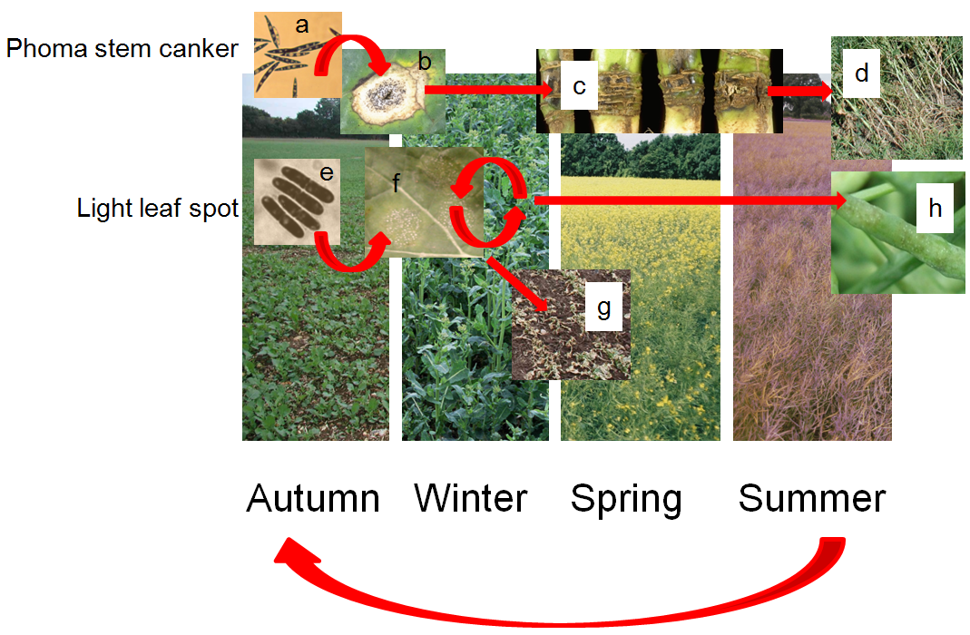
Figure 1.

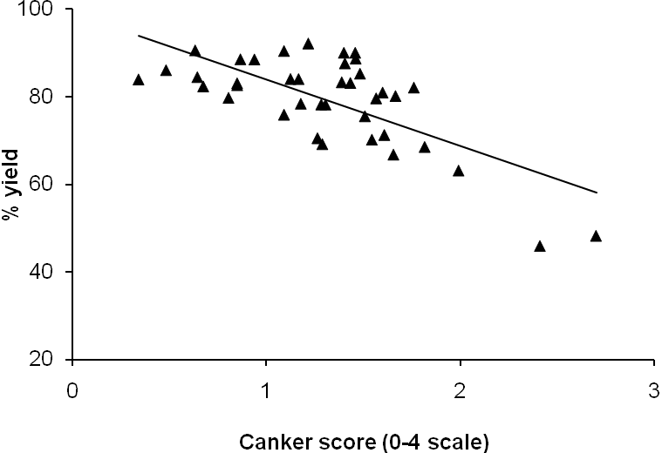
Figure 2.

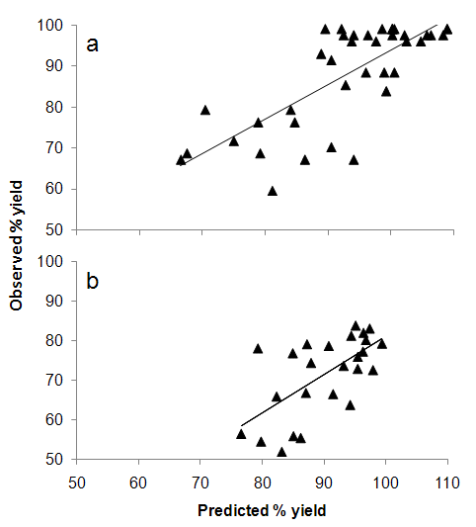
Figure 3.

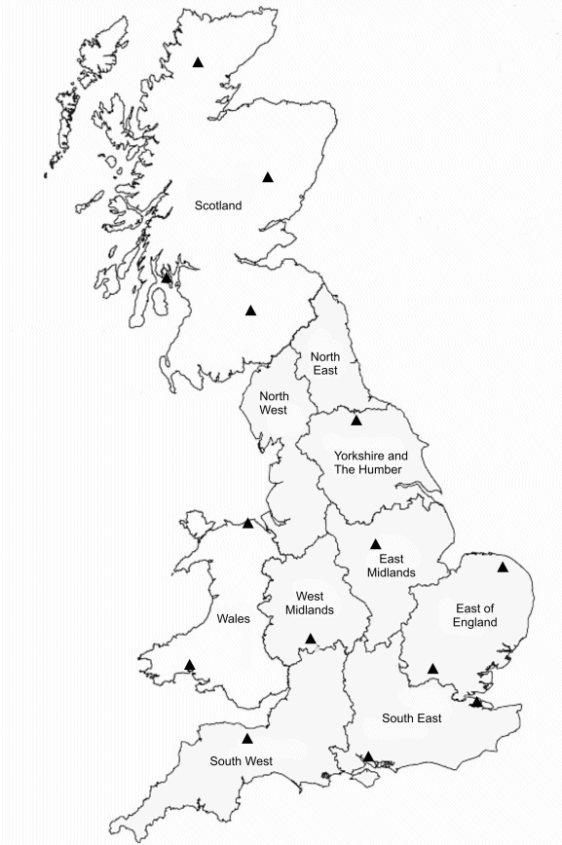

Figure 4.

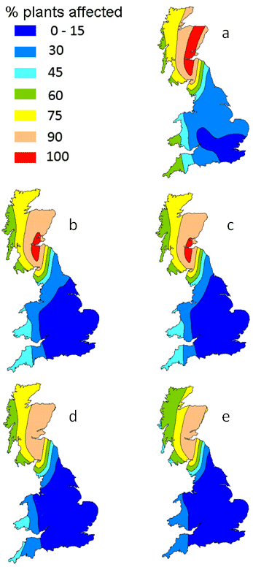
Figure 5.

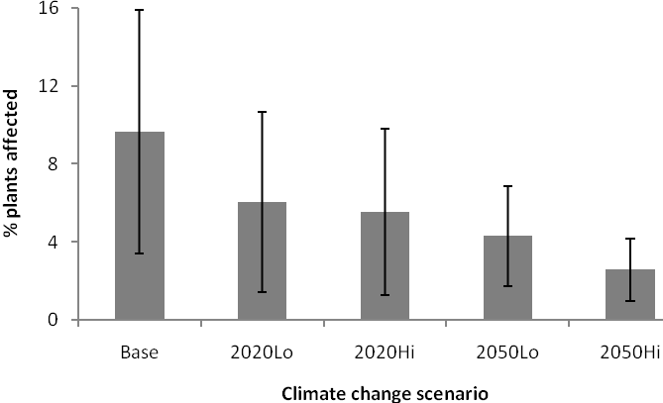

Figure 6.

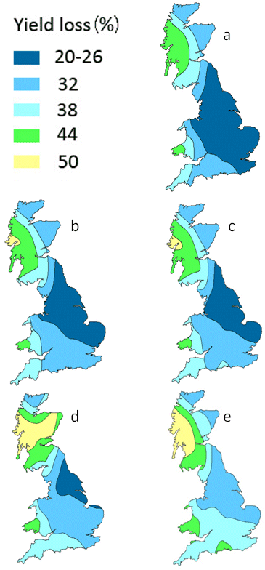
Figure 7.

Table 1 Details of winter oilseed rape field experiments in England, including locations, cultivars and harvest seasons, that provided data on severity of basal phoma stem canker and yield of plots with or without fungicide treatments that were used to construct and validate the model for describing the relationship between canker severity and yield loss (yield of plots with severe canker was expressed as a percentage of the yield of plots in which the disease was controlled by the fungicide programme1
Location | Harvest season(s) | Cultivars  (resistance rating at time²) | No. fungicide treatments³ | Purpose
Boxworth | 1997 | Rocket (4) | 2 | Model validation
Boxworth | 1998 | Apex (6) (3 experiments)  Bristol (5) | 2 | Model validation
Boxworth | 1999 | Apex (6) (2 experiments) | 2 | Model validation
Boxworth | 2000 | Pronto (5) (3 experiments) | 2 | Model validation
Boxworth | 2001 | Apex (6) (2 experiments)  Pronto (5) (4 experiments) | 2 | Model validation
Boxworth | 2002 | Apex (6) (2 experiments)  Pronto (5)  Escort (7) | 2 | Model validation
High Mowthorpe | 2001 | Pronto (5) | 2 | Model validation
Rothamsted | 1997 | Capitol (6) | 2 | Model validation
Rothamsted | 2000 | Apex (6) | 2 | Model validation
Rothamsted | 2006 | 20 different cvs (3-8)⁴ | 2 | Model construction
Rothamsted | 2007 | 19 different cvs (3-8)⁴ | 2 | Model construction
Withington | 1993 | Envol (5)⁵ | 22 | Model validation

¹ Only experiments in which the optimum fungicide treatment programme provided good control of phoma stem canker were used for model construction or validation.
² Numbers in parentheses indicate cultivar rating for resistance to L. maculans from the HGCA Recommended List for winter oilseed rape for that season, or its predecessors (9, very resistant; 1 very susceptible, www.hgca.com). Cultivars with a rating of 1-5 were regarded as susceptible and cultivars with a resistance rating of 6-9 as resistant.
³ For most experiments, there was a comparison between untreated plots and plots that received a full disease control programme consisting of autumn and spring treatments. However for the Withington 1993 experiment, there were 22 different fungicide treatments, including untreated. Canker symptoms were assessed in late June/ early July using the 0-4 scale (Zhou et al. 1999).
⁴ Cultivars: Apex, Bristol , Canberra, Castille, Courage, Disco, Elan, ES Astrid, Escort, Expert, Fortis, Hearty, Lioness, NK Bravour, NK Victory, Ontario, Recital, Royal, Shannon and Winner. Data from one cv (Hearty) in 2007 only, was omitted from model construction due to yield effects caused by light leaf spot, which was moderately severe on that cultivar only. Three replicated plots per cultivar were treated with an autumn foliar fungicide regime (2 sprays) and a further three replicates were untreated. Mean yields of the fungicide untreated plots per cultivar were expressed as '% yield,' i.e. a percentage of the respective fungicide-treated plot yield for that cultivar. Phoma stem canker symptoms were recorded in mid-late June 2006 and 2007, using the HGCA 0-6 scale based on the extent of girdling by canker at the stem base (0 = uninfected, 1 = < 25% stem circumference girdled, 2 = 26-50% girdled, 3 = > 51-75% girdled, 4 = > 76-100% girdled, 5= 100% girdled + stem weak, 6 = plant dead or lodged) (http://www.oregin.info/information/sops/OSR_field_experiment.htm) and converted to the 0-4 scale ( Zhou et al.1999).
⁵ Canker symptoms were assessed on 12 July using the 0-4 scale; more details of the different fungicide treatments are given in Zhou et al. (1999).

Table 2 Effects of climate change on the output of winter oilseed rape (treated with fungicide), calculated by region. The area grown per region (2006) and the predicted regional output are given for the baseline (1960-1990), 2020LO (low CO₂ emissions), 2020HI (high emissions), 2050LO and 2050HI climate scenarios and presented in thousands of pounds (£000s). The yield figures were calculated after interpolating the results from the oilseed rape yield predictions according to UK government region and then multiplied by an average price of £195.60 t⁻¹.

Value of oilseed rape crop (£000s)
Region ª | Baseline | 2020LO | 2020HI | 2050LO | 2050HI
North East | 14,098 | 13,168 | 14,536 | 14,646 | 14,812
North West | 2,097 | 2,024 | 1,861 | 2,115 | 2,169
Yorkshire & Humberside | 37,220 | 35,342 | 38,251 | 38,126 | 38,358
East Midlands | 69,007 | 69,480 | 69,277 | 69,744 | 70,874
West Midlands | 20,194 | 20,121 | 16,839 | 20,900 | 21,726
Eastern | 63,885 | 63,854 | 63,661 | 65,792 | 66,907
London and South East | 46,508 | 46,867 | 46,939 | 48,216 | 49,700
South West | 26,742 | 26,831 | 26,873 | 27,570 | 28,538
England total | 279,749 | 277,688 | 278,237 | 287,110 | 293,085
Scotland | 22,038 | 23,086 | 23,600 | 24,182 | 24,567
UK total | 301,787 | 300,774 | 301,837 | 311,292 | 317,652

ª Government regions can be found at http://www.statistics.gov.uk/geography/downloads/uk_gor_cty.pdf

Table 3 Effects of climate change on the losses from phoma stem canker and light leaf spot (for cultivars with average resistance) in winter oilseed rape crops not treated with fungicide. The values are given for the baseline (1960-1990), 2020LO (low CO₂ emissions), 2020HI (high emissions), 2050LO and 2050HI climate scenarios and presented in thousands of pounds (£000s). The figures were calculated after interpolating the results from the stem canker and the light leaf spot yield loss predictions according to UK government region and then multiplied by an average price of £195.60 t⁻¹.

Value of losses caused by phoma stem canker and light leaf spot (£000s)^{b}
Region ª | Baseline | 2020LO | 2020HI | 2050LO | 2050HI
North East | 3,431 | 3,526 | 3,934 | 4,208 | 4,630
North West | 520 | 533 | 501 | 602 | 676
Yorkshire & Humberside | 7,804 | 8,118 | 9,074 | 9,661 | 10,874
East Midlands | 15,116 | 16,869 | 17,567 | 18,871 | 21,748
West Midlands | 5,038 | 5,539 | 4,716 | 6,244 | 7,308
Eastern | 14,481 | 16,179 | 16,582 | 18,454 | 21,359
London and South East | 12,388 | 13,540 | 13,874 | 15,381 | 17,882
South West | 7,910 | 8,198 | 8,337 | 8,996 | 10,191
England total | 66,690 | 72,502 | 74,584 | 82,417 | 94,668
Scotland | 7,109 | 7,663 | 7,901 | 10,240 | 9,067
UK total | 73,890 | 80,165 | 82,485 | 92,657 | 103,735

ª Government regions can be found at http://www.statistics.gov.uk/geography/downloads/uk_gor_cty.pdf
^{b} The stem canker and light leaf spot loss predictions depend on the crop yield predictions in Table 2.

Table 4 Effects of climate change on the yield of untreated oilseed rape after phoma stem canker and light leaf spot losses, calculated by region. The area grown per region (2006) and the predicted total regional yield are given for the baseline (1960-1990) scenario. The total regional yield as a percentage of the baseline scenario is given for the 2020LO (low CO₂ emissions), 2020HI (high emissions), 2050LO and 2050HI climate scenarios. The figures were calculated after interpolating the results from the treated oilseed rape yield predictions, the stem canker yield loss predictions and the light leaf spot loss predictions according to UK government region.

 | Area of oilseed rape grown (ha) b | Baseline total yield (t) | Yield (% of baseline yield)
Region ª |  |  | 2020LO | 2020HI | 2050LO | 2050HI
North East | 22,787 | 72,649 | 90.4 | 99.4 | 97.9 | 95.5
North West | 3,601 | 10,769 | 94.5 | 86.2 | 96.0 | 94.7
Yorkshire & Humberside | 61,068 | 189,125 | 92.6 | 99.2 | 96.8 | 93.4
East Midlands | 113,479 | 342,630 | 97.6 | 96.0 | 94.4 | 91.2
West Midlands | 34,419 | 97,510 | 96.2 | 80.0 | 96.7 | 95.1
Eastern | 103,488 | 309,496 | 96.5 | 95.3 | 95.8 | 92.2
London and South East | 79,063 | 219,128 | 97.7 | 96.9 | 96.2 | 93.3
South West | 44,858 | 127,461 | 98.9 | 98.4 | 98.6 | 97.4
England total | 462,764 | 1,368,770 | 96.3 | 95.6 | 96.1 | 93.1
Scotland | 35,780 | 76,324 | 103.3 | 105.2 | 93.4 | 103.8
UK total | 498,544 | 1,165,583 | 99.4 | 99.8 | 94.9 | 97.8

ª Government regions can be found at http://www.statistics.gov.uk/geography/downloads/uk_gor_cty.pdf
^{b} Area of winter oilseed rape grown in each region in harvest year 2006 (www.defra.gov.uk)

Table 5 Effects of climate change on the output of untreated winter oilseed rape (for cultivars with average resistance) after phoma stem canker and light leaf spot losses, calculated by region. The area grown per region (2006) and the predicted regional output are given for the baseline (1960-1990), 2020LO (low emissions), 2020HI (high emissions), 2050LO and 2050HI climate scenarios and presented in thousands of pounds (£000s). The figures were calculated after interpolating the results from the treated oilseed rape yield predictions, the stem canker yield loss predictions and the light leaf spot loss predictions according to UK government region and then multiplied by an average price of £195.60 t⁻¹.
 | Value of oilseed rape crop (£000s)
Region ª | Baseline | 2020LO | 2020HI | 2050LO | 2050HI
North East | 10,666 | 9,642 | 10,602 | 10,438 | 10,182
North West | 1,576 | 1,490 | 1,359 | 1,513 | 1,493
Yorkshire & Humberside | 29,415 | 27,224 | 29,177 | 28,466 | 27,484
East Midlands | 53,891 | 52,612 | 51,711 | 50,873 | 49,126
West Midlands | 15,155 | 14,582 | 12,123 | 14,656 | 14,418
Eastern | 49,404 | 47,676 | 47,080 | 47,338 | 45,548
London and South East | 34,120 | 33,327 | 33,065 | 32,835 | 31,818
South West | 18,831 | 18,633 | 18,536 | 18,574 | 18,348
England total | 213,059 | 205,186 | 203,653 | 204,693 | 198,417
Scotland | 14,929 | 15,423 | 15,699 | 13,942 | 15,500
UK total | 227,988 | 220,609 | 219,352 | 218,635 | 213,917

ª Government regions can be found at
http://www.statistics.gov.uk/geography/downloads/uk_gor_cty.pdf
^{b} Area of winter oilseed rape grown in each region in harvest year 2006 (www.defra.gov.uk)

Table 6 Present value of the effects of climate change on oilseed rape (for cultivars with average resistance) with phoma stem canker and light leaf spot. The values are given for the baseline (1960-1990), 2020LO (low emissions), 2020HI (high emissions), 2050LO and 2050HI climate scenarios and presented in thousands of pounds (£000s). The figures were calculated after interpolating the predictions for oilseed rape yield and stem canker yield loss according to UK government region and then multiplied by a discounted average price. These data represent the present value of the predicted gains (+) or losses (-) (calculated as the difference from the baseline scenario) attributable to climate change for each region. The values have been discounted to 2008 prices using a discount rate of 3.5% for the 2020s and 3.0% for the 2050s.

Present value of the effects of climate change (£000s)
Region ª Scenario | 2020LO | 2020HI | 2050LO | 2050HI
North East | -678 | -43 | -66 | -140
North West | -57 | -143 | -18 | -24
Yorkshire & Humberside | -1,450 | -158 | -274 | -558
East Midlands | -846 | -1,443 | -872 | -1,377
West Midlands | -379 | -2,007 | -144 | -213
Eastern | -1,144 | -1,538 | -597 | -1,114
London and South East | -525 | -698 | -371 | -665
South West | -131 | -195 | -74 | -140
England total | -5,210 | -6,225 | -2,417 | -4,231
Scotland | 327 | 510 | -285 | 165
UK total | -4,883 | -5,715 | -2,703 | -4,066

ª Government regions can be found at http://www.statistics.gov.uk/geography/downloads/uk_gor_cty.pdf

