Title: A comparison of methods to estimate anaerobic capacity: Accumulated oxygen deficit and W’ during constant and all-out work-rate profiles.
Running title: AOD and W’ during constant-load and all-out exercise

Abstract
This study investigated i) whether the accumulated oxygen deficit (AOD) and the curvature constant of the power-duration relationship (W’) are different during constant work-rate to exhaustion (CWR) and 3-min all-out (3MT) tests; and ii) the relationship between AOD and W’ during CWR and 3MT. Twenty-one male cyclists (age: 40 ± 6 years; maximal oxygen uptake (V̇O_{2max}): 58 ± 7 ml·kg⁻¹·min⁻¹) completed preliminary tests to determine the V̇O₂-power output relationship and V̇O_{2max}. Subsequently, AOD and W’ were determined as the difference between oxygen demand and oxygen uptake and the work completed above critical power, respectively, in CWR and 3MT. There were no differences between tests for duration, work, or average power output (p ≥ 0.05). AOD was greater in the CWR test (4.18 ± 0.95 vs. 3.68 ± 0.98 L; P = 0.004), whereas W’ was greater in the 3MT (9.55 ± 4.00 vs. 11.37 ± 3.84 kJ; P = 0.010). AOD and W’ were significantly correlated in both CWR (p < 0.001, r = 0.654) and 3MT (p < 0.001, r = 0.654). In conclusion, despite positive correlations between AOD and W’ in CWR and 3MTs, between-test differences in the magnitude of AOD and W’, suggests that the measures have different underpinning mechanisms.
Abstract word count: 203
Key words: AOD, high-intensity, anaerobic work capacity, anaerobic
Introduction
At the onset of exercise, ATP in skeletal muscle is continuously resynthesised by the interaction of different, but closely integrated, aerobic and anaerobic energy pathways (Gastin, 2001). However, whilst aerobic energy production is relatively easy to quantify as the rate of oxygen uptake at the mouth (V̇O₂) (Poole et al., 1991), quantification of anaerobic energy production remains challenging (Noordhof, de Koning, & Foster, 2010; Noordhof, Skiba, & de Koning, 2013). Direct methods for quantifying anaerobic capacity are invasive and/or expensive, and, as a consequence, anaerobic capacity is more commonly estimated using indirect tests (Noordhof et al., 2013).
A common test to estimate anaerobic capacity is the accumulated oxygen deficit (AOD), as proposed by Medbø et al. (1988). The AOD determines the difference between the accumulated oxygen demand and the accumulated oxygen uptake and can be determined from a constant work-rate test to exhaustion (CWR) at a supramaximal intensity (i.e. above maximal V̇O₂ [V̇O_{2max}]); or an all-out test of known duration. In order to be considered as a measure of anaerobic capacity, AOD needs to reach its maximum value. Using a supramaximal CWR, it has been shown that the highest AOD is attained in tests lasting 2-5 min, which corresponds to intensities of 110-120% of V̇O_{2max} (Medbø et al., 1988; Muniz-Pumares, Pedlar, Godfrey, & Glaister, 2006; Weber & Schneider, 2001). The AOD, determined during all-out efforts, also appears to be sensitive to the duration of the test. All-out tests shorter than 60 s tend to underestimate anaerobic capacity. Instead, if the all-out effort lasts 60-90 s, the AOD seems to plateau and reach its maximum value (Calbet, Chavarren, & Dorado, 1997; Gastin, Costill, Lawson, Krzeminski, & McConell, 1995; Withers et al., 1991; Withers, Ploeg, & Finn, 1993). The effect of all-out efforts longer than 90 s on the AOD has not been studied. It is important to note that the AOD relies on the assumptions that i) the oxygen demand can be extrapolated from the V̇O₂-power output relationship determined at submaximal intensities; and ii) for a given power output, the required oxygen demand is not altered during high-intensity exercise. Whilst both assumptions have been questioned, and are considered to be a limitation of the test, the AOD is considered to be the best non-invasive test to estimate anaerobic capacity (Noordhof et al., 2010).
Another approach to estimate anaerobic capacity has been derived from the parameters of the hyperbolic power output-duration relationship. The first component is the asymptote of the hyperbola, termed critical power, which represents the boundary between the ‘heavy’ and ‘severe’ exercise domains (Hill, 1993; Jones, Vanhatalo, Burnley, Morton, & Poole, 2010; Poole, Burnley, Vanhatalo, Rossiter, & Jones, 2016). The second component is the curvature constant (W’), which represents a fixed amount of work that can be performed above critical power (Chidnok et al., 2013; Morton, 2006). Traditionally, W’ has been described as ‘anaerobic work capacity’, and thought to represent work produced using anaerobic energy sources (e.g. Hill, 1993; Morton, 2006). However, it has been recently suggested that the precise aetiology of W’ may be more complex than originally thought, leaving its underpinning mechanisms unresolved (Broxterman et al., 2015; Dekerle et al., 2015; Murgatroyd, Ferguson, Ward, Whipp, & Rossiter, 2011; Poole et al., 2016; Simpson et al., 2015; Skiba, Chidnok, Vanhatalo, & Jones, 2012). Nonetheless, W’ is affected by glycogen content (Miura, Sato, Whipp, & Fukuba, 2000) and creatine supplementation (Smith, Stephens, Hall, Jackson, & Earnest, 1998). Moreover, W’ depletion results in the build-up of fatigue-inducing metabolites associated with anaerobic energy production (Jones, Wilkerson, Dimenna, Fulford, & Poole, 2008; Poole, Ward, Gardner, & Whipp, 1988), and the rate of accumulation of those metabolites is proportional to the rate of W’ depletion (Vanhatalo, Fulford, DiMenna, & Jones, 2010). As a result, the magnitude of W’ typically remains constant irrespective of the its rate of depletion (Chidnok et al., 2013; Fukuba et al., 2003; cf. Dekerle et al., 2015; Jones, Wilkerson, Vanhatalo, & Burnley, 2008).
The traditional method of determining W’ was to model the results of 4-6 bouts of CWR exercise to exhaustion. However, the time-consuming demands of the protocol makes the approach very impractical. Vanhatalo et al. (2007) observed that the end-power output during a 3-min all-out test (3MT) corresponded to critical power; whilst the work performed above end-power output corresponded to W’. If this new approach to determining W’ is valid, it should produce the same strong positive correlations with AOD as those reported when W’ is determined using the traditional approach (Chatagnon, Pouilly, Thomas, & Busso, 2005; Miura, Endo, Sato, Barstow, & Fukuba, 2002),
The aims of this study, therefore, were i) to determine whether AOD and W’ remain constant irrespective of their rate of depletion (i.e. CWR vs. 3MT); and ii) to investigate the relationship between AOD and W’ during CWR and 3MT. It was hypothesised that both the AOD and W’ would not be affected by the exercise mode. It was also hypothesised that W’ and AOD would be strongly and positively correlated in both the CWR and 3MT.
Methods
Participants
Twenty-one trained male cyclists and triathletes volunteered to participate in this study, which was approved by St Mary’s University Ethics Committee. Their mean ± standard deviation (SD) for age, height and mass were 40 ± 6 years, 1.81 ± 0.08 m and 79.8 ± 7.5 kg, respectively. The participants were recruited from local cycling and triathlon clubs and can be classified as ‘trained’ (performance level 3; De Pauw et al., 2013). All participants provided written informed consent.
Procedures
The study consisted of four trials in an exercise physiology laboratory with controlled environmental conditions (19 ± 1 °C; 33 ± 5% relative humidity). All tests were performed on an electromagnetically braked cycle-ergometer (Lode Excalibur Sport, Groningen, Netherlands). The cycle-ergometer was individually adjusted for cyclists comfort and performance. All subsequent tests were performed using the same settings on the cycle-ergometer and at approximately the same time of the day (± 1 h). After two preliminary trials to determine the gas exchange threshold (GET), the V̇O₂–power output relationship, and V̇O_{2max}; participants completed a CWR at 112.5% of V̇O_{2max} and a 3MT. All trials were separated by at least 48 h to allow complete recovery. The participants were provided with a food record diary and were advised to follow a similar diet and to avoid strenuous exercise in the 24 h before each trial. Similarly, they were requested to avoid caffeine and alcohol ingestion 12 h before each trial.
Preliminary tests
The preliminary tests included two trials. In Trial 1, participants completed a ramp test to exhaustion. The test started with 3 min of unloaded cycling. The resistance of the flywheel increased thereafter at a constant rate of 30 W∙min⁻¹ until exhaustion, defined in this study as a decrease in cadence of > 10 rpm for > 5 s despite strong verbal encouragement. The cadence was freely chosen by each participant and kept constant throughout the test. The preferred cadence was recorded and replicated in subsequent trials. Common to all trials was the measurement of gas exchange using an online, rapid response gas analyser (Oxycon Pro, Jaeger, Hoechberg, Germany). Participants breathed through a silicone facemask connected to a mouthpiece and a low resistance (0.75 mmHg.L⁻¹.s⁻¹) turbine assembly (Triple V, Jaeger, Hoechberg, Germany). Ventilation volume and gas concentrations were continuously sampled at 100 Hz and analysed using differential paramagnetic (O₂) and infrared absorption (CO₂) analysers, respectively, so that V̇O₂, V̇CO₂ and minute ventilation were calculated and displayed breath-by-breath for subsequent analysis. The gas analyser was calibrated prior each trial using gases of known concentration and ambient air. The GET was independently identified by two investigators using the V-slope method (Beaver, Whipp, & Wasserman, 1986), and the average of the two values was used for subsequent calculations. In instances where GET estimates differed by > 10%, a third investigator determined the GET, and the average of the two closest estimates was used for analysis. Trial 2 consisted of 10 × 3-min consecutive steps to determine the relationship between V̇O₂ and power output, followed by a ramp test to exhaustion to determine V̇O_{2max}. The first step was performed at 50% GET and the intensity increased by 10% GET in each subsequent step, so that the final work rate corresponded to 140% GET. Steps were interspersed with 30 s of rest to allow a capillary blood sample to be drawn from the earlobe using a 20 μL tube (EKF Diagnostics, Barleben, Germany). Whole blood samples were analysed for blood lactate concentration (BLa) using an enzymatic-amperometric method (Biosen C-line, EKF Diagnostic, Germany). After completion of the final step, participants were allowed 5 min of stationary rest on the ergometer. Cycling was resumed at 70% GET, and increased at a rate of 15% GET every minute until volitional exhaustion (as defined above). V̇O_{2max} was determined as the highest V̇O₂ obtained from a 30-s rolling average, which excluded breath-by-breath values outside 4 SD from a local (5-breath) average (Lamarra, Whipp, Ward, & Wasserman, 1987). Finally, after ~25 min of rest, participants performed a CWR test to exhaustion at ~112.5% of the V̇O_{2max} (see below) that was used for familiarisation purposes only.
Constant-work rate test to exhaustion
The CWR commenced with 3 min of unloaded cycling followed by 5 min at 70% GET. Then, after 5 min stationary rest on the cycle-ergometer, participants were instructed to attain their preferred cadence after a 5-s countdown. The power output during the CWR test corresponded to 112.5% V̇O_{2max}, determined from linear extrapolation of the relationship between V̇O₂ and power output. The assumption of a linear V̇O₂-power output relationship has been challenged, though using 3-min stages, a linear relationship has been observed during for intensities up to ~95% V̇O_{2max}, which allows estimation of supramaximal oxygen demands with 6.7% test-retest variability (Muniz-Pumares, Pedlar, Godfrey, & Glaister, 2015). Moreover, a CWR at 112.5% has been shown to elicit the greatest AOD (Muniz-Pumares et al., 2016). V̇O₂ values to construct the V̇O₂-power output relationship were determined from each stage as the highest V̇O₂ derived from a 30-s rolling average (see above). Participants were instructed before, and encouraged throughout the test to exercise for as long as they possibly could, but were unaware of elapsed time or expected duration. Capillary blood samples were drawn 1, 3 and 5 min after exhaustion for BLa determination.
3-min all-out test
The 3MT was performed as outlined by Vanhatalo et al. (2007). The trial commenced with 5 min cycling at 70% GET and a further 5 min resting on the cycle ergometer. Participants then completed 3 min of unloaded pedalling at their preferred cadence. In the last 10 seconds of the unloaded phase, they were instructed to increase their cadence to 110–120 rpm. At the start of the 3MT, the cycle-ergometer switched to linear mode, so that the resistance (i.e. power output) represented a function of the cadence. The alpha factor for the linear mode was determined to elicit a power output at each participant’s preferred cadence corresponding to 50% of the difference between the intensity at GET and that at the end of the ramp test. The subjects were instructed before the test to attain peak power (i.e. highest cadence) as soon as possible and to maintain the highest possible cadence throughout the test. Strong verbal encouragement was provided by the same investigator throughout the duration of the test. As in the CWR test, time cues were removed from the area to prevent pacing. All participants completed one familiarization trial of the 3MT that was not included in data analysis. The criteria to deem a 3MT as valid is yet to be established. Nevertheless, it has been reported that, during a 3MT: i) peak power is typically attained within the first 10 s (Vanhatalo, Doust, & Burnley, 2007); ii) peak V̇O₂ corresponds to 97-99% V̇O_{2max} (Burnley, Doust, & Vanhatalo, 2006; Sperlich, Haegele, Thissen, Mester, & Holmberg, 2011; Vanhatalo et al., 2007), although there seems to be large intrasubject variability (Sperlich et al., 2011); iii) W’ is depleted to ~5% of its initial value within the first 90 s (Vanhatalo, Doust, & Burnley, 2008); and iv) end-test cadence should be within ±10 rpm of each participant’s preferred cadence, or otherwise it may affect W’ (Vanhatalo et al., 2008). As in the CWR test, capillary BLa was determined 1, 3 and 5 min after the 3MT test.
Data analyses
The AOD was determined as the difference between the estimated oxygen demand and accumulated oxygen uptake (Medbø et al., 1988). In the CWR test, the oxygen demand was equivalent to 112.5% V̇O_{2max}. Since power output remains constant during the CWR test, we assumed that oxygen demand was constant also (Medbø et al., 1988). The accumulated oxygen demand, therefore, was estimated as the product of oxygen demand and the time to exhaustion (TTE). In the 3MT, raw recording of power output (6 Hz) were averaged at 1 s intervals to produce second-by-second values. The second-by-second oxygen demand was calculated from a linear projection of the V̇O₂-power output relationship. Subsequently, the accumulated oxygen demand was determined as the integral of second-by-second oxygen demand. Breath-by-breath V̇O₂ data were filtered (as described above) and linearly interpolated to produce second-by-second values. The accumulated oxygen uptake was determined as the integral of second-by-second V̇O₂. End-exercise V̇O₂ and oxygen demand were determined in CWR and 3MT as the average V̇O₂ and oxygen demand, respectively, in the last 10 s of the CWR and 3MT. In the 3MT, critical power was considered to be the average power output in the last 30 s of the test. W’ was determined from the 3MT (W’_{3MT}) as the integral of power output above critical power. Assuming no change in critical power (Chidnok et al., 2013), W’_{CWR} was determined as the work completed above critical power during CWR. Figure 1 outlines the protocol to determine AOD and W’ during the CWR and 3MT (AOD_{CWR}, AOD_{3MT}, W’_{CWR}, and W’_{3MT}, respectively).
Statistical analyses
Data are presented as mean ± SD. Using IBM SPSS 21 (IBM Corp, Armonk, NY), physiological responses to CWR and 3MT were compared using paired samples t-tests. The magnitude of the differences between CWR and 3MT were expressed as the effect size using Cohen’s d, calculated as the absolute difference between means divided by the pooled SD (Cumming, 2012). Qualitative descriptors of the effect size were as follows: negligible (d < 0.19), small (d = 0.20 – 0.49), moderate (d = 0.50 – 0.79), or large (d > 0.8). V̇O_{2max} and peak V̇O₂ during the CWR and 3MT were compared using repeated measures analysis of variance, and a post hoc Bonferroni t-test was conducted to locate differences between trials if a significant F value was detected. Pearson product-moment correlations were determined between AOD_{3MT} and W’_{3MT}, and between AOD_{CWR} and AOD_{3MT}. In all instances, significance was accepted at P < 0.05.
Figure 1 near here
Results
Preliminary tests
In the ramp test, GET occurred at 188 ± 25 W and peak power output corresponded to 397 ± 46 W, so 50%∆ was 293 ± 34 W. For the 10 × 3 min step test, the intensity at 50% GET was 94 ± 13 W and increased by 19 ± 3 W in each step, so the final intensity was 263 ± 36 W. These work rates corresponded to intensities from 41 ± 4% to 84 ± 7% V̇O_{2max}, and raised BLa from 0.97 mmol∙L⁻¹ at the end of the first stage to 3.93 ± 1.72 mmol∙L⁻¹ for the last stage. The relationship between V̇̇O₂ and power output was well described by linear regression for all participants (P < 0.001; r = 0.995 ± 0.004); characterised by a slope of 11.74 ± 0.90 mL·min⁻¹·W⁻¹ and a y-intercept of 773 ± 163 mL. In the ramp test of Trial 2, V̇O_{2max} was 4.60 ± 0.61 L∙min⁻¹ (58 ± 7 mL∙kg⁻¹∙min⁻¹).
Constant work-rate to exhaustion and 3-min all-out tests
The results from CWR and 3MT are presented in Table 1. The average power output during the 3MT was, incidentally, the same as in the CWR (with identical standard deviation). The duration of the CWR was ~2.7 min (not significantly different from that of the 3MT). Similarly, there were no differences between CWR and 3MT for total work and peak HR, but BLa was greater after 3MT compared to CWR. There was a significant effect of trial on maximal values attained for V̇O₂ (P < 0.001). Specifically, post-hoc tests revealed that peak V̇O₂ during the CWR was lower than both V̇O_{2max} determined in the ramp test (P < 0.001) and peak V̇O₂ during the 3MT (P = 0.005). All participants completed a valid 3MT given that: i) peak power (645 ± 127 W) was attained at the beginning of the test (6 ± 4 s); ii) peak V̇O₂ approached V̇O_{2max} (98 ± 5% V̇O_{2max}); iii) W’ was depleted to < 15% of its initial value after 90 s (6 ± 4%); and iv) the end-test cadence was within 10 rev·min⁻¹ of the preferred cadence (4 ± 4 rev·min⁻¹). Estimations of CP and W’ derived from the 3MT were 316 ± 50 W (67 ± 8% of the difference between GET and V̇O_{2max}) and 11.37 ± 3.84 kJ, respectively.
Table 1 near here
Estimation of anaerobic capacity from AOD and W’
There were differences for both estimations of anaerobic capacity between CWR and 3MT. Specifically, W’ in the 3MT (W’_{3MT}) was ~19% greater than of W’_{CWR} (9.55 ± 4.00 vs.11.37 ± 3.84 kJ, small effect) whilst AOD_{CWR} was ~13% greater than AOD_{3MT} (4.18 ± 0.95 vs. 3.68 ± 0.98 L O₂; moderate effect; Table 1; Figure 2). In the CWR test, AOD represented 31 ± 7% of the total oxygen demand, more than the contribution of W’ to all work (20 ± 12%; P < 0.001; d = 1.17). In contrast, there were no differences between estimations of the relative contribution of AOD and W’ to total oxygen demand and work in the 3MT derived from AOD and W’ (Table 1; 23 ± 5% vs. 17 ± 6%; P = 0.175; d = 1.36). The relationship between AOD and W’ are presented in Figure 3. AOD and W’ were significantly and positively correlated in both the CWR (r = 0.654; P < 0.001) and 3MT (r = 0.664; P < 0.001).
Figure 2 near here
Discussion
The aim of the present study was to investigate AOD and W’, two parameters suggested to estimate anaerobic capacity, during a CWR and a 3MT. The main findings of the study were that i) both AOD and W’ were affected by the work-rate profile adopted and therefore different between the CWR and 3MT; ii) the differences observed between CWR and 3MT in AOD and W’ followed contrasting directions such that AOD was greatest in CWR, whilst W’ was greatest in 3MT; iii) there was a positive correlation between AOD and W’; and vi) the strength of the correlation between AOD and W’ was similar irrespective of the work-rate profile (i.e. CWR vs. 3MT). These results suggest that, although ~43% of the variance of AOD and W’ is determined by a shared factor, most likely related to anaerobic energy production, these two parameters should not be used interchangeably. Moreover, these data suggest that neither AOD nor W’, the two traditional approaches to determine anaerobic capacity, appear to truly estimate this physiological construct, and indeed challenges whether anaerobic capacity can actually be measured indirectly.
In the present study, both AOD and W’ were sensitive to the work-rate profile, as denoted by the differences between both estimates of anaerobic capacity during CWR and 3MT. However, those differences followed contrasting directions. Previous research has shown that W’ remains unaffected irrespective of its rate of depletion (Chidnok et al., 2013; Fukuba et al., 2003; Vanhatalo et al., 2008); although, it has been shown that sudden (Dekerle et al., 2015) or progressive (Jones et al., 2008) decreases in power output might augment W’, and therefore delay exercise intolerance. In order to accept that W’ remains constant irrespective of its rate of depletion, it is necessary to assume that aerobic energy production supplies power output at intensities below critical power from the onset of exercise (Jones, Vanhatalo, Burnley, Morton, & Poole, 2010; Morton, 2006), which, in turn, implies infinitely fast V̇O₂ kinetics (Figure 1D). Despite this limitation, it is assumed that W’ remains constant during a CWR test lasting > 3 min (Morton, 2006). Indeed, Chidnok et al. (2013) observed constant W’ irrespective of the work-rate profile during a 3MT and a CWR of ~3.1 min. In the current study the duration of the CWR test was not different from 3 min (~2.7 min), so it is not clear why W’ was different between CWR and 3MT protocols.
The AOD is thought to reach its peak value, and therefore provide an estimate of anaerobic capacity, during CWRs in which exhaustion occurs within 2-4 min (Medbø et al., 1988) or during all-outs test of at least 60 s (Gastin et al., 1995; Withers et al., 1993). In the present study, despite CWR and 3MT meeting those two conditions, AOD_{CWR} was 12% greater than AOD_{3MT}. It is possible that, given the progressive increase in V̇O₂ and decrease in power output observed during an all-out test, V̇O₂ at the end of the 3MT was greater than the oxygen demand, decreasing AOD_{3MT}. However, V̇O₂ and oxygen demand at the end of the 3MT were similar (Table 1, Figure 1), and most of the AOD occurs at the onset of all-out tests (see Figure 1). Alternatively, at the onset of the 3MT there is a higher demand on ATP turnover which can accelerate kinetics of V̇O₂ and, possibly, reduce the AOD (Jones et al., 2008). Then again, studies that have examined the effects of work-rate profiles during 2-6 min trials have reported that an all-out start has no effect on the AOD (Aisbett, Lerossignol, McConell, Abbiss, & Snow, 2009; Bishop, Bonetti, & Dawson, 2002). Moreover, BLa and pH, which can also be considered markers of anaerobic energy production, remain unaffected by an all-out start (Aisbett et al., 2009; Bishop et al., 2002; Chidnok et al., 2013). In contrast, the higher BLa observed in 3MT in the current study may be indicative of a greater perturbation in the muscular milieu during the 3MT, which in turn would affect the V̇O₂ kinetics (e.g. Korzeniewski & Zoladz, 2015), and therefore AOD. Whilst the increased BLa suggests higher metabolic disturbance during the 3MT, there is evidence that all-out and CWR tests result in similar intramuscular metabolic perturbation (Burnley, Vanhatalo, Fulford, & Jones, 2010). Intramuscular metabolites were not quantified in the present study, and therefore, it is difficult to account for the effect that possible differences in the metabolic milieu between CWR and 3MT might contribute to explain the observed difference between AOD_{3MT} and AOD_{CWR}. Irrespective of the mechanisms, the current investigation suggests that the work-rate profile affects both AOD and W’, so that neither remain constant during a CWR and 3MT.
Another finding of the current study was the positive correlation observed between AOD and W’, which is consistent with previous research using cycle ergometry in healthy adults (Chatagnon et al., 2005; Miura et al., 2002) and children (Leclair et al., 2010). Whilst in the above studies W’ was determined from several CWRs, the present study demonstrates that the relationship holds true when W’ is determined from the more time-efficient 3MT. Moreover, the strength of the correlation between AOD and W’ reported previously (0.56 ≤ r ≤ 0.76) compares well with the results of the present study. Overall, results suggest that, in cycling, some 34-58% of the variance of AOD and W’ is underpinned by a shared mechanism, likely related to anaerobic energy production. In contrast, the same relationship has not been observed between D’, the running equivalent of W’, and AOD (Bosquet, Duchene, Delhors, Dupont, & Carter, 2008; Zagatto et al., 2013). Though unlikely to explain these discrepancies between studies, the time constant of the primary phase and the slow component of V̇O₂ kinetics contribute to determine both W’ (Murgatroyd, Ferguson, Ward, Whipp, & Rossiter, 2011) and AOD (Rossiter, 2011), and these two parameters are different between cycling and running (Hill, Halcomb, & Stevens, 2003; Pringle, Carter, Doust, & Jones, 2002). Nevertheless, the results of the present study suggest that factors other than anaerobic energy production appear to determine the magnitude of AOD and/or W’, and their relationship.
During a high-intensity bout of exercise at intensities above CP, peak V̇O₂ has been shown to correspond with V̇O_{2max}, irrespective of the work-rate profile, by some (Aisbett, Le Rossignol, & Sparrow, 2003; Aisbett et al., 2009; Bishop et al., 2002; Burnley et al., 2006; Chidnok et al., 2013; Jones et al., 2008; Simpson et al., 2015; Sperlich et al., 2011), but not all (Bailey, Vanhatalo, DiMenna, Wilkerson, & Jones, 2011; Sawyer, Morton, Womack, & Gaesser, 2012; Vanhatalo et al., 2008) studies. In the present investigation, peak V̇O₂ during the CWR and ~94% V̇O_{2max,} whereas peak V̇O₂ during the 3MT was within ~2% of V̇O_{2max}. Given similarities in mean power output, duration, heart rate, and total work between 3MT and CWR (Table 1), it is not clear why peak V̇O₂ did not reach V̇O_{2max} during the CWR test. It can be hypothesised that slower V̇O₂ kinetics during the CWR test (see above) resulted in a larger anaerobic energy contribution, as denoted by a greater AOD_{CWR} (Table 1), and as a result exercise terminated before V̇O_{2max} was reached in the CWR test, but this hypothesis seems unlikely given the training status of the participants in the present study. Moreover, it has been shown that V̇O_{2max} can be attained after ~2.25 min during CWR exercise (Hill, Poole, & Smith, 2002). It is currently not clear, therefore, why V̇O₂ during CWR did not reach V̇O_{2max} in the present study.
In conclusion, this is the first study to compare two approaches to estimate anaerobic capacity (AOD and W’) during CWR and 3MT. Contrary to the assumption of a constant AOD and W’, irrespective of the work-rate profile, AOD_{CWR} and W’_{3MT} were greater than AOD_{3MT} and W’_{CWR}, respectively. Nonetheless, the correlation between AOD and W’ during CWR and 3MT suggests that ~43% of the magnitude of AOD and W’ is determined by a shared factor, likely linked to anaerobic energy production. Moreover, the strength of the correlation between AOD and W’ seems to be consistent irrespective of the type of exercise. These results suggest that anaerobic energy production is not the sole factor contributing to the magnitude of AOD and W’. Moreover, the present study suggests that factors other than anaerobic energy production contribute to AOD and W’.
References
Aisbett, B., Lerossignol, P., McConell, G. K., Abbiss, C. R., & Snow, R. (2009). Influence of all-out and fast start on 5-min cycling time trial performance. Medicine & Science in Sports & Exercise, 41, 1965–71. doi.org/10.1249/MSS.0b013e3181a2aa78
Bailey, S. J., Vanhatalo, A., DiMenna, F. J., Wilkerson, D. P., & Jones, A. M. (2011). Fast-start strategy improves V̇O₂ kinetics and high-intensity exercise performance. Medicine and Science in Sports and Exercise, 43, 457–67. doi.org/10.1249/MSS.0b013e3181ef3dce
Beaver, W., Whipp, B. J., & Wasserman, K. (1986). A new method for detecting threshold by gas exchange anaerobic. Journal of Applied Physiology, 60, 2020–2027.
Bishop, D., Bonetti, D., & Dawson, B. (2002). The influence of pacing strategy on V̇O₂ and supramaximal kayak performance. Medicine & Science in Sports & Exercise, 34, 1041–1047.
Bosquet, L., Duchene, A., Delhors, P. R., Dupont, G., & Carter, H. (2008). A comparison of methods to determine maximal accumulated oxygen deficit in running. Journal of Sports Sciences, 26, 663–670. doi.org/10.1080/02640410701744420
Broxterman, R. M., Ade, C. J., Craig, J. C., Wilcox, S. L., Schlup, S. J., & Barstow, T. J. (2015). Influence of blood flow occlusion on muscle oxygenation characteristics and the parameters of the power-duration relationship. Journal of Applied Physiology, 118, 880–9. doi.org/10.1152/japplphysiol.00875.2014
Burnley, M., Doust, J. H., & Vanhatalo, A. (2006). A 3-min all-out test to determine peak oxygen uptake and the maximal steady state. Medicine and Science in Sports and Exercise, 38, 1995–2003. doi.org/10.1249/01.mss.0000232024.06114.a6
Burnley, M., Vanhatalo, A., Fulford, J., & Jones, A. M. (2010). Similar metabolic perturbations during all-out and constant force exhaustive exercise in humans: a ⁽³¹⁾P magnetic resonance spectroscopy study. Experimental Physiology, 95, 798–807. doi.org/10.1113/expphysiol.2010.052688
Calbet, J. A. L., Chavarren, J., & Dorado, C. (1997). Fractional use of anaerobic capacity during a 30- and a 45-s Wingate test. European Journal of Applied Physiology, 76, 308–313.
Chatagnon, M., Pouilly, J.-P., Thomas, V., & Busso, T. (2005). Comparison between maximal power in the power-endurance relationship and maximal instantaneous power. European Journal of Applied Physiology, 94, 711–717. doi.org/10.1007/s00421-004-1287-y
Cumming, G. (2012). Understanding the new statistics. Hove, East Sussex: Routledge.
Dekerle, J., de Souza, K. M., de Lucas, R. D., Guglielmo, L. G. A., Greco, C. C., & Denadai, B. S. (2015). Exercise tolerance can be enhanced through a change in work rate within the severe intensity domain: work above critical power is not constant. Plos One, 10, e0138428. doi.org/10.1371/journal.pone.0138428
Fukuba, Y., Miura, A., Endo, M., Kan, A., Yanagawa, K., & Whipp, B.J. (2003). The curvature constant parameter of the power-duration curve for varied-power exercise. Medicine & Science in Sports & Exercise, 35, 1413-8.
Gastin, P. B. (2001). Energy system interaction and relative contribution during maximal exercise. Sports Medicine, 31, 725–741.
Gastin, P. B., Costill, D. L., Lawson, D. L., Krzeminski, K., & McConell, G. K. (1995). Accumulated oxygen deficit during supramaximal all-out and constant intensity exercise. Medicine & Science in Sports & Exercise, 27, 255–263.
Hill, D. W., Poole, D. C. & Smith, J. C. (2002). The relationship between power and the time to achieve V̇O_{2max}. Medicine & Science in Sports & Exercise, 34, 709–714.
Jones, A. M., Vanhatalo, A., Burnley, M., Morton, R., & Poole, D. C. (2010). Critical power: Implications for determination of V̇O_{2max} and exercise tolerance. Medicine & Science in Sports & Exercise, 42, 1876–1890.
Korzeniewski, B., & Zoladz, J. A. (2015). Possible mechanisms underlying slow component of V̇O₂ on-kinetics in skeletal muscle. Journal of Applied Physiology, 118, 1240–1249. doi.org/10.1152/japplphysiol.00027.2015
Lamarra, N., Whipp, B. J., Ward, S. a, & Wasserman, K. (1987). Effect of interbreath fluctuations on characterizing exercise gas exchange kinetics. Journal of Applied Physiology, 62, 2003–12.
Leclair, E., Borel, B., Thevenet, D., Baquet, G., Mucci, P., & Berthoin, S. (2010). Assessment of child-specific aerobic fitness and anaerobic capacity by the use of the power-time relationships constants. Pediatric Exercise Science, 22, 454–66.
Medbø, J. I., Mohn, A. C., Tabata, I., Bahr, R., Vaage, O., & Sejersted, O. M. (1988). Anaerobic capacity determined by maximal accumulated O₂ deficit. Journal of Applied Physiology, 64, 50–60.
Miura, A., Endo, M., Sato, H., Barstow, T. J., & Fukuba, Y. (2002). Relationship between the curvature constant parameter of the power-duration curve and muscle cross-sectional area of the thigh for cycle ergometry in humans. European Journal of Applied Physiology, 87, 238–244. doi.org/10.1007/s00421-002-0623-3
Miura, A., Sato, H., Whipp, B. J., & Fukuba, Y. (2000). The effect of glycogen depletion on the curvature constant parameter of the power-duration curve for cycle ergometry. Ergonomics, 43, 133–41. doi.org/10.1080/001401300184693
Morton, R. H. (2006). The critical power and related whole-body bioenergetic models. European Journal of Applied Physiology, 96, 339–354. doi.org/10.1007/s00421-005-0088-2
Muniz-Pumares, D., Pedlar, C., Godfrey, R., Glaister, M. (2016). Accumulated oxygen deficit during exercise to exhaustion determined at different supramaximal work-rates. International Journal of Sports Physiology and Performance, in press.
Muniz-Pumares, D., Pedlar, C., Godfrey, R., Glaister, M. (2015). The effect of the oxygen uptake-power output relationship on the prediction of supramaximal oxygen demands. J Sports Med Phys Fitness. In press.
Murgatroyd, S. R., Ferguson, C., Ward, S. a, Whipp, B. J., & Rossiter, H. B. (2011). Pulmonary O₂ uptake kinetics as a determinant of high-intensity exercise tolerance in humans. Journal of Applied Physiology, 110, 1598–606. doi.org/10.1152/japplphysiol.01092.2010
Noordhof, D. A., Skiba, P. F., & de Koning, J. J. (2013). Determining anaerobic capacity in sporting activities. International Journal of Sports Physiology and Performance, 8, 475–82.
Noordhof, D. A., de Koning, J. J., & Foster, C. (2010). The maximal accumulated oxygen deficit method: a valid and reliable measure of anaerobic capacity? Sports Medicine, 40, 285–302. doi.org/10.2165/11530390-000000000-00000
Poole, D. C., Burnley, M., Vanhatalo, A., Rossiter, H. B., & Jones, A. M. (In press). Critical power: An important fatigue threshold in exercise physiology. Medicine & Science in Sports & Exercise. doi.org/10.1249/MSS.0000000000000939
Poole, D. C., Schaffartzik, W., Knight, D. R., Derion, T., Kennedy, B., Guy, H. J., … Wagner, P. D. (1991). Contribution of exercising legs to the slow component of oxygen uptake kinetics in humans. Journal of Applied Physiology, 71, 1245–60.
Rossiter, H. B. (2011). Exercise: Kinetic considerations for gas exchange. Compr Physiol, 1, 203–44. doi.org/10.1002/cphy.c090010
Sawyer, B. J., Morton, R. H., Womack, C. J., & Gaesser, G. a. (2012). V̇O_{2max} may not be reached during exercise to exhaustion above critical power. Medicine & Science in Sports & Exercise, 44, 1533–8. doi.org/10.1249/MSS.0b013e31824d2587
Simpson, L. P., Jones, A. M., Skiba, P. F., Vanhatalo, A., Wilkerson, D., Sciences, H., & Kingdom, U. (2015). Influence of hypoxia on the power-duration relationship during high-intensity exercise. International Journal of Sports Medicine, 36, 113–9. doi.org/10.1055/s-0034-1389943
Skiba, P. F., Chidnok, W., Vanhatalo, A., & Jones, A. M. (2012). Modelling the expenditure and reconstitution of work capacity above critical power. Medicine & Science in Sports & Exercise, 44, 1526–1532. doi.org/10.1249/MSS.0b013e3182517a80
Smith, J. C., Stephens, D. P., Hall, E. L., Jackson, A. W., & Earnest, C. P. (1998). Effect of oral creatine ingestion on parameters of the work rate-time relationship and time to exhaustion in high-intensity cycling. European Journal of Applied Physiology, 77, 360–365.
Sperlich, B., Haegele, M., Thissen, A., Mester, J., & Holmberg, H.C. (2011). Are peak oxygen uptake and power output at maximal lactate steady state obtained from a 3-min all-out cycle test? Int J Sports Med, 32, 433-7. doi: 10.1055/s-0031-1271770.
Vanhatalo, A., Doust, J. H., & Burnley, M. (2007). Determination of critical power using a 3-min all-out cycling test. Medicine & Science in Sports & Exercise, 39, 548–55. doi.org/10.1249/mss.0b013e31802dd3e6
Vanhatalo, A., Doust, J. H., & Burnley, M. (2008). Robustness of a 3 min all-out cycling test to manipulations of power profile and cadence in humans. Experimental Physiology, 93, 383–390. doi.org/10.1113/expphysiol.2007.039883
Vanhatalo, A., Fulford, J., DiMenna, F. J., & Jones, A. M. (2010). Influence of hyperoxia on muscle metabolic responses and the power-duration relationship during severe-intensity exercise in humans: a ³¹P magnetic resonance spectroscopy study. Experimental Physiology, 95, 528–540. doi.org/10.1113/expphysiol.2009.050500
Weber, C. L., & Schneider, D. A. (2001). Reliability of MAOD measured at 110% and 120% of peak oxygen uptake for cycling. Medicine & Science in Sports & Exercise, 33, 1056–1059.
Withers, R. T., Ploeg, G. Van Der, & Finn, J. P. (1993). Oxygen deficits during 45, 60, 75 and 90-s maximal cycling an air braked ergometer. European Journal of Applied Physiology, 67, 185–191.
Withers, R. T., Sherman, W. M., Clark, D. G., Esselbach, P. C., Nolan, S. R., Mackay, M. H., & Brinkman, M. (1991). Muscle metabolism during 30, 60 and 90 s of maximal cycling on an air-braked ergometer. European Journal of Applied Physiology and Occupational Physiology, 63, 354–62.
Zagatto, A. M., Kalva-Filho, C. A., Loures, J. P., Kaminagakura, E. I., Redkva, P. E., & Papoti, M. (2013). Anaerobic running capacity determined from the critical velocity model is not significantly associated with maximal accumulated oxygen deficit in army runners. Science & Sports, 28, 1–7. doi.org/10.1016/j.scispo.2013.03.001.

Figures & Tables Legends
Figures.
Figure 1. Schematic representation of the methods used to determine the accumulated oxygen deficit (AOD) and W’ during a 3-min all-out (3MT) test and a constant work-rate test to exhaustion. Top panels: AOD is determined as the difference between oxygen demand (dotted lines) and oxygen uptake (solid lines) during a 3MT and a CWR test (AOD_{3MT} and AOD_{CWR}; Panels A and B, respectively). Bottom panels: W’ is determined as the area between power output (solid line) and critical power (dotted line) during a 3MT and a CWR test (W’_{3MT} and W’_{CWR}; Panels C and D, respectively).

Figure 2. Accumulated oxygen deficit and W’ during constant work-rate exercise to exhaustion and a 3-min all-out test. Individual responses (dotted lines) and group means and standard deviations are shown. * denotes significantly different from the constant work-rate test (P < 0.05).
Figure 3. Relationship between AOD and W’ during a constant work-rate exercise to exhaustion (Panel A) and the 3-min all-out test (Panel B).

Table
Table 1. Physiological responses during a constant-work rate to exhaustion and a 3-min all-out test.
Figure 1.

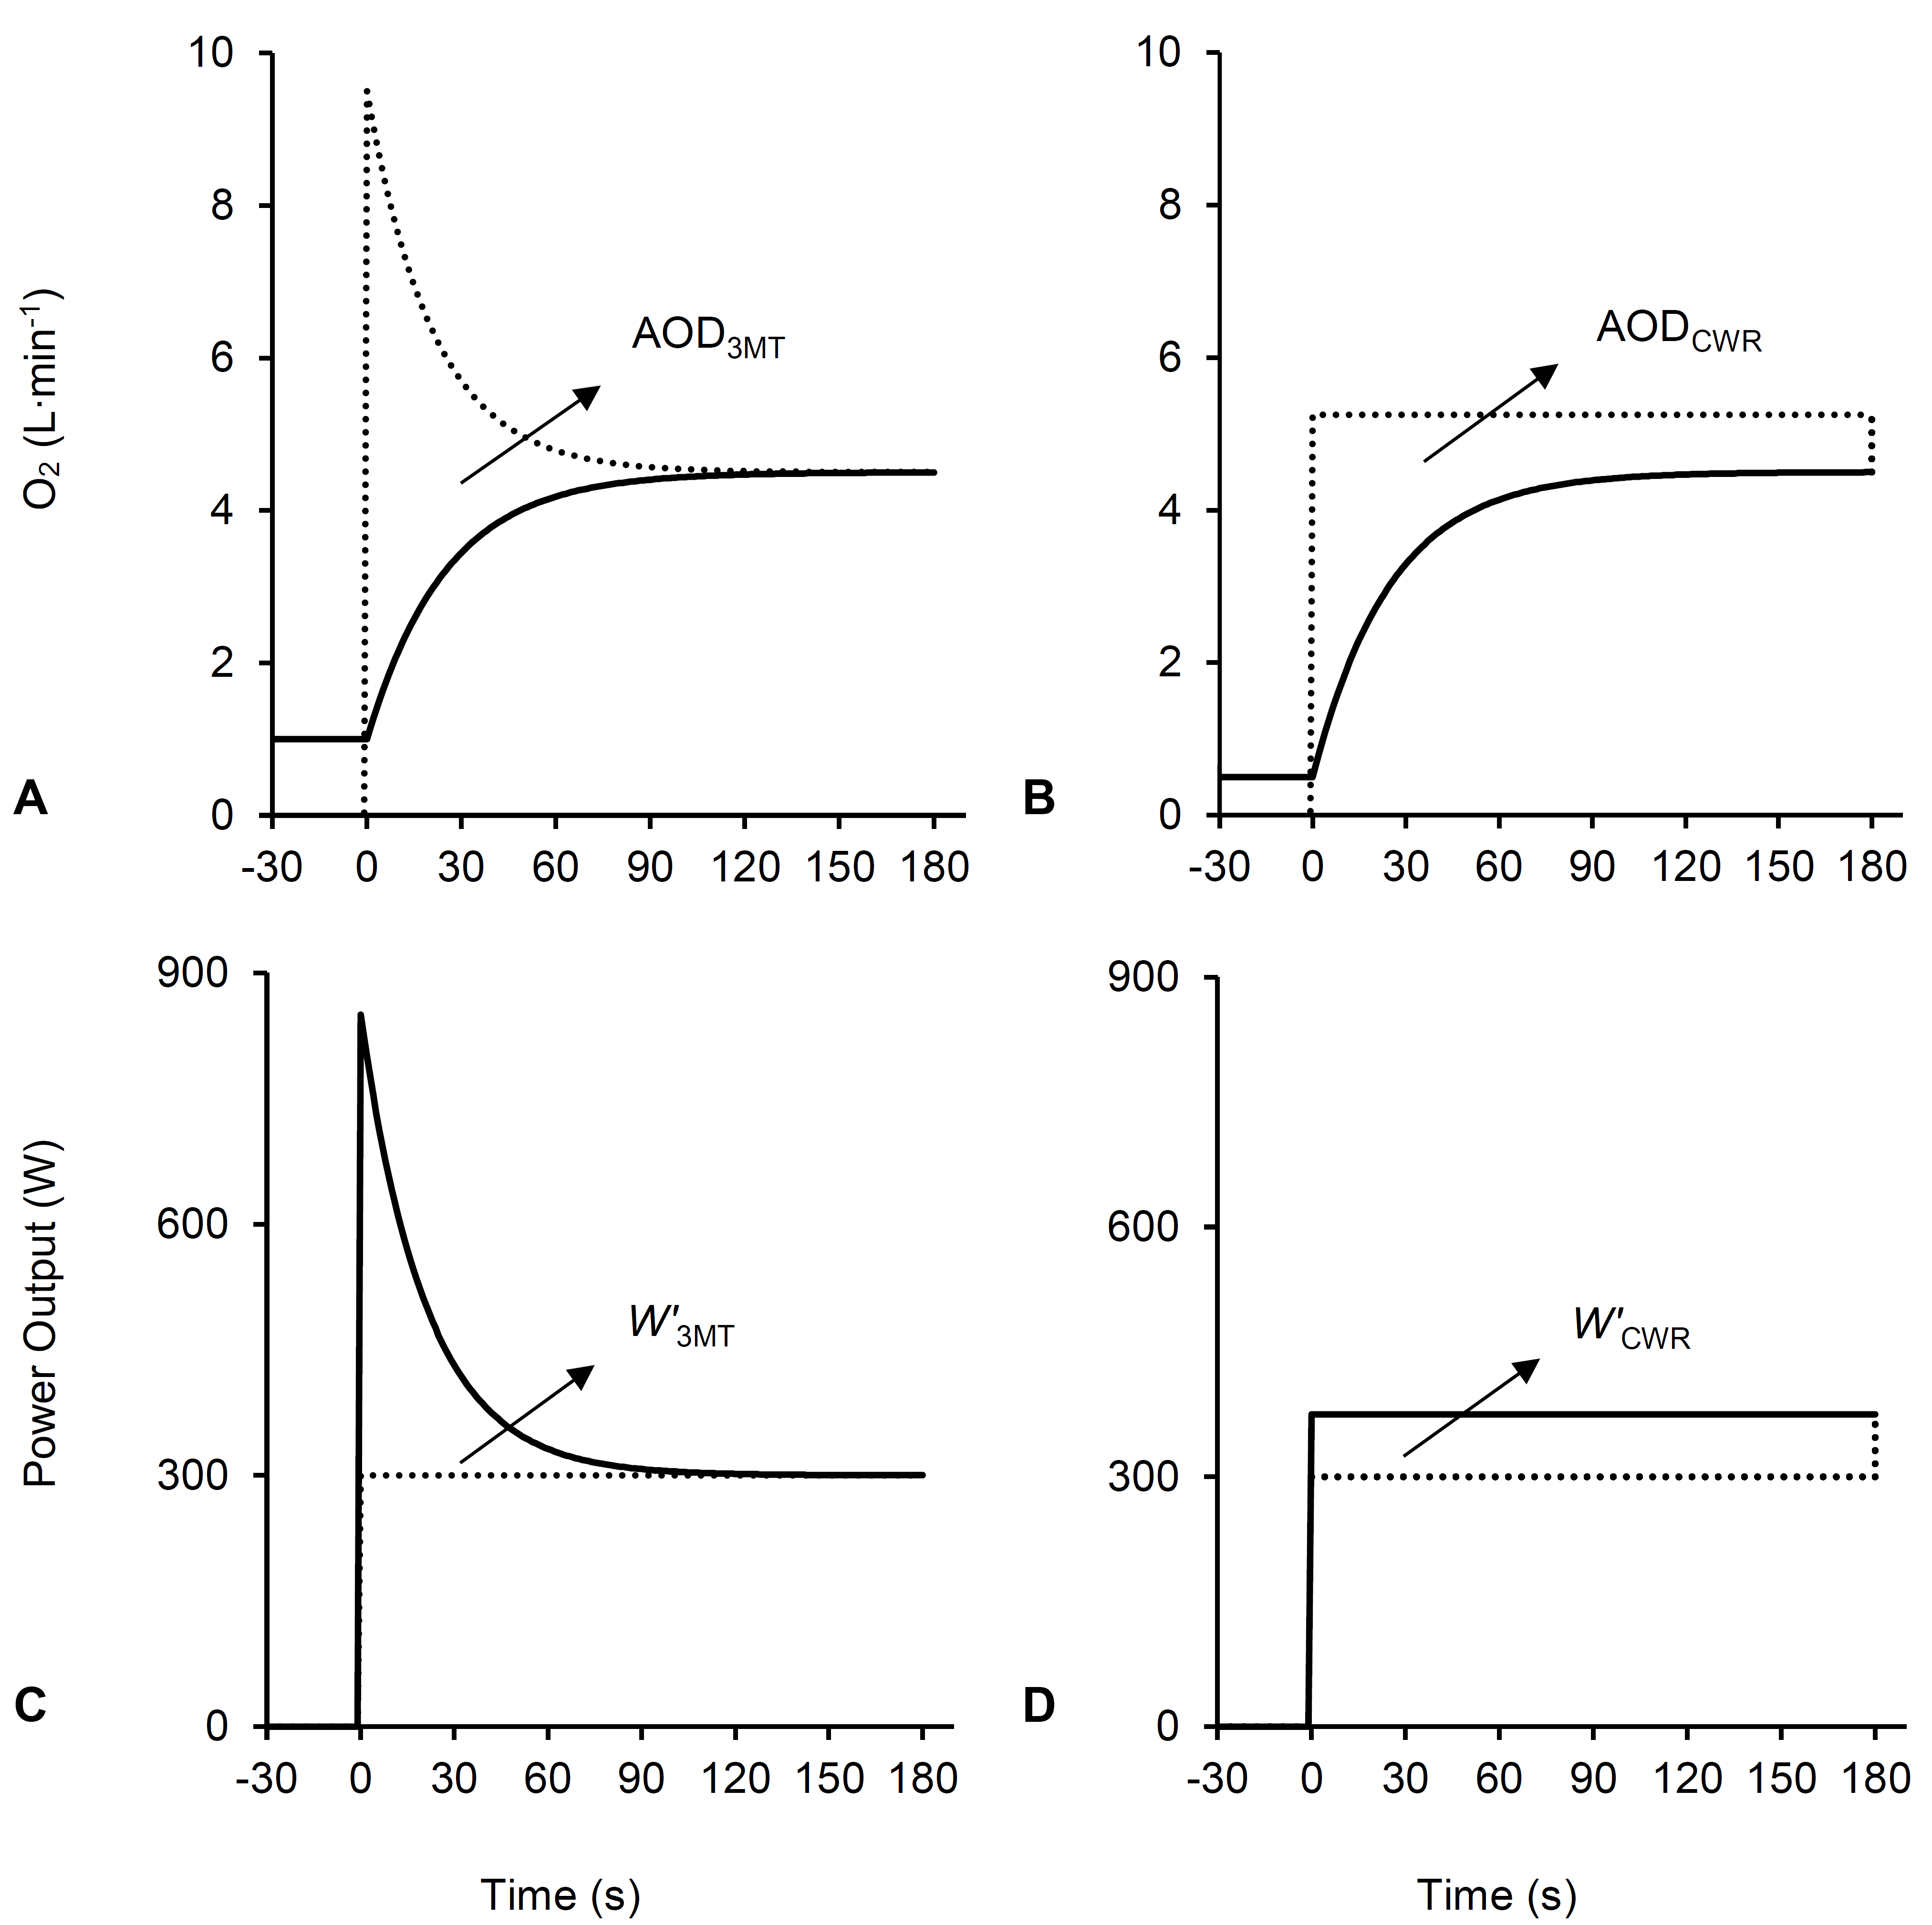
Figure 2.

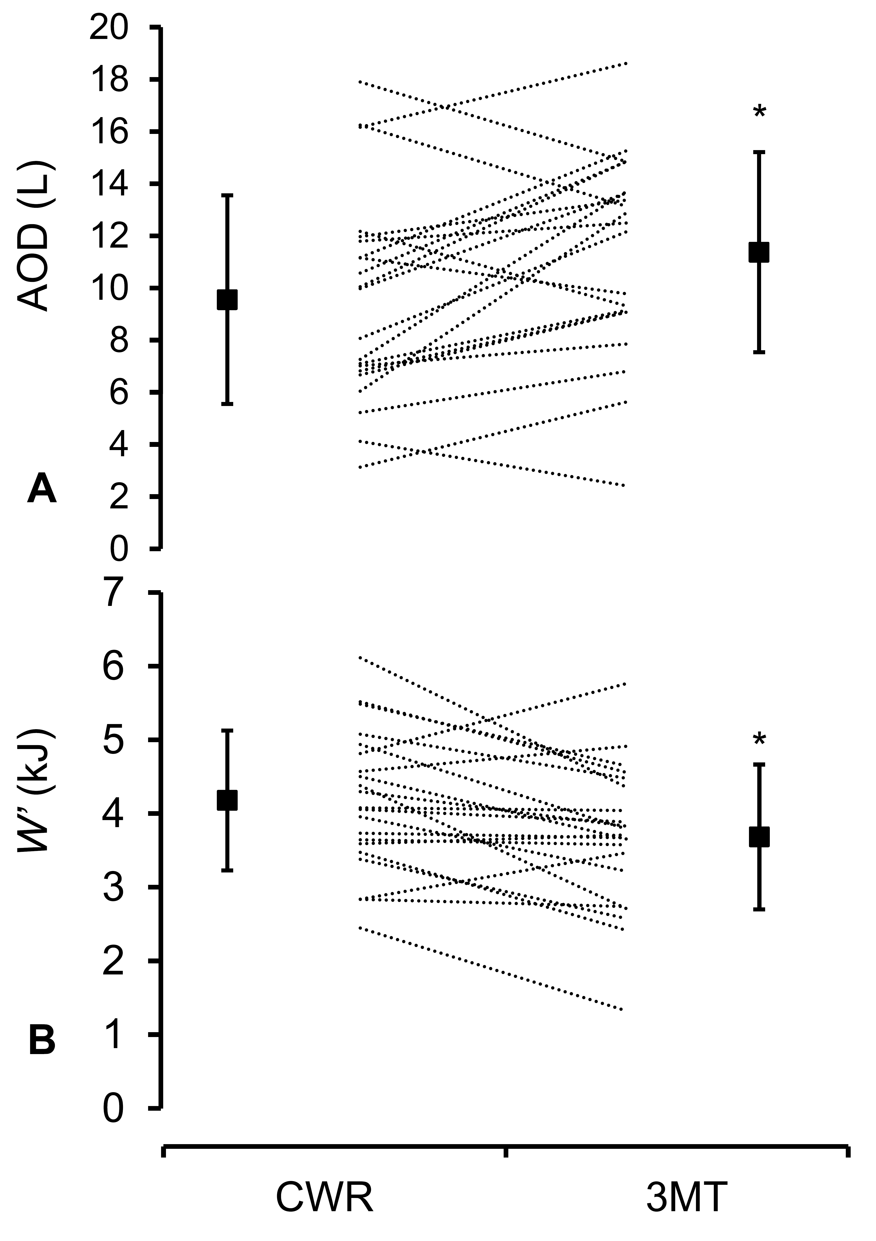
Figure 3.

Table 1.

 | CWR | 3MT | Difference | P value | Cohen’s d
Duration (s) | 164 ± 46 | 180 ± 0 | -16 ± 46 | 0.127 | 0.70
Power output (W) | 376 ± 55 | 376 ± 55# | -1 ± 23 | 0.882 | 0.01
Work (kJ) | 60.85 ± 17.30 | 67.72 ± 9.84 | -6.88 ± 15.63 | 0.057 | 0.51
W’ (kJ) | 9.55 ± 4.00 | 11.37 ± 3.84 | -1.82 ± 2.93 | 0.010 | 0.46
W’ (%) | 20 ± 12 | 17 ± 6 | -3 ± 9 | 0.116 | 0.37
Acc O₂ demand (L) | 14.08 ± 4.14 | 15.55 ± 2.14 | 1.48 ± 3.56 | 0.071 | 0.47
Acc O₂ uptake (L) | 9.90 ± 3.46 | 11.87 ± 1.48 | 1.97 ± 3.34 | 0.013 | 0.80
AOD (L) | 4.18 ± 0.95 | 3.68 ± 0.98 | 0.50 ± 0.71 | 0.004 | 0.51
AOD (%) | 31 ± 7 | 23 ± 5 | 8 ± 9 | 0.001 | 1.34
End-exercise V̇O₂ (L∙min⁻¹) | 4.29 ± 0.63 | 4.48 ± 0.61 | -0.20 ± 0.25 | 0.002 | 0.32
End-exercise O₂ demand (L∙min⁻¹) | 5.17 ± 0.69 | 4.49 ± 0.61 | 0.68 ± 0.25 | <0.001 | 0.55
Peak BLa (mmol·L⁻¹) | 10.70 ± 2.57 | 11.77 ± 2.94 | -1.07 ± 1.85 | 0.015 | 0.39
Peak HR (beats·min⁻¹) | 166 ± 11 | 165 ± 11 | 2 ± 7 | 0.131 | 0.11
# : average power output during the 3MT. W’ (%) and AOD (%) represent the contribution of W’ and AOD to the total work done and total oxygen demand, respectively.

