Estimating Willingness to Pay Air Passenger Duty
Highlights

- Carbon taxation on air travelers is an effective way to offset environmental externalities generated by air travel;
- This study estimates UK outbound travellers’ willingness to pay (WTP) the air passenger duty (ADP);
- The contingent valuation method is used to elicit the travellers’ WTPs;
- Empirical results show that travelers are willing to pay more ADP for business class and long-haul trips;
- All demand curves derived based on WTP data are downward sloping with increasing elasticities.

Abstract
Carbon taxation on air travellers is widely considered an effective way of offsetting environmental externalities and adjusting tourist flow. Despite the popularity of carbon taxation, research investigating travellers’ willingness to pay (WTP) such taxes remains scant. Using the air passenger duty (APD) levied by the UK government, this study estimates UK outbound travellers’ WTP and further derives the demand curves under six trip scenarios. The contingent valuation method is used to elicit the travellers’ WTP based on an online questionnaire survey. Comparative analysis and hierarchical linear modelling reveal that first, travellers are willing to pay more APD for business class and long-haul trips, and second, all of the demand curves are downward sloping with increasing elasticities.

Keywords: Air Passenger Duty; Willingness to Pay; Contingent Valuation Method; Elasticity; Hierarchical Linear Modelling

1 Introduction
Air travel is considered one of the major sources of greenhouse gas emissions (Becken, 2007; Scott, Peeters, & Gössling, 2010). In recent decades, the idea of sustainable tourism has gained momentum, and various efforts have been made to mitigate the air pollution caused by tourism (Gössling & Peeters, 2015). A global trend of encouraging or forcing airline travellers to pay additional fees to compensate for the carbon emissions generated during their trips has emerged as a means to ameliorate their impact. In this way, the negative externalities of travel behaviour are supposed to be internalised, and tourists themselves pay for the environmental consequences. This idea is represented by non-compulsory measures such as the voluntary carbon offset (VOC) programmes in Europe and the US (Jou & Chen, 2015), the carbon neutral programme in Australia (Choi & Ritchie, 2014) and compulsory carbon tax measures, including air passenger duty (APD) in the UK and the carbon tax in Australia.
Unlike VOC programmes, APD is compulsory and, once enforced, applies to all travellers, including those who are not willing to pay (that amount). Thus, a common concern is that its implementation may have a negative influence on the tourism industry through decreased visitation, as the taxes are mostly absorbed by the airfares, becoming part of trip prices, and thereby affect demand price-sensitive services such as tourism. The key issue for policymakers is the amount of carbon tax to charge, which is mainly determined by the decisions made by the regulator from the supply side. Such tax rates should be set in an appropriate way that considers the potential market tolerance. However, limited efforts have been made to investigate the amounts of such taxes that air travellers are willing to pay (Jou & Chen, 2015).
Pricing non-market goods (including environmental pollution) has long been of interest in tourism economics, and has been examined in various contexts (e.g., Herrero, Sanz, Bedate, & Barrio, 2012; Piriyapada & Wang, 2015; Reynisdottir, Song, & Agrusa, 2008). A common valuation method involves eliciting tourists’ stated willingness to pay (WTP) to gain certain (marginal) benefits or to offset the damage caused to public welfare. WTP to compensate for negative environmental externalities has been examined by a number of scholars, such as Brouwer, Brander and Beurkering (2008) and Choi and Ritchie (2014). However, these studies have mostly addressed non-compulsory carbon offset programmes, and only very limited efforts have been made to study WTP for carbon taxes (e.g., Gupta, 2016; Jou & Chen, 2015). While WTP studies have recognised that tourists’ WTP may vary among individuals, based on their socio-demographic or psychological traits, few studies have considered trip attributes. Moreover, the empirical findings on WTP and carbon taxes vary by context, and little consensus has been reached (see Chang, Shon, & Lin, 2010; Mair, 2011; McKercher, Prideaux, Cheung, & Law, 2010). Consequently, the market demand for carbon emission offsets remains under-researched, and there is considerable scope to develop knowledge and understanding of this issue (Semeijn & Behrens, 2011).
It is critical to find out why some tourists are willing to pay (or pay more) for these offsets while others are not, and to evaluate the impact of compulsory offsets on tourism demand. It is also important to examine whether this is an appropriate tool to address the problem of air pollution without damaging the market. In addition, the carbon footprint varies across trips with different flight classes and lengths (Bofinger & Strand, 2013). The carbon emission of a passenger flight grows linearly in relation to its flying time, and the average carbon emission per passenger/kilometre of business class is almost twice that of an economy class passenger (Bofinger & Strand, 2013).
This study aims to contribute to the dialogue by further comparing tourists’ WTP and demand curves across trips in different flight classes and of different lengths. Specifically, it elicits outbound UK tourists’ WTP for APD via the contingent valuation method (CVM), derives the demand curves and compares the WTP amounts and demand curves between six (2×3) trip types incorporating two flight classes and three travel distances. The study addresses several interrelated research questions: Are outbound UK tourists willing to pay for APD and, if so, how much? How does WTP vary across trips of different flight classes and travel lengths? Based on the derived WTP, how do current APD rates affect the demand for air travel?
This study targets outbound UK leisure tourists and follows three investigative steps. First, UK outbound tourists’ WTP for APD is elicited under six different trip types via the CVM, based on a sample of 2,002 responses collected via an online survey. Second, the effects of travel distance and flight class on WTP are examined, controlling for tourists’ socio-demographic attributes. Finally, the demand curves and price elasticities are derived based on WTP for each trip type and compared to identify the differences. However, prior to examining the research questions and methodology used, it is pertinent to examine the principal concepts underpinning the study: environmental externality, APD and WTP.

2 Literature review

Environmental externality and APD
As a natural evolution of the sustainable tourism paradigm, a large volume of international academic literature examines environmental externalities in the tourism industry, ranging from greenhouse gas (GHG) reduction to natural resource preservation and environmentally friendly forms of tourism. The term ‘externality’ is often used to refer to the unintended consequences of economic agents’ actions. The consequences of negative environmental externalities are usually suffered by the public. A widely accepted reason for negative externality is that the market fails to account for social costs, as no one owns his or her share of a sustainable environment to sell to polluters and no market or price exists. The result is the ‘tragedy of the commons’ (Patt, 2017).
Therefore, if these social costs were included in the prices of private production and consumption activities, i.e., if they internalised the environmental externalities, economic agents would have an incentive to produce and consume less, or to do so in a cleaner way. A common practice is to approximate a market price for the external cost of the pollution caused by corporations and individual consumers. For corporate and industrial pollution, current international examples of emission trading schemes (ETS) can be found in various countries and regions, including Australia (the Carbon Pricing Mechanism), the European Union (the EU Emissions Trading Scheme), Japan (the Voluntary Emission Trading Scheme) and the UK (the CRC Energy Efficiency Scheme). A typical ETS is a ‘cap-and-trade’ system, in which the cap on the total allowances of greenhouse gas emission creates scarcity in the market, and the emission allowance trading between participants turns this allowance into commodities based on the Earth’s capacity for carbon cycling, and the potential cost of correcting for air pollution, e.g., by planting more trees (Vlachou & Pantelias, 2017). Another example is the Carbon Offsetting and Reduction Scheme for International Aviation (CORSIA) adopted at the 39th session of the ICAO Assembly in 2016. It was created for the aviation industry, and requires airlines to buy carbon offsets to compensate for their CO² emissions. Unlike the ETS, CORSIA does not impose a cap on the total emission allowance, but instead prices carbon offsets in a direct and straightforward way.
Many countries have since the early 1990s adopted a carbon tax on individual consumers as a cost-effective measure to correct for environmental externality and reduce carbon dioxide emissions. A case in point is the APD introduced by the UK government. APD is an excise duty levied on travellers originating from a UK airport – destinations are split into different bands according to the distance from a country’s/territory’s capital city to London. The duty charged is also based on a distinction between economy and business class flights. The duty is subject to annual changes by the government, but the current situation is that there are two bands of APD. Band A covers destinations zero to 2,000 miles from London with a sliding scale of duty according to the class being travelled in. Band B is for travel to destinations over 2,000 miles from London. There are three categories of APD for each band, depending on the class of travel. The top rate of APD is for smaller aircraft, typically personal jets of 20 tonnes or more that are equipped to carry fewer than 18 passengers.
As a typical tourism regulatory tool, APD is levied on those best able to pay and predominantly on overseas visitors who cannot vote in the UK. It thus can be an effective revenue-raising mechanism and a way of retaining tourism income (Seetaram, Song, & Page, 2014). Although many economists agree that carbon taxes are a cost-effective way to reduce GHG emissions (e.g., Baumol & Oates, 1988; Mankiw, 2006), the potential consequences of APD enforcement have been a source of dispute, particularly in the travel trade.
For example, Seetaram et al. (2014) questioned the environmental benefits claimed for APD, as it did not sufficiently consider how the perceived problems associated with tourism could be politically harnessed for wider tax revenue purposes, despite its justification on environmental grounds. They doubted that these ‘crude’ policies could simply raise taxation revenue without addressing the underlying problems of encouraging sustainable travel behaviour. In fact, APD is expected to generate £3.4 billion in 2017/18 and may yield £3.5 billion in 2018/19. This number could rise to £4 billion by 2021/22 (HM Treasury, 2016). Mayor and Tol’s (2007) empirical research found that increased APD resulted in a slight drop in international visitation to the UK. Tourism industry representatives, in their criticism of the Australian carbon tax, are likely to claim that it may harm Australia’s destination competitiveness, industry profitability and employment for little or no benefit to the global environment. Seetaram et al. (2014) further supported this claim, finding that the effectiveness of carbon emission reduction was marginal and that travellers were prepared to pay more to maintain their demand. Mayor and Tol (2007) even found that increased APD could have the perverse effect of increasing carbon dioxide emissions, albeit only slightly, as it reduced the relative price difference between near and distant holidays.
However, tourism and transport stakeholders are concerned that such a tax may make the country a less competitive tourism destination by further increasing additional charges and pushing up tourism prices (Forsyth, Dwyer, Spurr, & Pham, 2014). Increased APD may affect outbound tourist demand, as traditional economic theory predicts that the higher the price of a good, the lower the number of people willing to pay it. In effect, APD is an export tax on international visitors and an import tax imposed on UK residents. In consequence, the World Travel and Tourism Council has criticised APD, as it may result in huge losses to tourism and the UK economy (Forsyth et al., 2014). The UK travel trade’s criticisms have been summarised by the Travel Association in its A Fair Tax on Flying (AFTOF) campaign (http://www.afairtaxonflying.org/), which communicates three key messages: first, APD imposes additional expenses on UK families taking holidays that are not borne by their European counterparts, even with the recent exemption for children; second, APD is bad for business because it is a tax on global trade; third, APD has a negative impact on tourism, given that 72% of visits to the UK are air-related.
The focal point of these polarised views on APD lies in the amount of APD that tourists are willing to pay. Implementing APD may discourage outbound travel activities by air because travellers would have to pay extra money, a point of both economic and environmental significance. However, its effect depends on how much the tourist tolerates the amount charged. In this sense, investigating the exact amount of WTP for APD can contribute insights to the dispute over its implementation.

3 Willingness to pay

Valuation of non-market goods and WTP
Quantifying the (marginal) economic value of offsetting carbon emissions and letting travellers pay their part of the cost has been a popular topic in environmental economic studies for decades (Choi & Ritchie, 2014). As a widely adopted valuation approach, stated WTP is typically used to approximate a non-market goods price. By definition, WTP refers to a hypothetical value assigned to the product (Frash, Dipietro, & Smith, 2014). WTP is used as a measure of non-market goods price based on the assumptions of rational choice and utility maximisation (Reynisdottir et al., 2008). If a change occurs in a non-market good (e.g., environmental improvement) by which a person believes he or she is better off in some way, that person may wish to pay to secure this change, and so WTP reflects a person’s economic valuation of the good in question (Hanley, Shogren, & White, 1997).
The application of WTP in tourism research has mainly focused on determining the amount of WTP and the factors driving the paying preference or amount (e.g., Chen, Zhang, & Nijkamp, 2016) in various contexts, including natural attractions such as natural parks and rainforests (e.g., Reynisdottir, Song, & Agrusa, 2008), outdoor recreation activities (Asafu-Adjaye & Tapsuwan, 2008), natural resource management and conservation (e.g., Piriyapada & Wang, 2015) and green tourism products (Hinnen, Hille, & Wittmer, 2015). These studies have identified a series of WTP determinants in different contexts and mapped the demand curve and elasticity patterns based on WTP values.

WTP, demand curve and elasticity
WTP is internally linked to demand curve and elasticity. Studies (e.g., Gupta, 2016; Greiner & Rolfe, 2004; Reynisdottir et al., 2008) have provided abundant evidence that a demand curve for non-market goods can be derived by aggregating the elicited WTP values. They have also found that demand is relatively responsive to price (Richer & Christensen, 1999; Stevens, More, & Allen, 1989). As traditional economic theory indicates, the higher the price of a good, the lower the demand.
The effect of APD on tourist visitation can thus be better captured by elasticity of demand, which measures the effectiveness of price mechanisms in reducing visitation. It can be calculated by dividing the percentage change in demand by the percentage change in APD (Greiner & Rolfe, 2004). Theoretically, a demand elasticity larger than 1 means that the relative decrease in demand is higher than the relative increase in price, and thus the demand can be described as price elastic (Greiner & Rolfe, 2004). Tourism research has found that in contexts such as national parks, tourist visitation is price inelastic at the initial levels of price increase (Grandage & Rodd, 1981). The introduction of modest fees or modest increases in user fees does not cause a dramatic reduction in demand (Eagles et al., 2002; Reynisdottir et al., 2008).

Determinants of WTP
Choi and Ritchie (2014) noted that the major factors driving air travellers’ WTP for carbon mitigation had yet to be fully identified, creating an opportunity for further understanding of the factors that affect WTP. Studies have generally approached the factors driving WTP from socio-demographic and psychographic perspectives because the focus is on behavioural responses to price and taxation. They have found that people’s WTP for carbon offsetting programmes varies based on demographic features such as age, gender, education level and household income level (Gupta, 2016; Reynisdottir et al., 2008; Carlsson & Johansson-Stenman, 2000; More & Stevens, 2000). Although the effect of income on WTP has been widely debated, there is no conclusive evidence to model its impact. A number of studies of outdoor recreation activities have found that low-income users are more sensitive to price changes than high-income users (More & Stevens, 2000; Reiling, Cheng, & Trott, 1992). However, Williams, Vogt and Vittersø (1999) found that charging entrance fees had little distributional impact on different income groups in the natural resource context.
Psychological factors such as moral responsibility, concerns about the environment and future generations and fear of disasters have also been emphasised (Choi & Ritch, 2014). Tourists’ perception of the programmes has been identified as a significant factor affecting WTP. A WTP tax could also be influenced by factors such as low credibility, confusion, complexity and low levels of transparency associated with the use of the generated taxation (Gössling et al., 2007; Juvan & Dolnicar, 2014; Polonsky, Grau, & Garma, 2010). Ample evidence has indicated that informing visitors why money is needed and where it will go is likely to positively affect their support for the fee-paying option and their WTP (Clawson & Knetsch, 1966; Eagles et al., 2002; Reiling, Criner, & Oltmanns, 1988).
Aside from socio-demographic and psychographic factors, previous experience has been found to influence WTP. Laarman and Gregersen (1996) stated that what consumers expected to pay related to what they had paid before. Kerr and Manfredo’s (1991) study of backcountry hut users in New Zealand’s national parks suggested that previous fee-paying behaviour affected paying intentions. With these issues in mind, we now turn to the methodology.

4 Methodology

Contingent valuation method (CVM)
The CVM has commonly been used to evaluate the benefit of public goods, especially environmental resources and pro-environmental projects (Mitchell & Carson, 1989; Venkatachalam, 2004). If appropriately carried out, it is a reliable method for assigning a monetary value to the consequences of pollution (Hanemann, 1994). It has been widely applied in various disciplines such as transportation, health economics, cultural economics and environmental and ecological economics (e.g., Choi, Ritchie, Papandrea, & Bennett, 2010; Correia, Santos, & Barros, 2007; Hensher & Greene, 2003; Lindberg, Dellaert, & Romer Rassing, 1999; Morey & Rossmann, 2003).
The CVM is a stated preference technique and is a survey-based method with a hypothetical market (Mitchell & Garson, 1989), in which the valuation is elicited by asking respondents to subjectively determine the dollar value of non-market goods. The maximum sum that respondents are willing to pay for a given good is then determined. The underlying assumption of the CVM is that individuals have preferences that can be elicited by creating a hypothetical market (Mmopelwa, Kgathi, & Molefhe, 2007) and that conclusions can be drawn about how individuals perceive the utility of a product or a service.
The CVM was introduced and gained popularity in tourism research for evaluating non-market goods such as natural tourism resources, cultural heritage and events (e.g., Herrero, Sanz, Bedate, & Barrio, 2012; Reynisdottir, Song, & Agrusa, 2008). Despite its popularity, the CVM has been criticised for its hypothetical bias (Mitchell & Carson, 1989), strategic behaviour, warm glow effect (Andreoni, 1990) and cheap talk effect (Green, Krieger, & Wind, 2001). Some scholars (e.g., Diamond & Hausman, 1994) have also warned that the CVM should be cautiously used in contexts where there could be an absence of presences. These biases, however, are not specific to the CVM and do not render the method invalid (Arrow et al., 1993). In fact, the cautious acceptance of the CVM by the Blue Ribbon Committee, which was set up by the National Oceanographic and Atmospheric Administration (NOAA) to evaluate this method’s validity, gave it a seal of approval. Currently, CVM still remains the most useful and popular tool for economic valuation when a functioning market for a good or a service is lacking (Carson, Flores, & Mitchell, 1999) and is widely used in the most recent studies related to different sectors (e.g., Birdir, Ünal, Birdir, & Williams, 2013; Saayman, Krugell, & Saayman, 2016).

Hierarchical linear modelling
It has been widely recognized that WTP may vary based on personal attributes and the characteristics of the valued objects. The variance in WTP according to different valued object attributes is thus embedded within the effect of personal attributes and forms a hierarchical data structure. In this study, each respondent was required to state his or her WTP according to six different flight trip types, and this formed the level-1 variation. Moreover, WTP may vary across different subjects, forming the level-2 variation. In this situation, observations can be clustered into higher-order subjects. The assumption that observations that belong to the same subjects are more similar than those belonging to different subjects forms the hierarchical or nested data structure (Kremelberg, 2011).
Two-level hierarchical linear modelling (HLM) has been widely used to analyse such nested data (Goldstein, 1999). It technically extends the linear model by incorporating levels directly into the model statement, thereby accounting for the aggregation present in the data. It is typically useful when examining repeated observations within a subject. In this study, trip traits, including flight class (economy or business class) and travel distance (short, medium or long haul), are level-1 variables that cause variation of WTP for a given respondent, while personal attributes are treated as level-2 variables that lead to difference among respondents.
Garson (2013) suggested a step-up strategy for HLM that involved estimating three sequential models: the null model, the random intercept (RIC) model and the intercept as outcome (IaO) model. The null model is constructed to test for the presence of a group-level clustering effect, and only random effects are considered on both levels. It is specified as follows:
Level-1:
${WTP}_{ij}=β_{0j}+r_{ij}$;
Level-2:
$β_{0j}=γ_{00}+μ_{0j}$.
WTP_{ij} denotes the amount of WTP of the ith observation in the jth respondent, r_{ij} denotes the level-1 random error term, u_{0j} denotes the level-2 random effect of the intercept, β denotes the level-1 regression coefficients and γ denotes the level-2 regression coefficients.
In the RIC model, the effects of level-1 control variables on flight class and distance are added into the level-1 model as covariates. The RIC model is specified as follows:

Level-1 (in matrix mode):
$${WTP}_{ij}=β_{0j}+\left[\begin{matrix}β_{1j} & β_{2j}\end{matrix}\right] \left[\begin{matrix}{FLYCLASS}_{i} \\ {FLYDIST}_{i}\end{matrix}\right]+r_{ij}$$

Level-2 (in matrix mode):

$$\left[\begin{matrix}β_{0j} \\ β_{1j} \\ β_{2j}\end{matrix}\right]=\left[\begin{matrix}γ_{00} \\ γ_{10} \\ γ_{20}\end{matrix}\right]+\left[\begin{matrix}μ_{0j} \\ 0 \\ 0\end{matrix}\right]$$

The IaO model further incorporates level-2 variables for personal attributes. It is theoretically reasonable to assume that the influence of observations is constant across different respondents. Thus, the coefficients of the level-1 covariates are set to have no random effect in the level-2 model. The IaO model is specified as follows:

Level-1 :
$${WTP}_{ij}=β_{0j}+\left[\begin{matrix}β_{1j} & β_{2j}\end{matrix}\right] \left[\begin{matrix}{FLYCLASS}_{i} \\ {FLYDIST}_{i}\end{matrix}\right]+r_{ij}$$

Level-2 :
$$\left[\begin{matrix}β_{0j} \\ β_{1j} \\ β_{2j}\end{matrix}\right]=\left[\begin{matrix}γ_{00} \\ γ_{10} \\ γ_{20}\end{matrix}\right]+\left[\begin{matrix}γ_{01} & γ_{02} & γ_{03} & γ_{04} & γ_{05} & γ_{06} & γ_{07} & γ_{08} \\ 0 & 0 & 0 & 0 & 0 & 0 & 0 & 0 \\ 0 & 0 & 0 & 0 & 0 & 0 & 0 & 0\end{matrix}\right]\left[\begin{matrix}{AGE}_{j} \\ {GENDR}_{j} \\ {EDU}_{j} \\ {INCOME}_{j} \\ {EMPLOY}_{j} \\ {FAMN}_{j} \\ {TRAdom}_{j} \\ {TRAabr}_{j}\end{matrix}\right]+\left[\begin{matrix}μ_{0j} \\ 0 \\ 0\end{matrix}\right]$$
where AGE, GENDR, EDU, INCOME, EMPLOY, FAMN, TRAdom and TRAabr represent age, gender, education level, yearly household income, employment status, number of families, domestic travel experience and international travel experience, respectively. Notably, both employment status and income are present in the model. Employed people, aside from enjoying higher salaries, have more social contacts and thus may feel a greater sense of responsibility for environmental and public welfare. As a result, by including employment status, we are emphasizing the potential effects of social embeddedness, aside from personal income.

The data
The questionnaire employed in the survey comprised three parts. The first part asked about the socio-demographic information of the respondents, including their gender, age, education level, current employment status, number of family members, household income per year before tax, domestic travel experience and international travel experience in 2015. The second part consisted of questions about the respondents’ knowledge and opinion of APD. The respondents were asked to indicate their level of awareness of APD and other relevant charges, in addition to their preferences for the way APD was charged and spent.
The third part aimed to elicit the respondents’ WTP for APD in regards to six air travel scenarios (2 flight classes × 3 trip lengths). The respondents were first presented with a brief introduction to APD, its purpose and the way it was charged. They were then asked about the maximum amount of money they considered it fair to pay for APD in the six holiday trip categories. A multiple-price list (MPL) with one zero item and eight price intervals was used to track the respondents’ WTP (Anderson, 2004; Saayman, Krugell, & Saayman, 2016). The respondents were asked to indicate the maximum amount of money based on nine intervals: ‘￡0’, ‘￡0.01–15’, ‘￡15.01–30’, ‘￡30.01–45’, ‘￡45.01–60’, ‘￡60.01–75’, ‘￡75.01–90’, ‘￡90.01–105’ and ‘more than ￡105’. Following Armbrecht (2014), the final WTP amount was decided based on the median value of each interval. Other studies have used a similar MPL method with a set of interval consistent estimators (e.g., Chen, Zhang, & Nijkamp, 2016). For those who selected zero for at least one of the flight classes, a follow-up question was asked about the reason.
The researchers examined the various methods available to derive a meaningful sample using a purposely designed survey instrument that was piloted in 2016. From these methods, the online survey method was selected. A market research company with a track record of generating robust and reliable panel data was hired and the survey was conducted online from 9 to 28 February 2016. Using such a conduit for surveying consumers is cost-effective and can overcome low response rates from postal surveys, given the relationship that the organisation already has with the panel. The survey respondents were UK residents who had travelled abroad for holidays.
In terms of the survey methodology, the survey was handled by Bournemouth University’s Market Research Group who sub-contracted the data collection (i.e. sending out requests to panel members) to CINT. CINT have access to up to 40 million respondents worldwide, who have signed up to individual research panels. There are 2,658,604 panel members within the UK that CINT can invite to take part in the survey. This specific survey was set up to be sent to panel members where existing information is held by CINT, in order to target specific groups based on income and employment status, thus increasing success rate of participants passing the quota selection set up. The combined number of complete responses and incomplete responses was 3,783 from an email invite sent to approximately 6,000 panel members. The Panel Data were collected between 09/02/2016 and 28/02/2016. There were 2011 completed surveys received. There were an additional 1,772 incomplete responses which could not be used, a problem which sometimes occurs with online surveys. Of these incomplete responses, 1,747 were due to being screened out due to full quotas based on income/employment status. The remaining 255 dropped out of the survey at some point prior to completing it. . The socio-demographic attributes of the samples are presented in Tables 1 and 2.

Table 1 Distribution of the respondents’ socio-demographic attributes
 | N | % |  |  | N | %
GENDER |  |  |  | EDUCATION
Male | 827 | 41.3 |  | GCSE or O level or equivalent | 460 | 23.0
Female | 864 | 43.2 |  | A or AS level or equivalent | 365 | 18.2
 |  |  |  | Higher qualification below degree level | 249 | 12.4
Total valid | 1,691 | 84.5 |  | Undergraduate degree | 455 | 22.7
Missing | 311 | 15.5 |  | Postgraduate degree | 287 | 14.3
Total | 2,002 | 100.0 |  | Other qualification | 95 | 4.7
 |  |  |  | School Leavers Certificate | 41 | 2.0
INCOME
<10,000 | 180 | 9.0 |  | Total valid | 1,957 | 97.5
10,000 to 20,000 | 482 | 24.1 |  | Missing | 50 | 2.5
20,000 to 30,000 | 400 | 20.0 |  | Total | 2,002 | 100
30,000 to 40,000 | 265 | 13.2
40,000 to 50,000 | 220 | 11.0 |  | EMPLOYMENT
50,000 to 60,000 | 174 | 8.7 |  | Employed full time | 763 | 38.1
60,000 to 70,000 | 98 | 4.9 |  | Employed part time | 320 | 16
>70,000 | 183 | 9.1 |  | Self-employed | 178 | 8.9
 |  |  |  | Retired | 492 | 24.6
Total valid | 2,002 | 100.0 |  | Student/training | 80 | 4
 |  |  |  | Unemployed/looking for work | 79 | 3.9
 |  |  |  | Looking after family/home/children | 90 | 4.5
 |  |  |  | Total valid | 2,002 | 100

Table 2 Descriptive statistics of the respondents’ socio-demographic attributes
 | Valid N | Min | Max | Mean | Skewness | Kurtosis
AGE | 1,614 | 18 | 87 | 46.930 | 0.026 | -1.150
FAMN | 1,961 | 1 | 15 | 2.590 | 1.769 | 8.010
TRAdom | 1,990 | 1 | 6 | 2.590 | 0.760 | -0.121
TRAabr | 1,896 | 1 | 6 | 1.550 | 2.213 | 4.157

Table 3 presents the respondents’ level of awareness of APD and other relevant charges. Nearly one third of the respondents knew nothing about APD and the relevant charges, and nearly half had heard about it but did not know how much it charged. Only a small portion of respondents had an idea of how much they were charged. As a result, it was critical to give the respondents an example of APD to elicit a reasonable WTP.

Table 3 Respondents’ level of awareness of APD and relevant charges
 | APD |  | Other tax |  | Service charge |  | Card handling fee
 | N | % | N | % | N | % | N | %
I don’t know if this was included | 668 | 33.4 | 651 | 32.5 | 668 | 33.4 | 668 | 33.4
I don’t know how much | 999 | 49.9 | 1,025 | 51.2 | 1,001 | 50.0 | 801 | 40.0
I have a rough idea of how much | 210 | 10.5 | 195 | 9.7 | 187 | 9.3 | 266 | 13.3
I am fairly certain how much I paid | 105 | 5.2 | 103 | 5.1 | 109 | 5.4 | 214 | 10.7
Total valid | 1,982 | 99 | 1,974 | 98.6 | 1,965 | 98.2 | 1,949 | 97.4
Missing | 20 | 1 | 28 | 1.4 | 37 | 1.8 | 53 | 2.6
Total | 2,002 | 100 | 2,002 | 100.0 | 2,002 | 100.0 | 2,002 | 100.0

5 Findings

Tourist perception and mean WTP for APD
Figure 1 demonstrates the proportion of respondents willing to pay for APD in different trip scenarios. In general, a large proportion of respondents was willing to pay for APD (minimum 74%). This finding echoes Gupta’s (2016) results in India, where a large percentage of passengers was willing to pay a carbon tax. A comparison of different trip scenarios reveals that as the travel distance increases, the proportion of respondents willing to pay APD also increases. However, the change in proportion is much more significant for economy class than business class travellers. For short-haul trips, 74% of the respondents were willing to pay APD for economy class – less than the 78.2% for business class. In contrast, the WTP amount for economy class was close to that for business class for medium-haul trips, and exceeded it for long-haul trips. Generally speaking, it appears that more travellers are willing to pay APD for longer and higher-class trips.

As for those who were unwilling to pay APD, 28.3% of the respondents stated their reasons, as presented in Table 4. Their major reasons included insufficient information about APD and the concern that APD was merely another type of tax. Furthermore, 4.7% of the respondents indicated that their income was too low to allow them to pay APD.

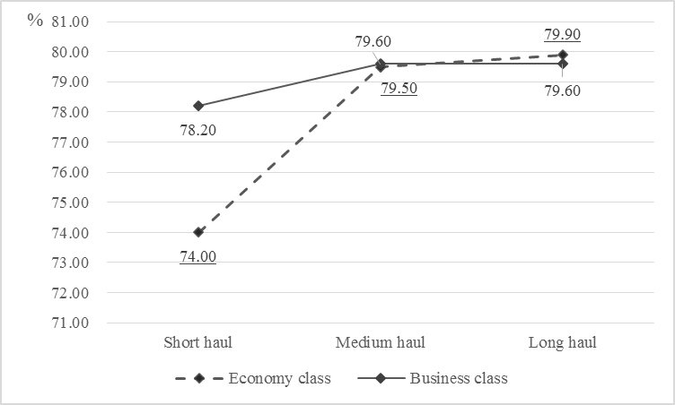
Figure 1 Proportion of respondents willing to pay for APD

Table 4 Reasons for zero WTP
 | N | %
I do not have sufficient information about APD | 203 | 10.1
I already pay enough tax | 201 | 10.0
My income is too low | 95 | 4.7
Other | 68 | 3.4
Total valid | 567 | 28.3
Missing | 1,435 | 71.7
Total | 2,002 | 100.0

According to Gupta (2016), the mean WTP can be regarded as an estimator of WTP and can be obtained through the equation $MWTP=\frac{1}{n}\sum_{i=1}^{n}{{WTP}_{i}}$, where i denotes the ith respondents and n denotes the total number of respondents. Table 5 and Figure 2 demonstrate that MWTP varies based on flight class and trip distance. Generally, MWTP increases as travel distance increases, and business class has a higher MWTP than economy class across all trip lengths.

Table 5 Descriptive statistics of estimated WTP for APD
 | N | Min | Max | Mean | Skewness | Kurtosis
WTPes | 1,988 | 0 | 112.5 | 16.543 | 2.128 | 4.523
WTPbs | 1,958 | 0 | 112.5 | 24.116 | 1.424 | 1.771
WTPem | 1,966 | 0 | 112.5 | 22.885 | 1.510 | 2.191
WTPbm | 1,966 | 0 | 112.5 | 30.408 | 1.001 | 0.444
WTPel | 1,965 | 0 | 112.5 | 29.298 | 1.090 | 0.758
WTPbl | 1,960 | 0 | 112.5 | 36.792 | 0.694 | -0.415
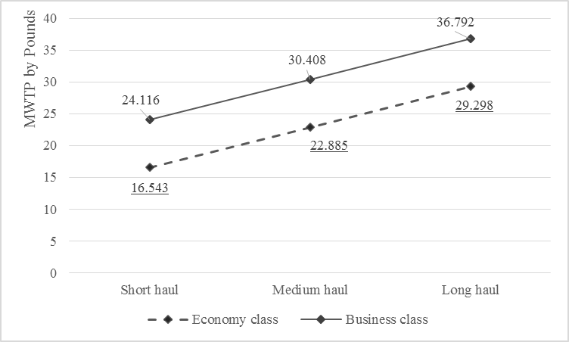
Figure 2 MWTP for different flight trip types

The respondents were also asked to indicate their preferred way to charge and spend APD. Tables 6 and 7 present the results of the survey. More than one third of the respondents preferred a fixed amount charged per ticket. This was followed by the suggestion that a fixed amount be charged depending on the distance travelled, which accounted for 14.9%. Notably, this is exactly how APD is currently charged. Another 12.7% of the respondents preferred the APD charge to be based on a percentage of the ticket cost. Furthermore, most of the respondents (35%) were in favour of spending APD on environmental projects. Airport development was another widely accepted way to use the income, supported by 26% of the respondents. Only 6.3% of the respondents agreed that APD should be used for general government expenditures.
It seems that an overwhelming majority of APD payers would prefer that the money they pay be used for a specific purpose instead of for a general, unspecified purpose. However, it is interesting that only a limited proportion of tourists expressed a preference for spending on environmental projects, although APD is implemented in the name of carbon offsetting. This finding reveals the complexity of the motivation underlying paying for carbon offsetting and a likely inconsistency between the motive for paying and preferences for spending taxes. The findings require further investigation and examination.

Table 6 Preferred ways to charge APD
 | N | %
Fixed amount per ticket | 756 | 37.8
Percentage of the ticket cost | 255 | 12.7
Fixed amount depending on distance travelled | 298 | 14.9
Other | 46 | 2.3
Don’t know | 607 | 30.3
Total valid | 1,962 | 98.0
Missing | 40 | 2.0
Valid | 2,002 | 100

Table 7 Preferred ways to spend APD
 | N | %
Environmental projects | 718 | 35.9
Tourism-related projects | 303 | 15.1
Airport developments | 521 | 26.0
General government expenditure | 127 | 6.3
Charity projects | 238 | 11.9
Other | 73 | 3.6
Total valid | 1,980 | 98.9
Missing | 22 | 1.1
Total | 2,002 | 100.0

Determinants of WTP: HLM results
The preceding descriptive analysis reveals that WTP for APD varies across trip types and that different respondents may perceive WTP differently and thus have different preferences for WTP. To further validate these findings and determine whether they can be generalised to the population, the effects of individual socio-demographic and trip attributes are examined via HLM.
Table 8 presents the overall fitness of the three sequential hierarchical models. In the null model, the ICC value is 0.729, notably surpassing the critical value of 0.059 (Ho & Huang, 2009) with a significant χ², indicating a potential significant clustering effect and showing that 72.9% of the variance in WTP occurs among different tourists. Therefore, the HLM must be applied. For the RIC model with added trip attribute variables, a significant drop in level-1 residual variance (σ²) and -2dll values is observed, implying that the trip attribute variables have significant effects and are thus worthy of investigation. For the IaO model with level-2 predictors for personal attributes, the R²_{between} value is 0.11, meaning that these individual socio-demographic variables may significantly explain 11% of the total variance. Meanwhile, R²_{within} takes the value of 0.244, which means the IaO model may significantly explain 24.4% of the total variance. In summary, HLM has a strong ability to predict WTP.

Table 8 Overall fitness of hierarchical models
 | Null Model | RIC Model | IaO Model
σ² | 195.578 | 147.847 | 147.837
τ | 525.895 | 535.804 | 468.080
ICC | 0.729
R²_{within} |  | 0.244 | 0.244
R²_{between} |  |  | 0.110
d.f. | 1,467.000 | 1,467.000 | 1,443.000
χ² | 24,812.378 | 32,849.346 | 28,454.036
Sig. | *** | *** | ***
-2dll |  | 2,022.471 | 2,298.695

Table 9 presents the regression coefficient estimation results. As for the level-1 effects of trip attributes, both flight class and travel distance have a significant negative influence on WTP. Specifically, WTP is lower for economy class than for business class. This finding fits with the descriptive analysis results, which show that the MWTP for APD is lower for economy flights than for business flights. Moreover, compared with long-haul trips, tourists exhibit significantly lower WTP for APD in the cases of short- and medium-haul trips. This finding again echoes the previous descriptive findings, which reveal that the MWTP for APD is larger for longer-haul trips.
The level-2 effects of personal socio-demographic traits, age, employment status and travel experience (both domestic and international) may significantly affect WTP. Specifically, age is negatively correlated with WTP, meaning that older travellers tend to have less WTP for APD. The effect of employment is noteworthy: compared to travellers who do not have jobs and instead look after their families, those who are employed, whether full time, part time or self-employed, and those who are retired tend to have a higher WTP for APD. This finding concurs with previous studies’ findings about people who have more contact with society and thus a greater sense of social responsibility. Domestic and international travel experiences are both positively correlated with WTP, and it seems that those who travel more tend to be more willing to pay APD.

Table 9 Estimated coefficients
 | Null Model |  | RIC Model |  | IaO Model
 | B | Sig. | B | Sig. | B | Sig.
INTRCPT | 25.674 | *** | 35.676 | *** | 26.032 | ***
Level-2 effects
AGE |  |  |  |  | -0.283 | ***
GENDR=
Male |  |  |  |  | 0.234 | 0.850
Female
EDU=
GCSE or O level |  |  |  |  | 4.751 | 0.128
A or AS level |  |  |  |  | 3.253 | 0.328
Higher qualification |  |  |  |  | 3.962 | 0.243
Undergraduate |  |  |  |  | 4.573 | 0.163
Postgraduate |  |  |  |  | 2.724 | 0.436
Other qualification |  |  |  |  | 4.049 | 0.309
School leaver
INCOME=
<10,000 |  |  |  |  | -3.807 | 0.199
10,000-20,000 |  |  |  |  | 0.401 | 0.871
20,000-30,000 |  |  |  |  | -0.397 | 0.873
30,000-40,000 |  |  |  |  | -0.062 | 0.981
40,000-50,000 |  |  |  |  | 4.049 | 0.145
50,000- 60,000 |  |  |  |  | 1.642 | 0.548
60,000-70,000 |  |  |  |  | 2.008 | 0.539
>70,000
EMPLOY=
Full time |  |  |  |  | 5.431 | **
Part time |  |  |  |  | 7.677 | ***
Self-employed |  |  |  |  | 6.519 | **
Retired |  |  |  |  | 6.995 | **
Student train |  |  |  |  | 0.451 | 0.903
Unemployed |  |  |  |  | 7.182 | *
Looking after family
FAMN |  |  |  |  | 0.703 | 0.156
TRAdomestic |  |  |  |  | 1.753 | ***
TRAabroad |  |  |  |  | 4.142 | ***
Level-1 effects
FLYCLASS=
Economy |  |  | -7.378 | 0.000 | -7.378 | ***
Business
FLYDIST=
Short |  |  | -12.519 | 0.000 | -12.521 | ***
Medium |  |  | -6.247 | 0.000 | -6.248 | ***
Long
Note: ***, ** and * denote significance at the 0.01, 0.05 and 0.1 levels, respectively.
Restricted maximum likelihood was used for estimation.

The effect of APD: The demand curve and elasticities
Figure 3 demonstrates the estimated demand curves of WTP for APD for different types of trips. The demand curves are produced by plotting the aggregate number of respondents who are willing to pay at each amount level. All of the demand curves are downward sloping, as expected, but they are also downward curved instead of straight-lined, which indicates that as APD increases, the demand elasticity may increase accordingly. Furthermore, the curvature degree varies between business- and economy-class flights and between different trip lengths. Generally, the curvature degree is larger for economy-class flights than for business-class flights and larger for longer-haul trips than for short-haul trips. In the case of long-haul trips, the demand curve is almost fitted into the regression line. The preceding descriptive characteristics of demand curves imply that the demand elasticity for APD may change and that its change rate varies across different trips.

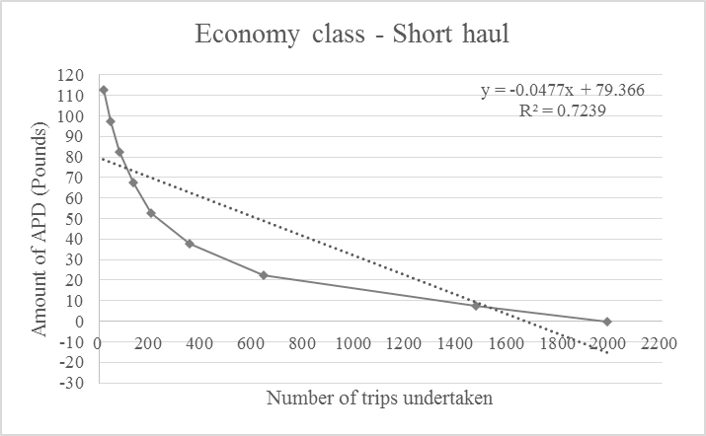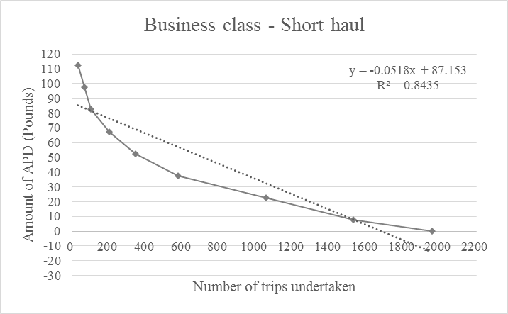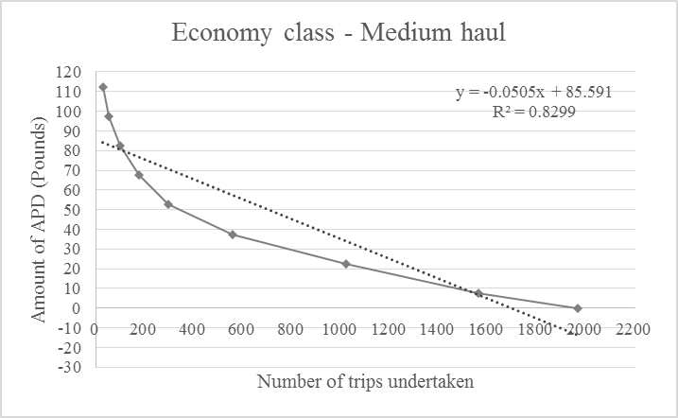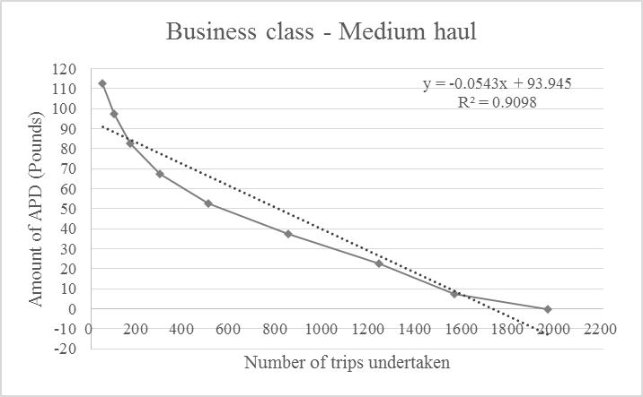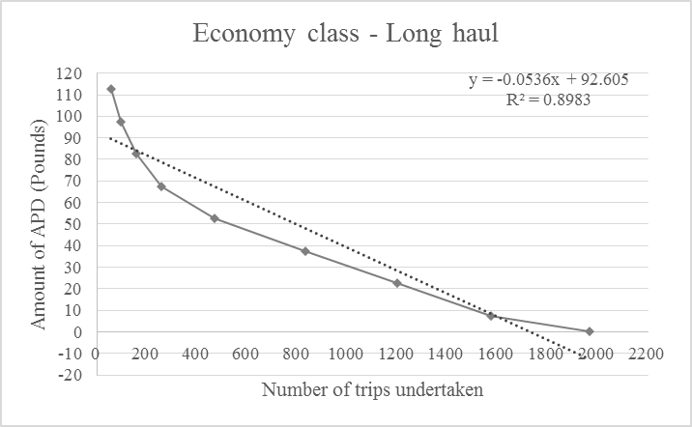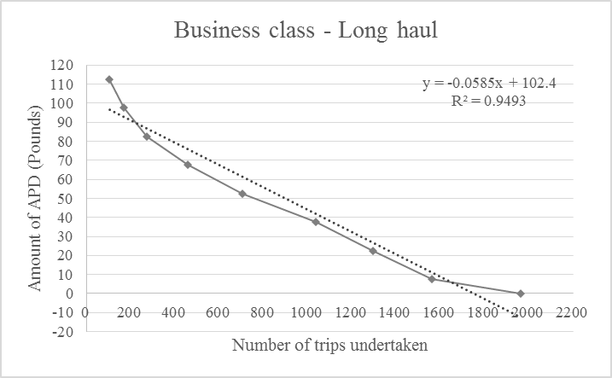
Figure 3 Demand curves and regression lines for different air travel types

Table 10 demonstrates the calculated APD elasticities along the demand curves for different trip scenarios. The demand is inelastic (elasticity less than 1) at first and then becomes elastic (elasticity larger than 1) from a certain point forward. The critical value is £37.505 in all of the scenarios, except for business-class flights on long-haul trips, where the value is £52.505. This implies that before the critical value is reached, the demand is inelastic to changes in APD, but after that, the changes may increasingly affect demand for each trip category. However, its effect varies among different flight classes and travel distances. These findings also echo those of Reynisdottir et al. (2008), Gupta (2016) and Eagles et al. (2002) in that the demand curve for tourist visitation tends to be inelastic at a modest charge. They confirm Reynisdottir et al.’s (2008) finding that the demand elasticity of tourist visitation increases along price levels, from inelastic to highly elastic.

Table 10 APD elasticity for different air travel types
Economy class – Short-haul |  |  |  |  | Business class – Short-haul
APDwtp | Number of Respondents | Cumulative Trips Taken | Elasticity |  | APDwtp | Number of Respondents | Cumulative Trips Taken | Elasticity
0.000 | 516 | 1,988 | N/A |  | 0.000 | 427 | 1,958 | N/A
7.505 | 831 | 1,472 | 0.282 |  | 7.505 | 476 | 1,531 | 0.156
22.505 | 291 | 641 | 0.681 |  | 22.505 | 477 | 1,055 | 0.678
37.505 | 149 | 350 | 1.064 |  | 37.505 | 233 | 578 | 1.008
52.505 | 70 | 201 | 1.219 |  | 52.505 | 144 | 345 | 1.461
67.505 | 55 | 131 | 1.889 |  | 67.505 | 97 | 201 | 2.172
82.505 | 34 | 76 | 2.461 |  | 82.505 | 37 | 104 | 1.957
97.505 | 27 | 42 | 4.180 |  | 97.505 | 35 | 67 | 3.397
112.500 | 15 | 15 | N/A |  | 112.500 | 32 | 32 | N/A
Economy class – Medium-haul |  |  |  |  | Business class – Medium-haul
APDwtp | Number of Respondents | Cumulative Trips Taken | Elasticity |  | APDwtp | Number of Respondents | Cumulative Trips Taken | Elasticity
0.000 | 404 | 1,966 | N/A |  | 0.000 | 402 | 1,966 | N/A
7.505 | 543 | 1,562 | 0.174 |  | 7.505 | 326 | 1,564 | 0.104
22.505 | 464 | 1,019 | 0.683 |  | 22.505 | 391 | 1,238 | 0.474
37.505 | 259 | 555 | 1.167 |  | 37.505 | 343 | 847 | 1.013
52.505 | 122 | 296 | 1.443 |  | 52.505 | 209 | 504 | 1.452
67.505 | 78 | 174 | 2.017 |  | 67.505 | 127 | 295 | 1.937
82.505 | 44 | 96 | 2.521 |  | 82.505 | 68 | 168 | 2.226
97.505 | 26 | 52 | 3.251 |  | 97.505 | 49 | 100 | 3.186
112.500 | 26 | 26 | N/A |  | 112.500 | 51 | 51 | N/A
Economy class – Long-haul |  |  |  |  | Business class – Long-haul
APDwtp | Number of Respondents | Cumulative Trips Taken | Elasticity |  | APDwtp | Number of Respondents | Cumulative Trips Taken | Elasticity
0.000 | 394 | 1,965 | N/A |  | 0.000 | 400 | 1,960 | N/A
7.505 | 374 | 1,571 | 0.119 |  | 7.505 | 265 | 1,560 | 0.085
22.505 | 366 | 1,197 | 0.459 |  | 22.505 | 260 | 1,295 | 0.301
37.505 | 365 | 831 | 1.098 |  | 37.505 | 332 | 1,035 | 0.802
52.505 | 209 | 466 | 1.570 |  | 52.505 | 248 | 703 | 1.235
67.505 | 103 | 257 | 1.804 |  | 67.505 | 183 | 455 | 1.810
82.505 | 61 | 154 | 2.179 |  | 82.505 | 107 | 272 | 2.164
97.505 | 39 | 93 | 2.727 |  | 97.505 | 63 | 165 | 2.483
112.500 | 54 | 54 | N/A |  | 112.500 | 102 | 102 | N/A

6 Conclusion, implications and limitations
This study examined UK outbound tourists’ WTP for APD, a carbon tax levied on tourists departing from UK airports in six scenarios formed based on two flight classes and three travel distances. WTP was derived for each scenario, and its values and the derived demand curves were compared. A range of implications arise from these investigations.
First, a large proportion of respondents were willing to pay for APD, which echoes Gupta (2016) and Choi and Ritchie (2014) but marks an important shift in behaviour from Miller et al.’s (2010) finding that home-based behaviour did not necessarily translate into sustainable holiday behaviour. The MWTP for short-haul trips is £16.543 in economy class and £24.116 in business class. In comparison, the current APD rate (enforced from 1 April 2017 to 1 April 2018) is £13 for economy class and £26 for business class (HM Revenue & Customs, 2017). It is evident that the ‘average tourist’ is prepared to accept the current APD rate for short-haul trips. For medium- and long-haul trips, the MWTP ranges from £22.885 to £36.795. In contrast, the current APD rates are £75 for economy class and £150 for business class (HM Revenue & Customs, 2017), which are far beyond what the average tourist is willing to accept. Therefore, the current rate for medium- and long-haul trips may largely decrease outbound travel demand, confirming many of the concerns raised by trade lobby groups about the perceived effects of APD on air travel.
Second, this study derives demand curves and elasticities along the curves based on WTP for all six trip scenarios. For short-haul trips, tourist demand is inelastic for APD below £37.505. As the current APD rate ranges from £13 to £26 for short-haul trips, it has a limited effect on tourist demand. However, for longer-haul trips, the current APD rate is more than £75, which is more than the critical value of £52.505, above which the tourist demand becomes highly elastic. This further confirms that the current APD rate for medium- and long-haul trips may deter tourists from travelling overseas.
Finally, this study identifies significant differences in WTP and demand curves across different trip scenarios. WTP is higher for business class than for economy class and for longer-haul trips than for short-haul trips. This is entirely logical and rational, as longer-haul trips and higher flight classes tend to generate more carbon emissions, and tourists may be willing to pay more to offset them.
Although tourism researchers have widely acknowledged the significant role of carbon taxes in sustainable tourism development, WTP for these types of tax has remained an under-researched topic, particularly in relation to assessing the effect of national policy on taxing tourists. This is an area of taxation research that is applicable to the tourism economy and begins to address the key question: at what point does APD begin to limit demand and WTP a tax to fly by trip type? Only a limited number of studies have addressed such topics, and the majority have been published in non-tourism journals. The one exception is Choi and Ritchie (2014), who examined WTP for carbon neutrality in Australia. Their study, however, was not directly about carbon taxes, but about VOC programmes. Gupta (2016) derived WTP for a carbon tax and its determinants, but did not consider differences between trip types or the demand curves. In this sense, the present study contributes to the knowledge of carbon taxes in the tourism field.
By comparing WTP for APD across different types of trips and identifying significant differences in WTP values, demand curves and demand elasticities, we demonstrate key findings that destinations can use to design proper taxation policies with a view to avoiding damage to the competitiveness of the market while simultaneously offsetting the externalities generated by air travel. Although studies of WTP have paid attention to air carbon offsetting measures, few have considered the influence of trip characteristics. Most studies have relied on personal socio-demographic attributes to explain the determinants of WTP. In this sense, this study contributes to WTP theory by identifying the effects of trip attributes.
In terms of practical implications, this study evaluates the current APD rate and finds that although the rate for short-haul trips may not pose a serious threat to outbound tourist demand, the rate for longer-haul trips may significantly decrease UK outbound travel. By comparing WTP across different trip types, this study confirms the effectiveness of distinguishing between trip types when setting APD rates. Lastly, by deriving the demand curves and estimating WTP for APD, this study helps to predict the effects of APD on tourism demand based on micro-level findings. Reviews of APD (e.g., Seeley, 2014) have suggested that one alternative to taxing the individual may be to tax the aircraft to encourage the use of fuller aircraft, although this measure would still be passed on to the consumer in the form of higher fares.
In summary, this study is useful in that by measuring ‘passenger WTP (it) will help policy makers to design effective financial instruments aimed at discouraging climate-unfriendly travel activities and to generate funds for the measures directed at climate change mitigation and adaptation’ (Brouwer, Brander, & Van Beukering, 2008, p.299). The future challenge in any increase in APD will be in communicating how the additional revenue is to be used for sustainability objectives, to convince consumers already reluctant to pay the existing taxes on some flight types. However, some commentators (e.g., Cairns & Newson, 2005) have demonstrated that APD is an effective tool if a government wishes to quickly constrain travel by air to address aviation emissions, as our WTP confirms. Other tools, such as adding a Value Added Tax to domestic air travel and eventually developing personal carbon budgets, may be used in a post-APD world to force individuals to pay for the pollution they cause, thereby forcing a behaviour change by constraining the personal consumption of carbon to radically address climate change.
This study has several limitations that could be addressed in future studies. First, more level-2 control variables could be included (e.g., place of residence) so as to further validate the findings. Second, this survey mainly targeted holiday travellers; future research could include business travellers. Finally, the preferences of consumers change over time. This is especially true if they obtain more information about the disputes over APD, as WTP is very sensitive to cognition and knowledge of the tax. As a result, the demand curve derived could also be dynamic and evolving over time.

References
Andreoni, J. (1990). Impure altruism and donations to public goods: A theory of warm-glow giving. The Economic Journal, 100(401), 464-477.
Armbrecht, J. (2014). Use value of cultural experiences: A comparison of contingent valuation and travel cost. Tourism Management, 42, 141-148.
Arrow, K., Solow, R., Portney, P. R., Leamer, E. E., Radner, R., & Schuman, H. (1993). Report of the NOAA panel on contingent valuation. Federal Register, 58(10), 4601-4614.
Asafu-Adjaye, J., & Tapsuwan, S. (2008). A contingent valuation study of scuba diving benefits: Case study in Mu Ko Similan Marine National Park, Thailand. Tourism Management, 29(6), 1122-1130.
Baumol, W. J., & Oates, W. E. (1988). The theory of environmental policy. Cambridge University Press.
Becken, S. (2007) Tourists’ perception of international air travel’s impact on the global climate and potential climate change policies. Journal of Sustainable Tourism, 15(4), 351-368.
Birdir, S., Ünal, Ö., Birdir, K., Williams, A. T. (2013). Willingness to pay as an economic instrument for coastal tourism management: Cases from Mersin, Turkey. Tourism Management, 36, 279-283.
Bofinger, H. & Strand, J. (2013). Calculating the carbon footprint from different classes of air travel. World Bank, Development Research Group, Env. & Energy Team. May 2013.
Brouwer, R., Brander, L., & Van Beukering, P. (2008). ‘A convenient truth’: Air travel passengers’ willingness to pay to offset their CO 2 emissions. Climatic Change, 90(3), 299-313.
Cairns, S. & Newson, C. (2006). Predict and decide: Aviation, climate change and UK policy: Final report. Oxford: Environmental Change Institute, University of Oxford.
Carlsson, F., & Johansson-Stenman, O. (2000). Willingness to pay for improved air quality in Sweden. Applied Economics, 32(6), 661-669.
Carson, R. T., Flores, N. E., & Mitchell, R. C. (1999). The theory and measurement of passive-use value. Valuing environmental preferences: Theory and practice of the contingent valuation method in the US, EU, and developing countries (pp. 97-130).
Casey, J. F., Brown, C., & Schuhmann, P. (2010). Are tourists willing to pay additional fees to protect corals in Mexico? Journal of Sustainable Tourism, 18(4), 557-573.
Chang, J. S., Shon, J. Z., & Lin, T. D. (2010). Airline carbon offset: Passengers’ willingness to pay and reasons to buy. In 12th World Conference on Transport Research (WCTR), Lisbon, Portugal, July (pp. 11-15).
Che, H. C., & Cao, F. (2014). A research of environment management policy based on the externality theory. In Advanced Materials Research (Vol. 989, pp. 1324-1327). Trans Tech Publications.
Chen, J. M., Zhang, J., & Nijkamp, P. (2016). A regional analysis of willingness-to-pay in Asian cruise markets. Tourism Economics, 22(4), 809-824.
Choi, A. S., & Ritchie, B. W. (2014). Willingness to pay for flying carbon neutral in Australia: An exploratory study of offsetter profiles. Journal of Sustainable Tourism, 22(8), 1236-1256.
Choi, A. S., Ritchie, B. W., Papandrea, F., & Bennett, J. (2010). Economic valuation of cultural heritage sites: A choice modeling approach. Tourism Management, 31(2), 213-220.
Clawson, M., & Knetsch, J. L. (1966). Economics of outdoor recreation. Washington, DC: Resources for the Future.
Correia, A., Santos, C. M., & Barros, C. P. (2007). Tourism in Latin America a choice analysis. Annals of Tourism Research, 34(3), 610-629.
Diamond, P. A., & Hausman, J. A. (1994). Contingent valuation: Is some number better than no number? Journal of Economic Perspectives, 8(4), 45-64.
Eagles, P. F., McCool, S. F., Haynes, C. D., & Phillips, A. (2002). Sustainable tourism in protected areas: Guidelines for planning and management (Vol. 8). Gland: IUCN.
Forsyth, P., Dwyer, L., Spurr, R., & Pham, T. (2014). The impacts of Australia’s departure tax: Tourism versus the economy? Tourism Management, 40, 126-136.
Frash Jr, R. E., DiPietro, R., & Smith, W. (2015). Pay more for McLocal? Examining motivators for willingness to pay for local food in a chain restaurant setting. Journal of Hospitality Marketing & Management, 24(4), 411-434.
Garson, G. D. (2013). Introductory guide to HLM with HLM 7 software. Hierarchical Linear Modeling: Guide and Applications (pp. 55-96).
Gössling, S., Broderick, J., Upham, P., Ceron, J. P., Dubois, G., Peeters, P., & Strasdas, W. (2007). Voluntary carbon offsetting schemes for aviation: Efficiency, credibility and sustainable tourism. Journal of Sustainable Tourism, 15(3), 223-248.
Gössling, S. & Peeters, P. (2015). Assessing tourism’s global environmental impact 1900–2050. Journal of Sustainable Tourism, 23(5), 639-659.
Grafeld, S., Oleson, K., Barnes, M., Peng, M., Chan, C., & Weijerman, M. (2016). Divers’ willingness to pay for improved coral reef conditions in Guam: An untapped source of funding for management and conservation? Ecological Economics, 128, 202-213.
Grandage, J., & Rodd, R. (1981). The rationing of recreational land use. The Rationing of Recreational Land Use (pp. 76-91).
Green, P. E., Krieger, A. M., & Wind, Y. (2001). Thirty years of conjoint analysis: Reflections and prospects. Interfaces, 31(3), S56-S73.
Greene, W. H., & Hensher, D. A. (2003). A latent class model for discrete choice analysis: Contrasts with mixed logit. Transportation Research Part B: Methodological, 37(8), 681-698.
Greiner, R., & Rolfe, J. (2004). Estimating consumer surplus and elasticity of demand of tourist visitation to a region in North Queensland using contingent valuation. Tourism Economics, 10(3), 317-328.
Gupta, M. (2016). Willingness to pay for carbon tax: A study of Indian road passenger transport. Transport Policy, 45, 46-54.
Hanley, N., Shogren, J. F., & White, B. (1997). The economics of sustainable development. In Environmental Economics in Theory and Practice (pp. 425-449). Macmillan Education, UK.
Herrero, L. C., Sanz, J. Á., Bedate, A., & Barrio, M. J. (2012). Who pays more for a cultural festival, tourists or locals? A certainty analysis of a contingent valuation application. International Journal of Tourism Research, 14(5), 495-512.
Hanemann, W. M. (1994). Valuing the environment through contingent valuation. Journal of Economic Perspectives, 8(4), 19-43.
Hinnen, G., Hille, S. L., & Wittmer, A. (2017). Willingness to pay for green products in air travel: Ready for take-off? Business Strategy and the Environment, 26(2), 197-208.
HM Revenue & Customs. (2017). Excise Notice 550: Air Passenger Duty. Retrieved from https://www.gov.uk/government/publications/excise-notice-550-air-passenger-duty
HM Treasury. (2016). Autumn Statement 2016. Retrieved from https://www.gov.uk/government/uploads/system/uploads/attachment_data/file/571556/autumn_statement_2016_print.pdf
Ho, S. H., & Huang, C. H. (2009). Exploring success factors of video game communities in hierarchical linear modeling: The perspectives of members and leaders. Computers in Human Behavior, 25(3), 761-769.
Jou, R. C., & Chen, T. Y. (2015). Willingness to pay of air passengers for carbon-offset. Sustainability, 7(3), 3071-3085.
Juvan, E., & Dolnicar, S. (2014). Can tourists easily choose a low carbon footprint vacation? Journal of Sustainable Tourism, 22(2), 175-194.
Kerr, G. N., & Manfredo, M. J. (1991). An attitudinal based model of pricing for recreation services. Journal of Leisure Research, 23(1), 37.
Kremelberg, D. (2011). Logistic, ordered, multinomial, negative binomial, and Poisson regression. Practical statistics: A Quick and Easy Guide to IBM® SPSS® Statistics, STATA, and Other Statistical Software (pp. 235-287).
Laarman, J. G., & Gregersen, H. M. (1996). Pricing policy in nature-based tourism. Tourism Management, 17(4), 247-254.
Lindberg, K., Dellaert, B. G., & Rassing, C. R. (1999). Resident trade-offs: A choice modeling approach. Annals of Tourism Research, 26(3), 554-569.
Mair, J. (2011). Exploring air travellers’ voluntary carbon-offsetting behaviour. Journal of Sustainable Tourism, 19(2), 215-230.
Mankiw, N. G. (2006). Raise the gas tax. The Wall Street Journal, 20.
Mayor, K., & Tol, R. S. (2007). The impact of the UK aviation tax on carbon dioxide emissions and visitor numbers. Transport Policy, 14(6), 507-513.
McKercher, B., Prideaux, B., Cheung, C., & Law, R. (2010). Achieving voluntary reductions in the carbon footprint of tourism and climate change. Journal of Sustainable Tourism, 18(3), 297-317.
Miller, G., Rathouse, K., Scarles, C., Holmes, K. & Tribe J. (2010). Public understanding of sustainable tourism. Annals of Tourism Research, 37(3), 627-645.
Mitchell, R. C., & Carson, R. T. (1989). Using surveys to value public goods: The contingent valuation method. Resources for the Future.
Mmopelwa, G., Kgathi, D. L., & Molefhe, L. (2007). Tourists’ perceptions and their willingness to pay for park fees: A case study of self-drive tourists and clients for mobile tour operators in Moremi Game Reserve, Botswana. Tourism Management, 28(4), 1044-1056.
More, T., & Stevens, T. (2000). Do user fees exclude low-income people from resource-based recreation? Journal of Leisure Research, 32(3), 341.
Morey, E., & Rossmann, K. G. (2003). Using stated-preference questions to investigate variations in willingness to pay for preserving marble monuments: Classic heterogeneity, random parameters, and mixture models. Journal of Cultural Economics, 27(3-4), 215-229.
Patt, A. (2017) Beyond the tragedy of the commons: Reframing effective climate change governance. Energy Research and Social Science, 34, 1-3.
Piriyapada, S., & Wang, E. (2015). Modeling willingness to pay for coastal tourism resource protection in Ko Chang Marine National Park, Thailand. Asia Pacific Journal of Tourism Research, 20(5), 515-540.
Polonsky, M. J., Grau, S. L., & Garma, R. (2010). The new greenwash? Potential marketing problems with carbon offsets. International Journal of Business Studies, 18(1), 49.
Reiling, S. D., Cheng, H. T., & Trott, C. (1992). Measuring the discriminatory impact associated with higher recreational fees. Leisure Sciences, 14(2), 121-137.
Reiling, S. D., Criner, G. K., & Oltmanns, S. E. (1988). The influence of information on users’ attitudes toward campground user fees. Journal of Leisure Research, 20(3), 208.
Reynisdottir, M., Song, H., & Agrusa, J. (2008). Willingness to pay entrance fees to natural attractions: An Icelandic case study. Tourism Management, 29(6), 1076-1083.
Richer, J. R., & Christensen, N. A. (1999). Appropriate fees for wilderness day use: Pricing decisions for recreation on public land. Journal of Leisure Research, 31(3), 269.
Saayman, M., Krugell, W. F., & Saayman, A. (2016). Willingness to pay: Who are the cheap talkers? Annals of Tourism Research, 56, 96-111.
Scott, D., Peeters, P., Gössling, S. (2010). Can tourism deliver its ‘aspirational’ greenhouse gas emission reduction targets? Journal of Sustainable Tourism, 18(3), 393-408.
Seeley, A. (2014). Air passenger duty: Recent debates and reform. House of Commons Briefing Paper, http://www.sasig.org.uk/wp-content/uploads/2014/05/2014.05.16_HoC_StandardNote_APD.pdf
Seetaram, N., Song, H., & Page, S. J. (2014). Air passenger duty and outbound tourism demand from the United Kingdom. Journal of Travel Research, 53(4), 476-487.
Stevens, T., More, T., & Allen, P. G. (1989). Pricing policies for public day-use outdoor recreation facilities. Journal of Environmental Management, 28(1), 43-52.
van Birgelen, M., Semeijn, J., & Behrens, P. (2011). Explaining pro-environment consumer behavior in air travel. Journal of Air Transport Management, 17(2), 125-128.
Venkatachalam, L. (2004). The contingent valuation method: A review. Environmental Impact Assessment Review, 24(1), 89-124.
Vlachou, A. & Pantelias, G. (2017). The EU’s emissions trading system, part 1: Taking stock. Capitalism, Nature, Socialism, 28(2), 84-102.
Williams, D. R., Vogt, C. A., & Vittersø, J. (1999). Structural equation modeling of users’ response to wilderness recreation fees. Journal of Leisure Research, 31(3), 245.

