Machine learning for energy performance prediction
at the design stage of buildings

Razak Olu-Ajayi
Big Data Technologies and Innovation Laboratory, University of Hertfordshire, Hatfield, AL10 9AB, UK
r.olu-ajayi@herts.ac.uk

Hafiz Alaka
Big Data Technologies and Innovation Laboratory, University of Hertfordshire, Hatfield, AL10 9AB, UK
h.alaka@herts.ac.uk

Ismail Sulaimon
Big Data Technologies and Innovation Laboratory, University of Hertfordshire, Hatfield, AL10 9AB, UK
i.sulaimon@herts.ac.uk

Funlade Sunmola
School of Engineering and Technology, University of Hertfordshire, Hatfield, AL10 9AB, UK
f.sunmola@herts.ac.uk

Saheed Ajayi
School of Built Environment, Engineering and Computing, Leeds Beckett University, Leeds LS28AG, UK
S.Ajayi@leedsbeckett.ac.uk

ABSTRACT
The substantial amount of energy consumption in buildings and the associated adverse effects prompts the importance of understanding building energy efficiency. Developing an energy prediction model with high accuracy is considered one of the most effective approach to understanding building energy efficiency. Therefore, various studies have developed diverse models for predicting building energy consumption focused on the current building stock. However, to ensure future buildings are constructed to be more energy efficient, it is essential to consider energy efficiency at the design stage. Machine Learning (ML) algorithms are considered the most contemporary and best method for prediction, and these algorithms (such as Support Vector Machine (SVM) and Decision Tree (DT), among others) have gained much attention in the field of energy prediction. However, no study has explored the application of hyper parameter tuning and feature selection methods in developing a design stage Machine Learning (ML) energy predictive model. In this research, nine machine learning classification-based algorithms were compared for energy performance assessment at the design stage of residential buildings. Additionally, feature selection and hyper parameter tunning were implemented. The result shows that it is possible to develop a high performing ML model for building energy use prediction at the design stage. Furthermore, Gradient Boosting (GB) outperformed the other models with an accuracy of 0.67 for predicting building energy performance.

Keywords: Building energy performance, Building designers, Energy rating, Machine learning algorithms, Energy efficiency, Building design stage.

Nomenclature
TP is True Positive
TN is True Negative

- INTRODUCTION
With the world population and economy advancement, energy consumed in buildings has become a prime contributor to worldwide total energy consumption (Zhong et al., 2019; Hu et al., 2021; Kim and Suh, 2021). According to reports, buildings engender 40% of global energy consumption and 38% Carbon dioxide (CO₂) emission (United Nations Environment Programme, 2017; Amasyali and El-Gohary, 2018; Ding, Li and Fan, 2018), and it is estimated that global energy consumption will grow by over 50% before 2030 (Mawson and Hughes, 2020). In the United Kingdom (UK), buildings account for 70% of the total energy consumption (Building Energy Efficiency Survey, 2016). Generally, the adverse effects of excess energy consumption include air pollution mainly in the form of CO₂ emission and its associated health effects [e.g. kidney disease, lung cancer, heart disease, among others (World Health Organisation, 2019)], climate change and global warming (Dandotiya, 2020). This is because more than 80% of the world energy sources still emanate from non-renewable polluting sources i.e., fossil fuels (Ritchie and Roser, 2020) and it also causes high economic costs including substantial recurring energy costs for households.
The massive energy consumption and the associated adverse effects trigger the importance of understanding building energy efficiency and exploring various potentials for enhancement, so new buildings can be developed to consume energy more efficiently (TOPRAK et al., 2017). This point is well understood globally as various governments have initiated regulations, principles and sometimes incentives to help alleviate the amount of energy consumed by buildings (Amasyali and El-Gohary, 2021; Himeur et al., 2020; Qiao, Yunusa-Kaltungo and Edwards, 2021). For instance, in 2002, the European Union (EU) mandate on building energy performance applied a systematic framework for understanding energy performance which has since prompted member states to generate certification systems for rating building energy performance (European Parliament, 2002). Hence, the UK employs a standard scale rating system to notify building owners of current energy performance and effective methods to improve energy efficiency (Curtis, Devitt and Whelan, 2014).
Most government policies apply more to the current building stock, as evident in the example above. However, research has proven that to ensure future buildings are more energy efficient, it is essential to consider energy efficiency at the design stage (Jaber and Ajib, 2011; Wang, Li and Tam, 2014; Ding et al., 2018). Customarily, energy assessment at the design stage is achieved through energy simulation models, which assess a building design and provide the potential energy performance of such designs. However, these tools are considered inefficient due to the large number of required parameters and its time consumption (Pham et al., 2020). Researchers speculate that such an energy prediction model with high accuracy will save around 30% of total energy use in buildings (Colmenar-Santos et al., 2013; Aversa et al., 2016). This indicates why there have been various studies since the 1990s, that have developed diverse models for predicting building energy consumption (Dong, Cao and Lee, 2005; Neto and Fiorelli, 2008; Castelli et al., 2015; Tardioli et al., 2015; Ahmad, Mourshed and Rezgui, 2017a; Li et al., 2018; Zhong et al., 2019; Chokwitthaya et al., 2020; Kim and Suh, 2021). This method can be classified into two main types: physical and data driven method.

The physical method is mainly the utilization of energy simulation tools [e.g., DOE-2 (Chirarattananon and Taveekun, 2004) and eQuest (Yezioro, Dong and Leite, 2008), among others]. It is recognized as the traditional method utilized at the design stage for building energy assessment. It enables designers to upload building designs to access the potential energy performance of the building. However, it requires many variables and consumes a lot of time (sometimes up to an hour to load and run dependent on the computer platform) which often hinders designers work flow (Zhu, 2006). Conversely, Data driven method is often developed using mathematical models or Machine Learning (ML) algorithms [e.g. Support Vector Machine (SVM) (Li et al., 2009a; Niu, Wang and Wu, 2010) and Random Forest (RF) (Ahmad, Mourshed and Rezgui, 2017a; Wang et al., 2018) among others], which require less number of building parameters. Also, data driven method has been proven to be more accurate and efficient, as result can be generated in seconds (Runge & Zmeureanu, 2019; Qiao, Yunusa-Kaltungo and Edwards, 2020). For example, Neto & Fiorelli (2008) conducted a comparative analysis of a data driven method and physical simulation method for predicting building energy use. It was concluded that data driven method outperforms the physical method.

Despite the good properties of data driven method using ML algorithms, past studies (e.g. Aversa et al., 2016, 2016; K. Li et al., 2018; Pham et al., 2020; Robinson et al., 2017) have not been extensively developed for design stage analysis which is where the potential lies for around 30% energy savings (Colmenar-Santos et al., 2013; Aversa et al., 2016). However, data driven methods performance depends on the ML algorithm used for model development (Runge and Zmeureanu, 2019; Pham et al., 2020). Some of the most efficient algorithms used in past studies include Decision Tree (DT) (Tso and Yau, 2007; Yu et al., 2010), Artificial Neural Network(ANN) (Ahmad et al., 2014; Ahmad, Mourshed and Rezgui, 2017a) and Support Vector Machine (SVM) (Li et al., 2009a; Niu, Wang and Wu, 2010) among others. These algorithms have at different times outperformed one another. For instance, the study by Dong et al (2005), concluded that SVM produced better results than neural networks (Dong, Cao and Lee, 2005); while Khantach et al (2019) conducted a comparative analysis of Multi-layer Perceptron ANN and SVM among others. It was concluded that ANN outperformed SVM for energy use prediction (Khantach et al., 2019). Furthermore, a major factor that often affects the performance of ML models is feature selection and hyper parameter tuning.

Although some studies have compared different algorithms (Li et al., 2009a; Robinson et al., 2017; Khantach et al., 2019; Pham et al., 2020), some studies have implemented feature selection during model development (Chae et al., 2016; Liu et al., 2020; Dong et al., 2021) while some have conducted hyper parameter tuning (Zhao and Magoulès, 2012; Nwulu, 2017). However, no study has holistically implemented all these strategies to ensure a high performing model for energy prediction at the design stage of buildings. Therefore, this research aims to develop a high performing predictive model that facilitates the prediction of energy performance for designers at the early design stage of buildings. The key objectives implemented to achieve the aim are as follows:
- To conduct a comparative analysis of machine learning algorithms for building energy performance prediction.
- To investigate the impact of different feature selection methods on the model’s performance.
- To investigate the effect of hyper parameter tuning on the performance of the model.
The remainder of this paper is organized as follows: Section 2 presents a review of energy use prediction and various machine learning algorithms. Section 3 describes the data collected, research methodology, data pre-processing, and evaluation measures. Section 4 presents and discusses the performance results and findings. Finally, section 5 discusses the implication for practice and Section 6 conveys the conclusions and recommendations.

2.0 LITERATURE REVIEW
Accurate energy consumption prediction is considered one of the most effective approaches to understanding building energy efficiency. This is fundamental for energy conservation, improved decision making towards reducing energy consumption and the construction of energy inefficient buildings (Zhao and Magoulès, 2012; Lei et al., 2021). Decisions made at the early design stage of buildings have a significant effect on building energy performance. For instance, simply selecting the right design based on shape, type or orientation among different alternatives can reduce energy consumption by over 30% with no added cost (Elbeltagi et al., 2017). At the early design stage, designers rely tremendously on prior experience or building energy simulation tools to define the most suitable value for the design parameters. However, the application of prior experience often result in inaccurate conclusions (Wang, Zmeureanu and Rivard, 2005), while the energy simulation tool is considered to be time consuming and labour intensive (Deb et al., 2017; Runge & Zmeureanu, 2019).

According to academic literature, the advantages of using energy simulation tools are their clear correlation between input and output parameters. However, some drawbacks include the demand for a substantial number of detailed building parameters that are often inaccessible (e.g., HVAC (Heating, Ventilation and Air Conditioning) system, internal occupancy loads, physical properties and solar information among others (Li and Wen, 2014; Deb et al., 2017; Runge and Zmeureanu, 2019; Qiao, Yunusa-Kaltungo and Edwards, 2021). Nevertheless, some energy simulation tools have been applied for examining and predicting energy use, namely EnergyPlus (Neto and Fiorelli, 2008), DOE-2 (Chirarattananon and Taveekun, 2004) and eQuest (Yezioro, Dong and Leite, 2008) and have produced relatively good results (Crawley et al., 2008). These problems of energy performance assessment has attracted significant attention of researchers, constantly investigating diverse methods to better understand building energy efficiency, which is giving rise to new developments for predicting energy consumption (Ahmad, Mourshed and Rezgui, 2017a; Fathi et al., 2020; Serale, Fiorentini and Noussan, 2020; Bourdeau et al., 2019; Runge and Zmeureanu, 2019; Amasyali and El-Gohary, 2018). Machine Learning (ML) algorithms have been introduced in several studies (Aversa et al., 2016, 2016; Robinson et al., 2017; Li et al., 2018; Pham et al., 2020; Olu-Ajayi et al., 2022), because it is recognized as the most contemporary and best method for prediction (Vorobeychik and Wallrabenstein, 2013; Canales, 2016; Olu-Ajayi and Alaka, 2021).

ML algorithms have become more recognised due to their low time consumption and good performance (Seyedzadeh et al., 2020). These algorithms have proven suitable for different building groups [residential building (Curtis, Devitt and Whelan, 2014), non-residential (Chirarattananon and Taveekun, 2004)], other prediction time periods [hourly, monthly and annually (Qiong Li, Peng Ren, and Qinglin Meng, 2010; Dong et al., 2021)] and different prediction purposes [heating or cooling load, total consumption (Li et al., 2009b)]. However, there are not many studies to substantiate its suitability for prediction at the early design phase of buildings. Many machine learning algorithms are recognised to be efficient for prediction, such as SVM (Li et al., 2009a; Niu, Wang and Wu, 2010), RF (Ahmad, Mourshed and Rezgui, 2017a; Wang et al., 2018), Decision Tree (DT) (Tso and Yau, 2007; Yu et al., 2010), among others.

SVM, also known as Support Vector Classifier (SVC) and can be employed for the classification method. It is one of the recurrent models in the field of energy prediction, and it is recognised for its delivery of good outcomes in small datasets (Li et al., 2009b; Qiong Li, Peng Ren, and Qinglin Meng, 2010; Aversa et al., 2016). For example, in a study by Li et al 2008, SVM showed the best performance compared to other neural network regression models for energy consumption prediction (Li et al., 2009a). Likewise, another efficient method is DT which shows good performance in a study by Tso and Yau (2007), the results showed that decision tree and neural networks performed better than other regression methods (Tso and Yau, 2007).

Another class of ML algorithms that is slowly receiving attention in the field of building energy use prediction is called the ensemble model. For example, wang et al (2018) applied Ensemble Bagging Tree (EBT) to forecast the energy demand of an institutional building (Wang, Wang and Srinivasan, 2018). Ensemble models comprises of several algorithms, and due to their stability, they are liable to produce better results than single models (Amasyali and El-Gohary, 2021). These types of ensemble models include Random Forest (RF), Gradient Boosting (GB), Ensemble Bagging Tree (EBT), among others. In a study by Chae et al (2016), the ensemble model was compared with other ANN models to predict building energy use. Results showed the ensemble models as the more effective model (Chae et al., 2016). However, the various machine learning algorithms performance are dependent on the available dataset and input features (Zhong et al., 2019).

According to the United Nations Environment Program (UNEP), the rate of energy consumed in a building and the physical properties of the building are often closely interconnected (United Nations Environment Programme, 2017). Various studies have itemized that specific building properties (such as wall properties, roof properties, floor properties, wall thickness, among others) have a high effect on building energy consumption (Brown, Southworth and Sarzynski, 2009; Hankey and Marshall, 2010; Guhathakurta and Williams, 2015; Robinson et al., 2017; Li et al., 2018). However, feature selection is recognised as the most suitable method for identifying the most significant variables (Zhao and Magoulès, 2012), which can help identify the most important features at the early design stage.

3.0 DATA AND METHODOLOGY
The development of an efficient energy performance prediction model should be based on a sufficient dataset, considering the theory that prediction accuracy highly depends on the algorithm used, quality and quantity of data (Runge and Zmeureanu, 2019). Several studies [e.g. (Dong, Cao and Lee, 2005; Li et al., 2009b; Chou and Bui, 2014; Wang, Lu and Feng, 2020; Dong et al., 2021)] have not used beyond 2000 buildings for model development and based on the general hypothesis that the larger the data, the better the performance and more reliable the result (Lee et al., 2011; Kaur and Gupta, 2017; Dalal, 2018; Goyal, Tiwari and Sonekar, 2020; Kabir, 2020). Thus, to development an efficient and high performing predictive model, 4500 buildings were utilized. This study will use nine machine learning classification algorithms for the development of an energy performance prediction model namely Support Vector Machine (SVM), Gradient Boosting (GB), Random Forest (RF), Decision Tree (DT), K Nearest Neighbour (KNN), Extra Trees (ET), Adaboost, Gaussian process (GP), and Multi-Layer Perceptron (MLP). Each model development was implemented using python programming language and performed using the following hardware specification (Apple MacBook Air with macOS Big Sur 11.4 and an Apple M1 chip with16 GB RAM and 8 cores). The development of each machine learning model undertook several stages, namely: a) Data collection b) Data pre-processing c) Feature Selection d) Model development (training) e) Model Evaluation (Testing) as shown in Figure 1 below. Figure 1 shows the methodology used to achieve the aim.

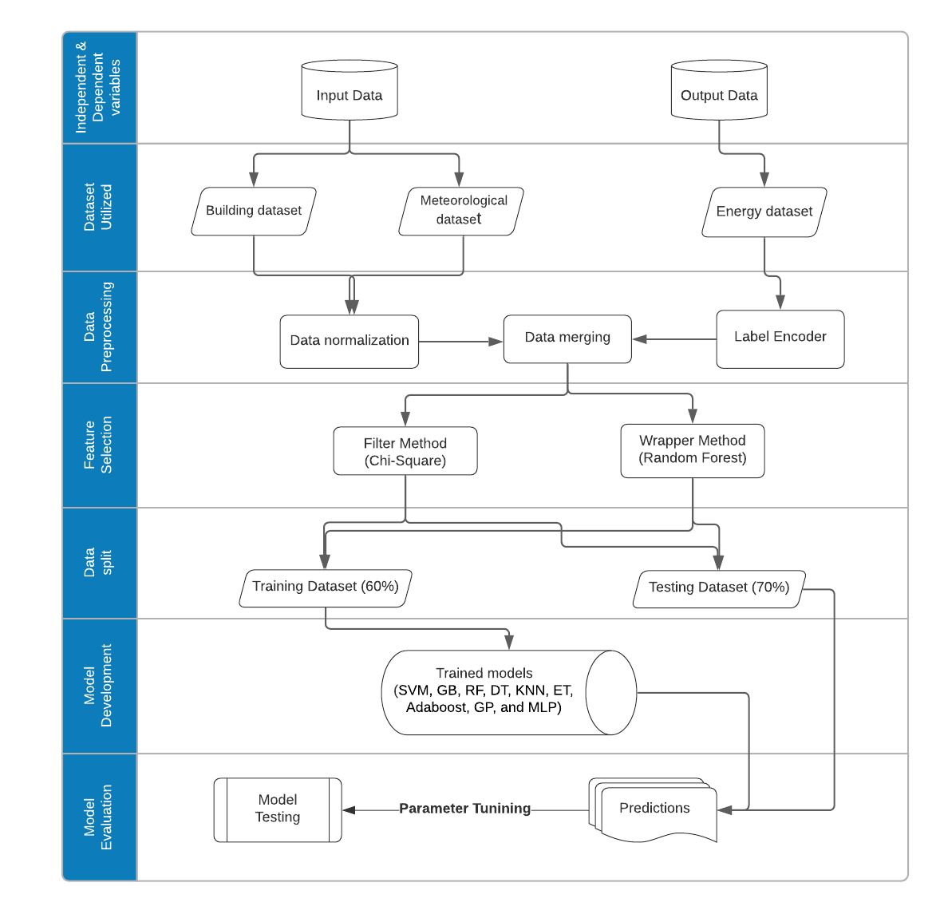
Figure 1: Flowchart diagram of the research methodology

  - Data Collection
The building dataset containing 4500 data rows was collected from the UK Ministry of Housing Communities and Local Government (MHCLG) database. This dataset consists of only parameters of that can be detected and modified at the early design stage. The type of buildings used include house, flat, bungalow and maisonette, and the built form include mid-terrace, semi-detached, detached and end-terrace. Figure 2a and 2b show the proportion of building type and built form in the dataset collected. This study focused on residential buildings only as they form the bulk of the building stock generally.

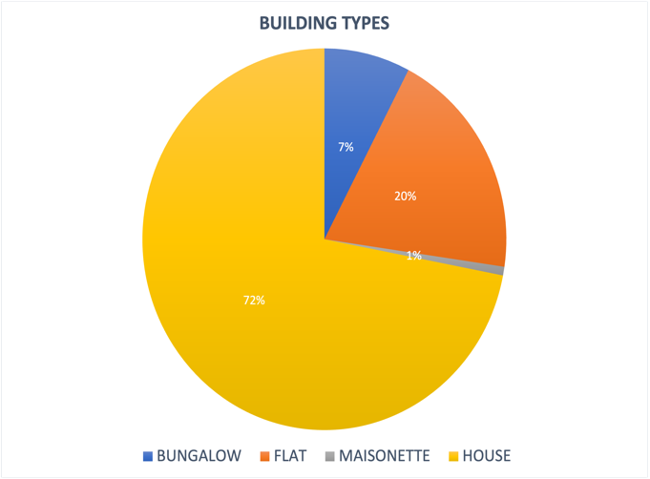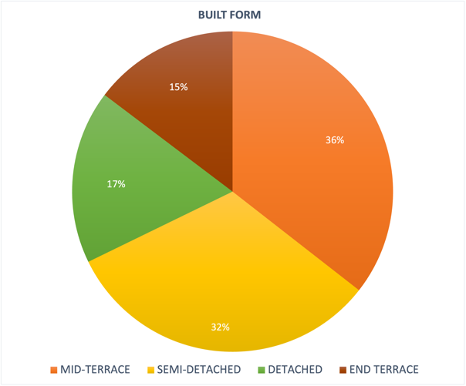
Figure 2a: Proportion of building types Figure 2b: Proportion of property built form
To achieve the aim of this paper, which is to develop a model specifically for the design stage of buildings that facilitates energy assessment for designers, only parameters that are easily changeable at the design stage were considered as the independent variables. This included total floor area, glazed area, property type, walls description, among others, as shown in Table 1 below. The building dataset also contains the energy consumption rating of each building for the year 2020. The other data considered in this study include meteorological data. According to (Ding and Liu, 2020) one of the key variables for building energy prediction is weather data. Although the meteorological data is not changeable at the design stage, the information is generally available at the design stage and can be considered in predicting building energy consumption. The meteorological data used was collected from the Meteostat database.

Since the dataset of buildings contains annual energy consumption rating of the year 2020, annual meteorological dataset relative to each building was collected. This granularity of data collected was monthly from January 2020 to December 2020 and averaged to calculate the annual data. This was collected using the area postcode of each building. The 4500 buildings are located within nine area postcodes around the UK; therefore, the meteorological data was collected for nine area postcodes. The meteorological data consisted of temperature, wind speed and pressure, as shown in Table 1 below. Table 1 also gives a description of each of the variables.

Table 1: List of variables selected from the dataset
S/N | Variable | Description | Internal/  External | Type | Label
1 | Temperature [ºc] (Annual Average) | Weather temperature is the degree of hotness or coldness of a particular area. | Meteorological Data | Continuous | Independent
2 | Wind speed [km/h] (Annual Average) | This is the rate at which air is moving in a particular area. | Meteorological Data | Continuous | Independent
3 | Pressure [Hg] (Annual Average) | Air pressure is the force exerted onto a surface by the weight of the air | Meteorological Data | Continuous | Independent
4 | Postcode | The postcode of the property | Building Data | Continuous | Independent
5 | Total Floor Area[m²] | This is the total of all enclosed spaces measured to the internal face of the external walls measured based on the Royal Institute of Chartered Surveyors guidance issued. | Building Data | Continuous | Independent
6 | Property Type | This describes the type of property (i.e., Flat, House, Maisonette etc). | Building Data | Categorical | Independent
7 | Glazed Area | This describes the total glazed area of the habitable area. e.g., much less than typical, less than typical, normal etc. | Building Data | Categorical | Independent
8 | Extension Count | The describes the number of extensions. | Building Data | Discrete | Independent
9 | Walls Description | This describes the wall type (e.g., Cavity wall, Solid brick, Park home wall etc). | Building Data | Categorical | Independent
10 | Floor Description | This describes the floor type (e.g., Solid, Suspended etc). | Building Data | Categorical | Independent
11 | Floor Level | Flats and maisonettes only. Floor level relative to the lowest level of the property (0 for ground floor). | Building Data | Discrete | Independent
12 | Windows Description | This describes the window type (e.g., Cavity wall, Solid brick, Park home wall etc). | Building Data | Categorical | Independent
13 | Windows Energy Efficiency | Energy efficient window glazing covers both double and triple glazing. These are windows with two or more glass panes in a sealed unit. Also, the energy efficiency of a building can be improved by the installation of secondary glazing. Therefore, the window energy efficiency is rated from very good to very poor based on the type of glazing utilized. | Building Data | Categorical | Independent
14 | Windows Environmental Efficiency | This is concerned with the rating of the quality of window in terms of environmental friendliness. The most important aspect of any window is the glass, a relatively environmentally harmless material made from sand. This is rated from very good to very poor. | Building Data | Categorical | Independent
15 | Walls Energy Efficiency | Good-quality energy efficient wall reduces air inflation and blocks the flow of heat. An energy-efficient wall also controls water and vapor intrusion and protect against thermal radiation. This is rated from very good to very poor. | Building Data | Categorical | Independent
16 | Walls Environmental Efficiency | Through shading, walls can lower temperatures in summer and reduce energy cost. Therefore, the window energy efficiency is rated from very good to very poor based on the type of glazing. | Building Data | Categorical | Independent
17 | Roof Description | This describes the roof type (e.g., 50m, 100m loft insulation). | Building Data | Categorical | Independent
18 | Roof Energy Efficiency | Roofs are good ways of conserving energy. This is rated from very good to very poor. | Building Data | Categorical | Independent
19 | Roof Environmental Efficiency | This describes the environmental efficiency of the type of roof selected. Also, this is rated from very good to very poor. | Building Data | Categorical | Independent
20 | Lighting Environmental Efficiency | This describes the environmental efficiency of the type of lighting selected. Also, this is rated from very good to very poor. | Building Data | Categorical | Independent
21 | Lighting Energy Efficiency | Energy-efficient lighting helps reduce the energy consumption and carbon dioxide emissions, all without decreasing the quality of light in our homes. | Building Data | Categorical | Independent
22 | Number of Heated Rooms | The number of heated rooms in the property. | Building Data | Discrete | Independent
23 | Number of Habitable Rooms | Number of Habitable rooms include any living room, sitting room, dining room, bedroom, study and similar. | Building Data | Discrete | Independent
24 | Energy Rating | This is the building’s annual energy rating | Building Energy Data | Categorical | Dependent

The building data and the meteorological data were employed as the independent variables while the building energy rating was utilized as the dependent variable. The building energy rating adopts the UK standard rating which is issued based on the energy consumption level of the building. The energy rating in this data includes A, B, C to G, with ‘A’ denoted as the most energy efficient with the lowest energy consumption level while ‘G’ signified the least energy efficient with the highest energy consumption level as represented in Table 2 below. Figure 3 shows the proportion of building energy efficiency rating for each building type. Subsequently, to prevent complexities during model development, the data was pre-processed

S/N | Energy performance value | Energy efficiency rating | Remarks
1 | 0-25 | A | More energy efficient
2 | 26-50 | B | More energy efficient
3 | 51-75 | C | More energy efficient
4 | 76-100 | D | Fairly energy efficient
5 | 101-125 | E | Less Energy efficient
6 | 126-150 | F | Less Energy efficient
7 | Over 150 | G | Less Energy efficient
Table 2: Energy rating and energy performance values

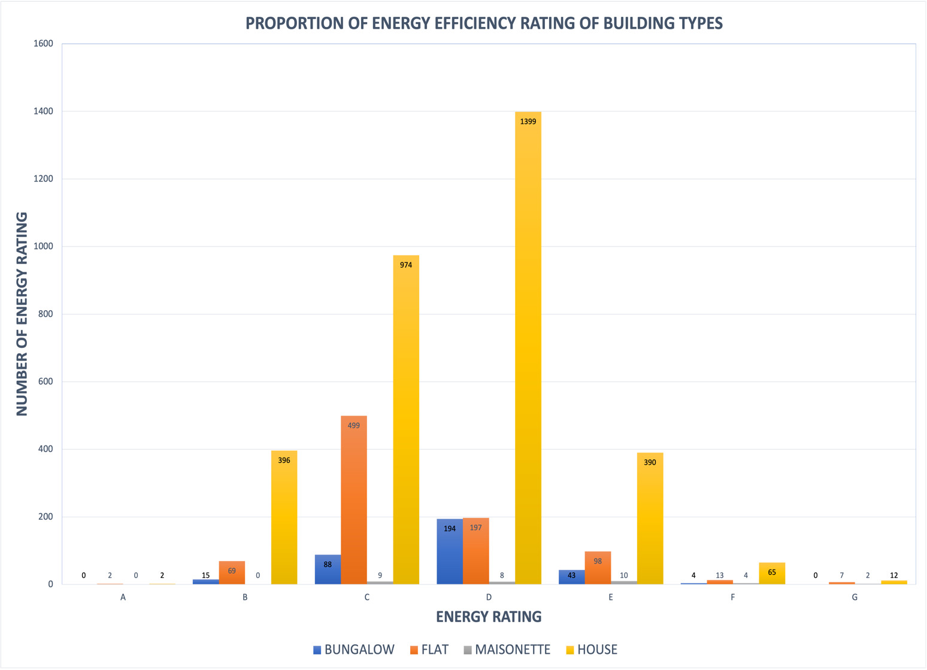
Figure 3: Proportion of energy efficiency ratings for each building type.

  - Data Pre-processing
Data pre-processing is essential for database quality assurance, however, it can be computationally expensive and time consuming (Shapi, Ramli and Awalin, 2021). The processing of data prevents complexities when training the model such as missing or abnormal values. The missing values discovered in the meteorological dataset were managed by adopting the mean value imputation as Newgard and Lewis, (2015) specified, while instances with missing values in the building dataset were deleted as the mean value imputation can only apply to continuous variables. 449 data rows containing missing values were removed to avoid complexities during model development. The data collected consisted of categorical data such as windows energy efficiency, wall energy efficiency and roof environmental efficiency among others (see Table 1). The categorical data were assigned values [e.g., very good = highest value (5) while very poor = lowest value (0)] to make the data suitable for the ML algorithm. Considering the presence of different types of data (e.g., continuous, discrete, and categorical); to avoid difficulties during development, it is important to normalize the data.
Data normalization: This is a process of data pre-processing that removes the influence of dimensions, as variables often have different dimensions (Liu et al., 2020; Olu-Ajayi et al., 2021). Normalization creates new values to keep the general distribution to avoid problems during model development. For instance, if a data column consists of values ranging from 0 to 5, and another column contains values ranging from 1,000 to 10,000. The variation in the scale of the numbers could engender difficulties during development. The building dataset and the meteorological dataset were normalized using sklearn python package normalizer.

Label encoder: Label encoding is the conversion of labels to numeric machine-readable form. For instance, encoding a column gender containing male and female can be converted to 0 and 1 respectively. The energy rating dataset was transformed using a label encoder of the sklearn python package.

Data Merging: The building and meteorological datasets were merged using the common variable (postcode) to pair each building data with its corresponding meteorological data. The datasets were merged using the panda package of the python programming language. The merged data resulted in a total of 108,000 data points.

  - Feature Selection
Research has shown that proper selection of features is closely associated with the prediction model accuracy (Zhao and Magoulès, 2012; Zhang and Wen, 2019a). It is also stated that the application of feature selection is required for optimum model performance (Alaka et al., 2018). Studies on building energy prediction [e.g., (Brown, Southworth and Sarzynski, 2009; Hankey and Marshall, 2010; Guhathakurta and Williams, 2015; Robinson et al., 2017; Li et al., 2018)] often select features only based on academic literature, however, feature selection implementation generates better accuracy (Zhang and Wen, 2019a). Given that the data collected contains the properties of the building and the energy consumed based on these properties, the machine learning algorithm can better identify most related and relevant features.
There are three major feature selection methods namely: filter, wrapper and embedded methods (Zhang and Wen, 2019b). Among these, the filter and wrapper methods have been applied in energy prediction studies. For example Kusiak et al (2010) applied boosting tree to rank input features for energy load prediction (Kusiak, Li and Zhang, 2010). The Embedded method is proven to be computationally expensive, sometimes produce worse results than filter and wrapper method (Bolón-Canedo et al., 2014; Asir, Gnana and Leavline, 2016), and it has not been used much in the field of energy prediction. Hence, it will not be considered in this study. The filter method removes irrelevant and redundant variables centred on statistics while the wrapper method deduces the best variable set for specific ML algorithms (Zhang and Wen, 2019b). Both have been proven to be very good in research. However, to make a less biased comparison; both types of feature selection methods were applied on various algorithms.
Some of the most used and efficient feature selection methods include Random Forest (RF) wrapper method (M. W. Ahmad et al., 2017; Z. Dong et al., 2021; Z. Wang, Wang, Zeng, et al., 2018; Zhang & Wen, 2019b) and Chi square filter method is one of the most used for filter feature selection (Jin et al., 2006; Sumaiya Thaseen and Aswani Kumar, 2017; Bahassine et al., 2020) among others. Hence, this study employed chi square filter method and the Random Forest (RF) wrapper method to examine the impact of feature selection on the prediction model performance. Each model was developed with and without the two types of feature selection. After the implementation of both feature selection methods, ten most significant features were selected based on the relevance values greater or equal to 0.05 (level of significance). Table 3 shows the ten variables selected by the filter method and the wrapper method for model development.
Table 3: List of variables selected using Feature selection methods
S/N | Filter method  (Chi-Square) | Filter ranking | Wrapper method  (Random Forest) | Wrapper ranking
1 | Total Floor Area | 1 | Total Floor Area | 1
2 | Wall Energy Efficiency | 10 | Wall Energy Efficiency | 5
3 | Number Heated Rooms | 2 | Number Heated Rooms | 4
4 | Walls Description | 4 | Walls Description | 7
5 | Roof Energy Efficiency | 7 | Floor Description | 3
6 | Windows Energy Efficiency | 9 | Number Habitable Rooms | 8
7 | Roof Environmental Efficiency | 8 | Wall Environmental Efficiency | 6
8 | Lighting Energy Efficiency | 5 | Roof Description | 2
9 | Lighting Environmental Efficiency | 6 | Temperature | 9
10 | Wind Speed | 3 | Pressure | 10
The common variables selected by the filter and wrapper method include total floor area, wall energy efficiency and number of heated rooms as shown in Table 3. These variables are considered very important. However, total floor area appears to be the most significant variable with equal rank in both feature selection methods and it is also one of the most used variables in various studies (Brown, Southworth and Sarzynski, 2009; Hankey and Marshall, 2010; Guhathakurta and Williams, 2015; Robinson et al., 2017; Li et al., 2018).
After completion of data pre-processing, the consolidated data was split into 60% for training and 40% for model testing, this was performed at random based on the dependent variables to ensure sufficient classes were present in the training and test data. This provides a 6:4 ratio of training to testing data. Considering the theory that feature selection is important for optimum model performance but influences various algorithms differently (Alaka et al., 2018). The machine learning algorithms utilized in this study were developed in three modes to ensure unbiased comparison. The first mode of development was conducted using the chi square filter method, the second was implemented using Random Forest (RF) wrapper method, while the third mode was the implementation without feature selection.

  - Model Development
Considering the type of dependent variable (categorical), the classification method was proposed which has not been explored in many previous studies for predicting energy performance. Machine learning classification method is devised for dependent variables that consist of categorical data (Loh, 2011). This method can be explained using a shape detection classification problem, as illustrated in Figure 4 below. The test sample (grey circle) is to be classified to predict the shape (yellow square or blue triangle). When x = 3 (first inner circle), the blue triangle will be selected because there are 2 triangles and just 1 square with the closest data points to the test sample. If x = 5 (second inner circle) the yellow square will be generated (3 squares against 2 triangles) (Olu-Ajayi, 2017). In relation to this study, the triangle and square are the seven different classes (Energy rating) which were used as the dependent variable (see table 2). Furthermore, as shown in Table 1, the building variables are the features of the triangle (sides = 3, colour = blue) and square (sides = 4, colour = yellow). At the building design stage, the building designer will only input the required building features into the model, and the energy rating is predicted (i.e., input variables 4 and yellow, Square is predicted). To expatiate further, once an energy predictive model is developed using machine learning, when certain parameters are inputted into it, the model will predict the energy consumption level (‘A’, ‘B’, ‘C’… ‘G’ as shown in Table 2) of a building. Firstly, the model will be trained with existing data of buildings and their energy performances. After model training, the model will be tested to evaluate the accuracy as shown in section 3.5. Subsequently, after getting of a satisfactory model performance, it will be deployed with a user interface which will simply request values for each variable provided in Table 1. This deployment can be delivered in form of a plugin or software. Furthermore, the software will be used by a building designer, to simply input values for variables related to the design such as total floor area (i.e., 20m²). Once these values have been inputted, the designer will run the model and receive result in seconds. The designer will receive the result and the most important variables will also be displayed to the building designer as shown in Table 3, so the key variables can be changed if the energy performance doesn’t meet the requirements or requires further improvement on the energy efficiency.

Figure 4: Example of ML classification method
Numerous studies have identified SVM, GB, RF, DT, K Nearest Neighbour (KNN), Extra Trees (ET), Adaboost, Gaussian process (GP), and Multi-Layer Perceptron (MLP) as high performing machine learning prediction algorithms (Tso and Yau, 2007; Qiong Li, Peng Ren, and Qinglin Meng, 2010; Ahmad et al., 2014; Ahmad, Mourshed and Rezgui, 2017; Wang et al., 2018; 2019; Wang, Lu and Feng, 2020). These high preforming algorithms were explored using the classification approach to predict building energy performance using certain parameters as stated below:
Multi-layer Perceptron (MLP): MLP is a function of deep neural network that uses a feed forward propagation process with one hidden layer where latent and abstract features are learned (Donoghue and Roantree, 2015). The Multi-layer Perceptron (MLP) modelled is a feed forward neural network with two hidden layers at 0.001 learning rate. Also, the ‘RELU’ activation and ‘Adam’ solver was utilized.
Support Vector Machines (SVM): SVM also known as Support Vector Classifier (SVC) is centred on the kernel, a technique primarily designed for resolving binary classification problems developed by Vapnik in the early 1990s (Sonkamble and Doye, 2008). SVC is considered an effective classifier due to its exceptional characteristic of dealing with samples of extremely high dimensionality. The parameters utilized in the SVM model development are as follows, 1.0 value of ‘C’, 0.1 value of Epsilon and radial basis function kernel.

Gradient Boosting (GB): Gradient boosting is an ensemble classifier which known to perform well in cases where the total number of variables exceeds the total number of samples (high-dimensional data) (Blagus and Lusa, 2017). This algorithm creates models in phases like other boosting systems but generalizes them by improving an arbitrary differentiable loss function (Flores and Keith, 2019). The parameters utilized in the GB model development are as follows; deviance loss function, 0.1 learning rate and 100 estimators.

Random Forest (RF): RF is formed on ensemble learning theory which allows it to learn both simple and convoluted problems (Ahmad, Mourshed and Rezgui, 2017a); The parameter utilized in the development of GB model is 100 numbers of estimators

Decision Tree (DT): DT uses a tree-like flowchart to partition data into groups. Decision Trees is an adaptable process that could advance with an enlarged amount of training data (Domingos, 2012). The parameter utilized in the development of DT model is the ‘best’ splitter.

K-Nearest Neighbour (k-NN): KNN is a non-parametric machine learning technique that utilizes similarity or distance function d to forecasts outcomes centred on the k nearest training examples in the feature space (Ortiz-Bejar et al., 2018). K nearest neighbours (KNN) was developed with five neighbours, uniform weights and a leaf size of 30.

Extra Trees Classifier (ET): ET is a tree-based ensemble techniques which uses DT as the primary component with top-down approach. ET is considered very useful when dealing with a large number of varying continuous features, since it reduces the burden of computing the best feature to split on by choosing at random (Ravi, 2020). ET was developed using 100 estimators as a parameter.

Ada boost: This is the simplest of boosting methods, which can be used for solving
classification problem (Rahul, Seth and Kumar, 2018). Ada boost is known for its low computational time and its high detection speed (Aadithyan et al., 2020). Ada boost was developed using 50 and 1.0 learning rate.

Gaussian process (GP): This is a powerful method for Bayesian classification, but their limitation is the high computational cost (Nguyen, Bouzerdoum and Phung, 2019). GP classifiers display explicit probabilistic formulation of the model and hyperparameters can be learned from data using a reliable theoretical framework; therefore, no additional cross-validation tuning is required (Sun et al., 2015).

  - Model Evaluation
Accuracy is one of the most utilized metric for classification evaluation (Gonzalez-Abril et al., 2014). It is based on a precise match of the predicted output and actual values. It is also considered as the probability that the developed model is suitable.

$$Accuracy= \frac{TP+TN}{TP+TN+FP+FN}$$

F1 score is a method for calculating the weighted mean of the precision and recall, where its best F1 score value is one and worst score at zero. The formula for the F1 score is:

$$Precision= \frac{TP}{(TP+FP)} || Recall= \frac{TP}{(TP+FN)}$$

$$F1= 2* \frac{(Precision*Recall)}{(Precision+Recall)}$$
- RESULT AND DISCUSSION
Table 4 shows the fitting performance results of the models for predicting energy performance. The nine models were developed without the implementation of feature selection. The obtained result denotes that the ensemble methods (Random Forest (RF), Gradient Boosting (GB) and Extra Trees (ET) perform better than other models. Gradient Boosting (GB) shows the best performance in terms of energy prediction accuracy. Furthermore, Table 4 also presents the result in terms of computational efficiency. Decision Tree and Multi-Layer Perceptron are the most computationally efficient model. However, they do not produce the best results. The best performing models based on prediction performance and computational efficiency are presented in bold font in Table 4 below.

Table 4: Performance result without feature selection
Model | Training Time(s) | Accuracy | F1
Random Forest | 1.4 | 0.65 |  | 0.64
Gradient Boosting | 2.7 | 0.67 |  | 0.65
Extra Trees | 1.4 | 0.64 |  | 0.63
Decision Tree | 1.2 | 0.56 |  | 0.57
K Nearest Neighbors | 1.3 | 0.58 |  | 0.56
Support Vector Machines | 1.8 | 0.46 |  | 0.29
Gaussian Process | 15.6 | 0.55 |  | 0.55
Multi-Layer Perceptron | 1.2 | 0.58 |  | 0.52
Ada Boost | 1.3 | 0.59 |  | 0.53

Box plot was implemented to graphically represent the predictive performance of each model with and without two types of the feature selection methods. Figure 5 conveys Gradient Boosting (GB) as the best performing model among the other models without feature selection. For example, the accuracy box plot presents Gradient Boosting (GB) as the closest to one amongst other models. Furthermore, the f1 and accuracy plot also shows the predictive model with the worst performance known as Support Vector Machine (SVM), as it is the closest zero.
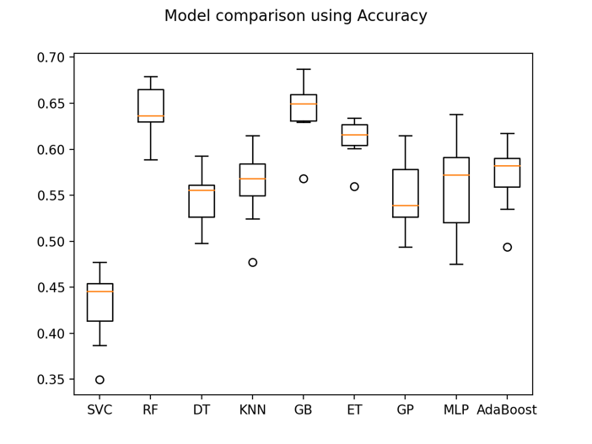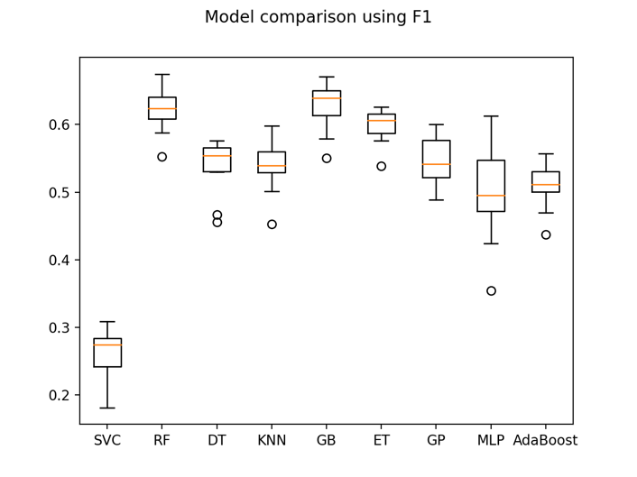
Figure 5: Visualization of Boxplot without feature selection
The performance result of each model using ten variables deduced after the filter method of feature selection is visualized in Figure 6 below. After development, it was determined that gradient boosting also produces the best prediction result with accuracy and f1 plot close to 1.0, similar to the first implementation conducted without the application of feature selection. However, the worst predictive model differs as the decision tree is the closest to zero in the accuracy plot.

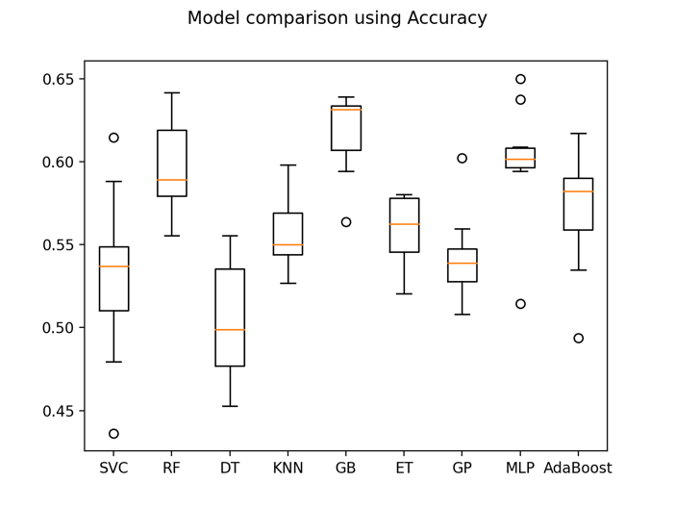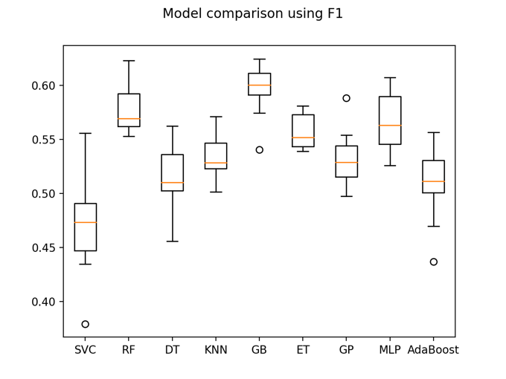
Figure 6: Visualization of Boxplot with filter feature selection (Chi Square)

The application of the wrapper method of feature selection produced a similar result with the first approach implemented without feature selection, as shown in Figure 7. As the best predictive performance is gradient boosting which is the closest to one while the support vector machine is the poorest model with values closest to zero.

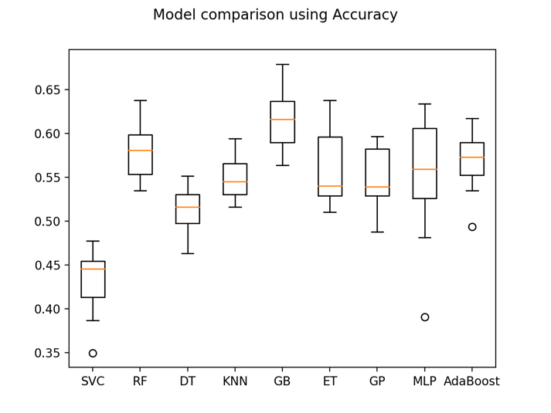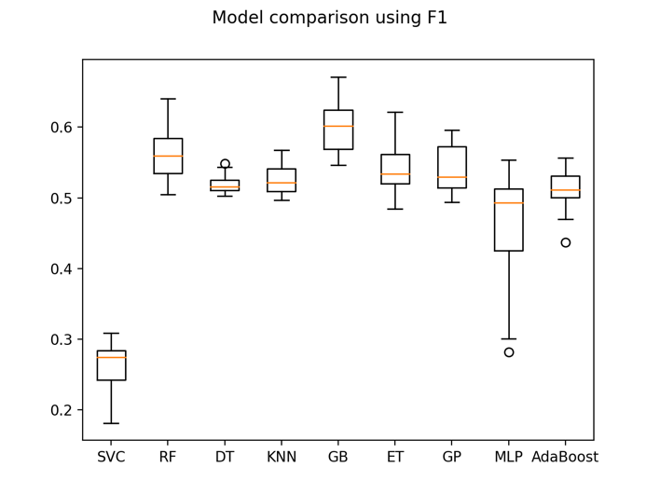

Figure 7: Visualization of Boxplot with Wrapper feature selection (Random Forest)

The evaluation of each model using all performance metrics was implemented, to explicitly determine the best predictive models with and without two types of feature selection methods. This is presented in Table 5 and Figure 8 below.

Table 5: Performance result of all models
 | Without Feature Selection |  | With Filter Feature Selection |  | With Wrapper Feature Selection
Model | Accuracy | F1 | Accuracy | F1 | Accuracy | F1
Random Forest | 0.65 | 0.64 | 0.61 | 0.60 | 0.64 | 0.63
Gradient Boosting | 0.67 | 0.65 | 0.64 | 0.63 | 0.67 | 0.65
Extra Trees | 0.64 | 0.63 | 0.59 | 0.58 | 0.61 | 0.60
Decision Tree | 0.56 | 0.57 | 0.53 | 0.53 | 0.57 | 0.57
K Nearest Neighbors | 0.58 | 0.56 | 0.56 | 0.54 | 0.56 | 0.55
Support Vector Machines | 0.46 | 0.29 | 0.55 | 0.50 | 0.46 | 0.29
Gaussian Process | 0.55 | 0.55 | 0.55 | 0.54 | 0.56 | 0.56
Multi-Layer Perceptron | 0.58 | 0.52 | 0.61 | 0.57 | 0.45 | 0.36
Ada Boost | 0.59 | 0.53 | 0.59 | 0.53 | 0.59 | 0.53

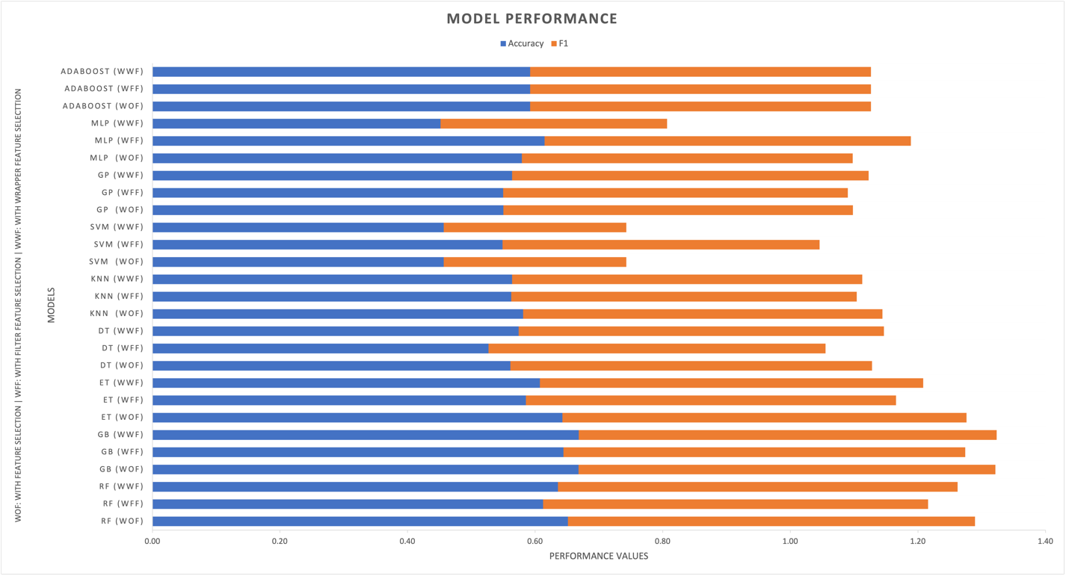
Figure 8: Prediction performance of models

Figure 8 shows gradient boosting as the best performance with the highest accuracy while the support vector machine is the poorest model among others. On the other hand, the second and third best predictive models are random forest and extra trees respectively. This shows ensembles methods as the higher performing model for energy performance prediction. Furthermore, Table 5 shows that both filter and wrapper feature selection had no impact on adaboost while the wrapper method had no effect on gradient boosting and support vector machines.

Hyper parameter tunning was applied to further improve the performance accuracy of each model. The 10-fold cross validation was used and the grid search technique of the sklearn python package was employed to identify the optimal parameter before model training. The performance result after parameter optimization is presented in Table 6. Gradient boosting produced the best accuracy results after parameter optimization. Although, Hyperparameter tuning is computationally expensive, it does improve the model accuracy.

Table 6: Performance result after hyper parameter tunning
Model | Training Time | Accuracy | F1
Random Forest | 9m3s | 0.66 |  | 0.64
Gradient Boosting | 5m15s | 0.67 |  | 0.65
Extra Trees | 14s | 0.64 |  | 0.63
Decision Tree | 1m9s | 0.63 |  | 0.60
K Nearest Neighbors | 6s | 0.64 |  | 0.59
Support Vector Machines | 14m31s | 0.66 |  | 0.62
Gaussian Process | 16m45s | 0.65 |  | 0.59
Multi-Layer Perceptron | 6m39s | 0.63 |  | 0.58
Ada Boost | 12m4s | 0.65 |  | 0.64

This study compared various machine learning models for energy performance prediction and the result shows that the ensemble model outperforms other models which could support their liability to producing good results due to their training on multiple algorithms similar to the theory by (Amasyali and El-Gohary, 2021). However, the findings also contradict some related research that infers SVM as a highly efficient model for predicting annual energy usage (Dong, Cao and Lee, 2005; Li et al., 2009b). Conversely, the outcome shows the inadequate result for SVM both in terms of performance and computational efficiency. However, this can be attributed to the theory that SVM produces better outcomes in small datasets (Li et al., 2009b; Qiong Li, Peng Ren, and Qinglin Meng, 2010; Aversa et al., 2016).

This study further investigated the effects of two different types of feature selection method on the performance of the models developed. Zhang et al (2019) stated that implementation of feature selection generates better accuracy (Zhang and Wen, 2019a). However, this is inconclusive because in some cases, the result shows that feature selection has a negative impact on certain algorithms which leads to poor accuracy. For instance, the multi-layer perceptron model without feature selection resulted in prediction accuracy of 0.58 while after applying feature selection, it produced an accuracy of 0.45. Therefore, the achievement of good accuracy using feature selection is also dependent on the type of algorithm selected and feature selection does not always lead to better results. These findings assert that feature selection is not favourable to all algorithms as stated in previous studies [e.g., (Alaka et al., 2018, 2019)].

Zhao & Magoulès, 2012 states that feature selection is often used to identify irrelevant features (Zhao and Magoulès, 2012). However, subsequent to the implementation of the two common feature selection method utilized for energy prediction, the results show that not all feature selection can identify irrelevant variables in their singular state. In this study, the implementation of the wrapper method for each model produced better accuracy than the filter method. The implementation of filter method for selecting important variables may still require domain knowledge considering the variable selected using the filter method did not include some important variables such as wall energy efficiency and windows energy efficiency in line in previous research on variable that have impact on energy consumption (Tahmasebi, Banihashemi and Hassanabadi, 2011; Marino, Nucara and Pietrafesa, 2017; Marwan, 2020). The wall variables are one of the most important variables for energy consumption forecasting as the selection of the appropriate wall material can considerably reduce energy consumption (Marwan, 2020). Window is considered one of the most important feature forenergy consumption and carbon emission reasons (Tahmasebi, Banihashemi and Hassanabadi, 2011). Despite being an essential part of a building, windows give designers the opportunity to save energy by incorporating of appropriate windows (Ahlers et al., 2005).

On the other hand, the implementation of the wrapper method selected some important variables that affect energy performance such as wall energy efficiency, window energy efficiency and roof energy efficiency. Although the meteorological features were not selected, and they are considered important for the prediction of energy use as applied in different studies (Lai, Magoules and Lherminier, 2008; Wong, Wan and Lam, 2010; Dong et al., 2021; Lei et al., 2021). This study further developed each model using wrapper selected variables including the meteorological features. This was conducted to deduce a fair comparison of the effect of meteorological data. The result generated shows that the addition of the meteorological data does not elicit better accuracy across models except Multilayer perceptron and k nearest neighbour as shown in Figure 9 below. The multilayer perceptron model showed considerably better performance in line with the theory that an increase in the input features contributes to better model performance (Carlsson, 2015). However, this cannot conclusively validate the importance of meteorological data. But this indicates that not all feature selection methods perform well in their unitary state without the domain knowledge. The wrapper method and filter method consist of several other types of algorithms that have not been applied in this study. Therefore, it is inconclusive to ascertain that wrapper method is better than the filter method.

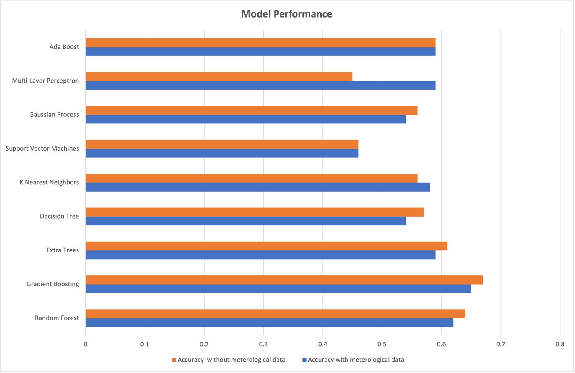
Figure 9: model’s performance with and without meteorological data

- IMPLICATION FOR PRACTICE
This study developed an energy prediction model for building designers and to determine the best, a comparative analysis was conducted on various algorithms. To ensure unbiased comparison, given that feature selection influences various algorithms differently. Two types of feature selection were used to ensure the selection of the most appropriate features for building energy prediction at the design stage. Each model was developed with and without the three feature selection methods for comparison. Hyper parameter was also applied to improve each model’s performance accuracy. This developed model is going to be a great transition for building designers, given that building designers currently rely on previous experience or building energy simulation tools which usually consumes a lot of time (sometimes up to an hour or more) to access the potential energy performance of buildings. Furthermore, if the energy performance is poor, the designer will need to redesign and repeat until optimum performance is achieved.

This time consumption and labour intensity can be quite frustrating and discouraging for designers, and the reliance on previous experience often leads to inadequate conclusions. However, this developed model will produce results in seconds. Additionally, it is a machine learning model which is recognised as the contemporary and most efficient tool for prediction. It is generally more likely to produce a more accurate result. This will undoubtedly expedite the work of designers by simply inputting only 10 features required by the ML model and obtain the estimated energy rating in seconds to optimise the building design appropriately. Hence, this conveys that if the potential energy consumption level generated is high, the designer can quickly make key changes based on those 10 variables and repeat the analysis to verify the change in consumption level. Therefore, it is possible for designers to achieve optimum performance in an hour or less. As opposed to hours or days, it could take using the traditional method to keep redesigning to achieve the optimum energy performance required. Using this developed model will encourage designers to develop more energy efficient designs.

Likewise, property marketers can benefit from building energy consumption levels as it constitutes a means to increase selling costs to customers searching for energy efficient properties. Consequently, this could encourage property developers and building consumers to consider energy performance before development or acquisition. This is the first study to conduct a comparative analysis of various algorithms including an application of feature selection and hyper parameter tuning for the development of an energy prediction model for the design stage of buildings. To develop this model further, this can serve as a starting point for other studies to leverage, by adding other features that are considered very important at the design stage.

- CONCLUSION AND RECOMMENDATION
Evidently, given the good level of accuracy in this study, it is possible to build a high performing ML model for building energy use prediction at the design stage that is useful for building designers. Past studies have already proven that building energy prediction is very possible, However, there is no recognized best ML model for building designers at the design stage. Machine learning model is a lot more efficient than traditional simulation methods because it can return energy performance output in seconds (see table 4). Some of the studies in the past have also proven this (Dong, Cao and Lee, 2005; Neto and Fiorelli, 2008; Castelli et al., 2015; Tardioli et al., 2015). However, no study has combined the implementation of feature selection methods and hyper parameter tuning on numerous algorithms to develop a model for the design stage of buildings. Nine models were developed and evaluated using the accuracy and f1 metric. In general, Gradient Boosting (GB) outperformed the other models for predicting building energy performance.

To satisfy the second objective, each model was developed and analysed with and without two feature selection methods. The result shows good performance in specific models and GB outperformed the other model in both filter and wrapper methods. However, there is no single feature selection method that is perfect for all algorithms when developing energy predictive models. These sort of trends has emanated in past studies, as using different feature selection methods has led to different results at different times and there is no consistency in studies that proposed one feature selection or the other as the most effective (Ahmad, Mourshed and Rezgui, 2017b; Zhang and Wen, 2019b; Dong et al., 2021).Therefore, it is concluded that feature selection is only favourable to certain algorithms. To satisfy the third objective of this study, Hyper parameter tuning did help produce better performance in certain algorithms such as RF, DT and KNN. Hyper parameter tuning does improve the accuracy of models according to (Singh, Singaravel and Geyer, 2021). Although, it must be noted that it is computationally expensive as it takes longer training and testing time. However, future studies should attempt correlation of parameter tuning from the perspective of the level of increase in performance and amount of computational cost increased. However, the overall time taken is still less than the traditional simulation method (see table 6).

Although GB has not received much attention in the field of energy performance prediction, the performance level of the ML algorithm proffers GB as an effective predictive model in the field of energy prediction. However, it is well noted that one study is not sufficient to justify this sort of conclusion. It is thus recommended that future studies compare GB to other algorithms for building energy prediction to further substantiate this conclusion. Future studies should also explore the comparison of several algorithms on a larger dataset beyond 4500 buildings in training the model. Furthermore, it should explore the performance of these algorithms on non-residential buildings.

- REFERENCES
Aadithyan, V. et al. (2020) ‘Smart Face Recognition System’.
Ahlers, N.A. et al. (2005) ‘Cost-benefit analysis of outfitting the windows of the Henry Hicks Arts and Administration building with more efficient models to improve Dalhousie University campus sustainability’, p. 32.
Ahmad, A.S. et al. (2014) ‘A review on applications of ANN and SVM for building electrical energy consumption forecasting’, Renewable and Sustainable Energy Reviews, 33, pp. 102–109. doi:10.1016/j.rser.2014.01.069.
Ahmad, M.W., Mourshed, M. and Rezgui, Y. (2017a) ‘Trees vs Neurons: Comparison between random forest and ANN for high-resolution prediction of building energy consumption’, Energy and Buildings, 147, pp. 77–89. doi:10.1016/j.enbuild.2017.04.038.
Ahmad, M.W., Mourshed, M. and Rezgui, Y. (2017b) ‘Trees vs Neurons: Comparison between random forest and ANN for high-resolution prediction of building energy consumption’, Energy and Buildings, 147, pp. 77–89. doi:10.1016/j.enbuild.2017.04.038.
Alaka, H. et al. (2019) ‘A Big Data Analytics Approach for Construction Firms Failure Prediction Models’, IEEE Transactions on Engineering Management, 66(4), pp. 689–698. doi:10.1109/TEM.2018.2856376.
Alaka, H.A. et al. (2018) ‘Systematic review of bankruptcy prediction models: Towards a framework for tool selection’, Expert Systems with Applications, 94, pp. 164–184. doi:10.1016/j.eswa.2017.10.040.
Amasyali, K. and El-Gohary, N. (2021) ‘Machine learning for occupant-behavior-sensitive cooling energy consumption prediction in office buildings’, Renewable and Sustainable Energy Reviews, 142, p. 110714. doi:10.1016/j.rser.2021.110714.
Amasyali, K. and El-Gohary, N.M. (2018) ‘A review of data-driven building energy consumption prediction studies’, Renewable and Sustainable Energy Reviews, 81, pp. 1192–1205. doi:10.1016/j.rser.2017.04.095.
Asir, D., Gnana, A. and Leavline, E.J. (2016) ‘Literature Review on Feature Selection Methods for High-Dimensional Data’.
Aversa, P. et al. (2016) ‘Improved Thermal Transmittance Measurement with HFM Technique on Building Envelopes in the Mediterranean Area’, Selected Scientific Papers - Journal of Civil Engineering, 11. doi:10.1515/sspjce-2016-0017.
Bahassine, S. et al. (2020) ‘Feature selection using an improved Chi-square for Arabic text classification’, Journal of King Saud University - Computer and Information Sciences, 32(2), pp. 225–231. doi:10.1016/j.jksuci.2018.05.010.
Blagus, R. and Lusa, L. (2017) ‘Gradient boosting for high-dimensional prediction of rare events’, Computational Statistics & Data Analysis, 113, pp. 19–37. doi:10.1016/j.csda.2016.07.016.
Bolón-Canedo, V. et al. (2014) ‘A review of microarray datasets and applied feature selection methods’, Information Sciences, 282, pp. 111–135. doi:10.1016/j.ins.2014.05.042.
Bourdeau, M. et al. (2019) ‘Modeling and forecasting building energy consumption: A review of data-driven techniques’, Sustainable Cities and Society, 48, p. 101533. doi:10.1016/j.scs.2019.101533.
Brown, M.A., Southworth, F. and Sarzynski, A. (2009) ‘The geography of metropolitan carbon footprints’, Policy and Society, 27(4), pp. 285–304. doi:10.1016/j.polsoc.2009.01.001.
Building Energy Efficiency Survey (2016) Building Energy Efficiency Survey (BEES), GOV.UK. Available at: https://www.gov.uk/government/collections/non-domestic-buildings-energy-use-project (Accessed: 29 March 2021).
Canales, V.R. (2016) ‘Using a Supervised Learning Model: Two-Class Boosted Decision Tree Algorithm for Income Prediction’, p. 7.
Carlsson, L. (2015) ‘Using Multilayer Perceptrons asmeans to predict the end-pointtemperature in an Electric ArcFurnace’.
Castelli, M. et al. (2015) ‘Prediction of energy performance of residential buildings: A genetic programming approach’, Energy and Buildings, 102, pp. 67–74. doi:10.1016/j.enbuild.2015.05.013.
Chae, Y.T. et al. (2016) ‘Artificial neural network model for forecasting sub-hourly electricity usage in commercial buildings’, Energy and Buildings, 111, pp. 184–194. doi:10.1016/j.enbuild.2015.11.045.
Chirarattananon, S. and Taveekun, J. (2004) ‘An OTTV-based energy estimation model for commercial buildings in Thailand’, Energy and Buildings, 36(7), pp. 680–689. doi:10.1016/j.enbuild.2004.01.035.
Chokwitthaya, C. et al. (2020) ‘A machine learning algorithm to improve building performance modeling during design’, MethodsX, 7, p. 100726. doi:10.1016/j.mex.2019.10.037.
Chou, J.-S. and Bui, D.-K. (2014) ‘Modeling heating and cooling loads by artificial intelligence for energy-efficient building design’, Energy and Buildings, 82, pp. 437–446. doi:10.1016/j.enbuild.2014.07.036.
Colmenar-Santos, A. et al. (2013) ‘Solutions to reduce energy consumption in the management of large buildings’, Energy and Buildings, 56, pp. 66–77. doi:10.1016/j.enbuild.2012.10.004.
Crawley, D.B. et al. (2008) ‘Contrasting the capabilities of building energy performance simulation programs’, Building and Environment, 43(4), pp. 661–673. doi:10.1016/j.buildenv.2006.10.027.
Curtis, J., Devitt, N. and Whelan, A. (2014) Estimating Building Energy Ratings for the Residential Building Stock: Location and Occupancy, Papers. WP489. Economic and Social Research Institute (ESRI). Available at: https://ideas.repec.org/p/esr/wpaper/wp489.html (Accessed: 15 June 2021).
Dalal, K.R. (2018) ‘Review on Application of Machine learning Algorithm for Data Science’, in 2018 3rd International Conference on Inventive Computation Technologies (ICICT). IEEE, pp. 270–273.
Dandotiya, B. (2020) ‘Climate-Change-and-Its-Impact-on-Terrestrial-Ecosystems’, in. doi:10.4018/978-1-7998-3343-7.ch007.
Deb, C. et al. (2017) ‘A review on time series forecasting techniques for building energy consumption’, Renewable and Sustainable Energy Reviews, 74, pp. 902–924. doi:10.1016/j.rser.2017.02.085.
Ding, Y. and Liu, X. (2020) ‘A comparative analysis of data-driven methods in building energy benchmarking’, Energy and Buildings, 209, p. 109711. doi:10.1016/j.enbuild.2019.109711.
Ding, Z. et al. (2018) ‘A system dynamics-based environmental benefit assessment model of construction waste reduction management at the design and construction stages’, Journal of Cleaner Production, 176, pp. 676–692. doi:10.1016/j.jclepro.2017.12.101.
Ding, Z., Li, Z. and Fan, C. (2018) ‘Building energy savings: Analysis of research trends based on text mining’, Automation in Construction, 96, pp. 398–410. doi:10.1016/j.autcon.2018.10.008.
Domingos, P. (2012) ‘A few useful things to know about machine learning’, Communications of the ACM, 55(10), pp. 78–87. doi:10.1145/2347736.2347755.
Dong, B., Cao, C. and Lee, S.E. (2005) ‘Applying support vector machines to predict building energy consumption in tropical region’, Energy and Buildings, 37(5), pp. 545–553. doi:10.1016/j.enbuild.2004.09.009.
Dong, Z. et al. (2021) ‘Hourly energy consumption prediction of an office building based on ensemble learning and energy consumption pattern classification’, Energy and Buildings, 241, p. 110929. doi:10.1016/j.enbuild.2021.110929.
Donoghue, J.O. and Roantree, M. (2015) ‘A Framework for Selecting Deep Learning Hyper-parameters’, in Maneth, S. (ed.) Data Science. Cham: Springer International Publishing (Lecture Notes in Computer Science), pp. 120–132. doi:10.1007/978-3-319-20424-6_12.
Elbeltagi, E. et al. (2017) ‘Visualized strategy for predicting buildings energy consumption during early design stage using parametric analysis’, Journal of Building Engineering, 13, pp. 127–136. doi:10.1016/j.jobe.2017.07.012.
European Parliament (2002) Directive 2002/91/EC of the European Parliament and of the Council of 16 December 2002 on the energy performance of buildings (repealed), https://webarchive.nationalarchives.gov.uk/eu-exit/https://eur-lex.europa.eu/legal-content/EN/TXT/?uri=CELEX:02002L0091-20081211. Queen’s Printer of Acts of Parliament. Available at: https://www.legislation.gov.uk/eudr/2002/91/2008-12-11 (Accessed: 15 June 2021).
Fathi, Soheil et al. (2020) ‘Machine learning applications in urban building energy performance forecasting: A systematic review’, Renewable and Sustainable Energy Reviews, 133, p. 110287. doi:10.1016/j.rser.2020.110287.
Flores, V. and Keith, B. (2019) ‘Gradient Boosted Trees Predictive Models for Surface Roughness in High-Speed Milling in the Steel and Aluminum Metalworking Industry’, Complexity, 2019, p. e1536716. doi:10.1155/2019/1536716.
Gonzalez-Abril, L. et al. (2014) ‘GSVM: An SVM for handling imbalanced accuracy between classes inbi-classification problems’, Applied Soft Computing, 17, pp. 23–31. doi:10.1016/j.asoc.2013.12.013.
Goyal, K., Tiwari, N. and Sonekar, J. (2020) ‘An Anatomization of Data Classification Based on Machine Learning Techniques’, IJRAR-International Journal of Research and Analytical Reviews (IJRAR), 7(2), pp. 713–716.
Guhathakurta, S. and Williams, E. (2015) ‘Impact of Urban Form on Energy Use in Central City and Suburban Neighborhoods: Lessons from the Phoenix Metropolitan Region’, Energy Procedia, 75, pp. 2928–2933. doi:10.1016/j.egypro.2015.07.594.
Hankey, S. and Marshall, J.D. (2010) ‘Impacts of urban form on future US passenger-vehicle greenhouse gas emissions’, Energy Policy, 38(9), pp. 4880–4887. doi:10.1016/j.enpol.2009.07.005.
Himeur, Y. et al. (2020) ‘Building power consumption datasets: Survey, taxonomy and future directions’, Energy and Buildings, 227, p. 110404. doi:10.1016/j.enbuild.2020.110404.
Hu, S. et al. (2021) ‘Building energy performance assessment using linked data and cross-domain semantic reasoning’, Automation in Construction, 124, p. 103580. doi:10.1016/j.autcon.2021.103580.
Jaber, S. and Ajib, S. (2011) ‘Optimum, technical and energy efficiency design of residential building in Mediterranean region’, Energy and Buildings, 43(8), pp. 1829–1834. doi:10.1016/j.enbuild.2011.03.024.
Jin, X. et al. (2006) ‘Machine Learning Techniques and Chi-Square Feature Selection for Cancer Classification Using SAGE Gene Expression Profiles’, in Li, J., Yang, Q., and Tan, A.-H. (eds) Data Mining for Biomedical Applications. Berlin, Heidelberg: Springer (Lecture Notes in Computer Science), pp. 106–115. doi:10.1007/11691730_11.
Kabir, M.A. (2020) ‘Vehicle Speed Prediction based on Road Status using Machine Learning’, Advanced Research in Energy and Engineering, 2(1).
Kaur, K. and Gupta, O.P. (2017) ‘A machine learning approach to determine maturity stages of tomatoes’, Oriental journal of computer science and technology, 10(3), pp. 683–690.
Khantach, A.E. et al. (2019) ‘Short-term load forecasting using machine learning and periodicity decomposition’, AIMS Energy, 7(3), pp. 382–394. doi:10.3934/energy.2019.3.382.
Kim, D.D. and Suh, H.S. (2021) ‘Heating and cooling energy consumption prediction model for high-rise apartment buildings considering design parameters’, Energy for Sustainable Development, 61, pp. 1–14. doi:10.1016/j.esd.2021.01.001.
Kusiak, A., Li, M. and Zhang, Z. (2010) ‘A data-driven approach for steam load prediction in buildings’, Applied Energy, 87(3), pp. 925–933. doi:10.1016/j.apenergy.2009.09.004.
Lai, F., Magoules, F. and Lherminier, F. (2008) ‘Vapnik’s learning theory applied to energy consumption forecasts in residential buildings’, International Journal of Computer Mathematics, 85(10), pp. 1563–1588. doi:10.1080/00207160802033582.
Lee, S. et al. (2011) Data Mining-Based Predictive Model to Determine Project Financial Success Using Project Definition Parameters.
Lei, L. et al. (2021) ‘A building energy consumption prediction model based on rough set theory and deep learning algorithms’, Energy and Buildings, 240, p. 110886. doi:10.1016/j.enbuild.2021.110886.
Li, K. et al. (2018) ‘A hybrid teaching-learning artificial neural network for building electrical energy consumption prediction’, Energy and Buildings, 174, pp. 323–334. doi:10.1016/j.enbuild.2018.06.017.
Li, Q. et al. (2009a) ‘Applying support vector machine to predict hourly cooling load in the building’, Applied Energy, 86(10), pp. 2249–2256. doi:10.1016/j.apenergy.2008.11.035.
Li, Q. et al. (2009b) ‘Predicting hourly cooling load in the building: A comparison of support vector machine and different artificial neural networks’, Energy Conversion and Management, 50(1), pp. 90–96. doi:10.1016/j.enconman.2008.08.033.
Li, X. and Wen, J. (2014) ‘Review of building energy modeling for control and operation’, Renewable and Sustainable Energy Reviews, 37, pp. 517–537. doi:10.1016/j.rser.2014.05.056.
Liu, Y. et al. (2020) ‘Energy consumption prediction and diagnosis of public buildings based on support vector machine learning: A case study in China’, Journal of Cleaner Production, 272, p. 122542. doi:10.1016/j.jclepro.2020.122542.
Loh, W.-Y. (2011) ‘Classification and regression trees’, WIREs Data Mining and Knowledge Discovery, 1(1), pp. 14–23. doi:10.1002/widm.8.
Marino, C., Nucara, A. and Pietrafesa, M. (2017) ‘Does window-to-wall ratio have a significant effect on the energy consumption of buildings? A parametric analysis in Italian climate conditions’, Journal of Building Engineering, 13, pp. 169–183. doi:10.1016/j.jobe.2017.08.001.
Marwan, M. (2020) ‘The effect of wall material on energy cost reduction in building’, Case Studies in Thermal Engineering, 17, p. 100573. doi:10.1016/j.csite.2019.100573.
Mawson, V.J. and Hughes, B.R. (2020) ‘Deep learning techniques for energy forecasting and condition monitoring in the manufacturing sector’, Energy and Buildings, 217, p. 109966. doi:10.1016/j.enbuild.2020.109966.
Neto, A.H. and Fiorelli, F.A.S. (2008) ‘Comparison between detailed model simulation and artificial neural network for forecasting building energy consumption’, Energy and Buildings, 40(12), pp. 2169–2176. doi:10.1016/j.enbuild.2008.06.013.
Newgard, C.D. and Lewis, R.J. (2015) ‘Missing Data: How to Best Account for What Is Not Known’, JAMA, 314(9), pp. 940–941. doi:10.1001/jama.2015.10516.
Nguyen, T.N.A., Bouzerdoum, A. and Phung, S.L. (2019) ‘A Scalable Hierarchical Gaussian Process Classifier’, IEEE Transactions on Signal Processing, 67(11), pp. 3042–3057. doi:10.1109/TSP.2019.2911251.
Niu, D., Wang, Y. and Wu, D.D. (2010) ‘Power load forecasting using support vector machine and ant colony optimization’, Expert Systems with Applications, 37(3), pp. 2531–2539. doi:10.1016/j.eswa.2009.08.019.
Nwulu, N.I. (2017) ‘An artificial neural network model for predicting building heating and cooling loads’, in 2017 International Artificial Intelligence and Data Processing Symposium (IDAP). 2017 International Artificial Intelligence and Data Processing Symposium (IDAP), pp. 1–5. doi:10.1109/IDAP.2017.8090314.
Olu-Ajayi, R. (2017) ‘An Investigation into the Suitability of k-Nearest Neighbour (k-NN) for Software Effort Estimation’, International Journal of Advanced Computer Science and Applications, 8(6). doi:10.14569/IJACSA.2017.080628.
Olu-Ajayi, R. et al. (2021) ‘Ensemble learning for energy performance prediction of residential buildings’, Environmental Design and Management Conference (EDMIC) [Preprint].
Olu-Ajayi, R. et al. (2022) ‘Building energy consumption prediction for residential buildings using deep learning and other machine learning techniques’, Journal of Building Engineering, 45, p. 103406. doi:10.1016/j.jobe.2021.103406.
Olu-Ajayi, R. and Alaka, H. (2021) ‘Building energy consumption prediction using deep learning’, Environmental Design and Management Conference (EDMIC) [Preprint].
Ortiz-Bejar, José et al. (2018) ‘k-Nearest Neighbor Regressors Optimized by using Random Search’, in 2018 IEEE International Autumn Meeting on Power, Electronics and Computing (ROPEC). 2018 IEEE International Autumn Meeting on Power, Electronics and Computing (ROPEC), pp. 1–5. doi:10.1109/ROPEC.2018.8661399.
Pham, A.-D. et al. (2020) ‘Predicting energy consumption in multiple buildings using machine learning for improving energy efficiency and sustainability’, Journal of Cleaner Production, 260, p. 121082. doi:10.1016/j.jclepro.2020.121082.
Qiao, Q., Yunusa-Kaltungo, A. and Edwards, R.E. (2021) ‘Towards developing a systematic knowledge trend for building energy consumption prediction’, Journal of Building Engineering, 35, p. 101967. doi:10.1016/j.jobe.2020.101967.
Qiong Li, Peng Ren, and Qinglin Meng (2010) ‘Prediction model of annual energy consumption of residential buildings’, in 2010 International Conference on Advances in Energy Engineering. 2010 International Conference on Advances in Energy Engineering, pp. 223–226. doi:10.1109/ICAEE.2010.5557576.
Rahul, K., Seth, N. and Kumar, U.D. (2018) ‘Spotting earnings manipulation: using machine learning for financial fraud detection’, in international conference on innovative techniques and applications of artificial intelligence. Springer, pp. 343–356.
Ravi, A. (2020) ‘Stacked Generalization for Human Activity Recognition’, arXiv:2009.10312 [cs] [Preprint]. Available at: http://arxiv.org/abs/2009.10312 (Accessed: 13 October 2021).
Ritchie, H. and Roser, M. (2020) ‘Energy’, Our World in Data [Preprint]. Available at: https://ourworldindata.org/energy-overview (Accessed: 2 August 2021).
Robinson, C. et al. (2017) ‘Machine learning approaches for estimating commercial building energy consumption’, Applied Energy, 208, pp. 889–904. doi:10.1016/j.apenergy.2017.09.060.
Runge, J. and Zmeureanu, R. (2019) ‘Forecasting Energy Use in Buildings Using Artificial Neural Networks: A Review’, Energies, 12(17), p. 3254. doi:10.3390/en12173254.
Serale, G., Fiorentini, M. and Noussan, M. (2020) ‘11 - Development of algorithms for building energy efficiency’, in Pacheco-Torgal, F. et al. (eds) Start-Up Creation (Second Edition). Woodhead Publishing (Woodhead Publishing Series in Civil and Structural Engineering), pp. 267–290. doi:10.1016/B978-0-12-819946-6.00011-4.
Seyedzadeh, S. et al. (2020) ‘Data driven model improved by multi-objective optimisation for prediction of building energy loads’, Automation in Construction, 116, p. 103188. doi:10.1016/j.autcon.2020.103188.
Shapi, M.K.M., Ramli, N.A. and Awalin, L.J. (2021) ‘Energy consumption prediction by using machine learning for smart building: Case study in Malaysia’, Developments in the Built Environment, 5, p. 100037. doi:10.1016/j.dibe.2020.100037.
Singh, M.M., Singaravel, S. and Geyer, P. (2021) ‘Machine learning for early stage building energy prediction: Increment and enrichment’, Applied Energy, 304, p. 117787. doi:10.1016/j.apenergy.2021.117787.
Sonkamble, B.A. and Doye, D.D. (2008) ‘An overview of speech recognition system based on the support vector machines’, in 2008 International Conference on Computer and Communication Engineering. 2008 International Conference on Computer and Communication Engineering, pp. 768–771. doi:10.1109/ICCCE.2008.4580709.
Sumaiya Thaseen, I. and Aswani Kumar, C. (2017) ‘Intrusion detection model using fusion of chi-square feature selection and multi class SVM’, Journal of King Saud University - Computer and Information Sciences, 29(4), pp. 462–472. doi:10.1016/j.jksuci.2015.12.004.
Sun, S. et al. (2015) ‘Active Learning With Gaussian Process Classifier for Hyperspectral Image Classification’, IEEE Transactions on Geoscience and Remote Sensing, 53(4), pp. 1746–1760. doi:10.1109/TGRS.2014.2347343.
Tahmasebi, M.M., Banihashemi, S. and Hassanabadi, M.S. (2011) ‘Assessment of the Variation Impacts of Window on Energy Consumption and Carbon Footprint’, Procedia Engineering, 21, pp. 820–828. doi:10.1016/j.proeng.2011.11.2083.
Tardioli, G. et al. (2015) ‘Data Driven Approaches for Prediction of Building Energy Consumption at Urban Level’, Energy Procedia, 78, pp. 3378–3383. doi:10.1016/j.egypro.2015.11.754.
TOPRAK, Ahmet et al. (2017) ‘International Journal of Intelligent Systems and Applications in Engineering’.
Tso, G.K.F. and Yau, K.K.W. (2007) ‘Predicting electricity energy consumption: A comparison of regression analysis, decision tree and neural networks’, Energy, 32(9), pp. 1761–1768. doi:10.1016/j.energy.2006.11.010.
United Nations Environment Programme, U.N. (2017) Sustainable buildings, UNEP - UN Environment Programme. Available at: http://www.unep.org/explore-topics/resource-efficiency/what-we-do/cities/sustainable-buildings (Accessed: 16 March 2021).
Vorobeychik, Y. and Wallrabenstein, J.R. (2013) ‘Using Machine Learning for Operational Decisions in Adversarial Environments’, p. 9.
Wang, J., Li, Z. and Tam, V.W.Y. (2014) ‘Critical factors in effective construction waste minimization at the design stage: A Shenzhen case study, China’, Resources, Conservation and Recycling, 82, pp. 1–7. doi:10.1016/j.resconrec.2013.11.003.
Wang, R., Lu, S. and Feng, W. (2020) ‘A novel improved model for building energy consumption prediction based on model integration’, Applied Energy, 262, p. 114561. doi:10.1016/j.apenergy.2020.114561.
Wang, W., Zmeureanu, R. and Rivard, H. (2005) ‘Applying multi-objective genetic algorithms in green building design optimization’, Building and Environment, 40(11), pp. 1512–1525. doi:10.1016/j.buildenv.2004.11.017.
Wang, Z. et al. (2018) ‘Random Forest based hourly building energy prediction’, Energy and Buildings, 171, pp. 11–25. doi:10.1016/j.enbuild.2018.04.008.
Wang, Z., Wang, Y. and Srinivasan, R.S. (2018) ‘A novel ensemble learning approach to support building energy use prediction’, Energy and Buildings, 159, pp. 109–122. doi:10.1016/j.enbuild.2017.10.085.
Wong, S.L., Wan, K.K.W. and Lam, T.N.T. (2010) ‘Artificial neural networks for energy analysis of office buildings with daylighting’, Applied Energy, 87(2), pp. 551–557. doi:10.1016/j.apenergy.2009.06.028.
World Health Organisation (2019) Health consequences of air pollution on populations. Available at: https://www.who.int/news/item/15-11-2019-what-are-health-consequences-of-air-pollution-on-populations (Accessed: 8 April 2021).
Yezioro, A., Dong, B. and Leite, F. (2008) ‘An applied artificial intelligence approach towards assessing building performance simulation tools’, Energy and Buildings, 40(4), pp. 612–620. doi:10.1016/j.enbuild.2007.04.014.
Yu, Z. et al. (2010) ‘A decision tree method for building energy demand modeling’, Energy and Buildings, 42(10), pp. 1637–1646. doi:10.1016/j.enbuild.2010.04.006.
Zhang, L. and Wen, J. (2019a) ‘A systematic feature selection procedure for short-term data-driven building energy forecasting model development’, Energy and Buildings, 183, pp. 428–442. doi:10.1016/j.enbuild.2018.11.010.
Zhang, L. and Wen, J. (2019b) ‘A systematic feature selection procedure for short-term data-driven building energy forecasting model development’, Energy and Buildings, 183, pp. 428–442. doi:10.1016/j.enbuild.2018.11.010.
Zhao, H. and Magoulès, F. (2012) ‘A review on the prediction of building energy consumption’, Renewable and Sustainable Energy Reviews, 16(6), pp. 3586–3592. doi:10.1016/j.rser.2012.02.049.
Zhong, H. et al. (2019) ‘Vector field-based support vector regression for building energy consumption prediction’, Applied Energy, 242, pp. 403–414. doi:10.1016/j.apenergy.2019.03.078.
Zhu, Y. (2006) ‘Applying computer-based simulation to energy auditing: A case study’, Energy and Buildings, 38(5), pp. 421–428. doi:10.1016/j.enbuild.2005.07.007.

